Agentic Banking Propensity ML Pipeline
Walkthrough & Reference for the Data Science Team

1. What this system is
In one line: you give it a business objective in plain language — say a credit-risk or propensity model — and it plans the approach, builds the pipeline, trains and evaluates candidate models, and produces deployable code and documentation.
The core principle: the AI does the thinking and planning; fixed, tested Python does the actual data work. There is no AI-generated code running blindly, and a human reviews and approves at every key step.

2. How it works — end-to-end flow
Reading the architecture left to right:
- Input (Jupyter notebook on CML). The user gives a few simple inputs: business objective, data source, target variable and a high-level model type (propensity / collections / fraud / credit risk). No modelling code needed.
- Data layer (Iceberg on CML). Data comes from the CML data layer; the user picks the source from a dropdown and only the needed data is pulled. Currently this runs on dummy/sample data while the workflow is validated.
- Orchestrator (LangGraph + Gemini). An AI agent translates the objective into a concrete modelling plan and calls a set of fixed tools to carry out each step. The agent decides what to do; the tools do it the same way every time.
- Tools (custom). Run in order: Research → Data Exploration → Feature Creation → Model Design → Training/Validation → Model Registry → Deploy → Monitoring. Only Research needs internet.
- Knowledge & plugins. Grounded in our own SOPs, validation guidelines, reusable SQL/feature templates and bureau rules. Integrates with MLflow and Bitbucket (other integrations to be confirmed).
- Output. End-to-end model code pushed to Bitbucket, all artifacts logged to MLflow, deployable .py and config files, scripts to register the model into monitoring, and a model summary/documentation.
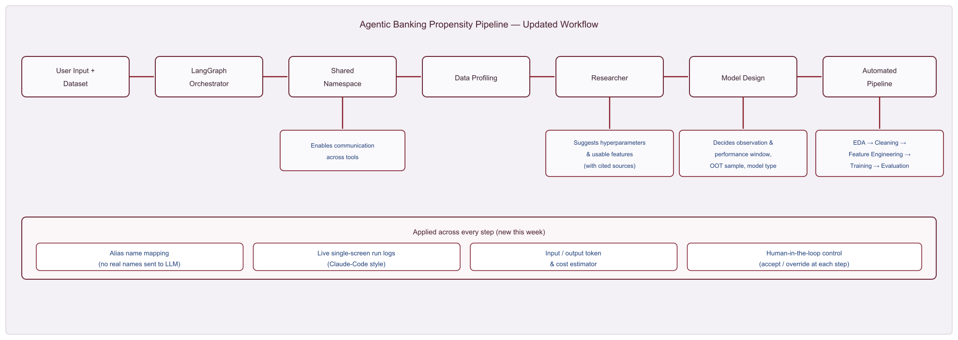
Figure 1 — Updated workflow: pipeline stages with this-week additions (alias mapping, live logs, token/cost estimator, HITL).

3. Human-in-the-loop (a deliberate strength)
This is not a fully autonomous system. There are human checkpoints at every major stage — after data profiling, after the model design is proposed, after feature selection, and after evaluation. At each gate the reviewer chooses one of three actions:
- Accept — proceed with the agent's decisions.
- Override — change a specific value, e.g. swap the metric or the algorithm.
- Regenerate — send the step back with feedback and re-plan.
Every decision is logged with its reason and source, so the run is fully auditable. The agent accelerates the work but never makes the final call alone.

4. What each code folder does
Think of it as three groups: the rules, the workers, and the boss.
Folder | Plain-English job
contracts/ | The rulebook. Defines RunConfig — the single recipe that describes a run. Everything reads/writes this.
pipeline/ | The workers (math). Profiling, splitting, cleaning, feature selection, training, evaluation, saving. Pure tested Python.
mlkit/ | The toolbox of reusable ML helpers (stats, IV, cross-validation) used by the workers.
advisors/ | The only place the LLM lives. Research, design, search-strategist, narrative. It thinks; it does not do data math.
app/ | The boss / orchestration. nodes.py = the steps; orchestrator.py = simple runner; graph.py = the LangGraph version.
runtime/ | Support staff: human-approval gates (hitl.py), live logging (run_logger.py), token/cost tracking (cost.py).
dataio/ | Where data comes from: the data-source registry (file/Hive/Impala…) and the privacy aliasing that masks real column names.
tests/ | The safety net: 66 tests that enforce reproducibility, no-leakage, and 'the LLM never touches the math'.
run_v2.py / notebook_v2.ipynb | The two front doors — command line and notebook.
One-liner: pipeline + mlkit do the ML and never call the AI; advisors is the only AI part; app + runtime glue them together with human checkpoints.

5. LangGraph node flow & branches
A run mostly flows top-to-bottom, but it has two loops — which is what makes it a graph rather than a straight line:
- Branch 1 — design regenerate loop: if the human is not happy with the proposed design, it loops back and re-plans.
- Branch 2 — search loop: after each round of training, the agent decides whether to run another round or stop. If it continues, a strategist step narrows to the best algorithms, then it searches again.
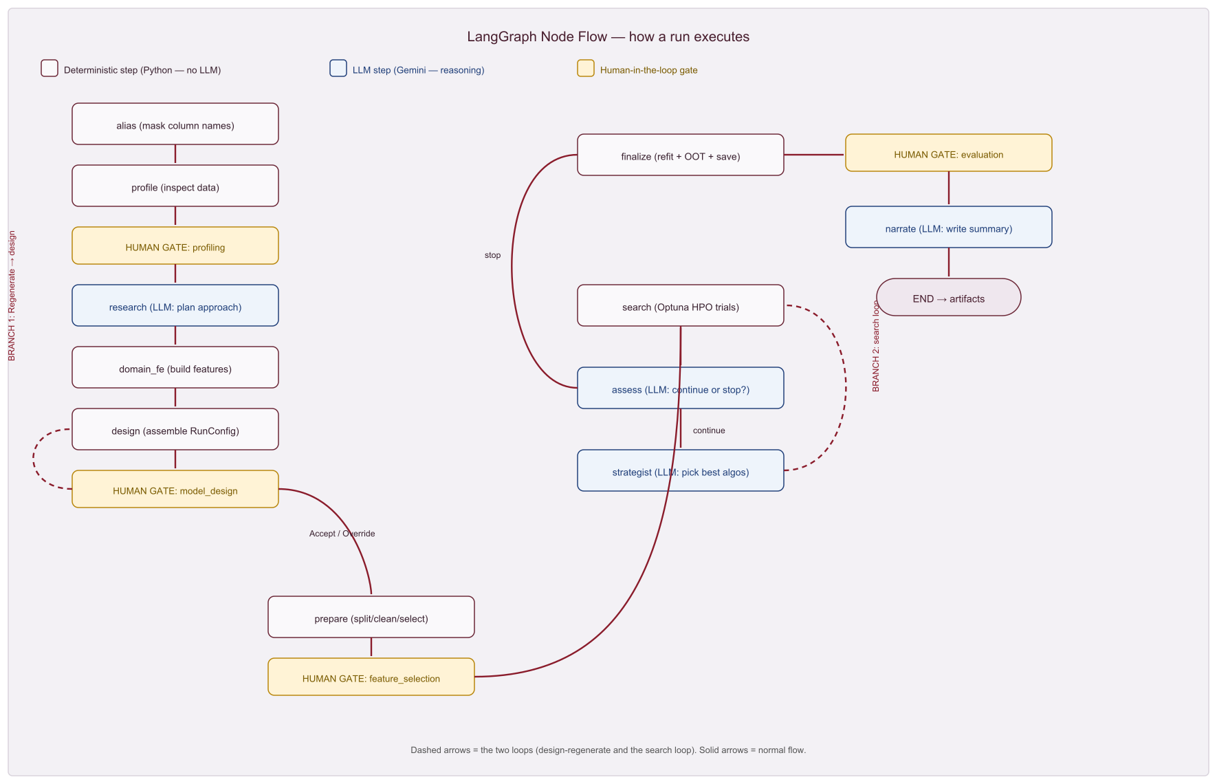
Figure 2 — Node flow. White = deterministic Python, blue = LLM (Gemini) reasoning, gold = human-in-the-loop gate. Dashed arrows are the two loops.

6. Why it is 'agentic', and where the LLM is
Agentic means it makes its own decisions, within guardrails. Three real decisions the agent makes on its own: which models/windows/features suit the problem (research); which algorithms deserve more tuning budget (strategist); and whether to keep searching or stop (assess). But the LLM only reasons and proposes — it never runs code.
Step | Who does it
alias, profile, prepare, search, finalize | Deterministic Python (no AI)
research, strategist, assess, narrate | LLM (Gemini) — judgment only
design | Assembles the LLM's plan into a validated config (deterministic)
One-liner: the AI is the strategist; the Python is the hands. The AI decides the plan; fixed code executes it the same way every time.

7. Current status (where it stands today)
- Dummy data: running on sample data while the workflow is validated; real CDP/Iceberg connection is the next milestone.
- MLflow logging — in progress: artifacts and the run config are captured; wiring them into MLflow so every run is tracked centrally is underway.
- Integrations to confirm: BedRock, SageMaker, Amazon Q.
- Internet: only the Research tool needs it; everything else runs internally.

8. Likely questions (quick answers)
Q: Does the LLM write code that runs?
A: No. There is no exec() of AI-generated code. The LLM fills in a configuration; pre-written, tested functions do the work. A test fails the build if the math layer ever imports the AI.
Q: Is it reproducible?
A: Yes. Same config + same data + same seed produces an identical model, byte-for-byte. A re-run involves no LLM at all.
Q: How do you prevent data leakage?
A: The data is split by time first, before anything is learned. Cleaning, feature selection and encoding are fit on the training part only. Cross-validation is grouped by customer.
Q: Does customer data go to Gemini?
A: No raw data, and not even real column names. Every column is masked to a neutral alias before the LLM sees anything; only aggregate statistics are sent. Names are translated back for the human.
Q: What if the LLM hallucinates or is wrong?
A: Three protections: its output is validated against the schema (bad values auto-corrected or rejected); a human approves at every gate; and a deterministic fallback keeps the run completing if the LLM fails.
Q: What if there is no internet or no API key?
A: It runs fully offline with deterministic defaults — just without the AI suggestions. Nothing breaks.
Q: How much does the LLM cost?
A: Every call's tokens are metered and logged per run; on the free tier it is effectively zero, and it is tracked so it stays transparent.
Q: Can we override its decisions?
A: Yes. At each gate you can Accept, Override a specific value (e.g. swap the metric or algorithm), or Regenerate with feedback.
Q: What models does it try, and how does it handle imbalance?
A: Logistic Regression, Random Forest and gradient boosting (LightGBM/XGBoost, with safe fallbacks). It picks the metric and sampling based on the imbalance level — e.g. PR-AUC/recall for fraud and credit risk.
Q: Will it handle our large CDP data?
A: The design pulls only needed columns and snapshots (pushdown), so heavy reduction happens on the cluster and only a reduced frame is modelled in pandas. That part is the next phase; today it runs on sample data.
Q: What do we get at the end?
A: A deployable model bundle, the leaderboard, a model card/summary, the full reasoning log, and (in progress) everything logged to MLflow and pushed to Bitbucket.
Q: linear vs graph engine — what's the difference?
A: Same steps and same results. graph (LangGraph) can truly pause at a human gate and resume later (UI/service-ready); linear runs start-to-finish in one go (simpler for scripts/CI).
Repeat this one line and you cover half their concerns: “the AI plans, fixed tested code executes, and a human approves each step” — that single sentence answers reproducibility, safety and governance at once.

