

SIMATS ENGINEERING

Saveetha Institute of Medical and Technical Sciences
Chennai- 602105

Student Name: Athavan K Reg. No.: 192524036
Course Code: CSA1402 Slot: C
Course Name: Compiler Design
Course Faculty: Dr N Deepa
Project Title: CHATRIX – COMPILER-BASED FRAMEWORK FOR SECURE CHAT MESSAGE ANALYSIS AND OPTIMIZATION
Module Photographs: (2 photographs –Module Photo, Individual student contribution module work in the project and presentation image)
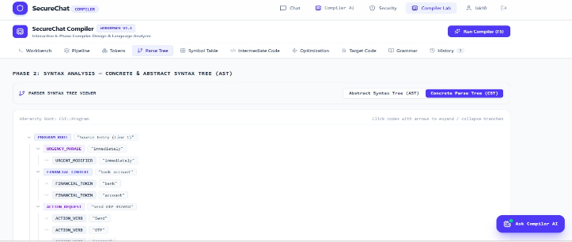
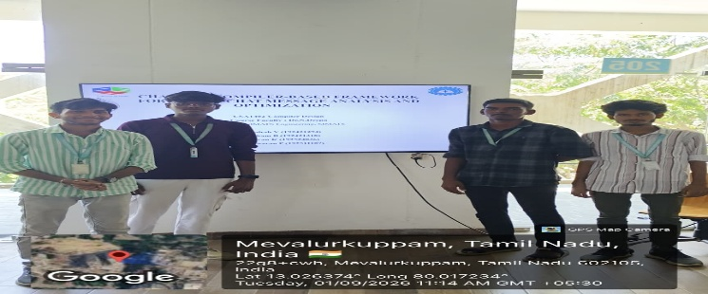
Project Description: (here you write what you did in this project (contribution) including Model Description
CHATRIX – Compiler-Based Framework for Secure Chat Message Analysis and Optimization is an intelligent compiler-based system designed to analyze and optimize chat messages before they are processed or transmitted. The framework treats chat messages as input programs and passes them through different compiler phases such as lexical analysis, syntax analysis, semantic analysis, intermediate representation, security analysis, and optimization. It can identify potentially harmful, suspicious, sensitive, or inappropriate content while preserving the original meaning of legitimate messages. The optimization phase can reduce unnecessary words, remove redundant patterns, and improve message structure without changing its intended meaning. CHATRIX provides a visual representation of each processing stage, helping users understand how compiler techniques can be applied to secure communication, message analysis, and intelligent text optimization.

Student Signature Guide Signature

Athavan k

