## Concept

### Explanation:

In my concept I want to help people who need to rehabilitate from certain arm injuries. For this rehabilitation I want the user of my VR experience to climb a rope. The setting is 17th century Amsterdam. To move crates up a few stories in building, the people used to use a pulley system to pull the heavy crates up. But the rope for this pulley system has gotten stuck. This allows the user to climb the rope.

### Goal:

The goal of my experience was helping people who need to rehabilitate from arm injuries. Helping them by simulating simple arm movement. Letting them move up and down the rope. While enjoying the 17th century Amsterdam environment.

## Assets

### Goal:

The goal for my assets work was learning Blender and making a realistic Rope, Crate and environment for my setting.

### Research:

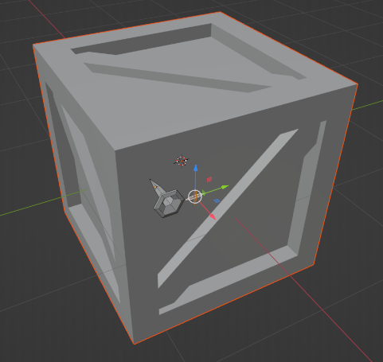The research I did for this was research on how to make a rope model in blender. Unfortunately, this ended up looking pretty bad. So, I opted to make it work though development in Unity instead of an asset. So the Rope research continues in the Development part of my portfolio.

Besides research for a rope model I looked at a few tutorials on how to use the different tools blender has to offer.

### Creation:

For my crate I used the techniques I learned from these tutorials as well as the techniques from the Asset creation classes.

### Evaluation:

Since it was my first time really diving into what Blender has to offer it took some time to get used to the environment. But nonetheless I am proud of the skills I took up after such a short period of time. Even though I would have loved to make even more assets to spice up the environment.

## Development

### Goal:

The goal of my Unity development was to create the interaction of climbing as rope. To climb a rope, we first need to have realistic rope physics. So, my first priority was to create a realistic rope. After which it would be time for the climbing interaction. After that all the development would be finished besides just implementing all the made assets.

### Research:

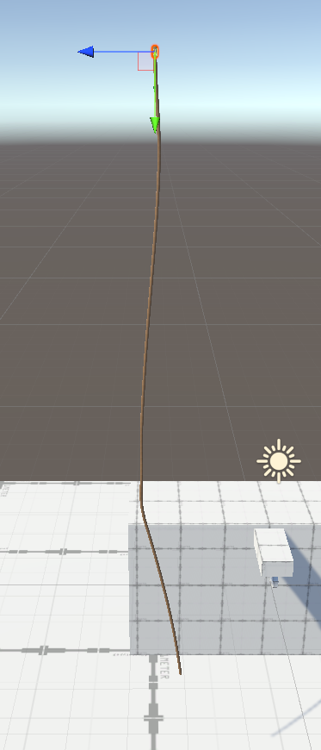To make a realistic rope I research different ways to do this in Unity. But the most straight forward and easy method would be using Joints. At first it seemed that a spring joint would be best suited. But after experimenting with these joints, it performed poorly. So, I researched more into Unity Joints and found that the configurable joint would be best, since it allows for the most customization of the joint.

For the research into climbing mechanics I found multiple methods of implementing it. All of them with different VR packages in unity. In the end in stuck with SteamVR since this was the most diverse but also the most challenging package to use. Since the SteamVR package has a lot to offer but can be difficult in changing it to your liking.

### Creation:

My first attempt at making a realistic rope was with a script that creates its own joints. These joints are in-between all the rope bones I modelled in Blender. But unfortunately, this ended up looking pretty bad. Also, it worked jittery. Then however I found a way to make a rope by instantiating cylinders that have a configurable joint that are connected through code. The first iteration can be seen in the first picture. My second attempt can be seen in the second picture.

// add climbing creation part

### Evaluation:

I never before tried making rope physics or a climbing mechanic in Unity, let alone VR. So I made quite the challenge for myself by setting these goals. With these goals unfortunately I did hit some roadblocks. Most notably in creating the climbing mechanic. This took a lot of bug fixing and retrying with different methods to implement. So in the end it all took longer than expected. Making me have less time for the other parts of my experience. Next time I would like to keep the interaction part of my experience simpler. So I can focus more on other aspects of VR development.

## Visual Design

### Goal:

The goal of my visual design was for the experience to resemble a 17th century Amsterdam canal street. This because during this time the hooks on the top front side of the building were used most. They were used for hauling up stuff more easily.

### Research:

For my style I did research in the colours used in most paintings of the city from the 17th century. These were a lot of browns, blacks and saturated colours. With a bright colour popping in every now and than.

Besides colours I researched into how most canal streets looked and tried to recreate that in blender.

### A picture containing text, wood Description automatically generatedCreation:

In order to give a lot of detail at the cost of a minor performance I used PixelPlant. This created a lot of different maps for my objects that give more detail.

### Evaluation:

The visual design aspect of my experience didn’t have the highest priority. But I am really happy with the result the PizelPlant maps gave my assets.

## Final product & effect

### Goal:

### For my achieved final product the goal was to make the user climb a rope with realistic rope physics. While being in a 17th century setting.

### Research:

### Creation:

### Evaluation: