IT3091 - MACHINE LEARNING

Member 2 - Ridge Regression Report
Group Assignment - 2026-AI-08K
Ames House Price Prediction & Valuation Analysis

Student Name | Student ID | Assigned Model
S P R H Wijesir | IT24100602 | Ridge Regression

1. Objective
The objective of this work is to train and evaluate a Ridge Regression model for house-price prediction using the team's shared preprocessing pipeline. The model is evaluated using 5-fold cross-validation, and the regularization parameter alpha is tuned using the values tested in the notebook.

2. Data Loading and Target Preparation
The notebook successfully loaded the Ames Housing training and test datasets. The training data contained 1,460 rows and 81 columns, while the test data contained 1,459 rows and 80 columns.
Item | Notebook Output
Train shape | (1460, 81)
Test shape | (1459, 80)
X shape | (1460, 79)
y shape | (1460,)

The target variable SalePrice was transformed using log1p before model fitting. Predictions were converted back to the original dollar scale using expm1 for RMSE, MAE, and dollar-scale R².

3. Cross-Validation and Pipeline
The notebook used KFold cross-validation with 5 folds, shuffling enabled, and random_state = 42. The Ridge model was combined with the shared preprocessing pipeline using scaled numeric features, log-transformed selected numeric features, one-hot encoding, feature engineering, and imputation.
Setting | Value
Cross-validation | KFold(n_splits=5, shuffle=True, random_state=42)
Model | Ridge Regression
Shared preprocessing | Scaled configuration with log_numeric=True
Initial alpha | 1.0

4. Initial Ridge Evaluation (alpha = 1.0)
The first Ridge model used alpha = 1.0. Its 5-fold cross-validated predictions were converted back to dollars before calculating the main prediction metrics.
Metric | Notebook Output
RMSE | $47,936.20
MAE | $16,027.68
Dollar-scale R² | 0.6356
Mean Train R² | 0.9414
Mean Validation R² | 0.8753
Overfitting Gap | 0.0662

5. Alpha Tuning
The notebook tested alpha values 0.1, 1.0, 10.0, and 50.0. The table below reproduces the exact tuning results shown in the notebook.
Alpha | RMSE | MAE | Dollar R² | Train R² | Validation R² | Overfit Gap
0.1 | $47,412.74 | $15,894.80 | 0.643564 | 0.945699 | 0.870322 | 0.075377
1.0 | $47,936.20 | $16,027.68 | 0.635650 | 0.941414 | 0.875258 | 0.066156
10.0 | $49,966.05 | $16,101.71 | 0.604140 | 0.931966 | 0.875163 | 0.056803
50.0 | $51,322.19 | $16,460.36 | 0.582360 | 0.919710 | 0.872467 | 0.047243

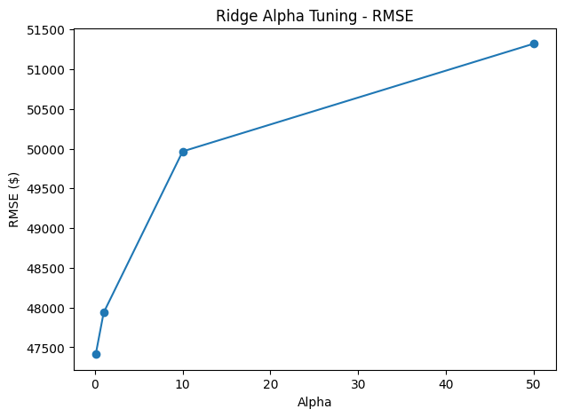
Figure 1. Ridge alpha tuning - RMSE (exact notebook output).
Alpha = 0.1 was selected because it achieved the lowest RMSE and MAE and the highest dollar-scale R² among the tested values. Although larger alpha values slightly reduced the train-validation gap, alpha = 0.1 gave the strongest overall predictive performance on the primary dollar-scale metrics.

6. Final Ridge Model
The final Ridge pipeline was trained on the full training dataset using alpha = 0.1. The notebook confirmed that the final model trained successfully.
Final Metric | Value
Selected alpha | 0.1
RMSE | $47,412.74
MAE | $15,894.80
Dollar-scale R² | 0.6436
Mean Train R² | 0.9457
Mean Validation R² | 0.8703
Overfitting Gap | 0.0754

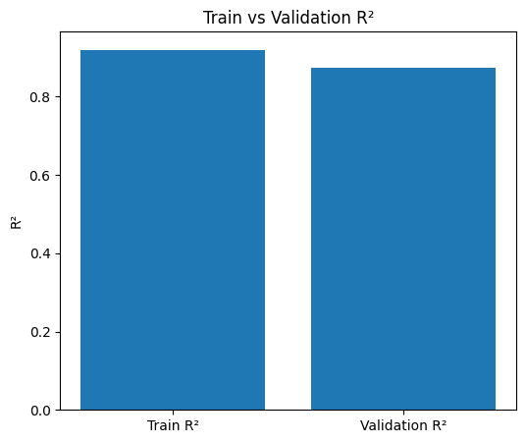
Figure 2. Train vs Validation R² (exact notebook output).

7. Coefficient Analysis
The fitted Ridge coefficients were extracted using the transformed feature names from the shared preprocessing pipeline. The notebook listed the strongest positive and negative coefficients and displayed them in a horizontal bar chart.
Top Positive Feature | Coefficient
nominal__RoofMatl_WdShngl | 0.322755
nominal__RoofMatl_Membran | 0.304668
nominal__Condition2_PosA | 0.274253
nominal__RoofMatl_Metal | 0.231920
indicators__MasonryConflict | 0.184789
nominal__RoofMatl_CompShg | 0.169469
nominal__RoofStyle_Shed | 0.169268
nominal__HouseStyle_1.5Unf | 0.160569
nominal__Condition2_RRNn | 0.157582
nominal__Condition2_Feedr | 0.135823

Top Negative Feature | Coefficient
nominal__RoofMatl_ClyTile | -1.378920
nominal__Condition2_PosN | -0.556305
indicators__HasPool | -0.390904
nominal__MSZoning_C (all) | -0.345535
nominal__Exterior1st_BrkComm | -0.294175
nominal__Condition2_RRAe | -0.143376
nominal__MiscFeature_TenC | -0.117013
nominal__MSSubClass_45 | -0.113561
nominal__Foundation_Wood | -0.110393
nominal__GarageType_2Types | -0.102941

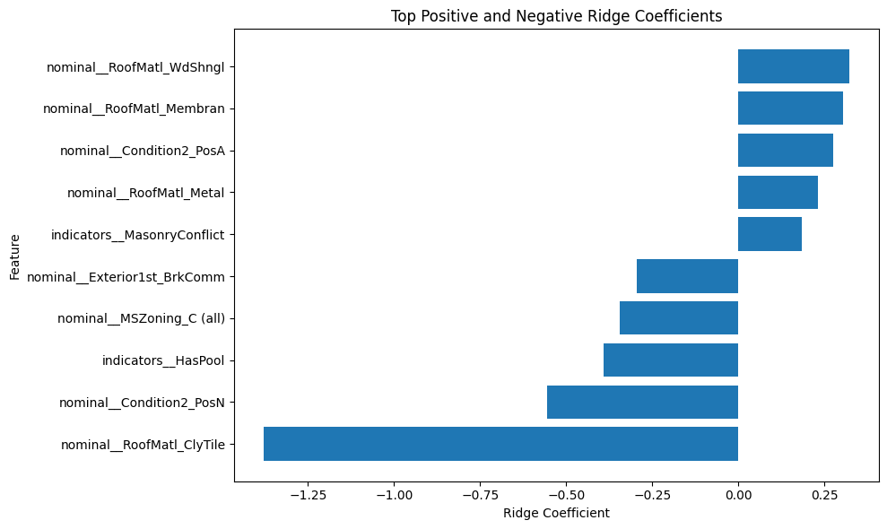
Figure 3. Top positive and negative Ridge coefficients (exact notebook output).
The coefficient interpretation in the notebook treats these values as associations with predicted log-sale price rather than causal effects. Positive coefficients are associated with higher predicted log-sale prices relative to their reference categories, while negative coefficients are associated with lower predicted log-sale prices. Large coefficients for rare categories, particularly some roof-material classes, should be interpreted cautiously.

8. Saved Outputs
The notebook saved the trained Ridge pipeline and exported the final metrics for the group's master model comparison.
Output | Notebook Path / Name
Trained model | ridge_model.joblib
Metrics JSON | reports/model_results/member2_ridge_metrics.json
Model name in JSON | Ridge Regression
Alpha in JSON | 0.1

9. Conclusion
Ridge Regression was trained using the shared preprocessing pipeline and evaluated with 5-fold cross-validation. Among the tested alpha values, 0.1 produced the best dollar-scale RMSE, MAE, and R². The final model achieved RMSE = $47,412.74, MAE = $15,894.80, and dollar-scale R² = 0.6436. Its mean training R² was 0.9457 and mean validation R² was 0.8703, giving an overfitting gap of 0.0754. The fitted coefficients were also examined to interpret the model's linear associations with predicted log-sale price. These results and saved outputs can now be used in the final group model comparison.

