IT3091 – MACHINE LEARNING
Member 3 Report
Preprocessing & Feature Engineering
Group Assignment – 2026-AI-08K
House Price Prediction and Valuation Feature Analysis
Student Name | Student ID | Core Responsibility
Ahamed M.A.W | IT24103352 | Preprocessing & Feature Engineering

1. Objective of Member 3 Work
The purpose of Member 3 work was to convert the raw Ames Housing records into consistent, modelling-ready inputs while preserving the meaning of the original property information. The work focused on missing-value treatment, categorical encoding, numerical preparation, feature engineering, outlier decisions, leakage prevention, and reproducible handover to the modelling stage.
The preprocessing strategy was guided by the official Ames data dictionary and by the evidence produced during Member 2 data understanding and EDA. The objective was not simply to remove missing values, but to distinguish genuine unknown information from cases where a feature is structurally absent, such as a property with no garage, basement, fireplace, pool, fence, or alley access.
Model training, model comparison, predictive evaluation, final model selection, and business recommendations were not performed in this stage. Those activities remain within Member 4 responsibility.
2. Handover from Member 2
Member 2 identified the main data-quality patterns that needed to be addressed before modelling. Member 3 used those findings as preprocessing evidence rather than repeating the full exploratory analysis.
Member 2 Finding | Member 3 Preprocessing Response
SalePrice is right-skewed. | Keep the target unchanged in dollars during preprocessing and leave target-transformation comparison to Member 4.
Garage and basement gaps often coincide with zero area or capacity. | Create explicit structural-absence rules and check inconsistent exceptions before assigning zero or absence categories.
Several optional-property features contain substantial missingness. | Apply feature-aware treatment instead of a single blanket imputation method.
GrLivArea contains unusual large properties. | Investigate the flagged records but retain them because the evidence does not prove recording errors.
Some features are dominated by one value. | Review them during preprocessing without automatically removing them.
No duplicate training rows were identified. | No duplicate-row removal was required.

3. Raw Data and Preprocessing Audit
Input | Records | Columns | Target Availability
train.csv | 1,460 | 81 | SalePrice present
test.csv | 1,459 | 80 | SalePrice absent

After separating SalePrice from the training data, the raw predictor schema matches the Kaggle test file. Id is preserved for row alignment and audit purposes but is excluded from the predictive feature matrix. The preprocessing implementation also uses a conservative property-only input contract so that fields whose availability at prediction time is uncertain do not influence the prepared features.
CSV parsing was handled carefully because some text tokens have semantic meaning. In particular, MasVnrType contains 864 literal “None” entries and eight “NA” entries in the training file. The literal “None” value is a valid no-veneer category and therefore must not be silently converted into a generic missing value. The same principle applies to data-dictionary fields where NA explicitly means that an amenity is absent.
Targeted compatibility checks were also performed on the test set. Examples included garages with a known garage type but missing measurements, pools with positive area but unknown quality, basement descriptors missing despite evidence of a basement, invalid GarageYrBlt values, and masonry descriptions that conflict with positive veneer area. These cases were retained and handled explicitly rather than being corrected through unsupported guesses.
4. Missing-Value Treatment
4.1 Structural Absence vs Genuine Unknown Values
A central preprocessing decision was to distinguish “feature does not exist” from “feature exists but its value is unknown.” Treating both situations as the same missing value would remove useful information and could produce incorrect numerical replacements.
Feature Group | Treatment | Reason
Garage | Use NoGarage and zero area/capacity only when absence is supported; otherwise keep unknown descriptors and impute applicable missing measurements from training data. | An existing garage with missing information must not be converted to a non-existent garage.
Basement | Use NoBasement and zero quantities only when the record consistently supports absence. Missing descriptors of an existing basement remain unknown. | Basement category gaps can be structural or genuinely unknown.
Fireplace / Pool | Use explicit absence when count/area is zero; preserve presence and unknown quality when capacity is positive. | Quality missingness does not always imply that the amenity is absent.
Alley / Fence | Interpret the documented NA token as no alley/no fence; a genuinely blank value remains unknown. | The data dictionary gives these tokens semantic meaning.
LotFrontage | Use a training-fit median and preserve a missingness indicator. | The dictionary does not define a structural-absence meaning for LotFrontage.
Masonry veneer | Preserve valid None states, keep positive area measurements, and flag contradictory type/area combinations. | Observed area should not be erased because the descriptive field is inconsistent.
Garage year | Invalid or unknown applicable years are imputed from training data; a missing garage is represented separately through HasGarage. | Year zero is not a valid construction year and unsupported corrections would be speculative.

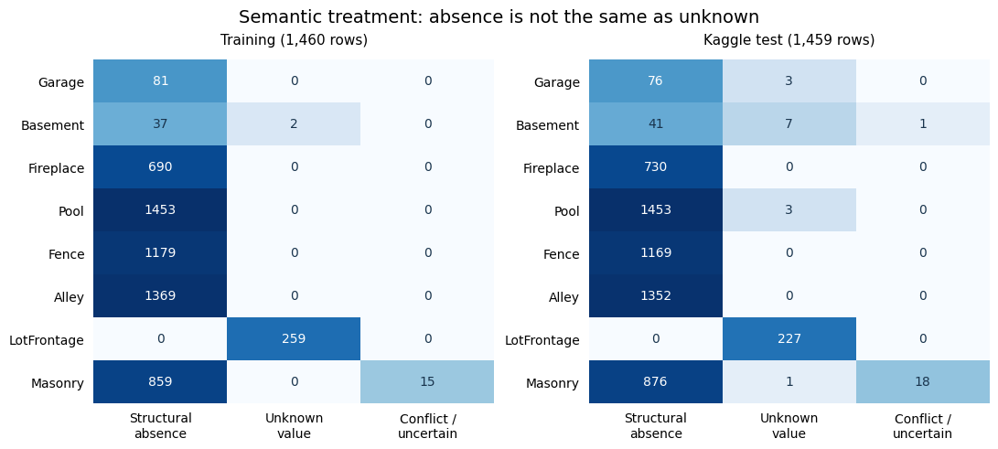
Figure 1. Semantic treatment of structural absence, genuine unknown values and conflicting/uncertain observations in the training and Kaggle test data.
4.2 Deterministic Recovery and Uncertainty Indicators
Where a missing basement total or component could be recovered exactly from the remaining values in the same record, deterministic reconstruction was used before statistical imputation. This avoids replacing a value with a population estimate when the record itself already contains enough information.
For genuinely unknown numerical values, medians are learned only from the rows supplied to the fitting stage. The implementation also creates missingness and consistency indicators such as LotFrontageUnknown, GarageYrBltUnknown, HasBasementUnknown, MasonryConflict, InvalidYear, and RemodelBeforeBuilt. These indicators preserve the difference between observed values, structural absence, and imputed uncertainty.
5. Semantic Feature Types and Encoding
Feature roles were assigned from their meaning rather than from storage type alone. This is important because several Ames Housing variables are stored as numbers even though they represent categories or ordered ratings. For example, MSSubClass is a dwelling-class code and is therefore treated as categorical rather than as a continuous quantity.
Semantic Group | Examples | Representation
Numerical measurements | LotArea, GrLivArea, GarageArea, TotalBsmtSF | Numerical branch with feature-aware missing handling; optional scaling/log transformation.
Counts / capacity | FullBath, Fireplaces, GarageCars | Preserved as numeric counts with structural zeros where appropriate.
Nominal categorical | Neighborhood, MSSubClass, GarageType, Fence | One-hot encoding with unseen categories safely ignored.
Ordinal | OverallQual, ExterQual, GarageFinish, BsmtExposure | Documented ordered mapping; unknown/absence states kept distinguishable.
Binary / indicators | CentralAir, HasGarage, conflict and unknown flags | Binary representation; not unnecessarily scaled.
Years | YearBuilt, YearRemodAdd, GarageYrBlt | Numeric representation with plausibility checks and explicit uncertainty.
Identifier / target / audit-only | Id, SalePrice and prediction-time exclusions | Kept outside the predictor matrix.

Nominal variables are processed with one-hot encoding and handle_unknown="ignore", allowing unseen test categories to be transformed without refitting. Ordinal mappings are used only where a defensible ordering exists. The numeric codes represent ordered states, not equal monetary differences between adjacent levels.
6. Feature Engineering
Feature engineering was intentionally limited to a small set of interpretable property features. No feature was derived from SalePrice, neighborhood target averages, or other target-based statistics.
Engineered Feature | Definition / Purpose
HasGarage | Presence indicator based on garage descriptions, capacity and area.
HasBasement | Presence indicator based on basement descriptions and quantities; uncertain cases retain a separate flag.
HasFireplace | Indicates fireplace presence from count and quality evidence.
HasPool | Indicates pool presence from area and quality evidence.
HasMasonryVeneer | Indicates veneer presence from area and material evidence.
TotalIndoorAreaSF | GrLivArea + TotalBsmtSF; combines above-ground living space and basement area.
FinishedBasementSF | BsmtFinSF1 + BsmtFinSF2; total finished basement area.
BathroomEquivalent | FullBath + BsmtFullBath + 0.5 × (HalfBath + BsmtHalfBath).
TotalPorchSF | OpenPorchSF + EnclosedPorch + 3SsnPorch + ScreenPorch.

The preprocessing schema also includes missingness and consistency indicators so that imputation does not hide uncertainty. These features provide traceable information about unknown values and contradictory records while remaining independent of the target variable.
7. Outlier and Low-Variation Decisions
Member 2 highlighted two very large GrLivArea observations: training IDs 524 and 1299. Their living areas are 4,676 and 5,642 square feet, with observed sale prices of $184,750 and $160,000. Both records were retained because the available evidence does not establish that they are data-entry errors. No target-dependent outlier deletion, fixed 4,000-square-foot rule, or automatic IQR removal was applied.
Low-variation features were reviewed rather than removed automatically. Utilities is especially dominant, with AllPub recorded for 1,459 of 1,460 training properties, while Street, Condition2, RoofMatl, Heating and several rare-area variables also show limited variation. Rarity alone was not treated as sufficient evidence that a feature should be discarded.
8. Prediction-Time Feature Availability
The project objective is to support a property-pricing decision before or during valuation. To avoid using information that may only become known at the completed transaction stage, the default preprocessing contract excludes fields with uncertain prediction-time availability.
Excluded Field | Reason
Id | Record identifier used only for alignment and audit.
SalePrice | Target variable and therefore unavailable as an input.
SaleType | Actual transaction type may not be known at the intended prediction point.
SaleCondition | Transaction circumstances may not yet be established.
YrSold | Actual sale year is a historical transaction field, not an independently supplied valuation date.
MoSold | Actual sale month may not be available before the final transaction.
MiscVal | Prediction-time provenance of this recorded monetary value is unclear.

These exclusions are availability decisions, not claims that the variables are statistically useless. The raw fields remain available for auditing but do not influence the default prepared predictor matrix.
9. Numerical Transformation and Scaling Strategy
The preprocessing implementation exposes both unscaled and scaled configurations because scaling requirements depend on the regression method chosen by Member 4. The scaled configuration applies StandardScaler to appropriate numerical and ordinal-score branches, while one-hot encoded columns and binary indicators remain unscaled.
An optional log_numeric setting is available for selected nonnegative size variables, including LotArea, LotFrontage, GrLivArea, MasVnrArea and TotalIndoorAreaSF. It is disabled by default and was not selected using predictive performance. SalePrice remains in original dollars during Member 3 work; any target log transformation is left to the modelling and validation stage.
10. Leakage-Safe Reusable Preprocessing Pipeline
The reusable preprocessing implementation is stored in src/member_03/preprocessing.py. The notebook provides the explanation, evidence and verification, while the Python module provides a consistent transformation component that Member 4 can attach to regression estimators.
The pipeline follows the sequence: raw property data → input contract → semantic cleaning → training-only imputation → feature engineering → categorical encoding → optional scaling → model input. Learned quantities such as medians, category vocabularies and scaling statistics must be fitted using training-fold rows only. Validation and Kaggle test rows reuse the fitted state through transform operations.
from src.member_03 import build_preprocessor

The build_preprocessor() factory returns an unfitted preprocessor in either scaled or unscaled form. This design prevents information from held-out observations entering learned preprocessing and makes the same rules reusable across Member 4 validation folds.
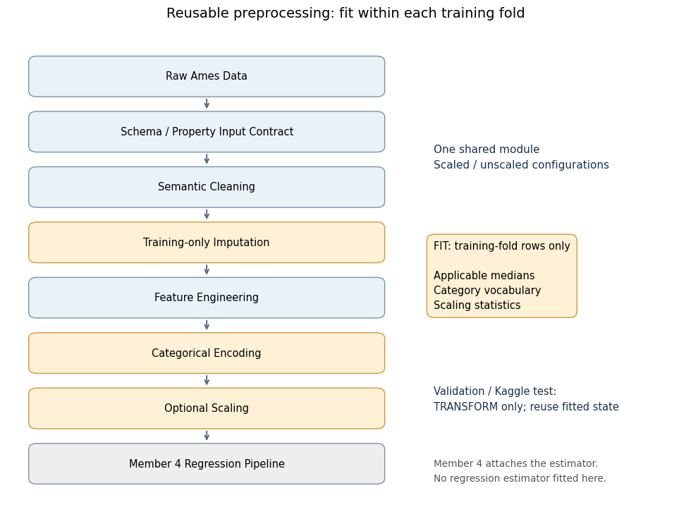
Figure 2. Leakage-safe Member 3 preprocessing workflow. Learned preprocessing is fitted on training-fold rows and reused to transform validation or Kaggle test rows.
11. Preprocessing Verification
A temporary 1,168-row fitting subset and 292-row held-out subset (random_state = 42) were used only to verify preprocessing correctness. This was not the group’s final model-evaluation split and no regression estimator was trained.
Verification Check | Result
Target / identifier exclusion | Id and SalePrice did not enter the transformed predictor matrix.
Row alignment | Input row order and exported IDs remained aligned.
Missing / infinite output | Transformed validation, test and exported predictor values contained no missing or infinite values.
Unseen categories | Previously unseen categories transformed successfully without refitting.
Scaled / unscaled configurations | Both configurations completed with compatible feature counts for the same fitting subset.
Determinism | Repeated transformation returned identical outputs.
Training-only learned state | Imputation, category vocabulary and scaler statistics were learned from fitting rows only.
Target independence | Changing target values did not change preprocessing output.
Full export reproduction | A fresh full-training unscaled fit reproduced the saved processed CSVs.

The verification split produced 297 transformed features for both scaled and unscaled configurations. The full-training export contains 300 transformed predictors because the full fitted category vocabulary differs from the temporary verification fit. These checks establish preprocessing correctness, not model accuracy.
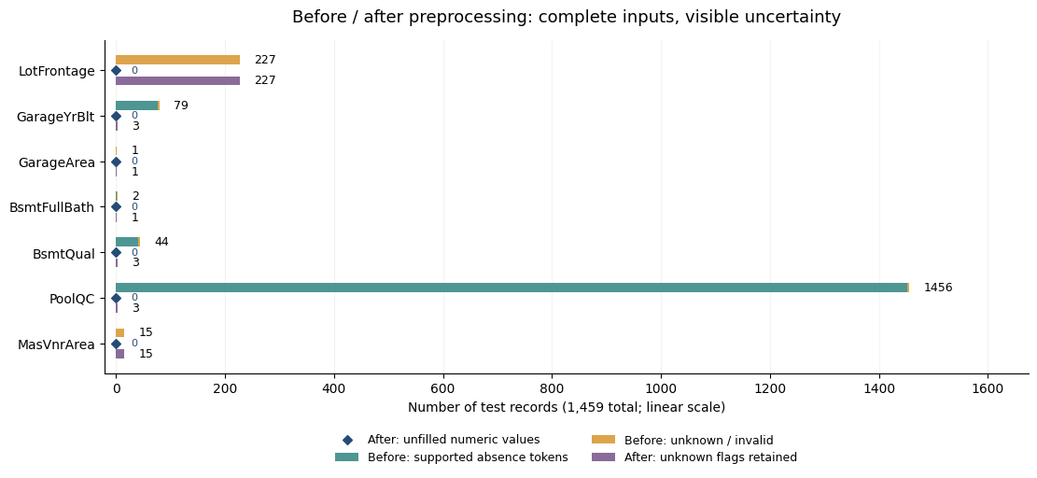
Figure 3. Before/after preprocessing completeness for selected Kaggle test features. Numerical gaps are filled while explicit uncertainty indicators remain visible.
12. Processed Dataset Handover
Following the group lead’s requirement, Member 3 also generated direct processed CSV files using the unscaled configuration fitted on all raw training predictors. The Kaggle test set was transformed using that fitted training state; no test rows or target values contributed learned preprocessing statistics.
Exported File | Rows | Columns | Composition
train_preprocessed.csv | 1,460 | 302 | Id + 300 transformed predictors + SalePrice
test_preprocessed.csv | 1,459 | 301 | Id + the same 300 transformed predictors; no SalePrice

The processed predictors contain no missing or infinite values, train and test use the same predictor names and order, IDs remain aligned with the raw data, and SalePrice is unchanged in the training export. These files support direct handover, inspection, final fitting and demonstration.
For cross-validation, however, Member 4 should use the unfitted preprocessing factory together with raw predictors. A CSV generated after fitting preprocessing on all 1,460 labelled rows must not be used as the input to later cross-validation because its imputation, encoding and scaling state has already seen rows that may subsequently be designated as validation observations.
13. Preprocessing Decision Log and Feature Schema
Two supporting evidence files were produced under reports/Member_03. The preprocessing_feature_decision_log.csv records each major issue, supporting evidence, selected treatment, alternatives considered, rationale, leakage implications and implementation status. The feature_schema.csv documents original and derived feature meanings, semantic types, structural-absence rules, missing-value strategies, encoding/scaling decisions, prediction availability and default use.
These files provide traceability without reproducing every implementation detail in the main report. They also make the preprocessing choices easier for Member 4 and the group to review independently of model performance.
14. Member 4 Handover
Handover Component | Purpose
Processed train/test CSVs | Direct processed-data handover requested by the group lead; suitable for inspection and final-fit/demo use.
Unfitted preprocessing factory | Leakage-safe preprocessing inside Member 4 training and cross-validation pipelines.
Scaled and unscaled configurations | Allow model-appropriate numerical representation without changing semantic rules.
Feature schema and decision log | Document feature meaning, missingness decisions, encoding, exclusions and assumptions.
Notebook and figures | Provide executable evidence and visual explanation of preprocessing behaviour.
Manifest / feature summary | Record shapes, versions, fingerprints, output configuration and reproducibility metadata.

Member 4 remains responsible for building the baseline and alternative regression models, choosing the validation strategy, comparing RMSE/MAE/R², evaluating optional target transformations, selecting the final model, interpreting model behaviour and preparing the final recommendation.
15. Limitations and Remaining Assumptions
Structural interpretation depends on the meanings defined by the Ames data dictionary and on consistency between related property fields. Completely missing basement information cannot always prove true absence, so uncertain cases retain explicit indicators. Imputed years and ordinal ranks are numerical representations rather than observed facts, and broad plausibility rules cannot detect every possible chronological inconsistency.
Several engineered aggregates remain mathematically related to their original components, and one-hot encoded feature blocks may introduce dependencies. The preprocessing stage intentionally does not choose features according to model performance. Estimator-specific treatment of collinearity, regularisation or feature importance remains part of the modelling stage.
The conservative property-only contract also excludes transaction-time fields whose availability at the intended prediction point is not established. This improves deployment realism but may remove information that could be useful in a different prediction scenario.
16. Member 3 Contribution Summary
Member 3 delivered a complete preprocessing and feature-engineering workflow for the Ames Housing regression project. The implementation distinguishes structural absence from genuine unknown information, applies training-only learned transformations, preserves uncertainty through indicators, handles nominal and ordinal features according to meaning, retains unsupported outliers instead of deleting them automatically, and creates a small set of interpretable property features.
The final handover includes the executable notebook, reusable preprocessing module, decision log, feature schema, processed training and test CSVs, and supporting reproducibility metadata. The processed training set contains 300 transformed predictors together with Id and SalePrice, while the test export contains the same 300 predictors with Id only. No regression model was trained and no predictive-performance claim is made within Member 3 work.

