IT3091 – MACHINE LEARNING
Member 3 Model Training Report
Random Forest Regressor
Group Assignment – 2026-AI-08K
House Price Prediction and Valuation Feature Analysis
Student Name | Student ID | Core Responsibility
Ahamed M.A.W | IT24103352 | Random Forest Model Training & Evaluation

1. Objective and Assigned Responsibility
The purpose of this Member 3 phase was to train, tune, evaluate and package a Random Forest Regressor for the Ames Housing price-prediction task. This work extends the earlier Member 3 preprocessing contribution by using the shared leakage-safe preprocessing factory directly inside the model pipeline.
The model was developed under the team comparison contract: five-fold K-Fold cross-validation with shuffling and random_state=42, log1p transformation of SalePrice for model fitting, and evaluation after converting predictions back to original dollar values. The notebook is focused on Random Forest only; comparison with Ridge, LightGBM and XGBoost remains a later group-level activity.
Executed Random Forest Result
Selected configuration | 200 trees; max_depth = 20
Mean CV RMSE | $30,814.76
Mean CV MAE | $17,506.27
Mean validation R² | 0.83664
Mean train R² | 0.98013
Overfit gap | 0.14348

2. Data and Fair-Comparison Contract
Item | Implemented Choice
Training data | 1,460 labelled Ames Housing records
Validation | KFold(n_splits=5, shuffle=True, random_state=42)
Rows per fold | 1,168 training / 292 validation
Target used for fitting | log1p(SalePrice)
Metric scale | Original dollars after expm1 inverse transformation
Primary metrics | Mean fold RMSE, MAE and R²; Train/Validation R² gap
Supplementary diagnostics | Pooled out-of-fold RMSE, MAE and R²

All 1,460 training records were preserved. Each row appears in validation exactly once across the five fixed folds. The Kaggle test set was used only for schema compatibility; it has no SalePrice labels and therefore does not provide validation performance evidence.
3. Leakage-Safe Random Forest Pipeline
The Random Forest model does not use the previously exported full-data preprocessed CSV during cross-validation. Instead, raw predictors are supplied to a scikit-learn Pipeline containing build_preprocessor(configuration="unscaled", log_numeric=False) followed by RandomForestRegressor. This ensures that imputation statistics, category vocabularies and other learned preprocessing state are fitted only on the current training fold.
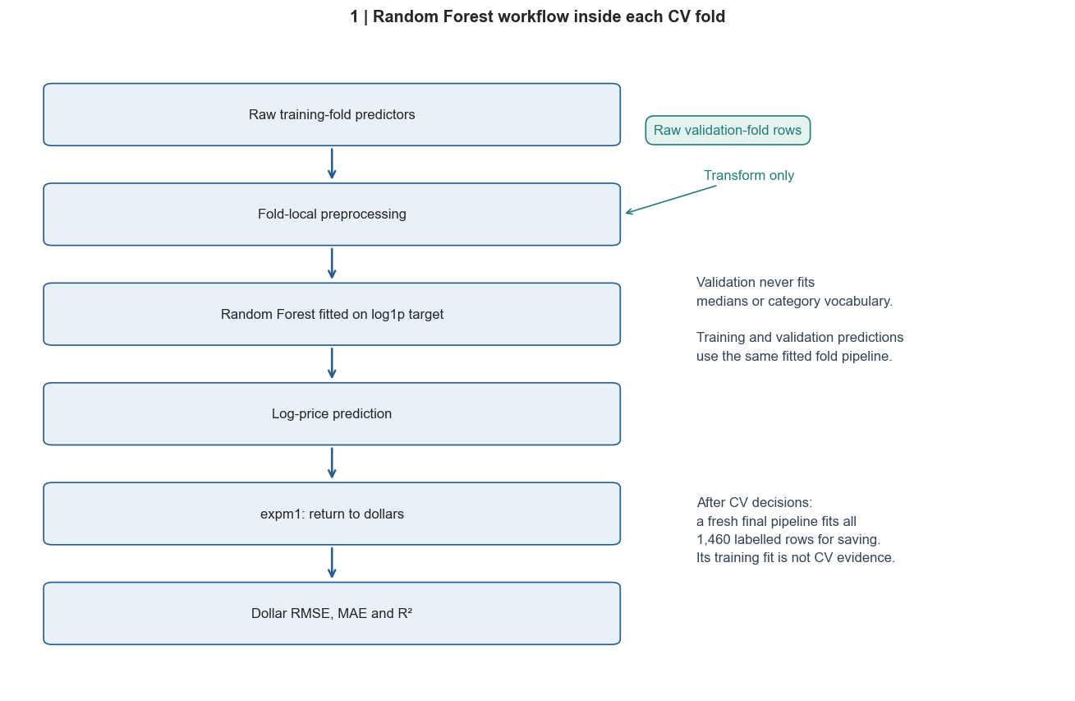
Figure 1. Leakage-safe Random Forest workflow: fold-local preprocessing, log-price modelling, inverse transformation and dollar-scale evaluation.
4. Hyperparameter Tuning
The assigned search space contained exactly six combinations: n_estimators in {100, 200} and max_depth in {10, 16, 20}. Other Random Forest settings were fixed for reproducibility, including random_state=42, squared-error splitting, bootstrap sampling, max_features=1.0 and n_jobs=-1. The best candidate was selected using the lowest mean validation RMSE calculated in dollars.
Trees | Depth | Val. RMSE | Val. MAE | Val. R² | Rank
100 | 10 | $31,263.21 | $17,646.44 | 0.83160 | 6
200 | 10 | $31,208.57 | $17,646.72 | 0.83176 | 5
100 | 16 | $30,866.58 | $17,501.39 | 0.83585 | 3
200 | 16 | $30,859.46 | $17,490.80 | 0.83625 | 2
100 | 20 | $30,987.97 | $17,490.65 | 0.83450 | 4
200 | 20 | $30,814.76 | $17,506.27 | 0.83664 | 1

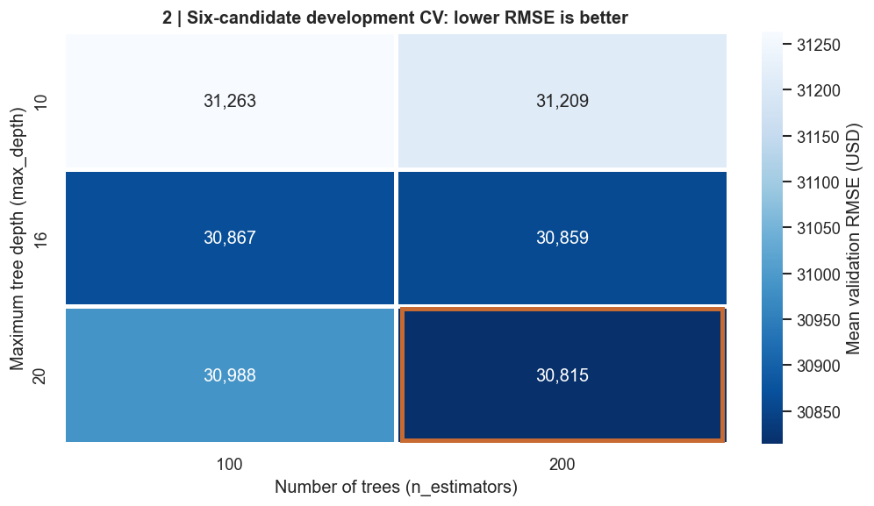
Figure 2. Hyperparameter search results. The selected 200-tree, depth-20 configuration achieved the lowest mean validation RMSE within the assigned six-candidate grid.
5. Five-Fold Cross-Validation Performance
Fold | RMSE | MAE | Train R² | Val. R² | Gap
1 | $30,423.69 | $17,688.73 | 0.97782 | 0.87933 | 0.09849
2 | $28,142.54 | $16,895.88 | 0.97903 | 0.88352 | 0.09551
3 | $43,779.46 | $20,270.63 | 0.98207 | 0.65308 | 0.32899
4 | $28,879.25 | $17,681.83 | 0.98165 | 0.86718 | 0.11448
5 | $22,848.87 | $14,994.30 | 0.98006 | 0.90012 | 0.07994

Metric | Primary Mean-Fold Result | Std. Dev.
CV RMSE | $30,814.76 | $6,965.32
CV MAE | $17,506.27 | $1,696.37
Validation R² | 0.83664 | 0.09239
Train R² | 0.98013 | —
Overfit Gap | 0.14348 | —

Fold 3 is substantially weaker than the other folds, with RMSE of approximately $43,779 and validation R² of 0.65308. This variation increases the overall RMSE standard deviation and shows that the selected forest is sensitive to difficult validation cases. The result is retained rather than hidden or removed.
6. Overfitting Analysis
The Random Forest achieves a mean training R² of 0.98013 compared with mean validation R² of 0.83664, producing an average gap of 0.14348. This indicates that the model fits the training folds much more closely than the held-out folds. The gap is most pronounced in Fold 3 (0.32899), which should be considered when the model is compared with the other team models.
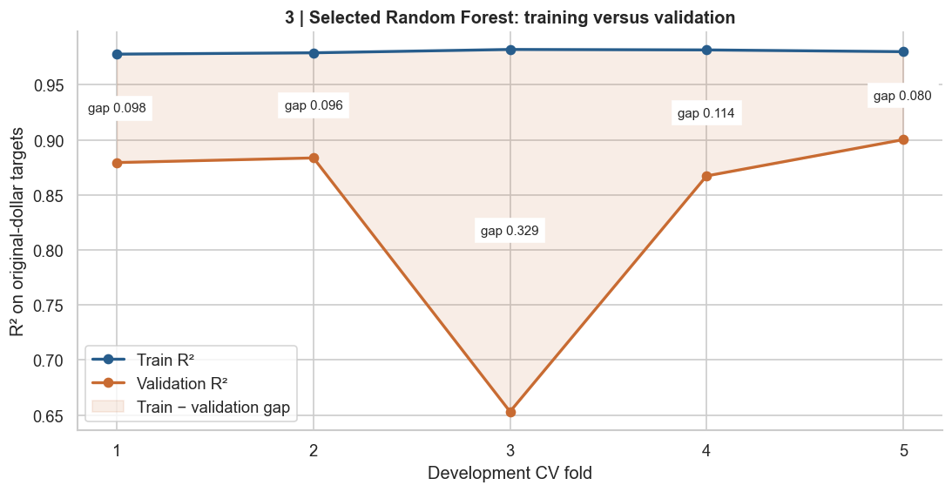
Figure 3. Train-versus-validation R² across the five development-CV folds, illustrating the selected Random Forest overfitting gap.
7. Out-of-Fold Prediction Diagnostics
Out-of-fold (OOF) predictions provide one held-out prediction for every training property. The pooled OOF metrics were RMSE $31,592.17, MAE $17,506.27 and R² 0.84175. These pooled values are supplementary diagnostics; the group comparison should use the predefined mean-fold metrics so that all members report results consistently.
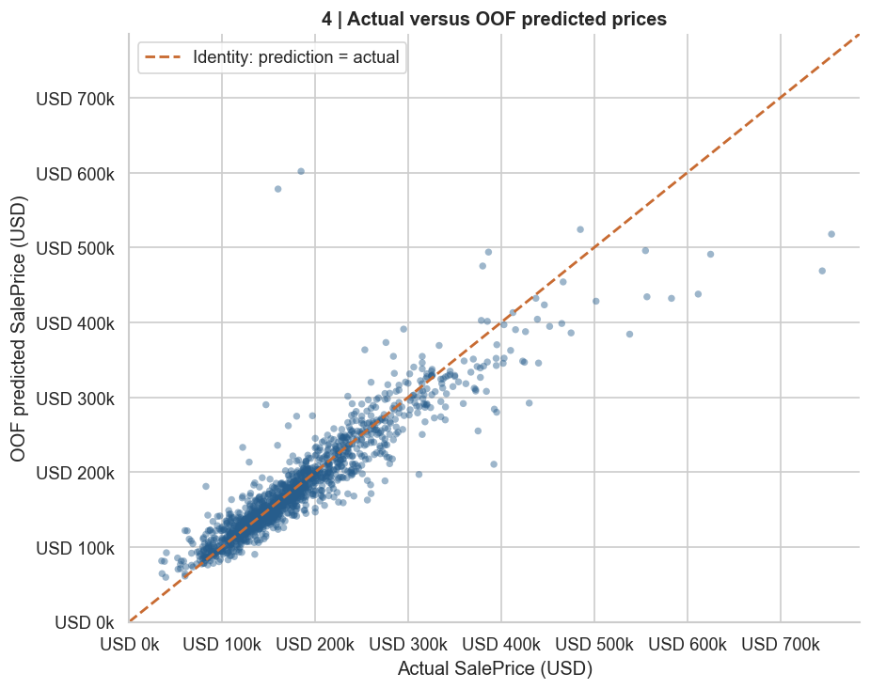
Figure 4. Actual SalePrice versus out-of-fold predicted SalePrice for all 1,460 training records. The diagonal reference line represents perfect prediction.
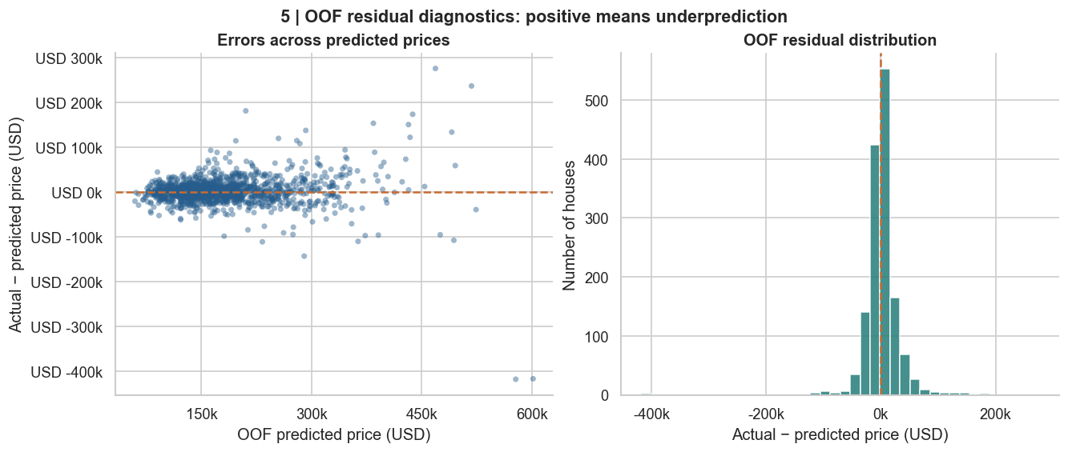
Figure 5. OOF residual diagnostics. Large residuals are retained as evidence of difficult cases rather than removed after observing model error.
The residual inspection identified a small number of very large errors. In particular, property IDs 1299 and 524 both appear in Fold 3 and are strongly overpredicted. These records had already been identified during earlier preprocessing/EDA as unusually large houses with comparatively low observed sale prices. Their presence helps explain the weaker Fold 3 result, but does not justify target-dependent row deletion.
8. Feature Importance and Valuation Evidence
After evaluation, a fresh pipeline using the selected configuration was fitted on all 1,460 labelled records. Feature names were recovered from the same fitted preprocessor that feeds the forest, then aligned directly with RandomForestRegressor.feature_importances_. The final full-data fit contains 300 transformed features.
Rank | Feature | Importance
1 | numeric__OverallQual | 0.45987
2 | numeric__TotalIndoorAreaSF | 0.29528
3 | indicators__CentralAir | 0.01833
4 | numeric__GrLivArea | 0.01468
5 | numeric__GarageCars | 0.01295
6 | numeric__LotArea | 0.01137
7 | numeric__GarageArea | 0.01115
8 | numeric__YearRemodAdd | 0.01021

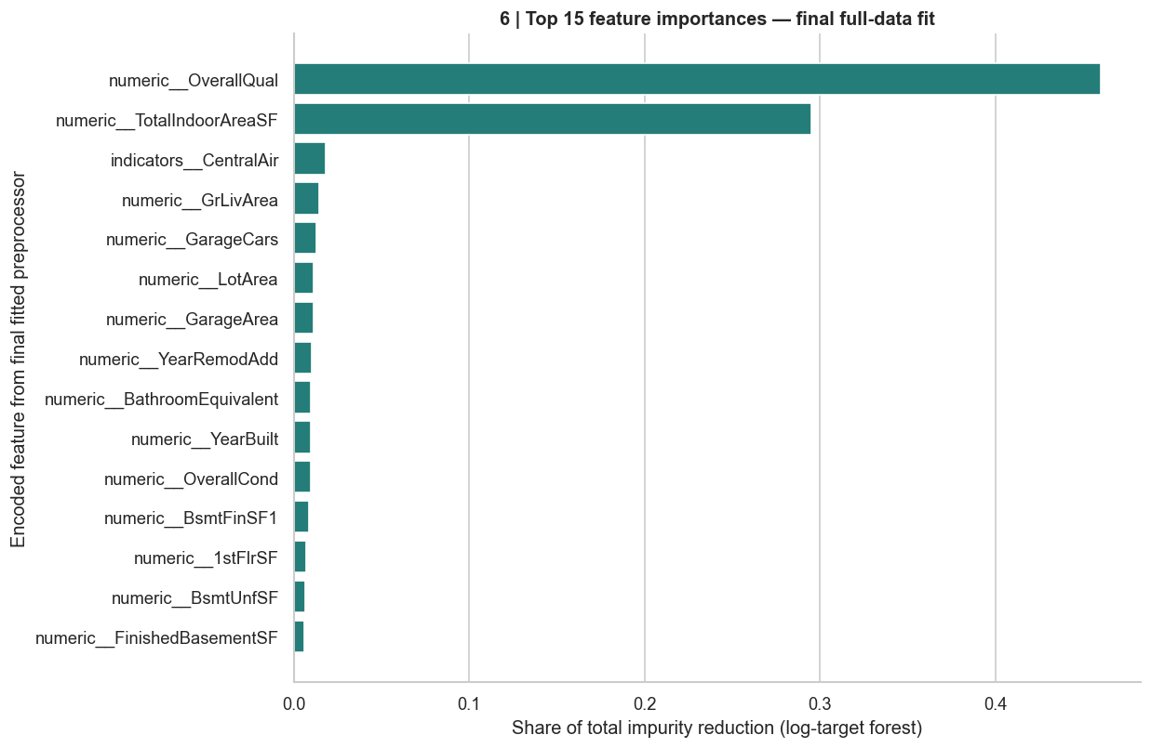
Figure 6. Top-15 Random Forest impurity-based feature importances from the final full-data fit.
OverallQual and TotalIndoorAreaSF dominate the fitted forest, followed by smaller contributions from CentralAir, GrLivArea, GarageCars, LotArea and other property characteristics. These values describe how the fitted Random Forest uses the transformed representation; they do not establish causal effects, direction of price change, or independent monetary impact.
9. Final Model Artifact and Handover
Following cross-validation, the selected pipeline was fitted once on all 1,460 labelled training records. The complete preprocessing-plus-Random-Forest pipeline was saved so that future users can supply raw predictors and receive log1p-price predictions without manually recreating preprocessing steps. Dollar predictions require exactly one np.expm1 inverse transformation.
Artifact | Location / Detail
Notebook | notebooks/Member_03/Member3_Random_Forest.ipynb
Saved pipeline | notebooks/Member_03/random_forest_model.joblib
Model size | 6,443,296 bytes (6.14 MiB)
Metrics handover | reports/model_results/member3_rf_metrics.json
Final feature count | 300 transformed features
Reload verification | Predictions matched the in-memory model within numerical tolerance

The metrics JSON records the selected parameters, fixed settings, preprocessing configuration, fold-level metrics, primary mean-fold metrics, pooled OOF diagnostics, feature count, package versions and reproducibility hashes. Member 4 can use these fields directly in the final model-comparison notebook without manually transcribing values from this report.
10. Limitations and Conclusion
The reported values are development cross-validation results. The same five folds were used for hyperparameter selection and subsequent reporting, so the estimates can contain selection optimism and should not be described as independent test performance. The relatively high train–validation R² gap also indicates overfitting, especially for Fold 3. In addition, impurity-based feature importance can favour some feature structures and can distribute importance across correlated variables.
Within the assigned six-candidate grid, 200 trees with max_depth=20 produced the lowest mean validation RMSE. The executed model achieved mean five-fold RMSE of $30,814.76, MAE of $17,506.27 and validation R² of 0.83664. The notebook, metrics JSON and reload-tested pipeline are ready for group comparison.

