

**King Abdulaziz University**

**Faculty of Computing and Information Systems**

**Course Code: CPIS – 483.**

**______________________________________________________________**

**American Football Games Network**

**Gephi Software**

**Team Member:**

Rawan AlMotairi 1507965

Atheer AlSobhi 1505433

Arwa Rashed 1506468

**Introduction**

We choose a network of American football games between Division IA colleges during season 2000. Then, visualize the network using Gephi software and analyze it. The network contains 115 nodes, 613 edges, and 12 communities.

**The communities of American football games are:**

0 = Atlantic Coast.

1 = Mountain West.

2 = Big Ten.

3 = Southeastern.

4 = Western Athletic.

5 = Independents.

6 = Mid-American.

7 = Big East.

8 = Conference USA.

9 = Big Twelve.

10 = Sun Belt.

11 = Pacific Ten. See Figure[1]

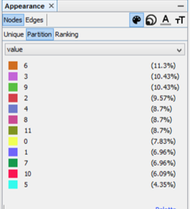

Figure 1: Partition based on the communities

**Visualization using Gephi Software**

The network of American Colleges game before the visualization was confused and hard to analysis. See Figure [2]. We made several steps to visualizing the network on Gephi to make it less messy and easy to analyze. See Figure [3]. The visualization in Gephi has a great interactive feature that when you are hovering over a college it displays the games the colleges team played and fade the other colleges teams**.**

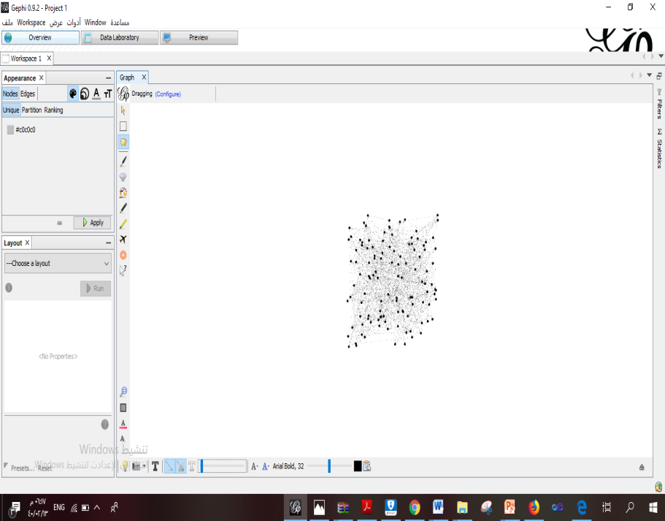

Figure 2: The social network before visualization

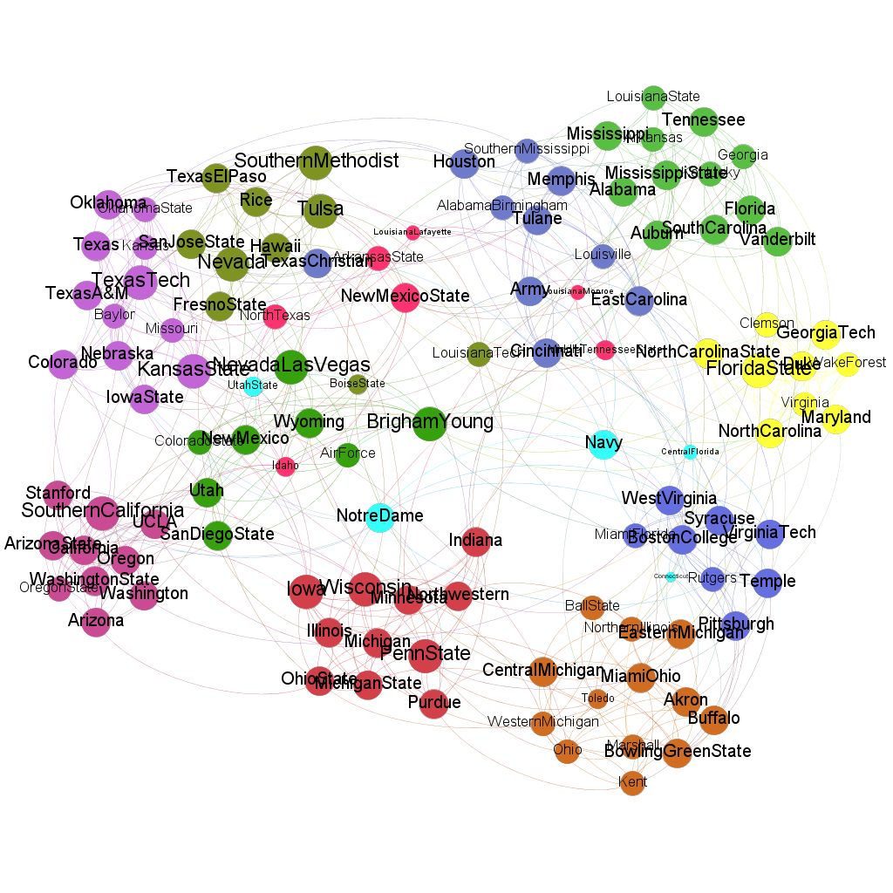

Figure 3: The social network after visualization

**American football games Network Analysis Using Gephi**

* The nodes represent the colleges with the colors of their communities.
* The edges represent the games.
* The nodes and edges represent the colleges and games between the teams.
* The communities represent the conferences to which they belong.
* The colleges from the same community are close to each other's.
* The lowest played team between the college's teams is "Connecticut" it played only with 7 teams (Louisville, Middle Tennessee, Boston College, Ball State, Eastern Michigan, Akron, and Buffalo). See Figure [4].
* Most of the college's teams played 12 times such as Nevda LasVegas team. See Figure [5].

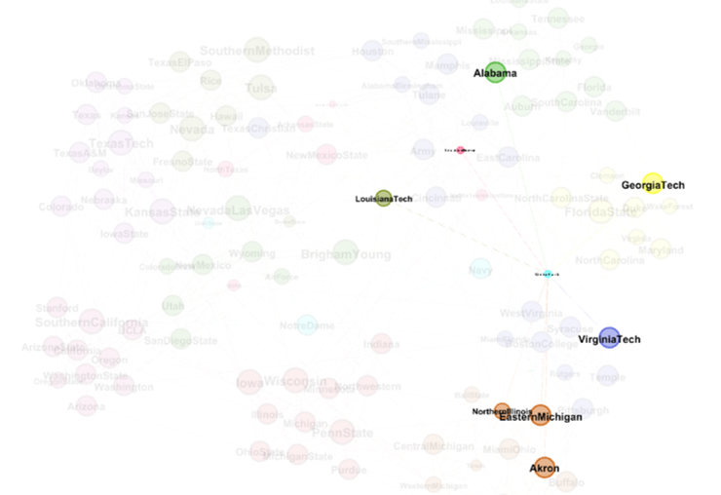

Figure 4: hovering over the team that played less

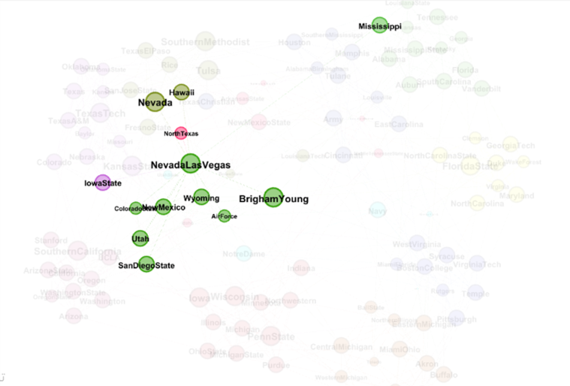

Figure 5: hovering over the Nevada Las Vegas team

**GitHub Link:**

<https://github.com/AtheerAlsobhi/CPIS483>

**References**

[**https://en.wikipedia.org/wiki/2000_NCAA_Division_I-A_football_season**](https://en.wikipedia.org/wiki/2000_NCAA_Division_I-A_football_season)

[**http://www-personal.umich.edu/~mejn/netdata/**](http://www-personal.umich.edu/~mejn/netdata/)