1. Using ***curl***, make a ***GET*** request to the *icanhazdadjoke.com* API to find all jokes involving the word “pirate”.

curl icanhazdadjoke.com/ "https://icanhazdadjoke.com/search?term=pirate&limit=30"

Why couldn't the kid see the pirate movie? Because it was rated arrr!

What did the pirate say on his 80th birthday? Aye Matey!

What does a pirate pay for his corn? A buccaneer!

Why do pirates not know the alphabet? They always get stuck at "C".

Why are pirates called pirates? Because they arrr!

1. Use ***dig*** to find what the IP address is for *icanhazdadjoke.com*

dig icanhazdadjoke.com

Two IP Addresses: 104.21.66.15, 172.67.198.173

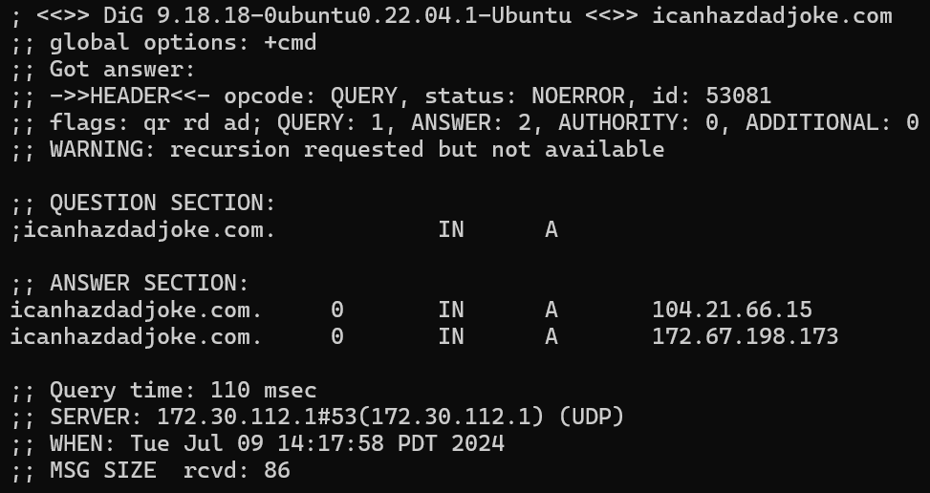

1. Make a simple web page and serve it using ***python3 -m http.server***. Visit the page in a browser.

Cd to the appropriate directory 🡪 start the terminal 🡪 python3 -m http.server 🡪 go to browser 🡪 localhost:8000 to see all files