Submission Instruction: Please submit this homework on Canvas in a single pdf format. The filename should be "HWXX_FullName_RedID.pdf" (ex. HW02_JamesGault_12345678.pdf).
Please copy your Matlab code in the given box. Adjust the box size as needed.
Please also submit all your m files separately. Don’t zip them.

Full Name: Evan Peres
Red ID: 129964468
Email address: eperes2481@sdsu.edu

Iteration (Write your code in the box.)
- Write a function with header [M] = myNMax(A,N) where M is an array consisting of the N largest elements of A. You may use MATLAB’s max function. You may also assume that N is less than the length of M, that A is a one-dimensional array with no duplicate entries, and that N is a strictly positive integer smaller than the length of A. ( / 10)
Test Cases:

>> x = [7,9,10,5,8,3,4,6,2,1]
>> M = myNMax(x,3)
M=
10 9 8

function [M] = myNMax(A,N)
M=[];
for k=1:N
M = [M,max(A)];
A(A == max(A))=[];
end
end

- The interest, i, on a principle, P0, is a payment for allowing the bank to use your money. Compound interest is accumulated according to the formula P_{n} = (1 + i)P_{n−1}, where n is the compounding period, usually in months or years. Write a function with header [years] = mySavingPlan(P0, i, goal) where years is the number of years it will take P0 to become goal at i% interest compounded annually. ( / 10)
Test Cases:

>> y = mySavingPlan(1000, 0.05, 2000)
y = 15
>> y = mySavingPlan(1000, 0.07, 2000)
y = 11
>> y = mySavingPlan(500, 0.07, 2000)
y = 21

function [years] = mySavingPlan(P0, i, goal)
P = P0;
years = 0;
while P < goal
years = years + 1;
P = P*(1+i);
end
end

- A number is prime if it is divisible without remainder only by itself and 1. The number 1 is not prime. Write a function with header [out] = myIsPrime(n) where out is 1 if n is prime and 0 otherwise. You may assume that n is a strictly positive integer. Hint: Use pre-defined function “rem(a, b)” that returns the reminder after division of a by b. For example, the result “rem(6.5, 3)” is 0.5 ( / 10)
function [out] = myIsPrime(n)
if n > 1
for i = 2:((n/2)+1)
if (rem(n,i) == 0) & (n/i ~= 1)
out = 0;
break
else
out = 1;
end
end
else
out = 0;
end
end

1D array (Write your code in the box.)
- Write a function with header [TemC] = myF2C(TemF) to convert fahrenheit to celsius. This function should work for one number, or an array of numbers to be converted. ( / 10)

function [TemC] = myF2C(TemF)
TemC=[]
for k=1:length(TemF)
TemC = [TemC,(TemF-32)*(5/9)];
end
end

- Write a function with header[indices] = myWithinTolerance(A, a, tol) where indices is an array of the indices in A such that |A − a| < tol. You may assume that A is a one-dimensional double array and that a and tol are 1 × 1 doubles. ( / 10)
Test Cases:
>> I = myWithinTolerance([0 1 2 3], 1.5, .75)
I =
2 3
>> I = myWithinTolerance(0: .01 : 1, 0.5, .03)
I =
48 49 50 51 52 53
function [indices] = myWithinTolerance(A, a, tol)
indices = []
for k = 1:length(A)
if abs(A(k)-a) < tol
indices = [indices,k];
end
end
end
- Write a function with header [boundedA] = myBoundingArray(A, top, bottom) where boundedA is equal to the array A wherever bottom < A < top, boundedA is equal to bottom wherever A <= bottom, and boundedA is equal to top wherever A >= top. You may assume that A is a one-dimensional double array and that top and bottom are 1 × 1 doubles. ( / 10)
Test Cases:
>> A = myBoundingArray(−5:5, 3, −3)

A =
−3 −3 −3 −2 −1 0 1 2 3 3 3
>> x = linspace(0,2*pi,10)
>> A = myBoundingArray(sin(x), .5, −.5)

I =
0 0.5000 0.5000 0.5000 0.3420 -0.3420 -0.5000 -0.5000 -0.5000 -0.0000
function [boundedA] = myBoundingArray(A, top, bottom)
boundedA = []
for k = 1:length(A)
if A(k) < bottom
boundedA = [boundedA,bottom];
elseif A(k) > top
boundedA = [boundedA,top];
elseif (A(k) >= bottom) && (A(k) <= top)
boundedA = [boundedA,A(k)];
end
end
end

Plotting (Write your code in the box.)
- A cycloid is the curve traced by a point located on the edge of a wheel rolling along a flat surface. The (x,y) coordinates of a cycloid generated from a wheel with radius, r, can be described by the parametric equations:

$$x=r(∅-sin∅)$$
$$y=r(1-cos∅)$$
where $∅$ is the number of radians that the wheel has rolled through.
Generate a plot of the cycloid for 0 ≤ $∅$ ≤ 2π using 1000 increments and r = 3. Give your plot a title ‘Cycloid’ and label the x-axis and y-axis with “x” and “y,” respectively. Turn the grid on and modify the axis limits to make the plot neat. ( / 10)
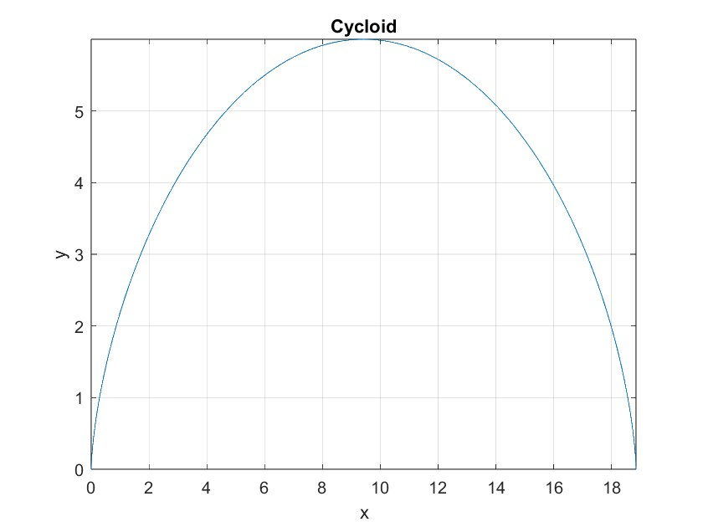

r=3;
theta = linspace(0,2*pi,1000);
x = r*(theta-sin(theta));
y = r*(1-cos(theta));
plot(x,y)
title('Cycloid');
xlabel('x');
ylabel('y');
grid on;
xlim([min(x) max(x)]);
ylim([min(y) max(y)]);

- Provide your scripts to create the following plot. All the subplots are y = cos(x) on the interval [-3,3] with 20 values in between. ( / 10)
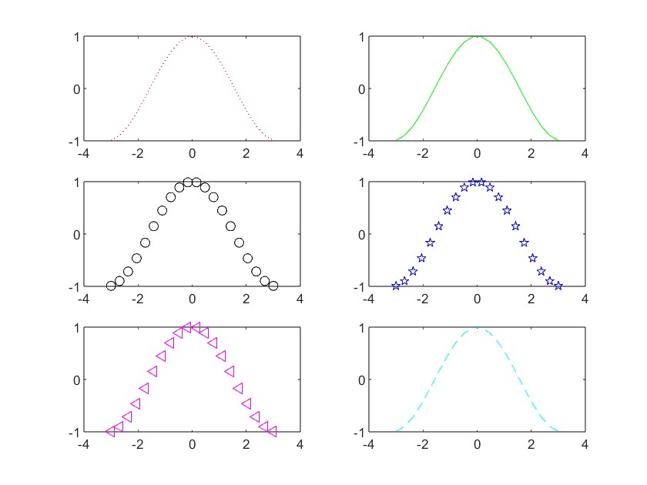
x=linspace(-3,3,20)
y=cos(x)

% red doted line
subplot(3,2,1);xlim([-4,4]);ylim([-1,1]);plot(x,y,":r")
% green line
subplot(3,2,2);xlim([-4,4]);ylim([-1,1]);plot(x,y,"g")
% black circle
subplot(3,2,3);xlim([-4,4]);ylim([-1,1]);plot(x,y,"ko")
% blue stars
subplot(3,2,4);xlim([-4,4]);ylim([-1,1]);plot(x,y,"b pentagram")
% magenta triangles
subplot(3,2,5);xlim([-4,4]);ylim([-1,1]);plot(x,y,"m<")
% cyan dashed line
subplot(3,2,6);xlim([-4,4]);ylim([-1,1]);plot(x,y,"--c")

- Write a function with header [] = myPolyPlotter(n,x) that plots the polynomials pk(x) = xk for k = 1,··· ,n. Make sure your plot has axis labels and a title., Hint: use hold on ( / 10)
Test Cases:
>> myPolyPlotter(5, -1: .01: 1 )
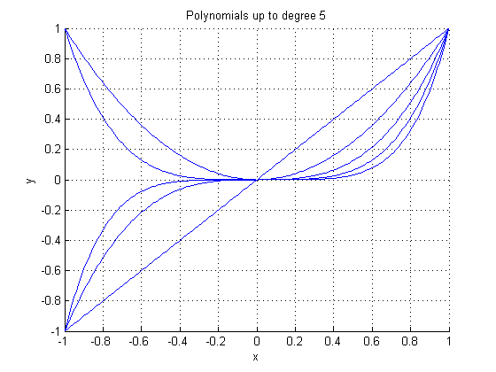
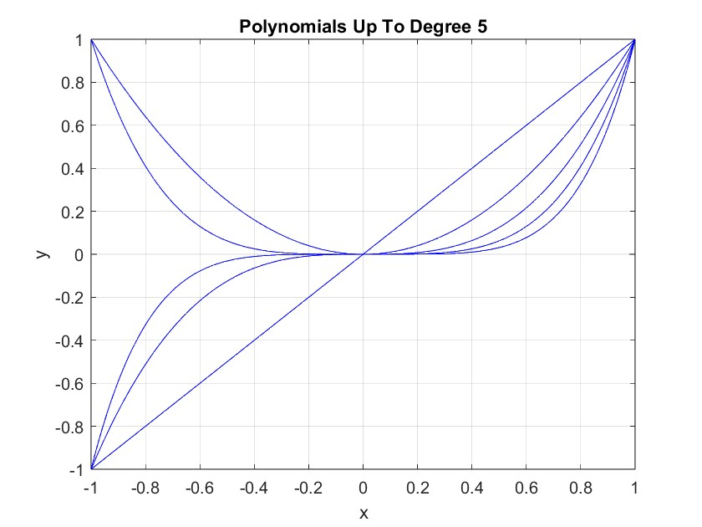

function [] = myPolyPlotter(n,x)
y=[];
for k = 1:n
y = x.^k;
plot(x, y,"b");
hold on;
end
hold off;
title(sprintf("Polynomials Up To Degree %d",n));
xlabel('x');
ylabel('y');
grid on;
xlim([min(x) max(x)]);
ylim([min(y) max(y)]);
xticks(min(x):.2:max(x));
yticks(min(y):.2:max(y));
end
- Write a function with header [ ] = myParametricPlotter(x,y,t) where x and y are handles to the functions x(t) and y(t), respectively, and t is a one-dimensional array. The function myParametricPlotter should produce the curve (x(t),y(t),t) in a three-dimensional plot. Be sure to give your plot a title and axis labels. ( / 10)
Test Cases:
>> f = @(t) sin(t);
>> g = @(t) t.ˆ2;
>> myParametricPlotter(f,g,linspace(0,6*pi,100))
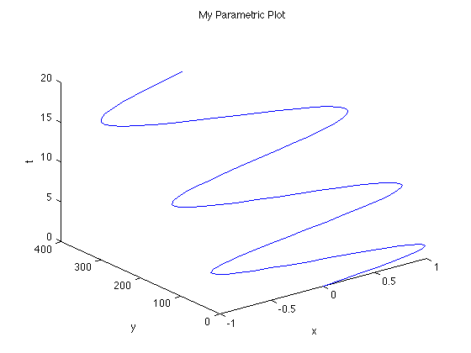
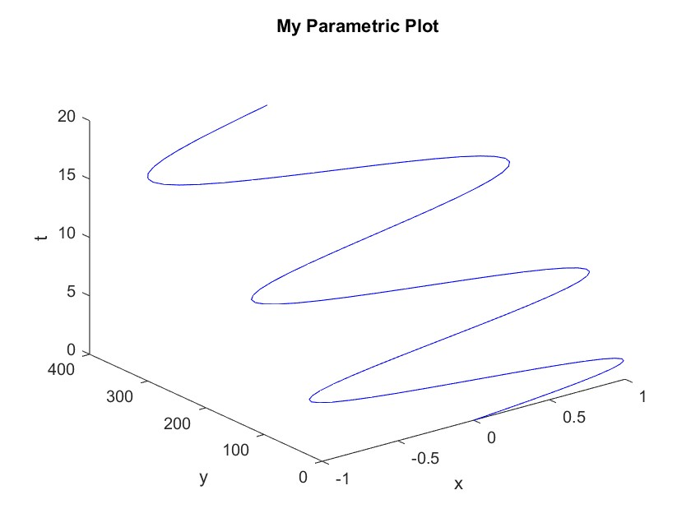
function [] = myParametricPlotter(x,y,t)
X = x(t);
Y = y(t);
plot3(X,Y,t,'b')
title('My Parametric Plot');
xlabel('x');
ylabel('y');
zlabel('t');
end

