Submission Instruction: Please submit this homework on Canvas in a single pdf format. The filename should be "HWXX_FullName_RedID.pdf" (ex. HW05_JamesGault_12345678.pdf).
Please copy your Matlab code in the given box. Adjust the box size as needed.
Please also submit all your m files separately. Don’t zip them.

Full Name: Evan Peres
Red ID: 129964468
Email address: eperes2481@sdsu.edu

Cell Array and Structure (Write your code in the box.)
- Write a function with header [newStudent] = myNewStudent (name, id, grades) that inputs a name, id, and grades, and generates a 1×1 struct array newStudent. ( / 10)
Test Cases:

>> student = myNewStudent('Tim', 1, [100, 98])
student =

struct with fields:

name: 'Tim'
id: 1
grades: [100 98]

function [newStudent] = myNewStudent(name, id, grades)
% Create a struct array with fields: name, id, and grades
newStudent.name = name;
newStudent.id = id;
newStudent.grades = grades;
end

- Let C be a square connectivity matrix containing zeros and ones. We say that point i has a connection to point j, or i is connected to j, if C(i,j) = 1. Note that connections in this context are one-directional, meaning C(i,j) is not necessarily the same as C(j,i). For example, think of a one-way street from point A to point B. If A is connected to B, then B is not necessarily connected to A.

Write a function with header [node] = myConnectivityMat2Struct(C, names) where C is a connectivity matrix and names is a cell array of strings (i.e., each element of names is a string) that denote the name of a point. That is, names(i) is the name of the i − th point.

The output variable node should be a struct with fields .name and .neighbors. The i − th element of node is defined as node(i).name = names(i) and node(i).neighbors is a row vector containing the indices, j, such that C(i,j) = 1. In other words, node(i).neighbors is a list of points that point i is connected to.

Warning: Make sure the field names are exactly correct: .name and .neighbors. ( / 10)
Test Cases:
>> C= [0 1 0 1; 1 0 0 1; 0 0 0 1; 1 1 1 0];
>> names = {'Los Angeles', 'New York', 'Miami', 'Dallas'};
>> node = myConnectivityMat2Struct(C, names);
>> node(1)
ans =
name: 'Los Angeles'
neighbors: [2 4]
>> node(2)
ans =
name: 'New York'
neighbors: [1 4]
>> node(3)
ans =
name: 'Miami'
neighbors: 4
>> node(4)
ans =
name: 'Dallas'
neighbors: [1 2 3]

function [node] = myConnectivityMat2Struct(C, names)
% Initialize the output struct array
n = length(names); % Number of points (nodes)
node = struct('name', cell(1, n), 'neighbors', cell(1, n));

% Populate the struct array
for i = 1:n
node(i).name = names{i}; % Set the name
node(i).neighbors = find(C(i, :) == 1); % Find indices where C(i, j) = 1
end
end

Custom Functions (Write your code in the box.)
- Let Q(x) be the quadratic equation $Q\left(x\right)=ax^{2}+bx+c$ for some scalar values a, b, and c. A root of Q(x) is an r such that Q(r) = 0. The two roots of a quadratic equation can be described by the quadratic formula, which is
$$r = \frac{-b±\sqrt{\left(b^{2}-4ac\right)}}{2a}$$
A quadratic equation has either two real roots (i.e. ${ b}^{2}>4ac$), two imaginary roots (i.e. ${ b}^{2}<4ac$),, or one root, (i.e. ${ b}^{2}=4ac$).
Write a function with header [nRoots, r] = myNRoots(a,b,c) where a, b, and c are the coefficients of the quadratic Q(x), nRoots is 2 if Q has 2 real roots, 1 if Q has 1 root, -2 if Q has two imaginary roots, and r is an array containing the roots of Q. (10)

Test Cases:
>> [nRoots, r] = myNRoots(1, 0,−9)
nRoots = 2
r=
3 −3
>> [nRoots, r] = myNRoots(3,4,5)
nRoots = −2
r=
−0.6667 + 1.1055i −0.6667 − 1.1055i
>> [nRoots, r] = myNRoots(2,4,2)
nRoots = 1
r=
−1

function [nRoots, r] = myNRoots(a, b, c)
% Calculate the discriminant
discriminant = b^2 - 4*a*c;

% Check the number of roots based on the discriminant
if discriminant > 0
% Two real roots
nRoots = 2;
r = [(-b + sqrt(discriminant)) / (2*a), (-b - sqrt(discriminant)) / (2*a)];
elseif discriminant == 0
% One real root
nRoots = 1;
r = -b / (2*a);
else
% Two imaginary roots
nRoots = -2;
realPart = -b / (2*a);
imaginaryPart = sqrt(-discriminant) / (2*a);
r = [realPart + imaginaryPart*1i, realPart - imaginaryPart*1i];
end
end

- Write a function with header [h] = mySplitFunction(f,g,a,b,x) where f and g are handles to functions f(x) and g(x), respectively. The output argument h should be f(x) if x ≤ a, g(x) if x ≥ b, and 0 otherwise. You may assume that b > a. (10)
Test Cases:
>> h = mySplitFunction(@exp, @sin, 2, 4, 1)
h= 2.7183
>> h = mySplitFunction(@exp, @sin, 2, 4, 3)
h= 0
>> h = mySplitFunction(@exp, @sin, 2, 4, 5)
h= −0.9589

function [h] = mySplitFunction(f, g, a, b, x)
% If x <= a, return f(x)
if x <= a
h = f(x);
% If x >= b, return g(x)
elseif x >= b
h = g(x);
% Otherwise, return 0
else
h = 0;
end
end

- Write a function with header [area, perimeter] = rectInfo (w, l) that outputs the area and perimeter of a rectangle, given that the two inputs are the width and length of the rectangle. If the user provides too few inputs, set both outputs to -1. (10)
Test Cases:
>> [area, perimeter] = rectInfo (10, 20)
area = 200
perimeter = 60
>> [area, perimeter] = rectInfo (10)
area = -1
perimeter = -1
function [area, perimeter] = rectInfo(w, l)
% Check if the user has provided both width and length
if nargin < 2
% If not, set area and perimeter to -1
area = -1;
perimeter = -1;
else
% Otherwise, calculate area and perimeter
area = w * l;
perimeter = 2 * (w + l);
end
end

Recursion (Write your code in the box.)
- Chebyshev polynomials are defined recursively. Chebyshev polynomials of the first kind, Tn(x), is defined by the following recurrence relation:

$$T_{n}(x)=\left\{\begin{aligned}1 \\ x \\ 2xT_{n-1}(x)-T_{n-2}(x)\end{aligned}\right.\begin{matrix}if n =0 \\ if n=1 \\ otherwise\end{matrix}$$

Write a function with header[y] = myChebyshevPoly1(n,x) where y is the n-th Chebyshev polynomial of the first kind evaluated at x. Be sure your function can take array inputs for x. You may assume that x is a row vector. The output variable, y, must be a row vector also. (10)
Test Cases:
>> myChebyshevPoly1(0,1:5)
ans =
1 1 1 1 1
>> myChebyshevPoly1(1,1:5)
ans =
1 2 3 4 5
>> myChebyshevPoly1(3,1:5)
ans =
1 26 99 244 485

function [y] = myChebyshevPoly1(n, x)
% Initialize the first two Chebyshev polynomials
T0 = 1; % T0(x) = 1
T1 = x; % T1(x) = x

% For n = 0 or n = 1, return the corresponding Chebyshev polynomial
if n == 0
y = T0 * ones(size(x)); % T0(x) = 1 for all x
elseif n == 1
y = T1; % T1(x) = x
else
% For n > 1, use the recurrence relation to calculate the nth Chebyshev polynomial
Tn_2 = T0; % T(n-2)
Tn_1 = T1; % T(n-1)

for k = 2:n
% Recurrence relation: Tn(x) = 2*x*T(n-1)(x) - T(n-2)(x)
Tn = 2 * x .* Tn_1 - Tn_2;
% Update for the next iteration
Tn_2 = Tn_1;
Tn_1 = Tn;
end

% Return the nth Chebyshev polynomial
y = Tn;
end
end

- The golden ratio, $∅$, is the limit of $\frac{F(n+1)}{F(n)}$ as n goes to infinity and $F(n)$ is the n-th Fibonacci number, which can be shown to be exactly $∅= \frac{1+\sqrt{5}}{2}$, and is approximately 1.62. We say that $G(n)=\frac{F(n+1)}{F(n)}$ is the n-th approximation of the golden ratio, and G(1)=1.

It can be shown that is also the limit of the continued fraction:
$$∅=1+\frac{1}{1+\frac{1}{1+\frac{1}{1+\frac{1}{1+...}}}}$$

Write a recursive function with header [G] = myGoldenRatio(n) where G is the n-th approximation of the golden ratio according to the continued fraction recursive relationship. You should use the continued fraction approximation for the Golden ratio, not the G(n) = F (n + 1)/F (n) definition. However for both definitions, G(1) = 1. (10)
Test Cases:
>> format long
>> G = myGoldenRatio(10)
G= 1.618181818181818
>> (1 + sqrt(5))/2
ans =
1.618033988749895

function [G] = myGoldenRatio(n)
% Base case: for n = 1, G(1) = 1
if n == 1
G = 1;
else
% Recursive case: G(n) = 1 + 1 / G(n-1)
G = 1 + 1 / myGoldenRatio(n-1);
end
end

- The greatest common divisor of two integers a and b is the largest integer that divides both numbers without remainder, and the function to compute it is denoted by GCD(a,b). The GCD function can be written recursively.
If b equals 0, then a is the greatest common divisor. Otherwise, GCD(a,b) = GCD(b, rem(a,b)) where rem(a,b) is the remainder of a divided by b. You may assume that a and b are 1×1 integer doubles.
Write a recursive function with header [gcd] = myGCD(a,b) that computes the greatest common divisor of a and b. You may assume that a and b are 1 × 1 integer doubles. (10)
Test Cases:
>> gcd = myGCD(10,4)
gcd = 2
>> gcd = myGCD(33,121)
gcd = 11
>> gcd = myGCD (18,0)
gcd =18
function [gcd] = myGCD(a, b)
% Base case: if b is 0, then the GCD is a
if b == 0
gcd = a;
else
% Recursive case: GCD(a, b) = GCD(b, rem(a, b))
gcd = myGCD(b, rem(a, b));
end
end

Simulink (20)
- Consider a small aircraft/drone as a point-mass dynamics model that is moving in a 2D space. The dynamics equations are
$$m\dot{V} = -mg sinγ - kV^{2}$$
$$mV\dot{γ} = -mg cosγ$$
And
$$\dot{p} = Vcosγ$$
$$\dot{h} = Vsinγ$$
Where p is called the horizontal range and h is the altitude or height of the aircraft. V is the speed and γ is the flight path angle, and $k= ρSC_{D}/2$,
The parameters are given as gravity constant: g = 9.81, mass of aircraft: m= 1, air density: rho=0.3809, drag coefficient: Cd=0.4, reference area: S=0.1, kappa = rho*S*Cd/2
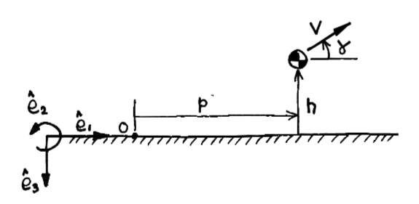
Please build a SIMULINK model of this aircraft model with state variables, V, $γ$, p, h. Test your model with the following initial conditions:
V= 10, $γ=pi/4$, p =0, h = 100.
Run your Simulink for 20s.
Put a snapshot of the SIMULINK diagram in this pdf file; illustrate your results with plots of the time histories of V, γ and h (height); also plot the aircraft trajectory, that is, h vs p.
Please also submit your SIMULINK diagram file with Matlab code on canvas(if any)
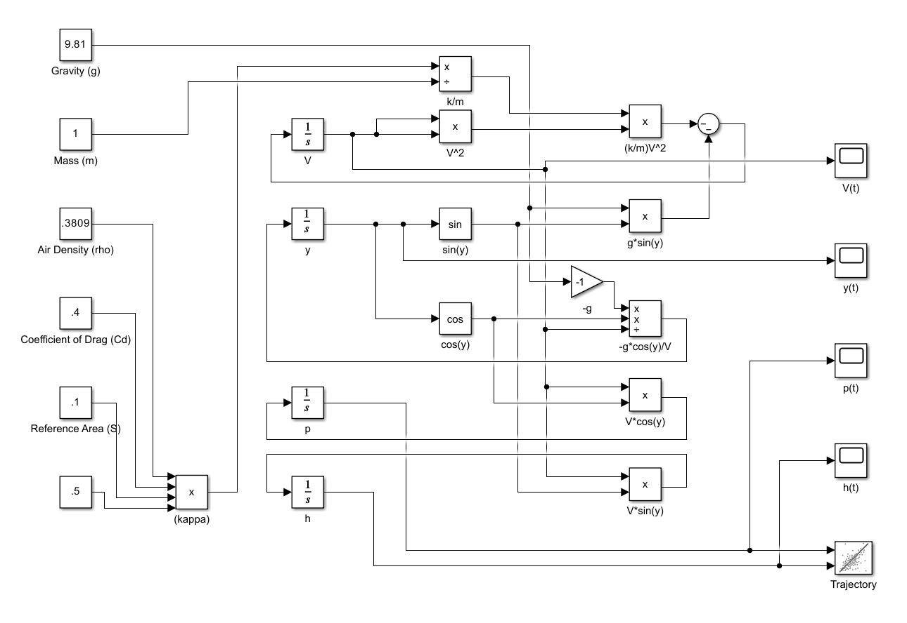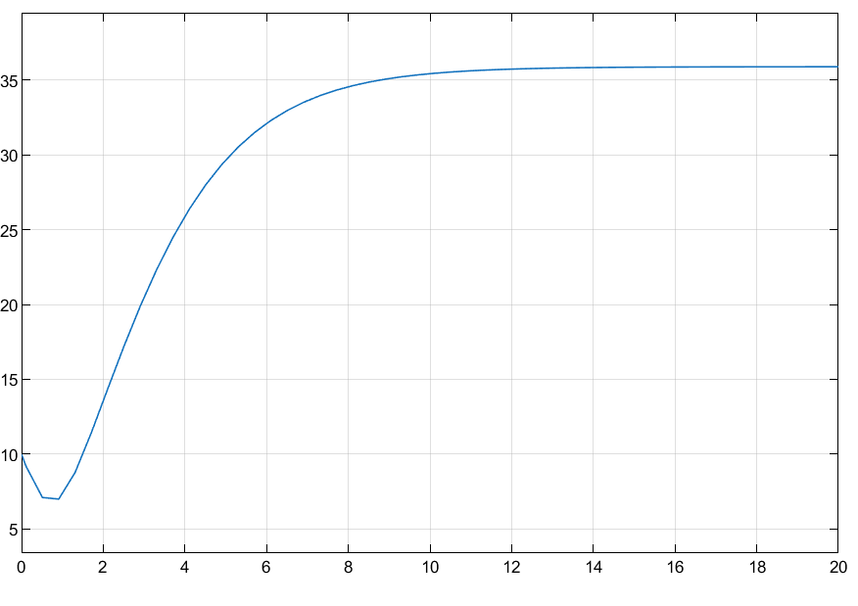 V(t)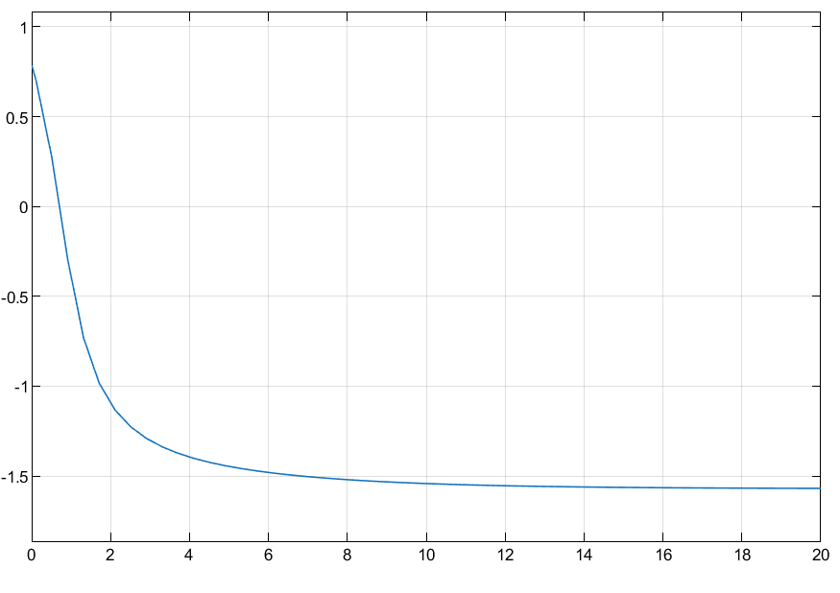 y(t) 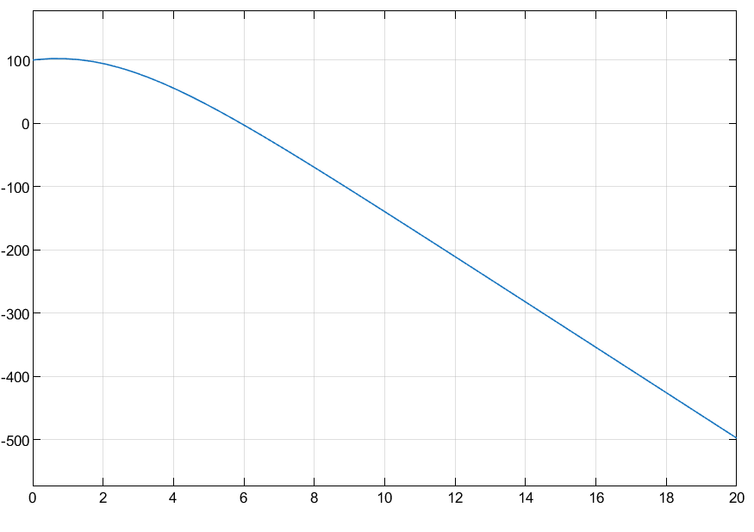 h(t)  trajectory

