Personal Portfolio Website

Name : Muhammad Akbar Utomo Putra Yuniar

Student ID : 001202600068

Major : Information Technology

Class : 5

1. Overview
This is a one page personal portfolio website with five pages that link with nav button: Home, About, Education, Experience and Contact. It is built with HTML and CSS only and works on desktop and mobile screen insyallah, and here is inside the folder :
- index.html – structure and content of all pages
- style.css – styling
- assets/ – background photo and cut-out photo

2. Page Explanation

Page 1 – Home (Hero)
The opening page fills the whole screen, with a library photo is used as the background, and the large red word “PORTFOLIO” placed behind a cut-out photo of the me, so my body can overlaps the lettering. A small rounded menu at the top center holds four buttons (About, Education, Experience, Contact) that scroll to each page through anchor links.
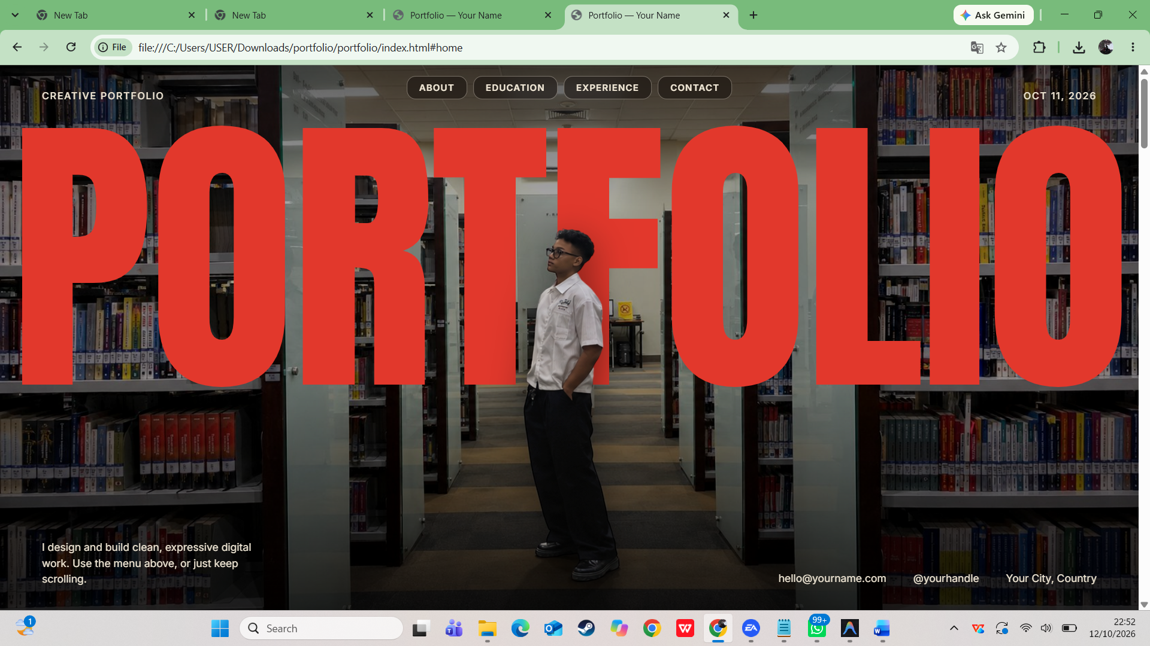

Page 2 – About
Introduces me with a short biography, skill tags and a portrait photo. The layout is a two column grid that becomes one column on small screens.
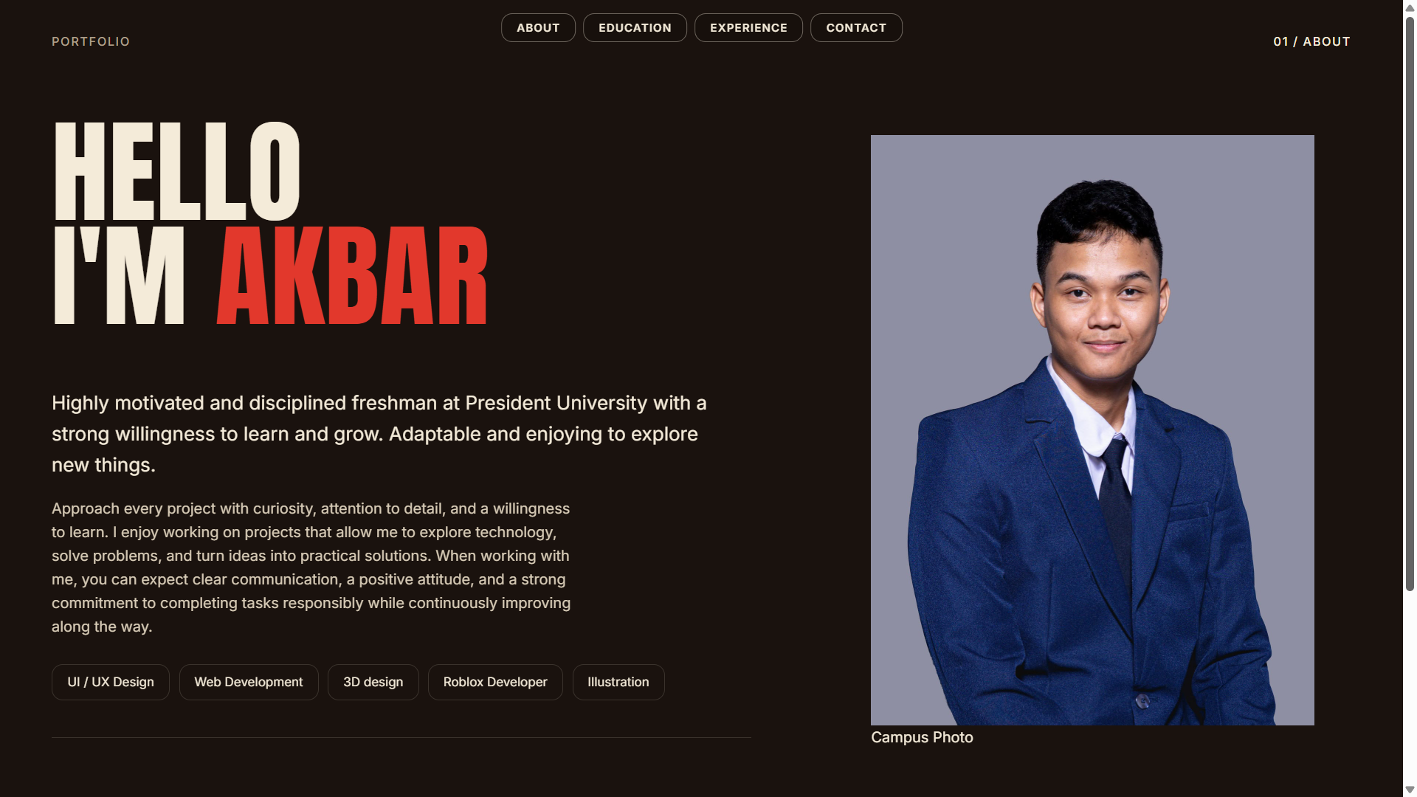

Page 3 – Education
Shows the my education history as a timeline, and each row has the period, the institution, the study program and a short description.
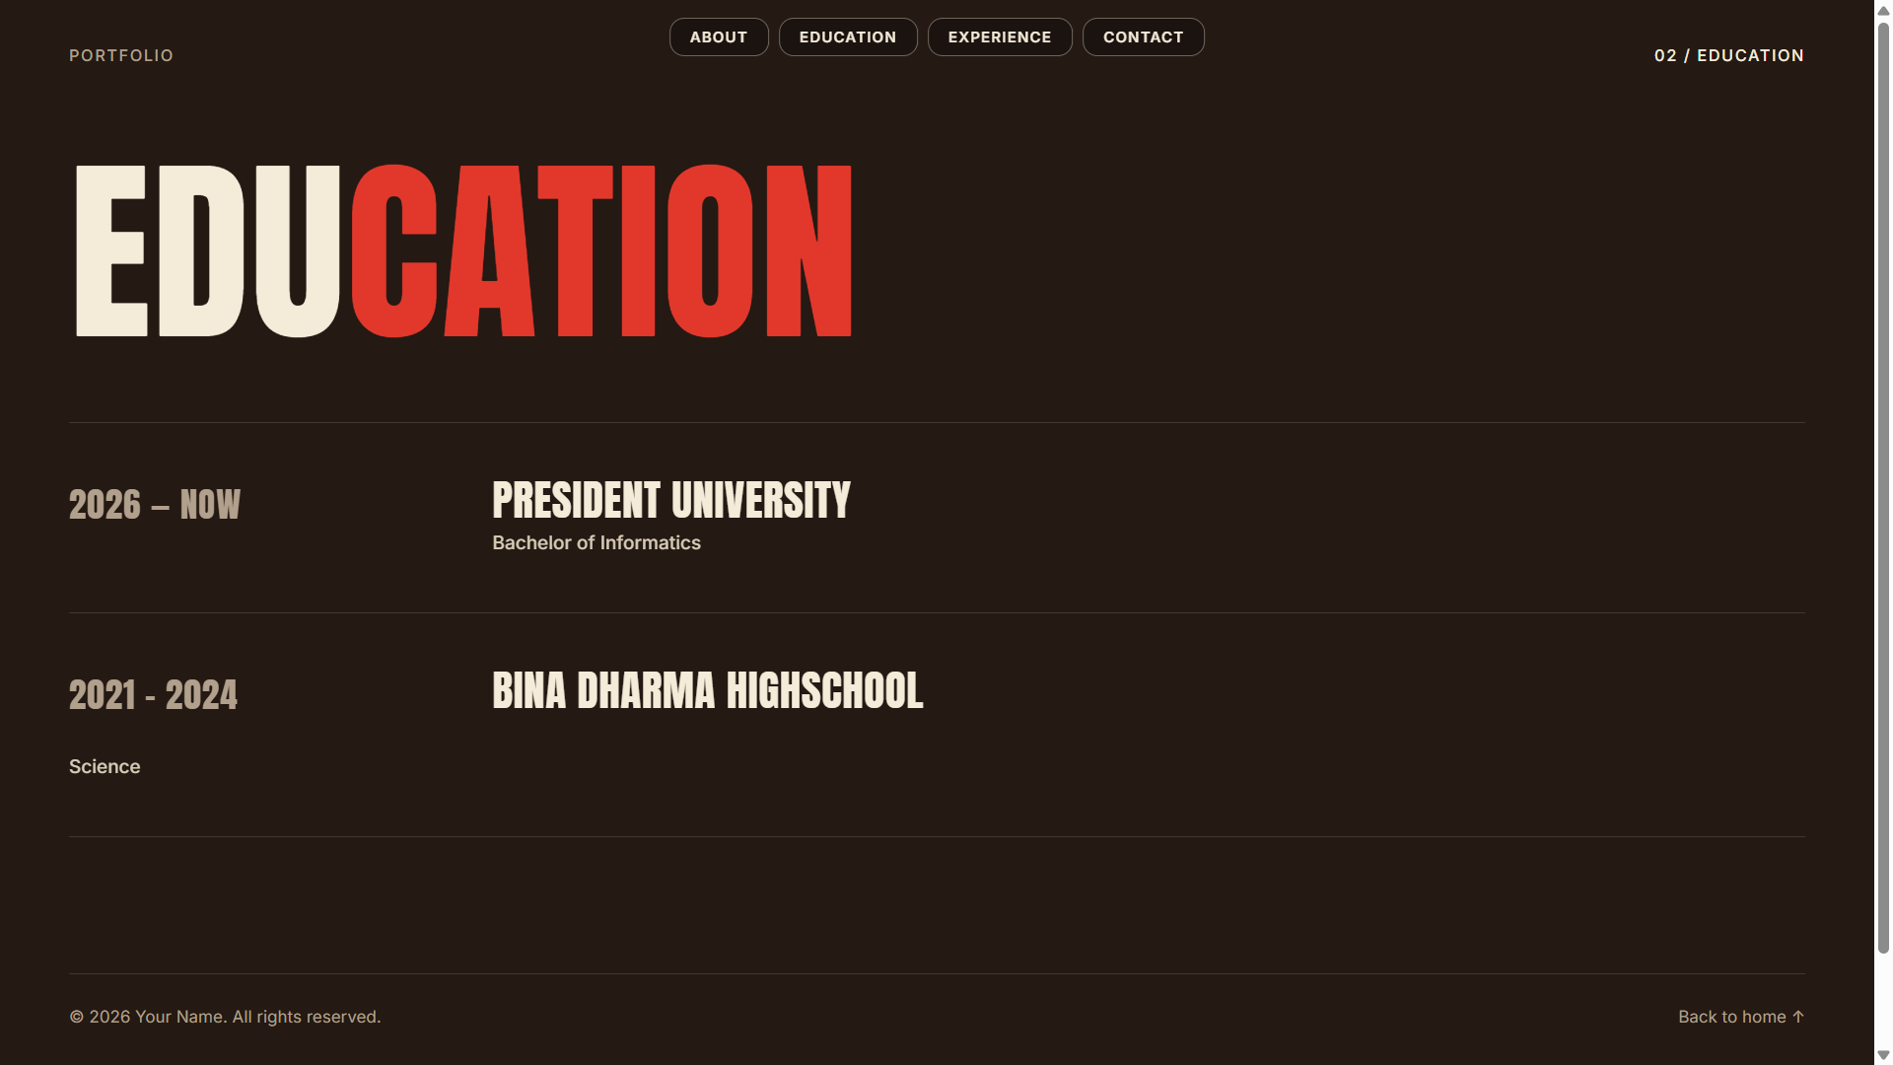

Page 4 – Experience
List of work and organization experience that I have been through as rows: number, role, company, description and period. And I add the featured that rows move slightly and change color when hovered
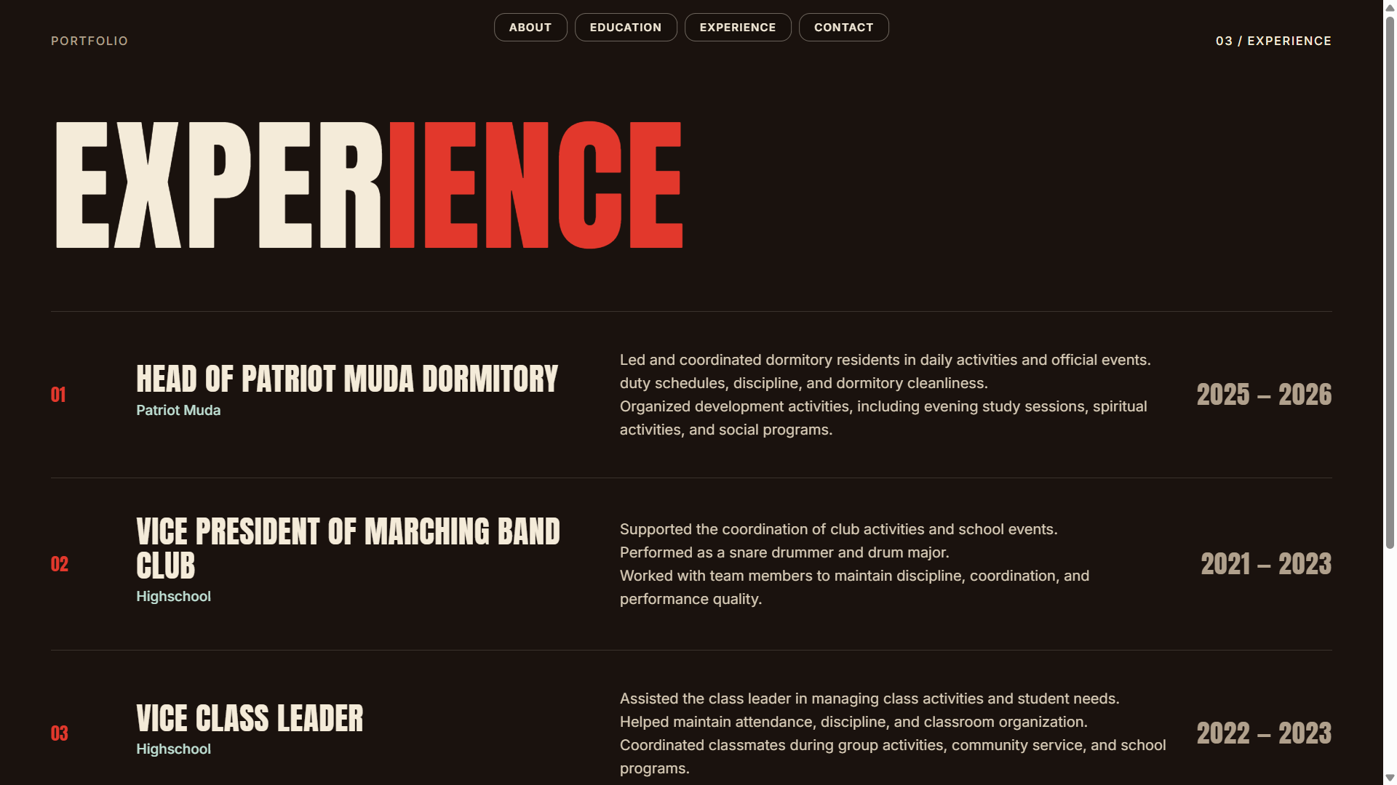

Page 5 – Contact
This slide contains contact cards, social media links and a contact form with validation. When a valid form is submitted, a “Thank you” box appears using the CSS target selector.
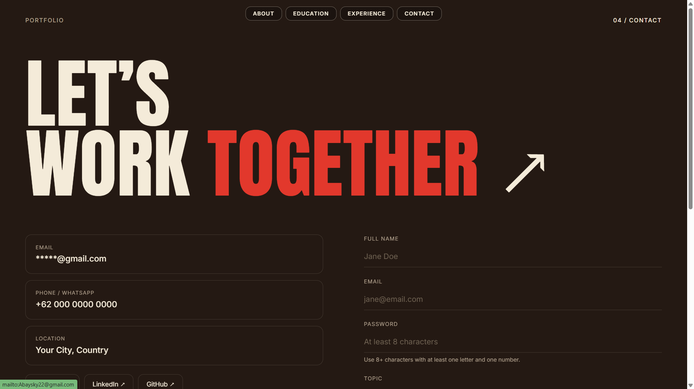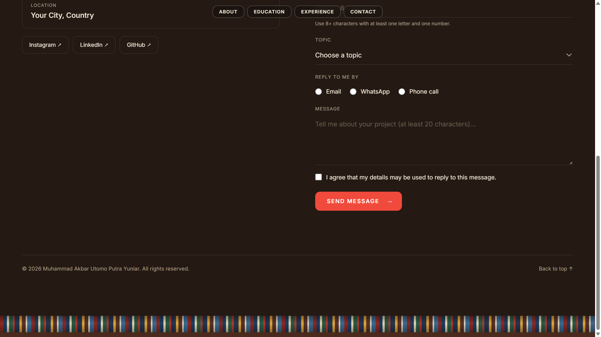

3. Form and Validation
The contact page has one form that uses all required input types, the validation use built in HTML attributes (required, minlength, maxlength, pattern), and error messages will appear under the wrong field through the CSS user valid selector, the form cannot be submitted until every field is valid.

The form also has an Email field (type email) that must contain a valid email address.
