FINAL YEAR PROJECT

AI Learner Rover Driver
Host Application Backend Architecture
Software Design Specification - Design V1

Formal backend design for a modular, asynchronous host application integrating LLM planning, computer vision, rover control, telemetry and voice input.
Project | SW-8 AI Learner Rover Driver
Document purpose | Formalise host application backend design before coding
Architecture status | Design V1 - pre-implementation
Primary interfaces | IP camera stream, LLM API, WebSocket rover link, microphone
Design basis | Host UI design and Command Protocol Specification supplied for the project

1. Purpose and Design Position
This document formalises the backend architecture for the AI Learner Rover Driver host application before implementation begins. It converts the planned operator workflow, engineer controls, settings requirements, camera processing, LLM planning and rover command protocol into a modular software architecture with explicit responsibilities, concurrency boundaries, data contracts and safety gates.
Recommended architecture
A modular monolith using Ports-and-Adapters (hexagonal) separation, an event-driven Mission Controller implemented as a finite-state machine, asynchronous I/O for network operations, and dedicated workers only for blocking or CPU-heavy tasks such as camera decoding, computer vision and optional speech processing.

1.1 Source design constraints
- The UI has three views of one host application: Operator, Engineer and Settings. The backend therefore needs one shared application state rather than page-specific copies of mission state.
- The rover protocol uses one persistent WebSocket/TCP connection and compact JSON messages. A whole path is sent as an ordered list ending in STOP; the rover reports command and path progress using application-level ACKs.
- The rover may asynchronously request a heading during execution. The heading is sourced from the overhead camera on the laptop.
- The Engineer page requires live camera, processed perception information, telemetry, command progress, logs, manual controls and plan confirmation.
- The Settings page is the commissioning/configuration point for rover address, camera stream, microphone, planner settings, safety limits and camera calibration.

1.2 Core design goals
Goal | Design response
Modularity | UI, planning, perception, rover communications, voice, persistence and settings are separate modules behind explicit interfaces.
Responsiveness | Long-running I/O and processing never block the GUI thread.
Safety | LLM output passes through parsing, schema and safety validation before the rover gateway can transmit it.
Observability | All run state, ACKs, telemetry, snapshots, timings and failures are recorded and visible to the Engineer view.
Replaceability | LLM provider, camera transport and speech implementation can be replaced without changing mission logic.
Testability | Mission logic depends on ports/interfaces that can be mocked during unit and integration tests.

2. System Architecture
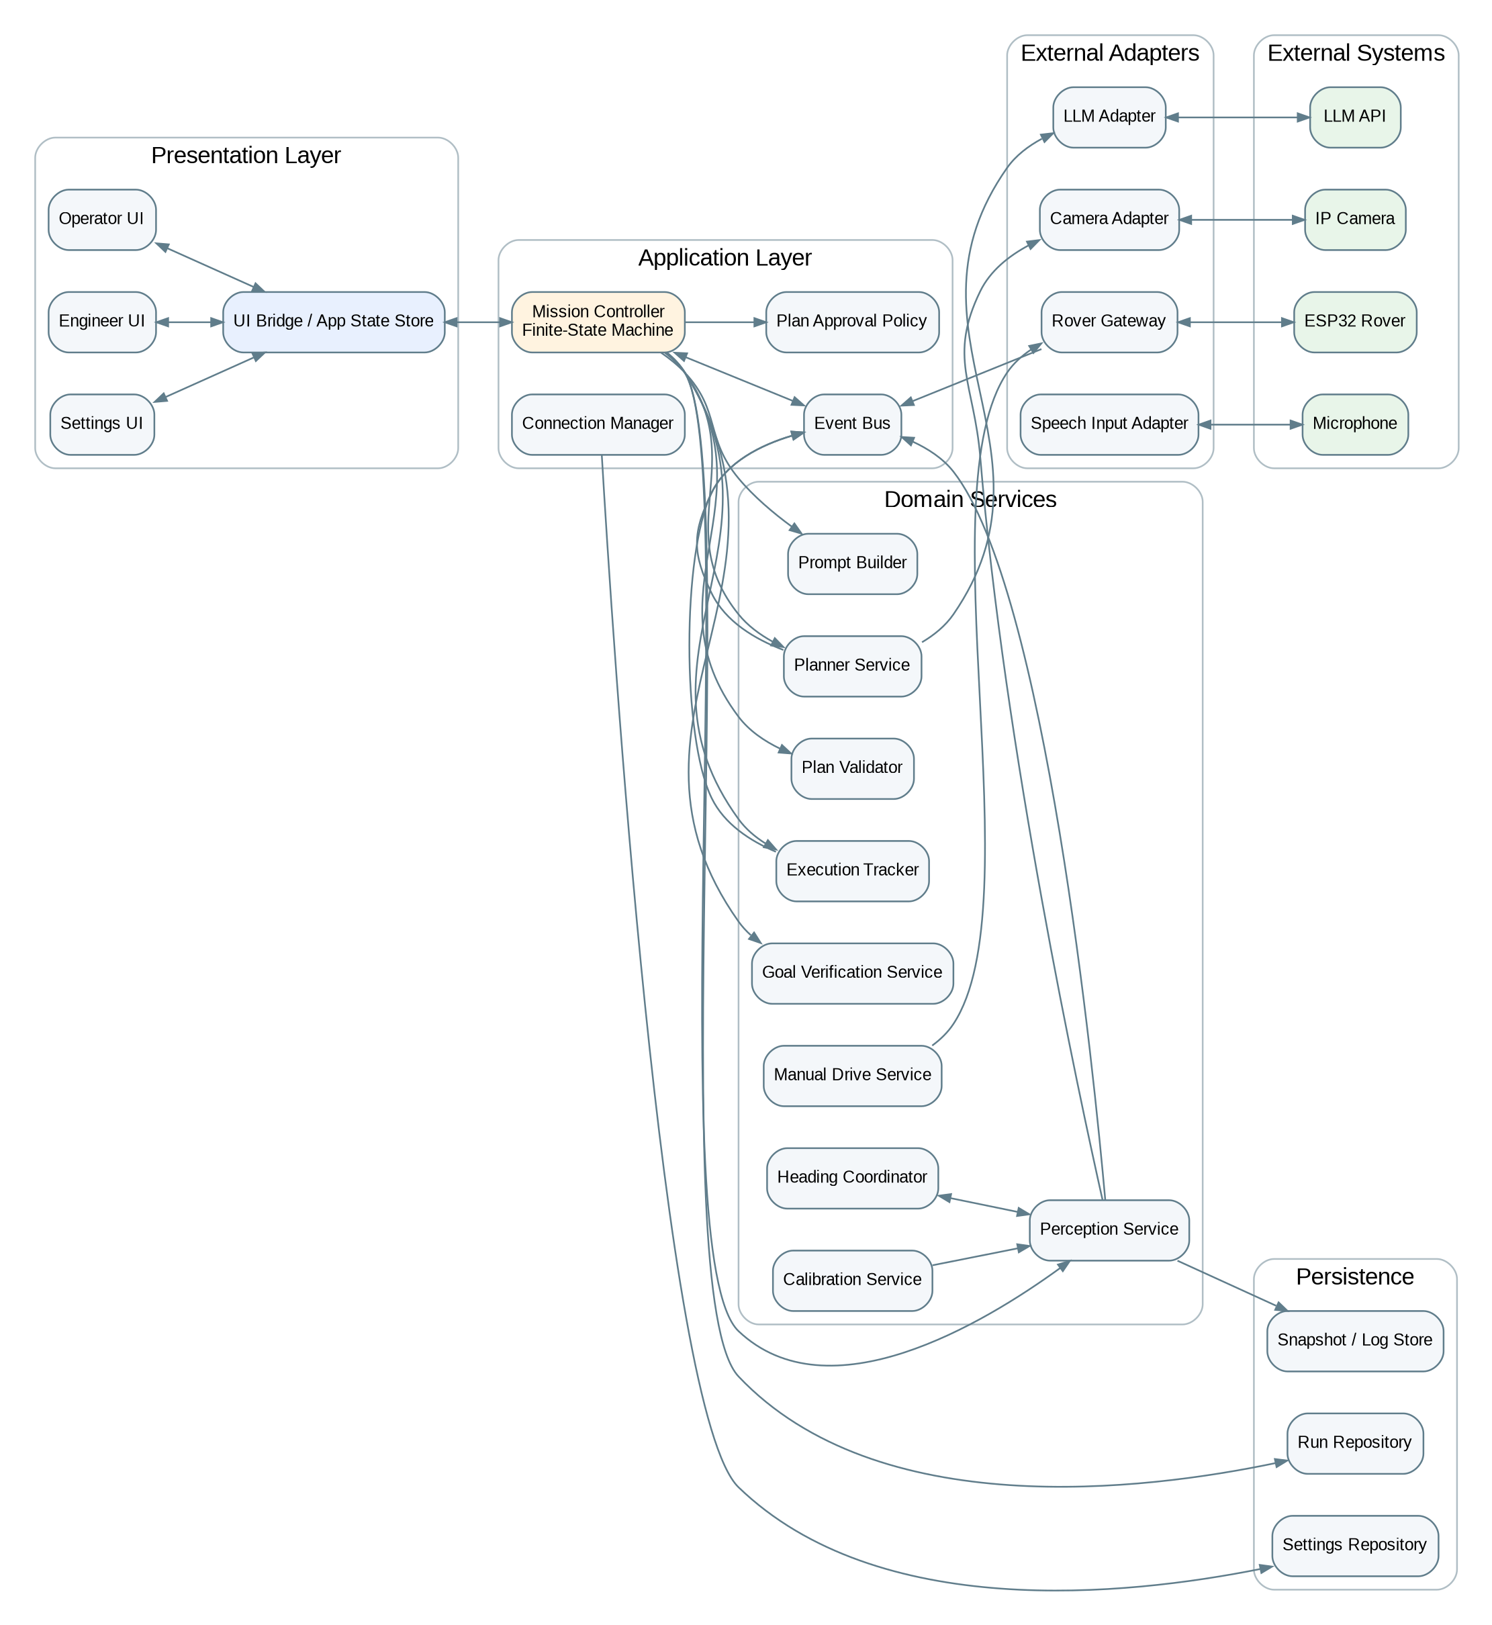
Figure 1. Layered modular architecture for the host application.
The frontend does not communicate directly with the camera, LLM or rover. It interacts with the application core through a state store and commands/events. The Mission Controller owns mission sequencing. External technologies are isolated behind adapters so that domain logic remains independent of a specific WebSocket library, camera library or LLM SDK.

2.1 Layer responsibilities
Layer | Responsibilities
Presentation | Operator, Engineer and Settings views; user commands; display of shared application state.
Application | Mission sequencing, finite-state transitions, connection readiness, event routing and plan-approval policy.
Domain services | Prompt construction, perception, planning, validation, execution tracking, goal verification, heading support, calibration and manual drive.
Adapters | WebSocket rover gateway, IP camera adapter, LLM API adapter and speech input adapter.
Persistence | Run history, telemetry, world-state snapshots, calibration profiles, settings and structured logs.

3. Concurrency and Responsiveness Model
The design is concurrent but intentionally avoids creating one operating-system thread for every activity. Network operations are I/O-bound and are best represented as asynchronous tasks. Worker threads or processes are reserved for components that block or consume meaningful CPU time.
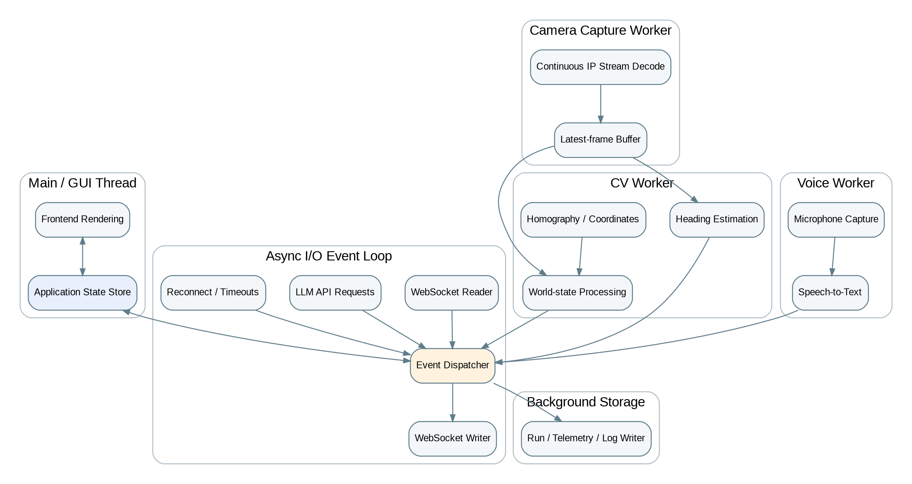
Figure 2. Hybrid asynchronous + worker concurrency model.
Execution lane | Typical work | Reason
GUI/main thread | Rendering, controls, view updates | Must remain responsive and should never wait on network, camera or LLM operations.
Async I/O loop | WebSocket receive/send, LLM requests, reconnect timers | Efficient for many waiting operations without unnecessary threads.
Camera worker | Continuous stream decode and latest-frame buffering | Video decoding can block and must continue independently of mission planning.
CV worker | Homography, detection, world-state extraction, heading | CPU-heavy processing should not interfere with UI or WebSocket handling.
Voice worker | Microphone capture and speech-to-text when enabled | Audio capture is blocking and optional.
Storage worker | SQLite/log writes | Prevents disk I/O from pausing time-critical event handling.

4. Rover Communication Architecture
The command protocol specifies one persistent bidirectional WebSocket connection. The host should therefore enforce a single reader and a single writer for that connection. Higher-level services never write to the socket directly; they enqueue outbound messages through the Rover Gateway.
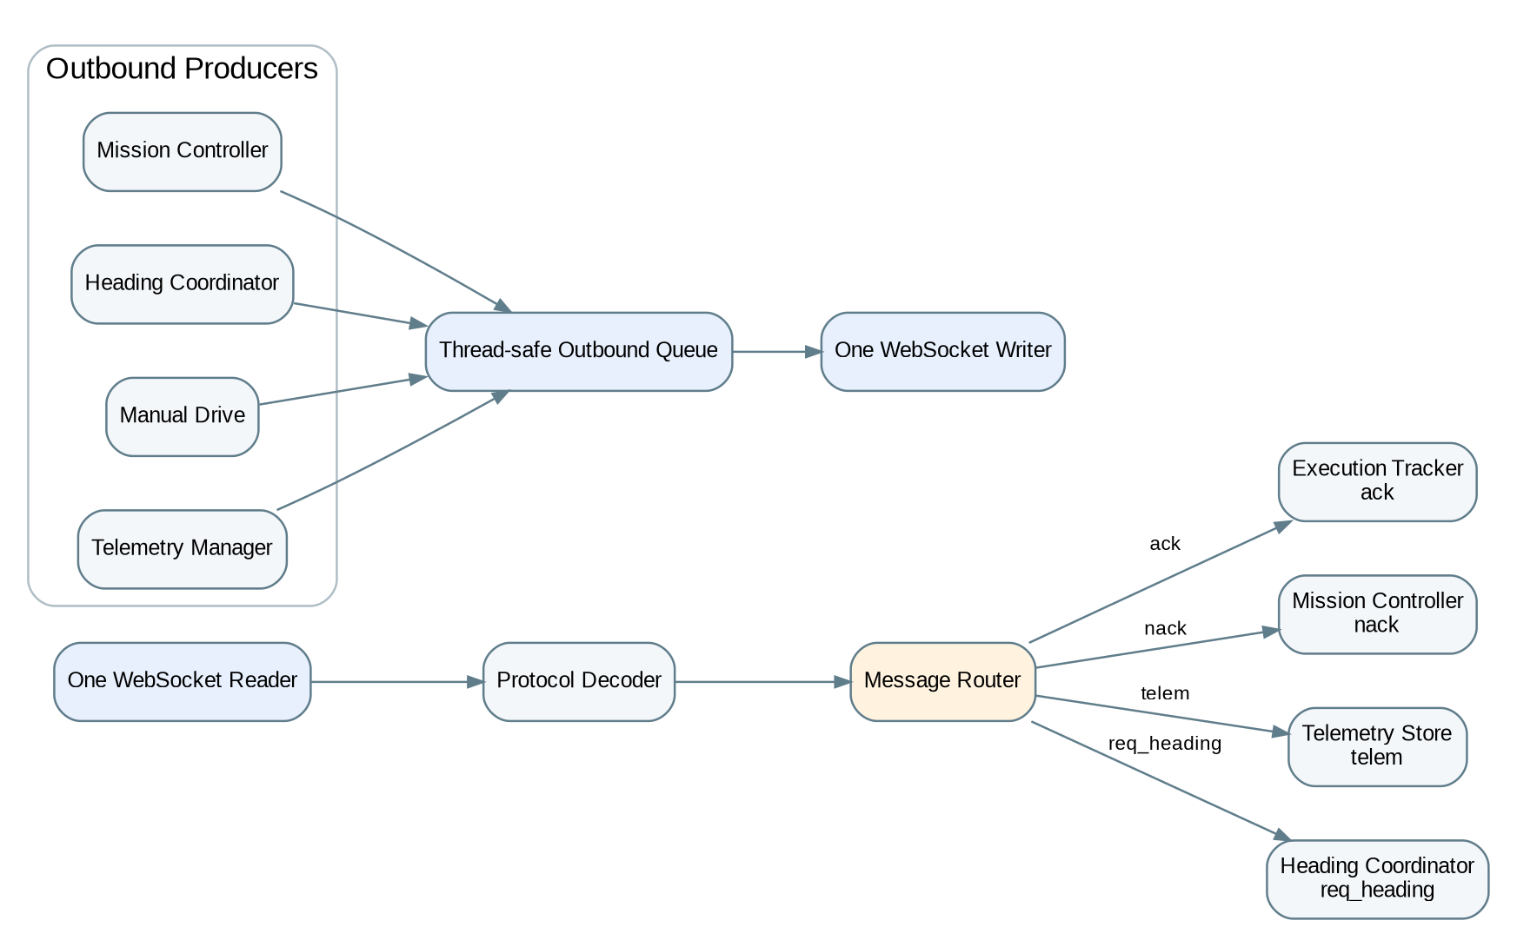
Figure 3. Single-reader/single-writer WebSocket gateway and inbound message routing.

4.1 Inbound event translation
Compact wire messages are decoded once and translated into richer internal events. This keeps protocol details such as the short field t out of the rest of the application.
Wire message | Internal event | Primary consumer
ack / command | CommandCompletedEvent | Execution Tracker and UI state
ack / path | PathCompletedEvent | Mission Controller
nack | PathFailedEvent | Mission Controller / replanning logic
telem | TelemetryUpdatedEvent | Telemetry store and Engineer view
req_heading | HeadingRequestedEvent | Heading Coordinator

4.2 Outbound ownership
- Mission Controller queues validated path messages.
- Heading Coordinator queues heading replies.
- Manual Drive Service queues manual movement or halt commands.
- Telemetry Manager queues telemetry enable/disable and tuning messages where supported.
- Only the WebSocket writer task performs the actual send operation.

5. Camera and Perception Architecture
The camera is treated as a continuously running sensor, not as a resource that is opened only when a prompt is submitted. The camera adapter continuously consumes the IP stream and maintains the latest usable frame in a thread-safe buffer.
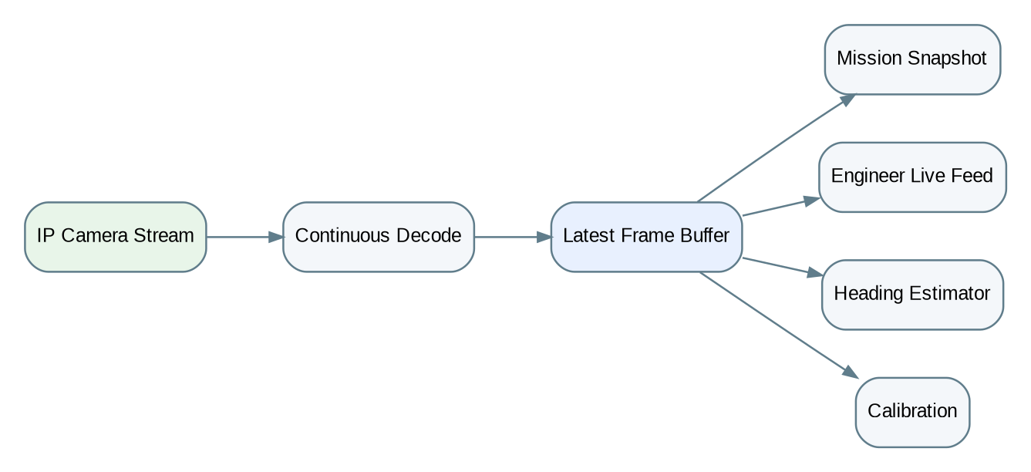
Figure 4. Continuous camera capture with a shared latest-frame buffer.
Snapshot rule
Consumers request the newest frame that satisfies a freshness requirement (for example, not older than a configured threshold). This is particularly important for heading requests during turns, where stale imagery could produce an incorrect correction.

5.1 WorldStateSnapshot as the canonical perception output
The processed image or Markdown description should not be the canonical world representation. Perception should produce one structured WorldStateSnapshot. Human-readable text and annotated images are derived views of the same snapshot.
Field | Purpose
snapshotId / timestamp | Traceability and freshness checks.
rawFrame | Original evidence from the camera.
annotatedFrame | Engineer-facing visualisation of detections, rover pose and arena geometry.
roverPose | x, y, heading and confidence in world coordinates.
detectedObjects[] | Objects/targets with class, position, size and confidence.
obstacles[] | Obstacle geometry used for planning and verification.
arenaDimensions | Calibrated arena dimensions.
sceneJSON | Machine-readable summary for logging/testing.
sceneMarkdown | Optional compact representation supplied to the LLM.

6. Mission Orchestration
A mission is modelled as an explicit finite-state machine rather than a collection of independent callbacks and Boolean flags. The state machine is the authoritative answer to what the host is currently doing and which transitions are legal.
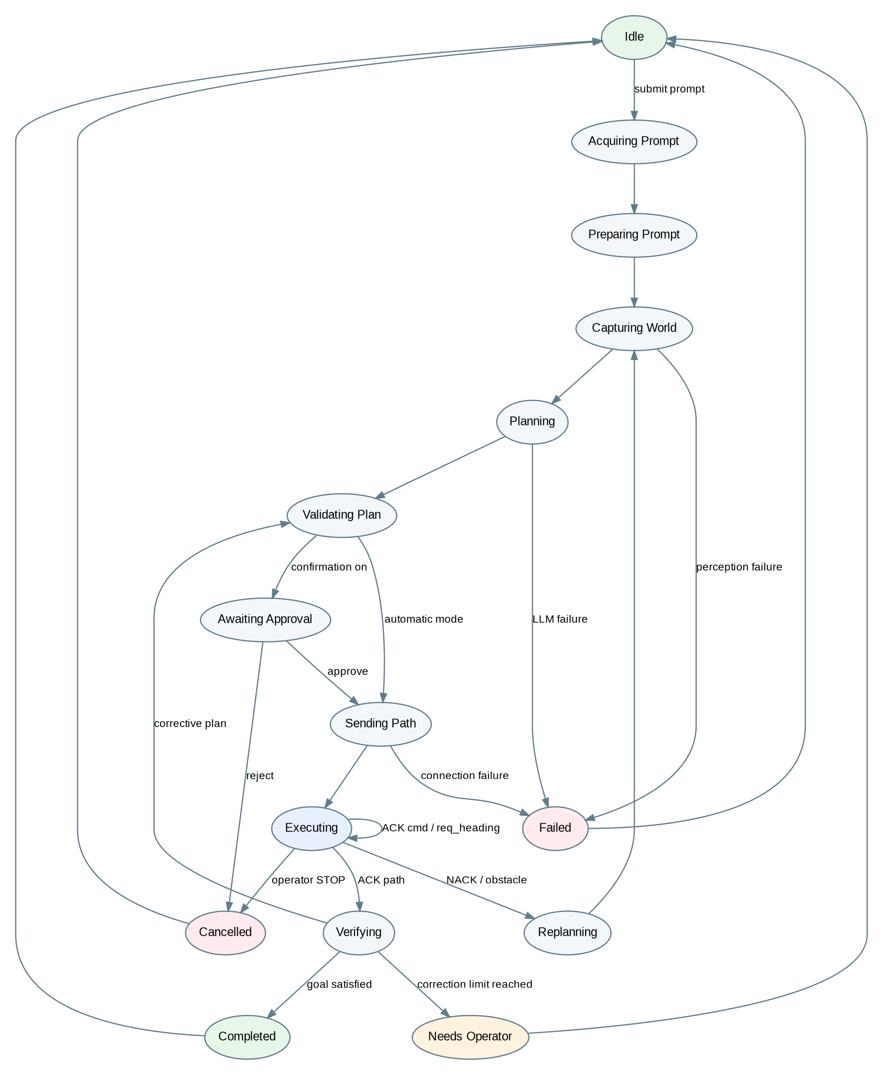
Figure 5. Proposed Mission Controller finite-state machine.

6.1 End-to-end mission flow
- Acquire the user instruction from text input or optional voice input. Voice is converted to text before the mission workflow continues.
- Build an enhanced planning prompt containing system context, command expectations and structured output requirements.
- Request a fresh camera frame and produce a WorldStateSnapshot through the perception pipeline.
- Send the enhanced prompt and world-state representation to the LLM asynchronously.
- Parse and validate the returned plan. If plan confirmation is enabled, present it to the operator and wait for approval.
- Send the validated full path through the Rover Gateway.
- Update command progress as rover ACKs arrive. Telemetry updates are handled independently.
- Whenever the rover sends req_heading, acquire a fresh frame, calculate heading using computer vision and send a heading reply without involving the LLM.
- When the final path ACK arrives, acquire a final world-state snapshot and verify task success against the original goal.
- If verification requests a correction, validate and execute the corrective plan. Stop autonomous refinement when the configured correction limit is reached.
- Persist the run result, timings, plans, snapshots, ACK history and final status.

7. LLM Planning Boundary and Validation
The LLM may propose driving primitives, but it should not own transport-level metadata or have direct access to the rover connection. The host is responsible for path identifiers, protocol encoding, approval policy and final safety checks.
Figure 6. Validation and ownership boundary between LLM output and rover transport.
Validation stage | Checks
JSON parsing | Response is valid structured data and does not contain uncontrolled prose around the plan.
Schema validation | Only the expected planning fields are present and have the correct types.
Command validation | Only supported primitives are accepted: FWD, BACK, TURN and STOP unless the protocol is explicitly extended.
Value validation | Distances and angles are numeric and within configured engineering limits.
Path validation | STOP is present at the end and primitive count is within the configured maximum.
Safety validation | Reject paths that violate configured bounds or known constraints.
Host metadata | Host assigns path ID and creates the final compact wire message.
Approval policy | If confirm-before-send is enabled, transmission is blocked until approval.

8. Goal Verification and Bounded Refinement
After a path-level ACK, the host captures a new world-state snapshot and asks the verification service to determine whether the original instruction has been achieved. Verification may return success or a corrective plan.
Bounded loop decision
Use a maximum correction count rather than a minimum repeat count. Recommended initial value: MAX_CORRECTION_ROUNDS = 2. This permits up to two autonomous refinement plans after the initial attempt and prevents an infinite verify-correct-verify cycle.

Outcome | Next action
Goal satisfied | Mark run COMPLETE and persist final evidence.
Correction required and limit not reached | Validate corrective plan and execute another path.
Correction required but limit reached | Enter NEEDS OPERATOR state; do not continue autonomously.
Verification unavailable | Fail safely or request operator decision according to policy.

9. Proposed Class / Service Model
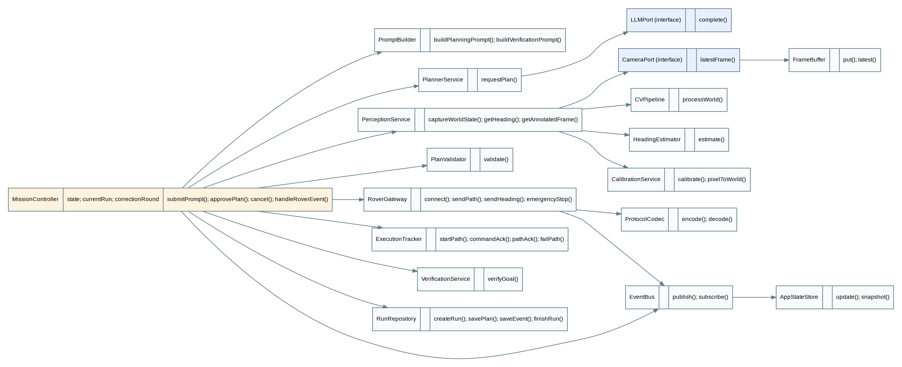
Figure 7. Initial UML-style class and service dependency model.
Component | Responsibility
MissionController | Owns mission state, transition logic, correction count and high-level orchestration.
PromptBuilder | Constructs planning and verification prompts from user intent and structured context.
PlannerService / LLMPort | Requests plans through an interface that can support different LLM providers.
PerceptionService | Coordinates camera snapshots, CV processing and world-state construction.
CameraPort / FrameBuffer | Abstracts camera technology and provides latest-frame access.
HeadingEstimator | Fast CV-only heading estimation used during rover heading requests.
CalibrationService | Homography calculation and pixel-to-world coordinate transformation.
PlanValidator | Schema, command, bounds and safety validation.
RoverGateway / ProtocolCodec | Connection lifecycle, message queues and protocol translation.
ExecutionTracker | Maps ACK/NACK events to command and path execution state.
VerificationService | Checks goal completion and, where needed, obtains corrective plans.
RunRepository | Persists mission history, plans, events and final outcomes.
EventBus / AppStateStore | Decouples background services from presentation state.

10. Shared Application State and Persistence
Operator and Engineer views are two presentations of the same mission. They should therefore read from one AppStateStore. The store is updated by events and contains only current state; durable history is persisted separately.
AppState area | Example contents
connections | Rover, camera, LLM and microphone readiness, error and latency information.
currentRun | State, user prompt, path ID, plan, current command and correction round.
perception | Latest raw/annotated frame, rover pose and world-state summary.
telemetry | Latest rover telemetry plus host-derived values.
settings | Connection endpoints, selected microphone, safety limits and calibration profile.

10.1 SQLite run model
Entity | Suggested contents
MissionRun | Run ID, prompt, input type, start/end timestamps, final status.
PlanAttempt | Revision/correction number, path ID, raw LLM output, normalized plan, validation result.
CommandExecution | Command index, primitive/value, transmit time, ACK time and outcome.
WorldSnapshot | Raw/annotated image paths and structured world state.
TelemetrySample | Timestamp and telemetry sample values.
VerificationAttempt | Verdict, confidence/reason, correction round and any corrective plan.
CalibrationProfile | Image size, selected corners, world dimensions, homography matrices and timestamp.
EventLog | Timestamp, severity, component, event type and human-readable message.

This persistence model supports both the Recent Prompts UI and later project evaluation. It enables direct measurement of planning latency, command completion time, mission duration, correction count, heading response latency, NACK rate and success rate.

11. Settings, Readiness and Camera Calibration
Settings is treated as the commissioning area of the host application. The supplied UI already groups connection, camera, voice input, planner, safety and history/log concerns. The backend should expose a corresponding settings service and capability/readiness model.
Figure 8. Four-corner homography calibration workflow.

11.1 Calibration profile
Stored value | Use
Camera resolution | Detect invalid profiles after stream configuration changes.
Four pixel-space corner coordinates | Define the visible arena quadrilateral.
Arena width and height in mm | Define world-coordinate scale.
Homography H | Transform image coordinates into arena/world coordinates.
Inverse homography H^-1 | Map world coordinates back into image coordinates for overlays.
Timestamp/version | Traceability and invalidation.

11.2 Capability-based readiness
Unavailable component | Expected degradation
LLM | Disable autonomous prompt planning; keep camera, telemetry and manual drive available.
Microphone | Disable voice input; text prompts remain available.
Camera | Disable autonomous planning/verification and heading service; manual rover controls may remain available under policy.
Rover WebSocket | Disable all movement commands while allowing camera/perception setup and calibration.

12. Protocol and UI Alignment Issues to Resolve Before Coding
Reviewing the current UI mock-up against the current Command Protocol Specification reveals several design mismatches. These should be resolved deliberately rather than hidden in implementation details.
Area | Current position | Required decision
Distance display | UI examples show FORWARD 1.4s while the protocol defines FWD/BACK in millimetres. | Use distance-based primitives consistently in the UI, or revise the protocol intentionally.
Engineer telemetry | UI presents distance, heading, speed, uptime and RSSI-like information; the current rover telemetry message specifies vbat, soc and dist, where dist is the ultrasonic distance measurement. | Classify each displayed value as rover telemetry, host-derived CV state or remove/extend protocol accordingly.
Rover endpoint label | Settings mock-up refers to a TCP endpoint while the protocol specifies WebSocket over TCP. | Store/display a WebSocket URI or clearly distinguish transport from endpoint configuration.
Emergency STOP | Engineer UI contains an immediate STOP control; the current protocol defines STOP only as a path terminator. | Add an out-of-band halt/emergency-stop command that can interrupt an active path.
Autostop margin | Settings exposes a host safety margin but no corresponding configuration message is currently defined. | Decide whether this is firmware-fixed, host-only UI information, or a new rover configuration message.
Heading request correlation | req_heading has no path/command/request identifier. | Consider correlation fields for stale/delayed requests, particularly if heading is requested multiple times during one turn.
Heading failure | Heading reply carries only deg. | Define behaviour when heading confidence is inadequate or perception is unavailable.

Highest-priority protocol change
The immediate halt/emergency-stop path should be specified before implementation because manual STOP must remain available even while an autonomous path is executing.

13. Manual Drive and Mode Arbitration
Manual controls should use the same Rover Gateway as autonomous commands. A Mode Controller arbitrates authority so that manual directional commands cannot conflict with an active autonomous path.
Mode | Behaviour
AUTONOMOUS RUN | Directional manual commands disabled. Emergency STOP always enabled.
MANUAL | Arrow/manual controls enabled. Mission execution cannot concurrently transmit a path.
FAULT / DISCONNECTED | Movement commands disabled until the required link and safety conditions are restored.

14. Initial Internal Data Contracts
The next design freeze should define language-level data structures independent of transport. The following contracts are recommended as the minimum shared vocabulary between modules.
Contract | Key fields
MissionRun | run_id, user_prompt, input_source, state, created_at, completed_at, correction_round
Plan | path_id, commands[], source_attempt, validation_status
Command | op, value, index
WorldStateSnapshot | snapshot_id, timestamp, frame refs, rover_pose, objects, obstacles, arena, scene_json, scene_markdown
RoverEvent | event type, path_id, command_index, timestamp, payload
TelemetrySample | timestamp, rover telemetry fields, optional host-derived metrics
CalibrationProfile | camera identity/resolution, corners, arena dimensions, H, H^-1, version
ConnectionStatus | component, state, latency, last_error, last_seen

15. Verification Strategy for the Software Architecture
The architecture is deliberately interface-driven so it can be exercised without the physical rover for most software tests.
Test level | Examples
Unit | PlanValidator rejects malformed/unsafe plans; state machine permits only legal transitions; ProtocolCodec round-trips valid messages.
Component | Camera adapter supplies fresh frames; HeadingEstimator returns pose/confidence; repositories persist and retrieve complete runs.
Integration | Fake rover emits ACK/NACK/req_heading sequences; fake LLM returns valid/invalid plans; MissionController responds correctly.
Fault injection | WebSocket disconnect, camera stall, stale frame, LLM timeout, malformed ACK, duplicate ACK and low-confidence heading.
Hardware-in-the-loop | Real rover executes controlled paths while host logs timing, ACK progression, heading requests and safety events.
Acceptance | Operator/Engineer views remain responsive while missions, telemetry, camera and logs run concurrently.

16. Design V1 Architecture Freeze
The following structure is the proposed baseline to implement unless a later design review deliberately changes it:
- Presentation: Operator, Engineer and Settings views over one shared state store.
- Application core: Mission Controller finite-state machine, Event Bus, Connection Manager and plan-approval policy.
- Planning: Prompt Builder, LLM Planner adapter, Plan Validator and Goal Verification service.
- Perception: continuous Camera Adapter, latest-frame buffer, world-state CV, heading estimator and homography calibration.
- Rover: single-reader/single-writer WebSocket gateway, Protocol Codec, Message Router, Execution Tracker, Telemetry Manager and Manual Drive Service.
- Voice: optional microphone capture and speech-to-text service.
- Persistence: SQLite-backed run history, telemetry, logs, snapshots, settings and calibration profiles.
Next formal design activity
Define the internal data contracts in detail and revise the wire protocol where needed for immediate halt, heading-request correlation, telemetry/UI alignment and safety configuration. After those contracts are frozen, implementation can proceed module-by-module with stable interfaces.

Appendix A. Design Basis
This design was derived from the project workflow described for the host application and the two supplied project artefacts:
Source | Used for
UI_Design.html | Operator/Engineer/Settings view responsibilities, recent prompt/run presentation, command progress, live camera/telemetry, manual drive, connection settings, microphone selection and safety controls.
command_protocol(1).docx - Command Protocol Specification | Persistent WebSocket/TCP transport, compact typed JSON messages, full-path execution, FWD/BACK/TURN/STOP primitives, ACK/NACK behaviour, telemetry switch/samples and req_heading flow.

Items labelled as proposed, recommended or required decisions in this document are architecture decisions introduced to make those source requirements implementable, modular, testable and safe; they are not claims that the existing source documents already specify those details.

