Digital Humanities: Program Instructions

Greg Dawkins, Marlene Williams & Kevin Woods

Fall 2015

1. **Build Instructions**
   1. Create new project in Microsoft Visual Studio or other IDE
   2. Add existing file to project source code
   3. Select Capstone project’s main.cpp from wherever it is stored
   4. Build Solution/Project from there
2. **Operation Instructions**
   1. **Setup**
      1. Input must be setup in one directory with all files (manuscripts/drafts)
         1. Name the files appropriately to meet your expectations
         2. Program will compare all files to each other, but will run in the following pattern (ex. 5 files):
            1. File 1 to file 2
            2. File 1 to file 3
            3. File 1 to file 4
            4. File 1 to file 5
            5. File 2 to file 3
            6. File 2 to file 4
            7. File 2 to file 5
            8. File 3 to file 4
            9. File 3 to file 5
            10. File 4 to file 5
   2. **Running the application**
      1. Navigate to the directory you want the output file to reside in upon application completion
      2. Launch the application (C:\path\to\executable) from this directory
         1. In windows, you may drat the executable into **cmd** prompt
      3. First, it states to “Enter the input file directory”
         1. In windows, you may drag the dir from file expolorer into **cmd** prompt, otherwise type in the full path
         2. Application will not accept files or non-existent directories
            1. If either is given, it will loop until valid input dir is provided. (See Figure B.3.b)
      4. Application will compare all files in the directory showing information in **cmd** or terminal (See Figure B.4) and creates output file* (Result.csv) in the current directory from where the application was launched.

**\*Note:** Output file can be opened directly in Microsoft Excel, and charts created from there.

1. **Figures**

B.3.b

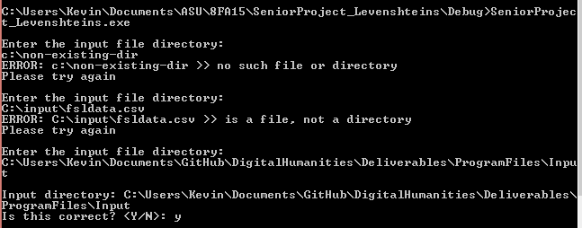

B.4

