IT-113 IT FUNDAMENTALS

FINAL PROJECT

<https://atheojessarrcaliao.github.io/index.html>



SUBMITTED TO:

JOHN LLOYD ROJO

INSTRUCTOR

SUBMITTED BY:

ATHEO JESSAR R. CALIAO

STUDENT

INTRODUCTION

1. **Background Information**

The project for the Intro to Computing course involves creating a website with three navigation menus. The Flex page, the Home Page, and the IT 111 Blog. This three-section navigation menu explains what is inside each section.

The home page should meet the requirements of introducing ourselves, listing our interests, talents, and goals, as well as a movie or infographic depicting how we envision ourselves in eight years. The highlights of that area are seen here, where we have added some hover and animation. The project title, our photo, and the three-navigation menu are all visible in the first section, which is located at the top. A paragraph presenting interests, our talents, desires, and ourselves makes up the second section.

The IT Blog section of the second navigation menu summarizes the most exciting and challenging lessons from the Introduction to Computing course. A three-navigation menu and the page title are visible from the initial section or top of the page. The lesson's highlights are included in the second section or below, and each lesson serves as a reflection of what was learned. The final section includes a reflection and an image of the lesson that challenges and excites me.

The final page is the "Flex Page," where I list the people who will be my lifelong flex. The title, navigation menu, and collage are located at the top. The photo of my mother, my family, and my girlfriend, together with a note expressing my gratitude, are shown below, starting from the top.

1. **Chosen Web Hosting Service**

The Webhosting that I choose is the Github. GitHub, represented by its distinctive octocat logo, is a widely utilized web-based platform that serves as a hub for version control and collaborative software development. Launched in 2008, the platform enables developers to host, share, and manage code repositories. The octocat, a cat/octopus hybrid, is an iconic mascot symbolizing the platform's approachability and adaptability.

GitHub supports open-source projects, allowing developers to contribute, track issues, and propose changes through pull requests. Its features, including branching, forking, and integrated workflows, facilitate efficient collaboration and project management. GitHub has become an integral part of the software development ecosystem, promoting transparency, community engagement, and the seamless coordination of coding efforts worldwide.

**CONCEPTUAL DESIGN**

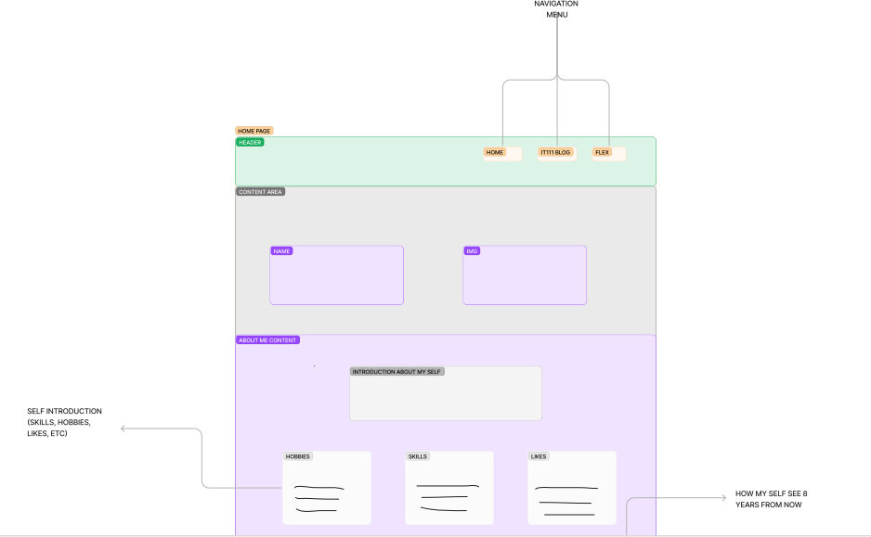

**HOME PAGE**

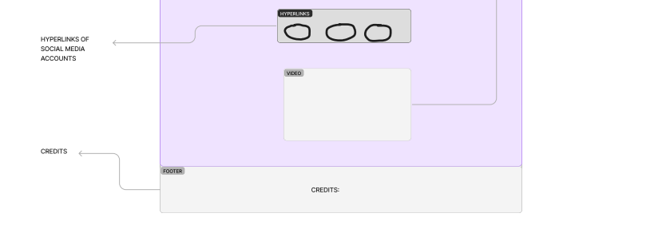

**IT BLOG ENTRIES PAGE**

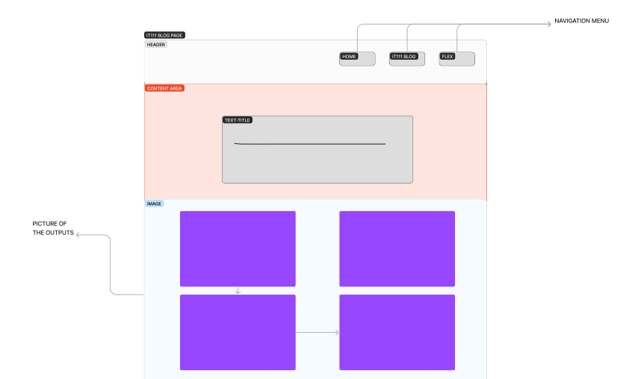

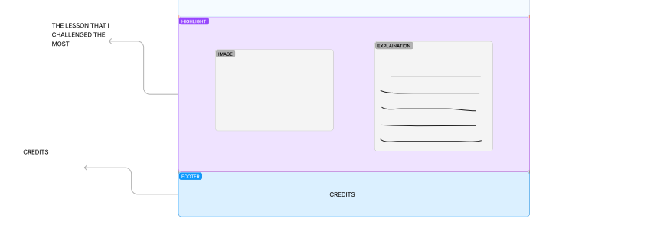

**FLEX PAGE**

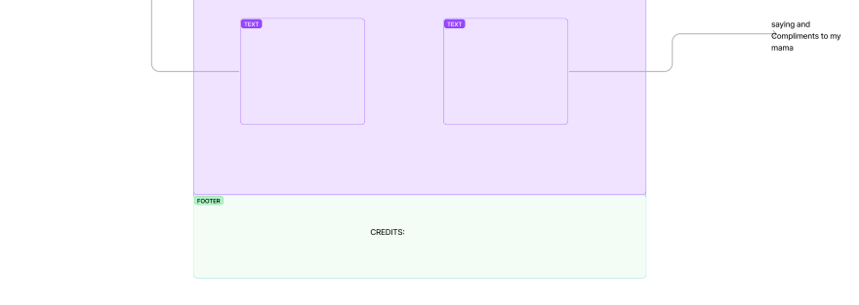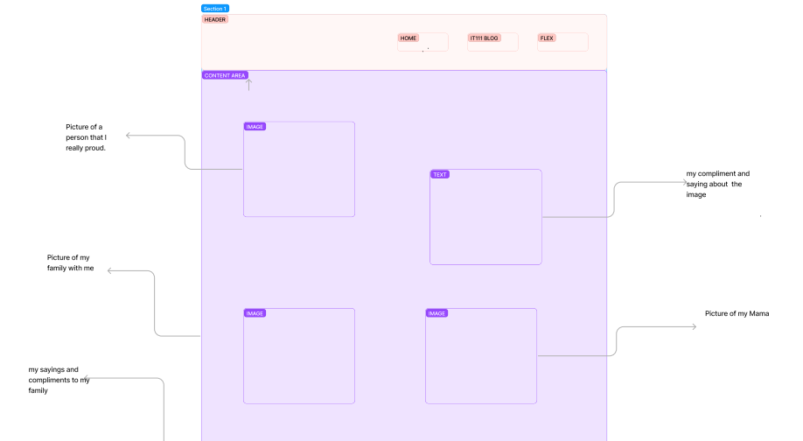

1. **GITHUB PAGE**
2. **REPOSITORY’S CODE TAB**

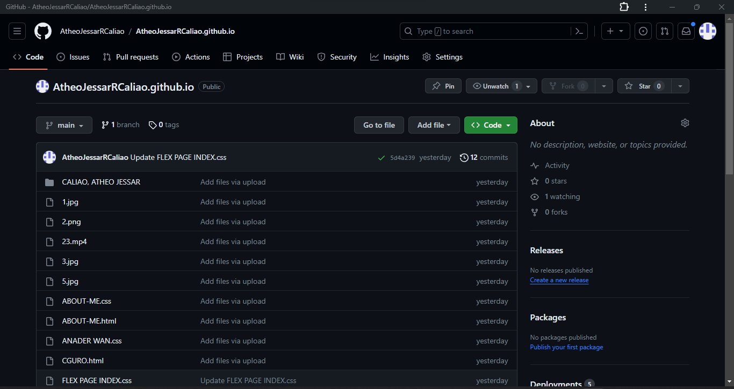

**\**

1. **REPOSITORY ACTION TAB**

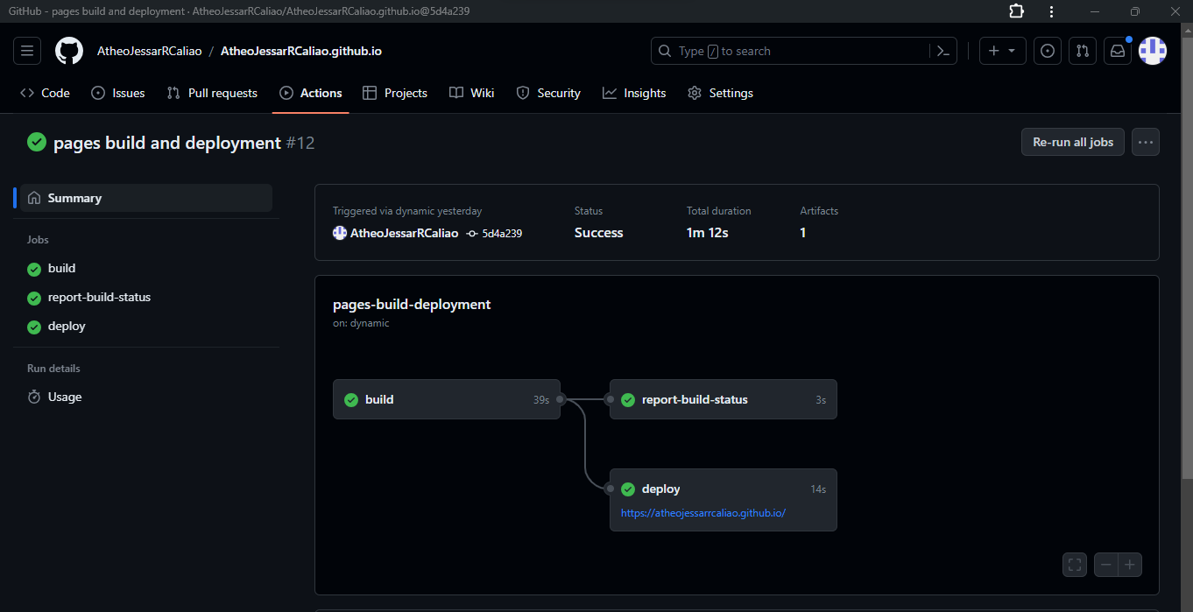

1. **WEBSITE’S URL LINK**

<https://atheojessarrcaliao.github.io/index.html>

1. **HOME PAGE’S SCREENSHOT**

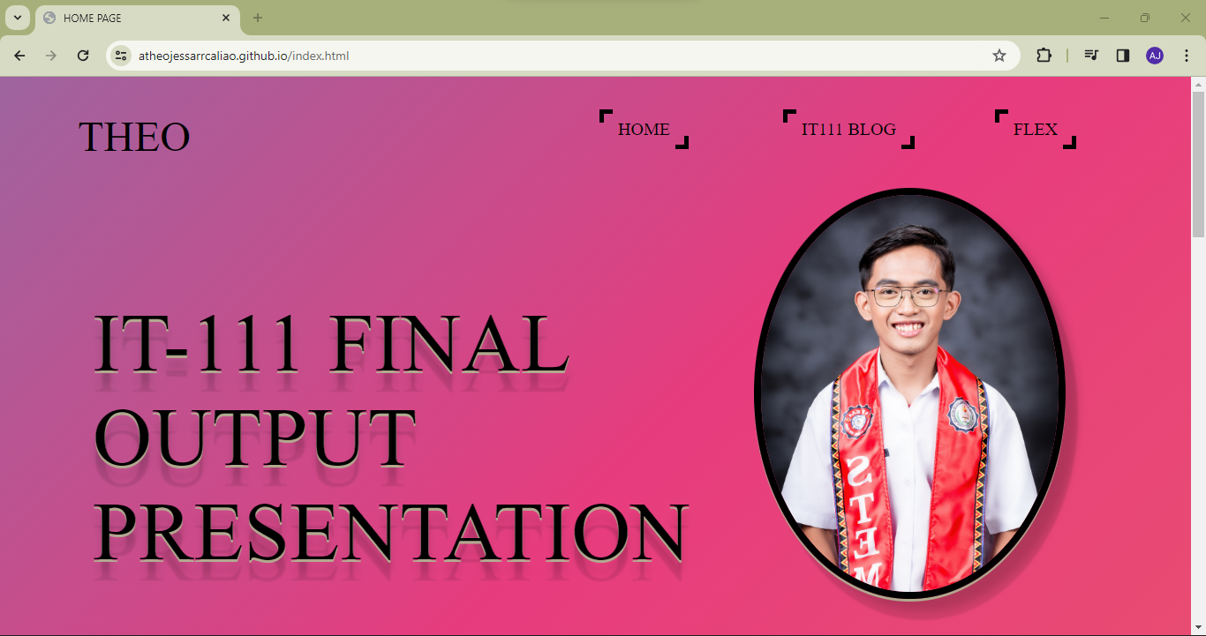

1. **FINAL TESTING AND CONCLUSION**
2. **Functionality Testing**

Integrating the site design project for IT 111 with the web hosting provider. The web hosting service we choose, GitHub, has few obstacles and is straightforward to use because to its easy compromise feature and visually stunning website design.

1. **Recommendation for Future Work**

Because of GitHub's unmatched ability to facilitate effective version control and collaborative development processes, I heartily advocate using it for future projects. GitHub offers a central platform where teams can work together on projects in an easy-to-use manner, recording changes, contributing code, and resolving bugs. Its sophisticated branching structure and user-friendly interface let developers to work on multiple features at once and keep the codebase tidy and orderly. Furthermore, by automating testing and deployment procedures, GitHub's interaction with well-known continuous integration tools improves the entire development lifecycle. The platform is an essential tool for any project, encouraging openness, responsibility, and creativity in software development because to its broad community support, comprehensive documentation, and broad usage.

1. **Conclusion**

To sum up, incorporating GitHub into the website development project is a calculated move that should greatly improve productivity, teamwork, and the project's success as a whole. The team will be able to easily manage code changes thanks to GitHub's version control features, which will guarantee a well-documented and traceable development process. Pull requests and issue tracking, two of the platform's collaborative capabilities, will let team members communicate more easily and create a more transparent and orderly workflow. Furthermore, GitHub's widespread use among developers guarantees an abundance of tools, plugins, and community support that may be utilized to overcome obstacles and improve the caliber of the project. Accepting GitHub as the primary location for version control and cooperation would surely aid in the development of the website in a way that is not just efficient.

1. **References**

<https://www.google.com/>