1. **Demonstrate minimum 15 basic docker command with explanation and screenshot.**
2. docker –version: To check docker version available

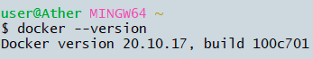

1. docker images : list all the available images

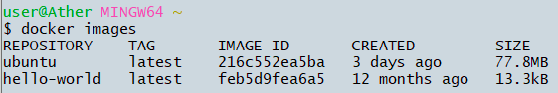

1. docker ps : lists all the available containers

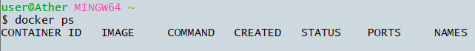

1. docker ps –a : list all the containers including the exited ones

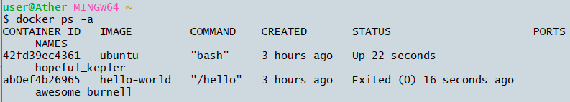

1. docker stop <container name> to stop a running container



1. docker rm <container-name> : this command removes the specific container



1. docker rmi <image-name> : removes the specified image

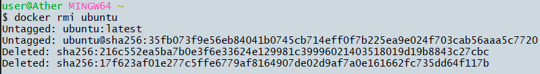

1. docker run nginx (i.e. <image-name>): It first tries to find locally if not found, pulls from online repository then runs the conainer

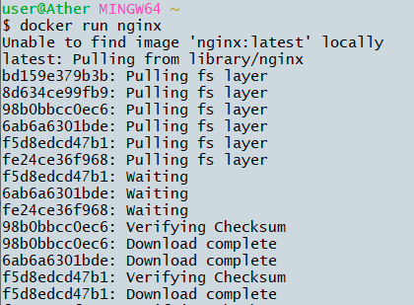

1. docker pull <image-name> : this commands pulls the image into the local but does not run a container unlike the run command.

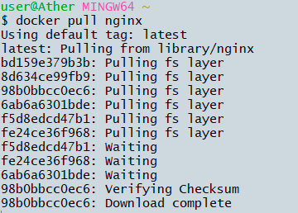

1. docker run –d <image-name> : runs the container in detach mode and therefore terminal does not freeze.

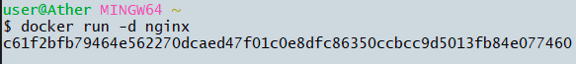

1. docker attach <container-id> : this command will change the container mode to attach mode.



1. docker run –it ubuntu bash: runs the ubuntu image in interactive mode.

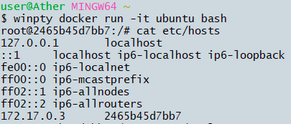

1. docker run - - help: to get help and see all available ptions available with the command.

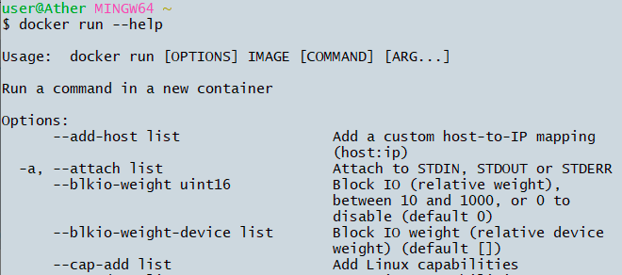

1. docker run alpine:3.12.8 : by default latest images version are downloaded. To get a specific version mention it in this command after colon. We can get the versions from the tags mentioned in the docker hub repository

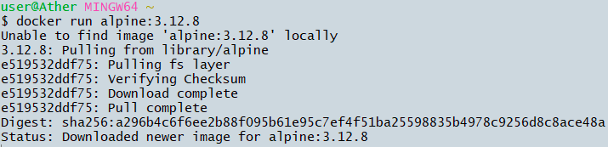

1. docker kill <container-id> : this command kills the container by stopping its execution immediately.



1. docker build –t< image-name> . : builds docker image with provided name

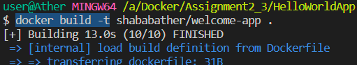

1. docker push username/image: to push docker image to the docker hub. Image name should follow the format username/image:tag

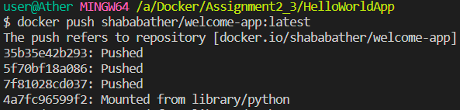

1. **Hello World Docker Image - Run Hello World Docker Image Locally.**

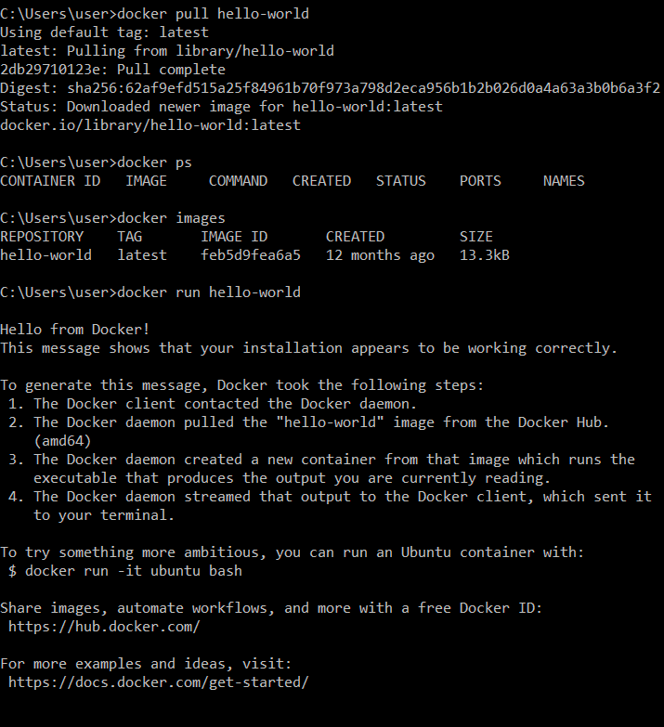

1. **Create a hello world fastapi application. Create a Dockerfile for your fastapi hello world application. Build Docker image using Docker file. Run docker image build in previous step. Push your Docker image to Docker Hub.**

docker pull shababather/welcome-app:latest