COL780
Assignment 2
Pratik Prawar(2018CS50415)
Aditya Mohan Mishra(2018ME10582)

Part 1:- Appearance Based Technique:

To implement the basic block based method, we have used the matchTemplate function in the openCV module of python. Using this matched template, we then calculate the mIOU score using the formula given in the problem statement.

Now, the mIOU scores and the limitaions of this method based on the given dataset is given below:-

BlurCar2 dataset:-

mIOU score = 0.51563219
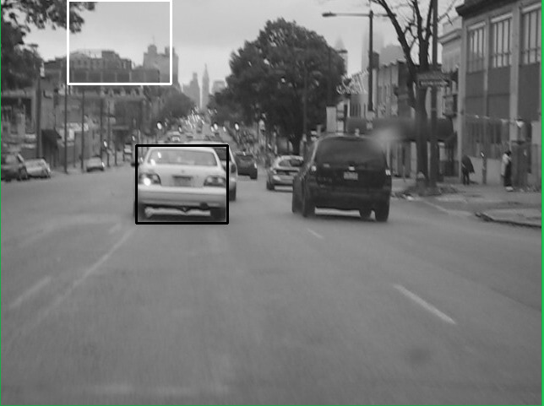
In this dataset, there are some errors in detecting, for example, one of them is given below:-

Now, here the template size has reduced a lot compared to the original template. This is why there is an error in the block based method in this image.

Bolt dataset:-

mIOU score = 0.00436710629

In this dataset, the mIOU score is quite less. This is because there are large changes in the consecutive frames in this dataset. Hence, these changes are not getting captured by the block based method and hence we get a wrong template as our output. Some of the failed examples in our dataset are given below:-

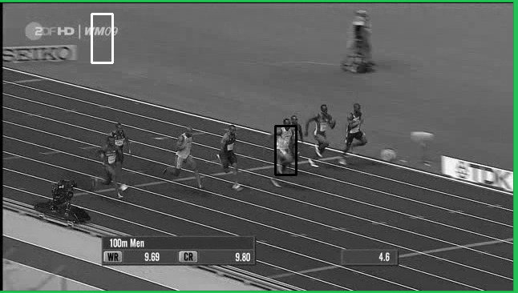

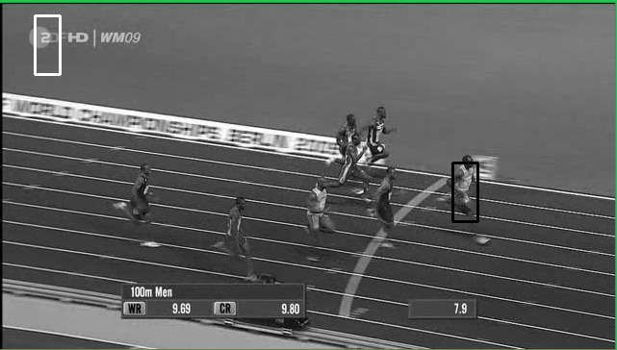

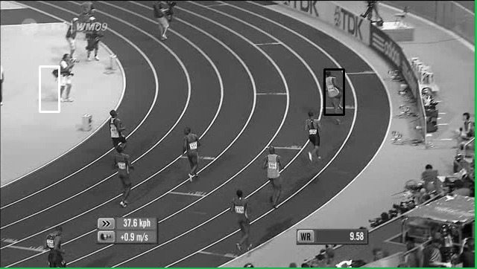
Liquor dataset:-

mIOU score = 0.5417417

Again, in this dataset, the mIOU score is better. However, still there are some errors in block based method in this dataset. This is mainly because of occlusion. This method fails when there is some hinderance to the original template in an image. An example can be seen below:-

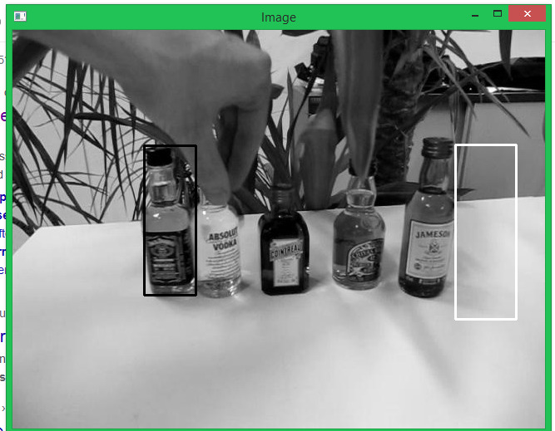
As can be seen, there is hinderence(occulsion) to the required template in this picture. Hence we are getting a wrong template using the block-based method.

Part 2:- Lucas Kanade Template Matching

A class is created to wrap the current image back to the template. It uses bilinear-interpolation to determine values of pixel intensities. The warping function used is Affine, although a projective transformation function is written as well. del_p is calculated for every image iteratively and is minimised for every next image by setting a tolerance value over L2-norm of del_p.
Del_Wp is defined for every transformation.

For blur car if the bounding box is kept the same as first one, the mIOU comes out to be ~0.35.

Due to the warping functions giving out of bound values at later stage, we were unable to fully implement a working solution using LK method. Most of the constituting functions ran fine.

We had planned out the whole part 3 on the success of part 2.

