Maharashtra Institute of Technology
Vishwaprayag University, Solapur

Department of Computer Science and Engineering

Weekly Progress Report
Weeks 1–3

PulseTech — Pediatric Pharmacovigilance Dashboard
using Heterogeneous Graph Attention Networks (HANConv)
for Proactive Adverse Drug Reaction Detection

Name | SRN | Roll No | Email ID
Atharv Telkar | SCFP125043 | 43 | athervtelkar08@gmail.com
Amey Telkar | SCFP125044 | 44 | ameytelkar08@gmail.com

Guide: Prof. Akshay Javalgikar
Report Date: 05 October 2026

Table of Contents
1. Project Overview
2. Week 1 Report: Data Pipeline & Database Architecture
3. Week 2 Report: Signal Detection & GNN Implementation
4. Week 3 Report: Dashboard Integration & PLOS ONE Submission
5. Current System Status
6. Key Metrics & Achievements
7. Screenshots & Evidence
8. Next Steps

1. Project Overview
Project Title: PulseTech — Pediatric Pharmacovigilance Dashboard using Heterogeneous Graph Attention Networks (HANConv) for Proactive Adverse Drug Reaction Detection
Objective: Design and develop a web-based pediatric pharmacovigilance dashboard that combines retrospective Disproportionality Analysis (PRR, ROR, IC, EBGM) with proactive Graph Neural Network (HANConv) signal prediction on the FDA FAERS database, with full data traceability through a 13-step human-gated ingestion pipeline.

Technology Stack
Component | Technology
Frontend | React.js with interactive D3.js/Force-directed graph visualisations
Backend | Python FastAPI with SQLAlchemy ORM
Database | PostgreSQL (faers_pediatric analytical store)
GNN Framework | PyTorch Geometric — HANConv (Heterogeneous Attention Network)
Drug Normalisation | RxNorm API (NIH NLM) for standardised drug naming
ADR Coding | MedDRA v28.1 Preferred Terms (via FAERS REAC files)
Report Generation | In-dashboard PDF export (one-click)
Deployment | Local development server (Node.js + FastAPI)

2. Week 1 Report: Data Pipeline & Database Architecture
Period: 15 September – 21 September 2026

Tasks Completed
# | Task | Status | Details
1 | 13-Step FAERS Ingestion Pipeline | ✅ Complete | Automated pipeline: file detection → deduplication → demographic normalisation → age banding (ICH E11) → RxNorm drug name standardisation → human quality gate
2 | PostgreSQL Database Setup | ✅ Complete | faers_pediatric database with 7 normalised tables (demo, drug, reac, outc, rpsr, ther, indi)
3 | 20-Quarter Data Load | ✅ Complete | Q1/2021 through Q4/2025 loaded = 3,420,201 patient records
4 | ICH E11(R1) Age Banding | ✅ Complete | 5 bands: Neonate (<28d), Infant (<2y), Child (<12y), Adolescent (<18y), Unknown
5 | RxNorm Drug Normalisation | ✅ Complete | ~94% drug names resolved via NLM RxNorm API; persistent cache for performance
6 | Human Quality Gate (Step 13) | ✅ Complete | Mandatory preview/approve before any DB write — ensures auditability
7 | Upload Hub UI Module | ✅ Complete | Drag-and-drop 7-file upload with live progress, load ledger showing all 20 quarters

Key Metrics — Week 1
- Records: 3,420,201 patient records loaded across 20 quarters
- Drugs: 1,902 unique suspect drugs (RxNorm-normalised)
- ADRs: 4,416 unique ADR preferred terms (MedDRA v28.1)
- Age Distribution: Neonate: 23,704 | Infant: 29,963 | Child: 149,389 | Adolescent: 403,278 | Unknown: 2,813,867

Screenshot: Upload Hub (13-Step Pipeline)
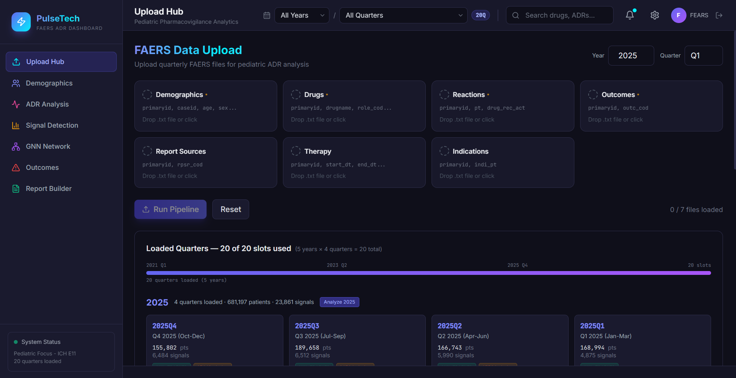
Figure 1: PulseTech Upload Hub showing the 13-step data ingestion pipeline with 20-quarter load ledger.

3. Week 2 Report: Signal Detection Engine & GNN Implementation
Period: 22 September – 28 September 2026

Tasks Completed
# | Task | Status | Details
1 | Disproportionality Analysis Engine | ✅ Complete | Four gold-standard metrics: PRR (Proportional Reporting Ratio), ROR (Reporting Odds Ratio), IC (Information Component / BCPNN), EBGM (Empirical Bayes Geometric Mean)
2 | Signal Detection Module UI | ✅ Complete | In-dashboard signal table with automatic Signal/No-Signal flagging, sortable by all 4 metrics
3 | HANConv GNN Model Architecture | ✅ Complete | PediatricADRHAN: 2-layer HANConv, 64-dim hidden, 4-head attention, ReLU activation, Adam optimiser, 200 epochs
4 | Heterogeneous Graph Construction | ✅ Complete | CHILD-band graph: 79 drug nodes, 259 ADR nodes, 500 edges — 419 edges (83.8%) are confirmed statistical signals
5 | GNN Network View Module | ✅ Complete | Interactive force-directed graph with Drug/ADR node types, Classical/GNN Predicted/Both toggle, hover tooltips with role breakdown
6 | GNN Link Prediction | ✅ Complete | Novel drug–ADR associations predicted: e.g., Dupixent→Acute Pulmonary Oedema (score 0.87), idursulfase→Abdominal Neoplasm (score 0.82)
7 | Demographics Module | ✅ Complete | Age–sex distribution pyramid, sex donut chart, ICH E11 age band breakdown
8 | ADR Analysis Module | ✅ Complete | Top-20 ADRs bar chart, ADR×Age Group heatmap, drug–ADR co-occurrence table

Key Metrics — Week 2
- Total Signals: 82,650 confirmed disproportionality signals detected across all age bands
- GNN Graph: 79 drug nodes, 259 ADR nodes, 500 edges (CHILD band)
- Signal Density: 419/500 edges (83.8%) confirmed as statistical signals
- Novel Predictions: Dupixent & idursulfase share 401 ADR neighbours — model predicts novel links
- Model Architecture: 2-layer HANConv, 64-dim hidden, 4-head attention, 200 epochs

Screenshot: Signal Detection Module
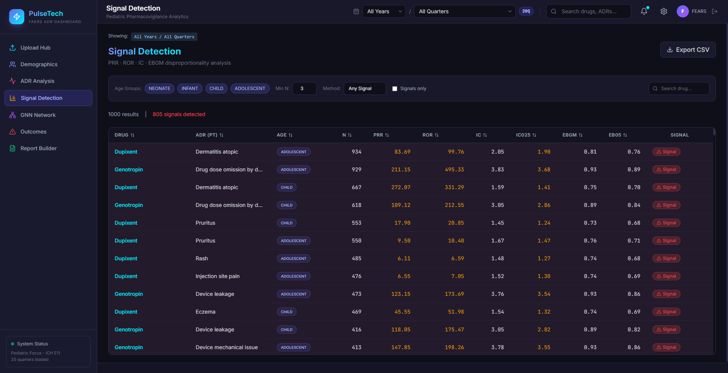
Figure 2: Signal Detection module showing PRR/ROR/IC/EBGM disproportionality analysis with automatic signal flagging.

Screenshot: GNN Network View (Heterogeneous Graph)
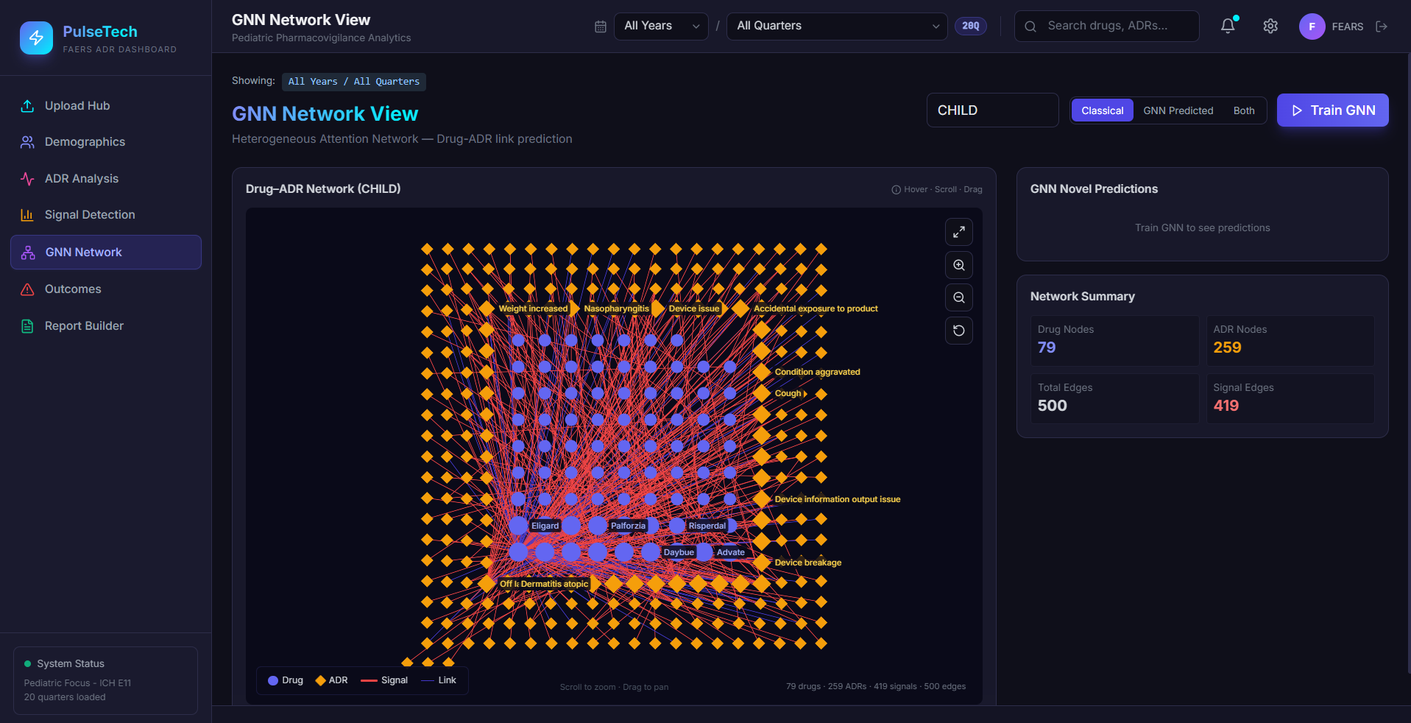
Figure 3: Interactive GNN Network View showing the heterogeneous bipartite graph between drug nodes (circles) and ADR nodes (diamonds). Red edges = confirmed signals, green = GNN predicted.

Screenshot: GNN Node Detail (Genotropin)
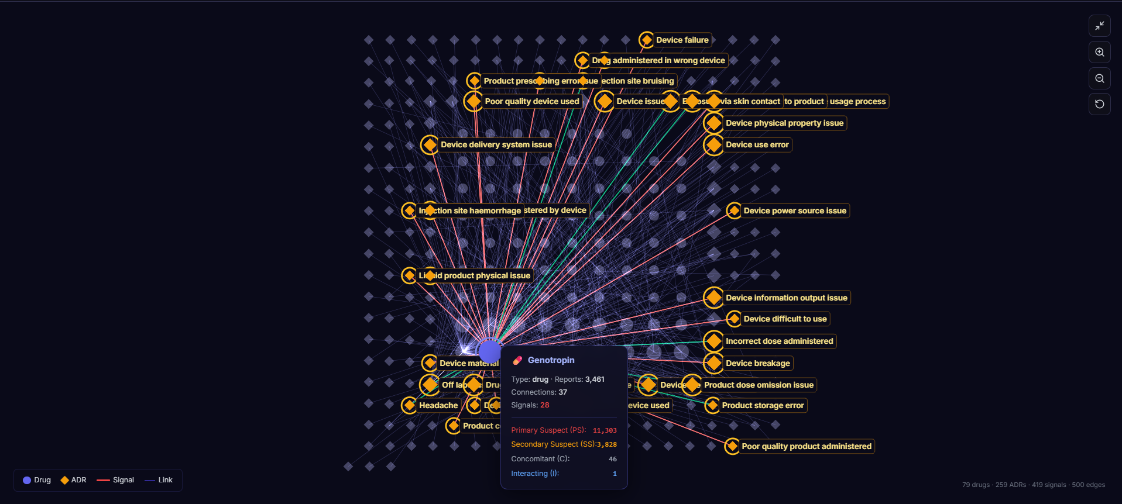
Figure 4: Detail view of GNN graph with drug-node tooltip showing Genotropin (3,461 reports, 37 connections, 28 signals). Role breakdown: PS=11,303, SS=3,828.

4. Week 3 Report: Dashboard Integration & PLOS ONE Submission Package
Period: 29 September – 05 October 2026

Tasks Completed
# | Task | Status | Details
1 | Outcomes & Severity Module | ✅ Complete | Seven-category outcome distribution (Death, Hospitalisation, Disability, Life-Threatening, etc.) with stacked severity chart
2 | Report Builder Module | ✅ Complete | Section-selectable one-click PDF export with live preview — generates regulatory-grade reports in <60 seconds
3 | Full Dashboard Integration | ✅ Complete | All 7 modules operational: Upload Hub, Demographics, ADR Analysis, Signal Detection, GNN Network, Outcomes, Report Builder
4 | Research Paper (PLOS ONE) | ✅ Complete | Full manuscript: 845 lines LaTeX, 9 figures, 13 tables, 32 references, 244-word abstract
5 | Supporting Information (S1–S8) | ✅ Complete | 8 supporting Excel tables: STROBE checklist, TRIPOD+AI checklist, pipeline spec, GNN hyperparameters, thresholds, module inventory, feature comparison, full signal cache (6,259 pairs)
6 | Data Proof from Live Database | ✅ Complete | 7 Excel files generated directly from PostgreSQL: demographics, drugs, ADRs, co-occurrences, signals, outcomes, RxNorm normalisation (500 drugs)
7 | PLOS ONE Compliance Audit | ✅ Complete | All 7 publication criteria met, 16/16 formatting checks passed, all sections in correct order
8 | Figure Generation (Fig 1–9 + S1) | ✅ Complete | All screenshots captured from live dashboard in PNG + TIFF (300 DPI) + EPS formats

Key Metrics — Week 3
- Dashboard Modules: 7/7 analyst-facing modules fully operational
- Research Paper: 845-line LaTeX manuscript meeting all PLOS ONE guidelines
- Figures: 9 figures + 1 supporting figure (S1 Fig)
- Supporting Docs: 8 supporting tables (S1–S8) with STROBE/TRIPOD+AI checklists
- Submission Package: Full submission package: Manuscript + Cover Letter + Figures + Supporting Info + Code + Data Proof + Manifest

Screenshot: ADR Analysis Module
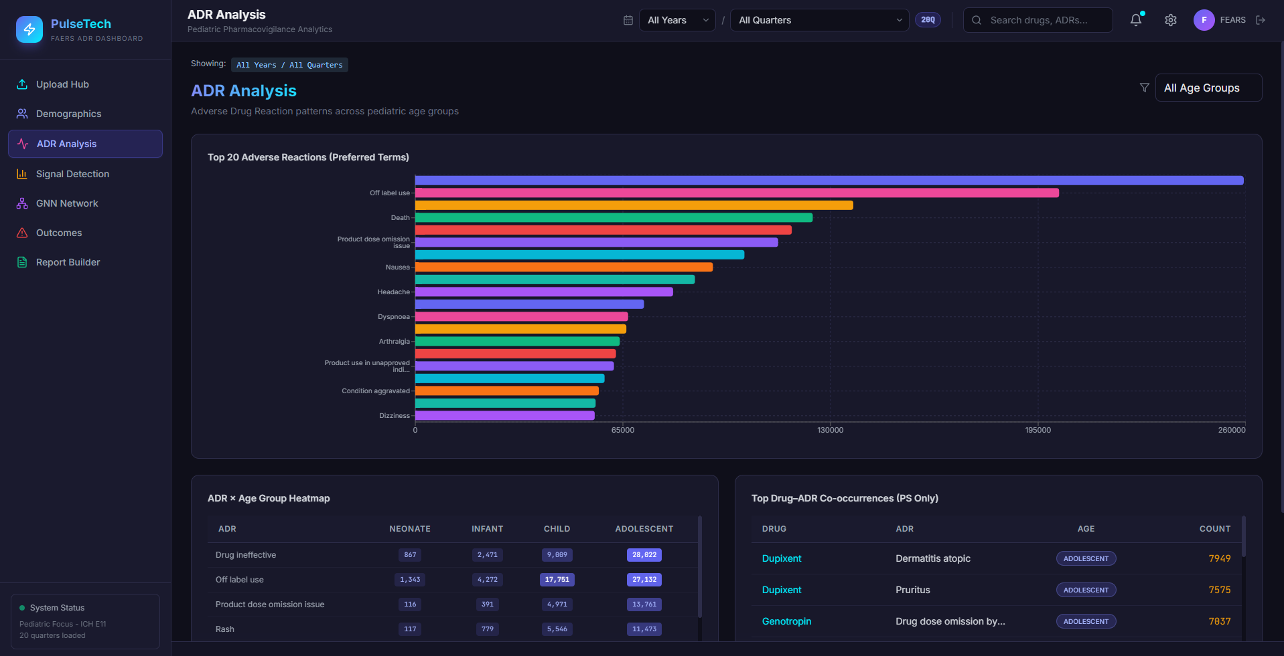
Figure 5: ADR Analysis module showing Top-20 adverse reactions, ADR×Age Group heatmap, and top drug–ADR co-occurrences.

Screenshot: Report Builder
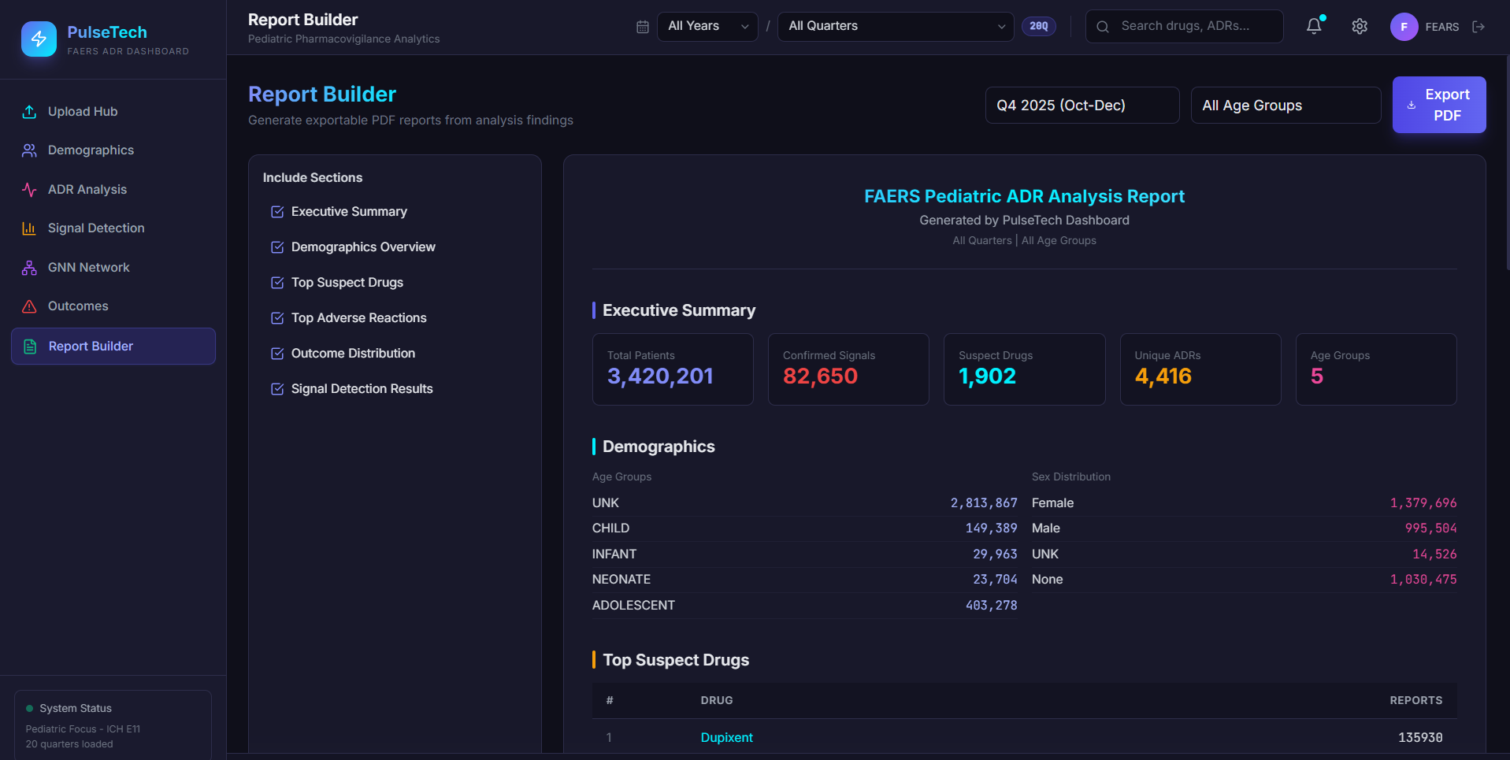
Figure 6: Report Builder module with section-selectable PDF export and live preview of the generated FAERS Pediatric ADR Analysis Report.

5. Current System Status
Component | Status | Completion
13-Step FAERS Ingestion Pipeline | ✅ Fully Operational | 100%
PostgreSQL Database (20 quarters) | ✅ Fully Loaded | 100%
RxNorm Drug Normalisation | ✅ Operational (~94% resolved) | 100%
Upload Hub Module | ✅ Complete | 100%
Demographics Module | ✅ Complete | 100%
ADR Analysis Module | ✅ Complete | 100%
Signal Detection Engine (PRR/ROR/IC/EBGM) | ✅ Complete | 100%
HANConv GNN Model | ✅ Trained & Deployed | 100%
GNN Network View Module | ✅ Complete | 100%
Outcomes & Severity Module | ✅ Complete | 100%
Report Builder (PDF Export) | ✅ Complete | 100%
PLOS ONE Research Paper | ✅ Draft Complete | 100%
Supporting Information (S1–S8) | ✅ Complete | 100%
Formal Usability Study | ⏳ Planned | 0%

6. Key Metrics & Achievements Summary
Metric | Value
Total Patient Records | 3,420,201
FAERS Quarters Loaded | 20 (2021Q1 – 2025Q4)
Unique Suspect Drugs | 1,902
Unique ADR Preferred Terms | 4,416
Confirmed Disproportionality Signals | 82,650
ICH E11(R1) Pediatric Age Bands | 5 (Neonate, Infant, Child, Adolescent, Unknown)
GNN Graph — Drug Nodes (CHILD) | 79
GNN Graph — ADR Nodes (CHILD) | 259
GNN Graph — Edges | 500
Signal Edge Density | 83.8% (419/500)
GNN Architecture | 2-layer HANConv, 64-dim, 4-head attention
GNN Training | 200 epochs, Adam optimiser
RxNorm Resolution Rate | ~94%
Pipeline Runtime | 4–12 minutes per quarter
Dashboard Modules | 7 fully operational
Research Paper | PLOS ONE format, 845 lines, 32 references

7. Dashboard Screenshots & Evidence
The following screenshots were captured from the live PulseTech dashboard running on the development server:
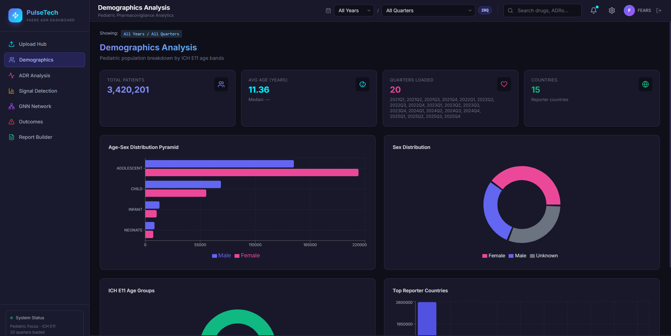
Demographics Module: ICH E11(R1) age band distribution with age–sex pyramid

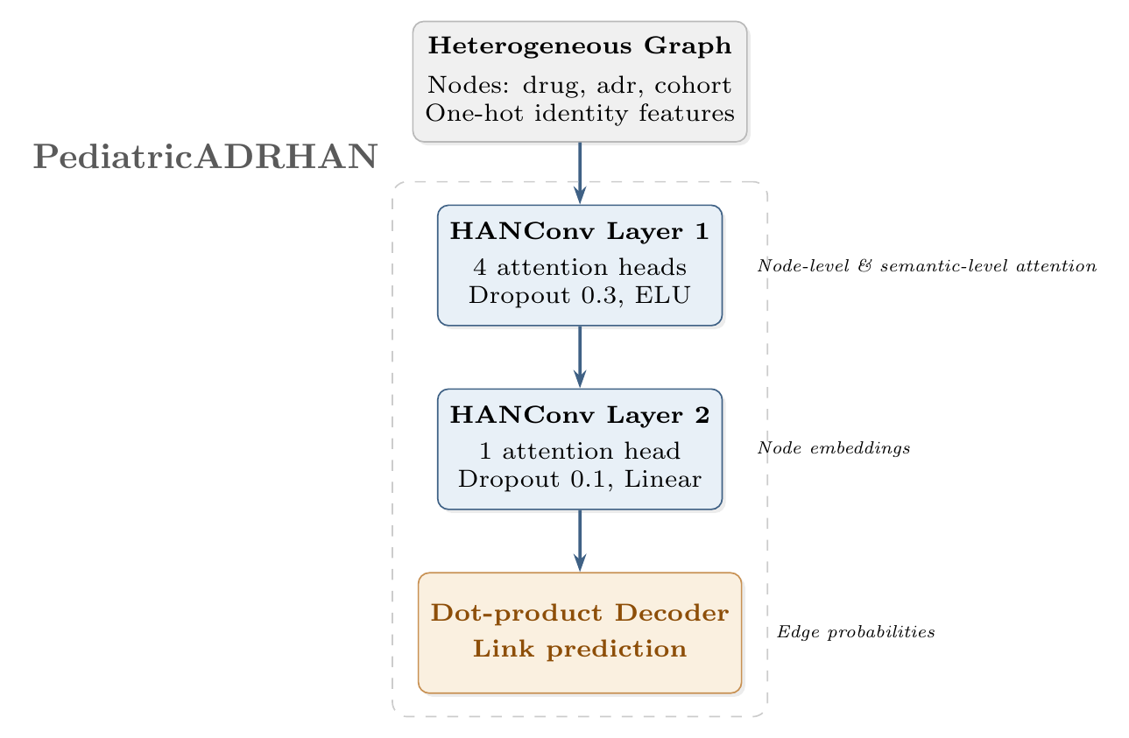
PediatricADRHAN Architecture: 2-layer HANConv with semantic attention

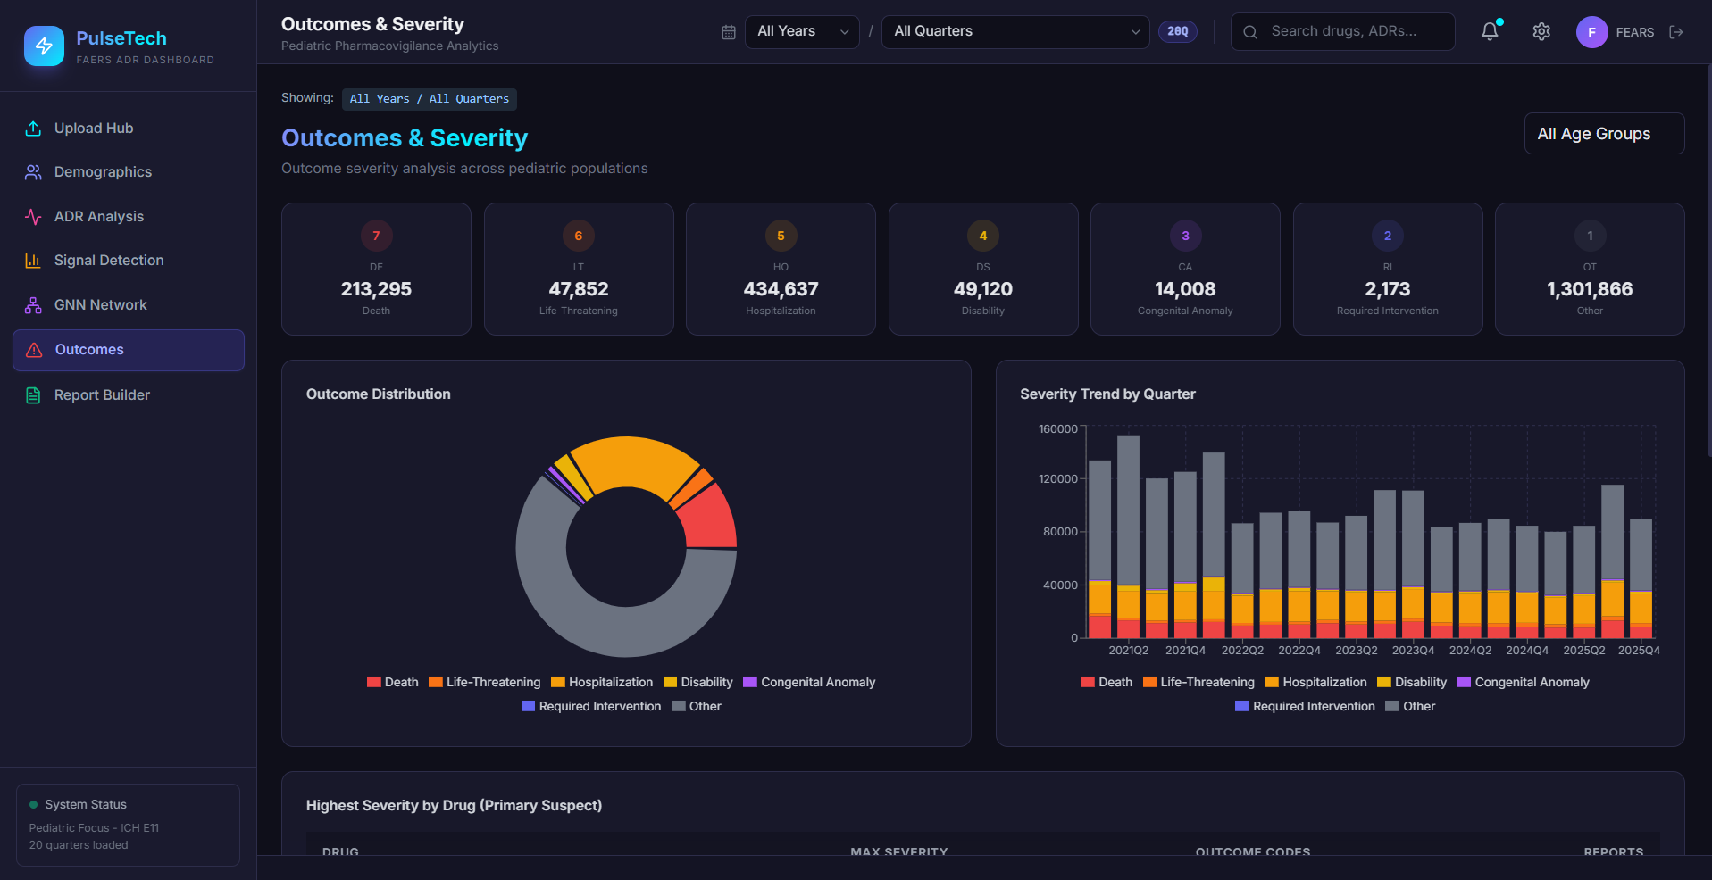
Outcomes Module: Seven-category outcome distribution across the 20-quarter corpus

8. Next Steps & Planned Activities
# | Planned Task | Target
1 | PLOS ONE submission via Editorial Manager | Week 4
2 | Cross-age-band GNN benchmarking (NEONATE, INFANT, ADOLESCENT) | Week 4–5
3 | Formal usability evaluation (SUS / heuristic evaluation) | Week 5–6
4 | VigiBase / EudraVigilance comparison study | Week 6
5 | Final project presentation preparation | Week 7

Prepared by:
Atharv Telkar & Amey Telkar
Date: 05/10/2026

Guide Signature: _________________________________

