Duet Translator
Install on an Android phone

A. On your computer (one time)
1 Unzip Duet_Translator_Android.zip
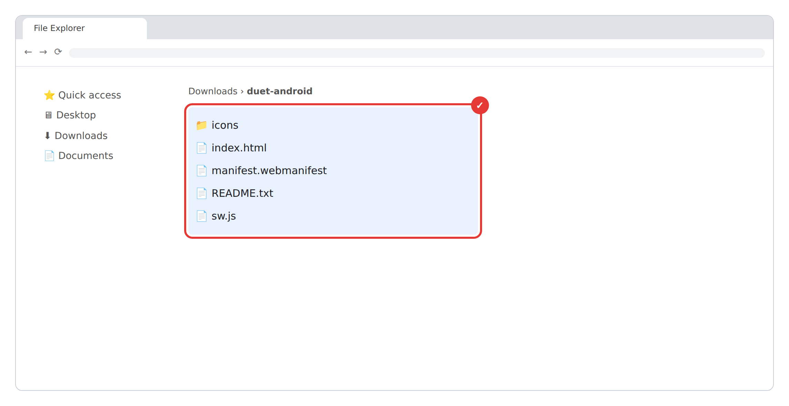
2 Go to github.com → Sign up (free)
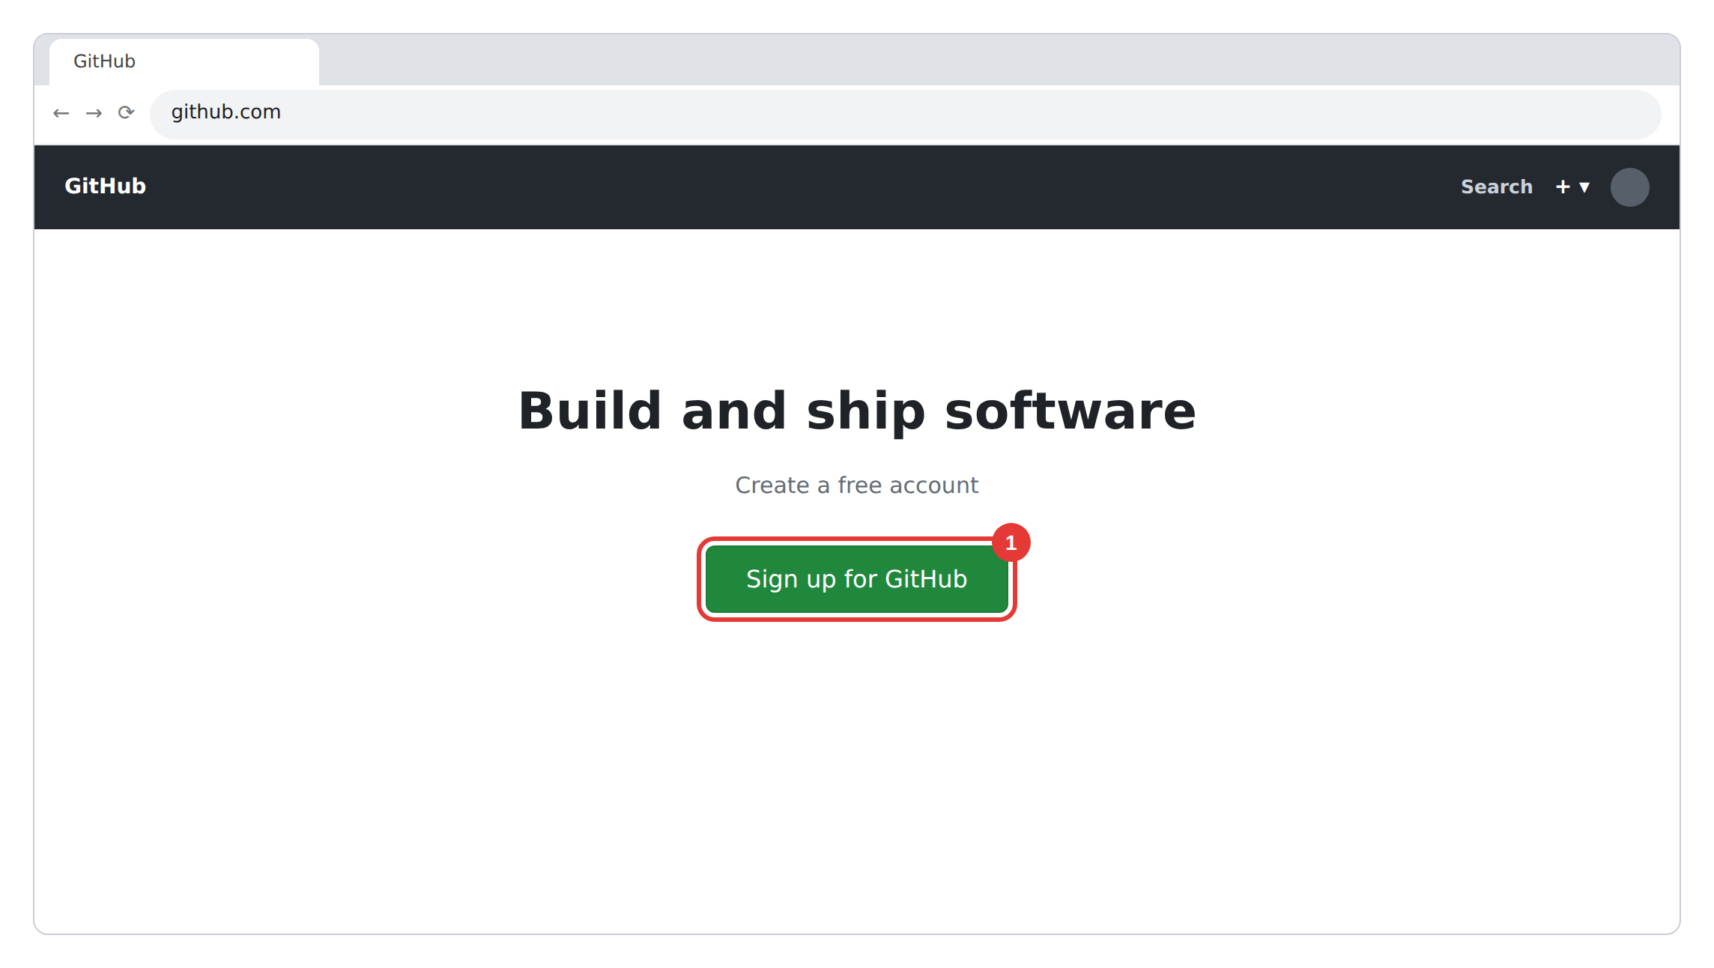

3 + → New repository → name it duet → Public → Create
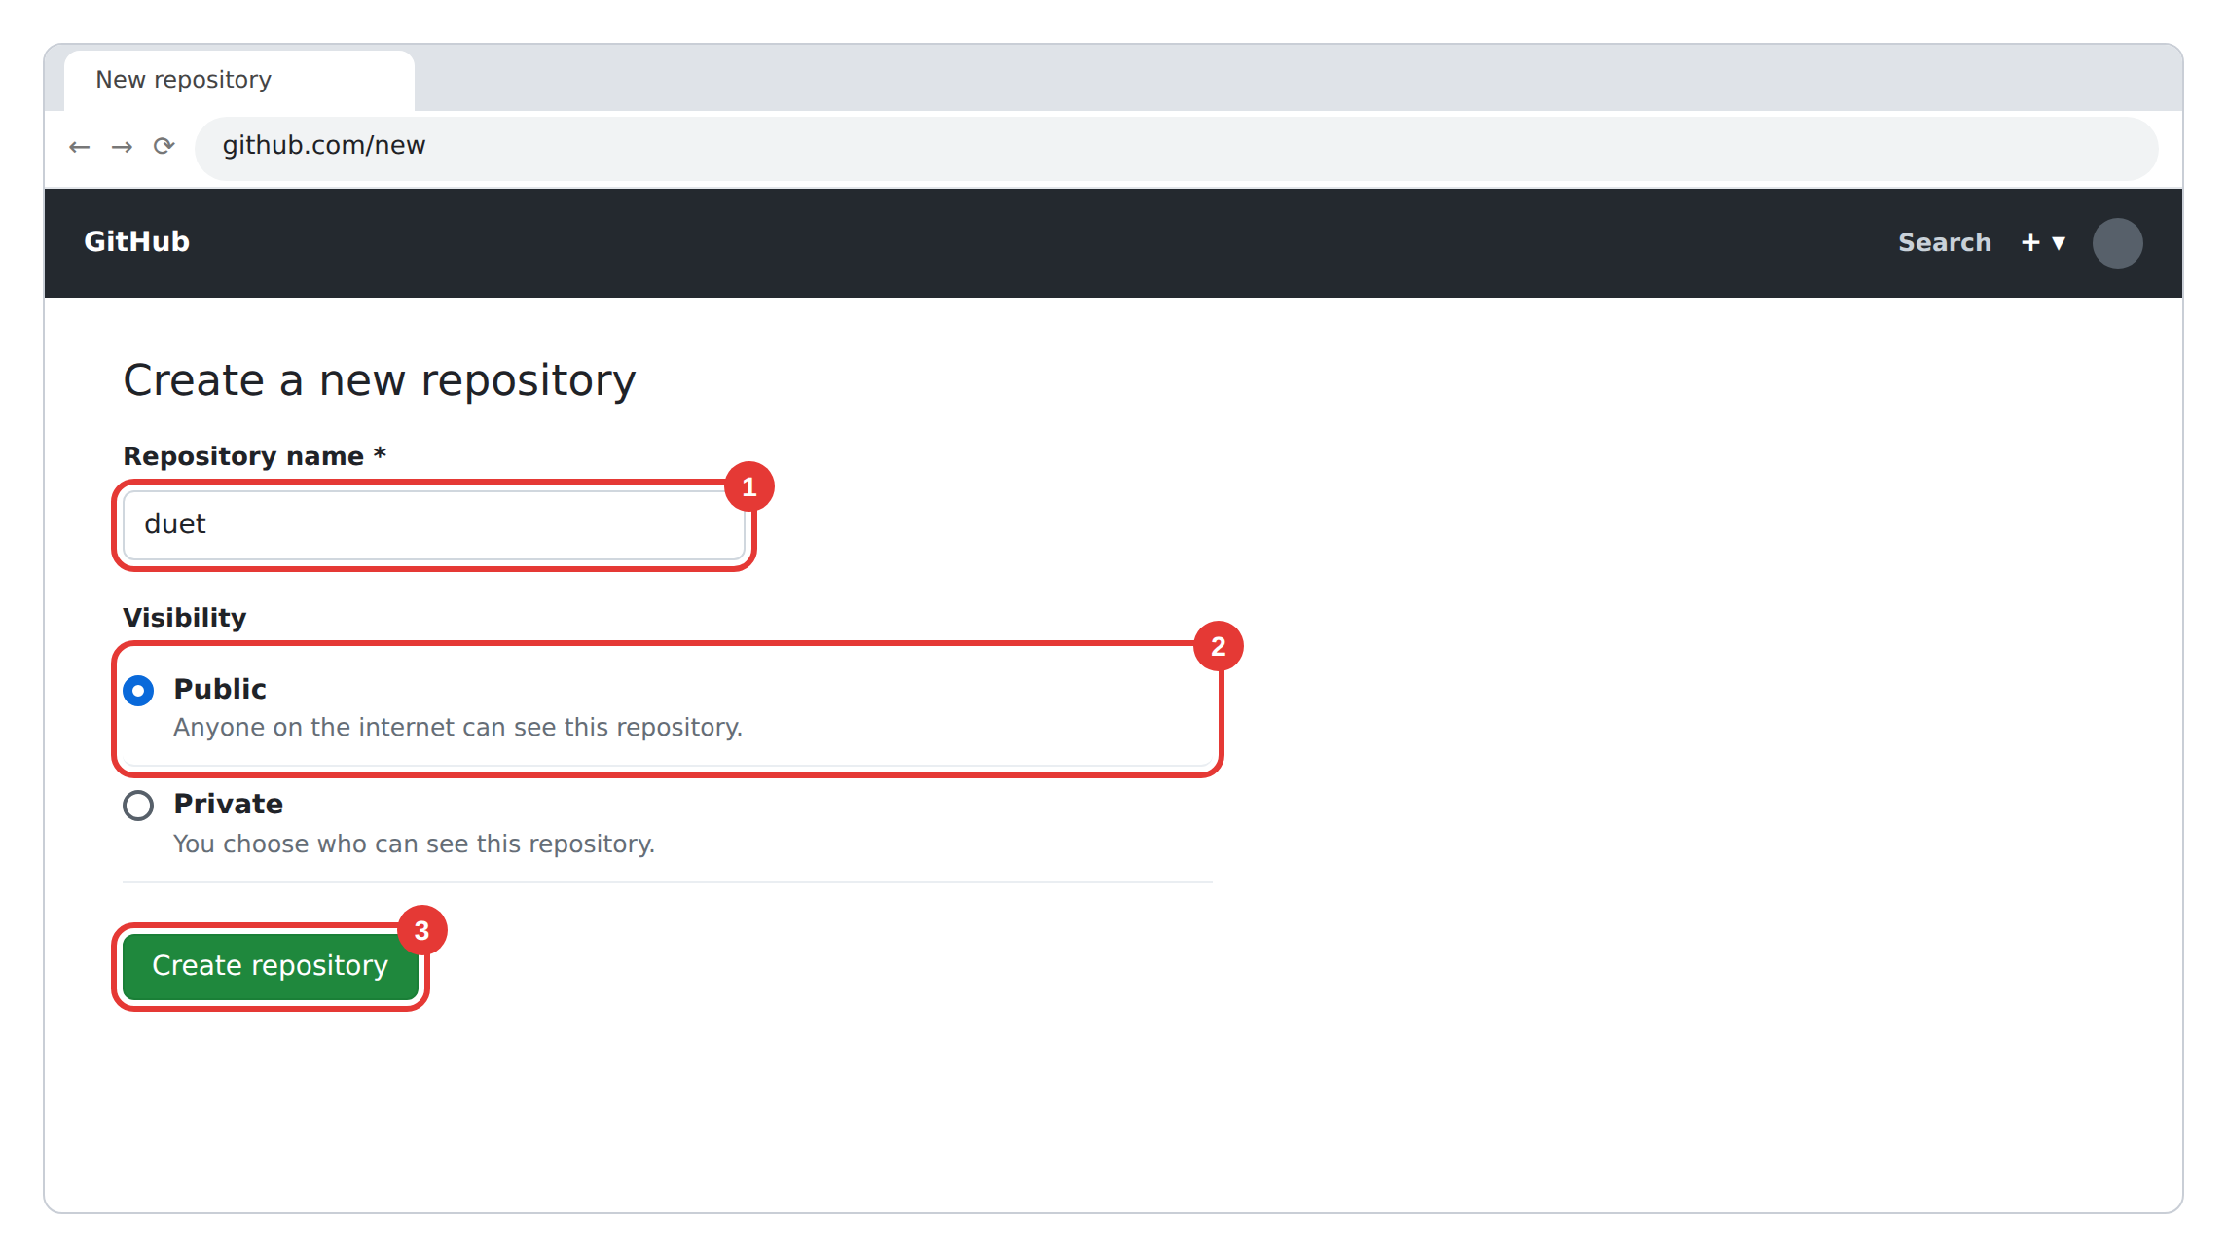
4 Click “uploading an existing file”
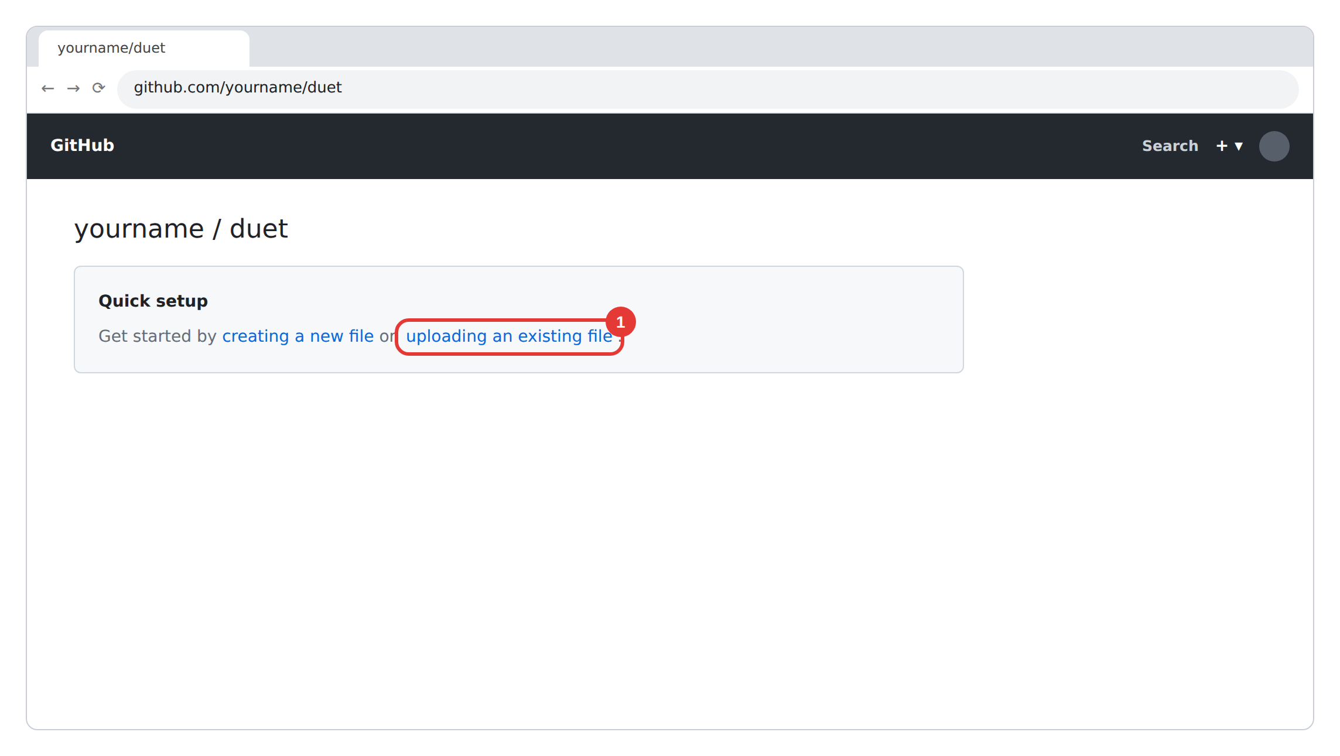

5 Drag in all files + icons folder → Commit changes
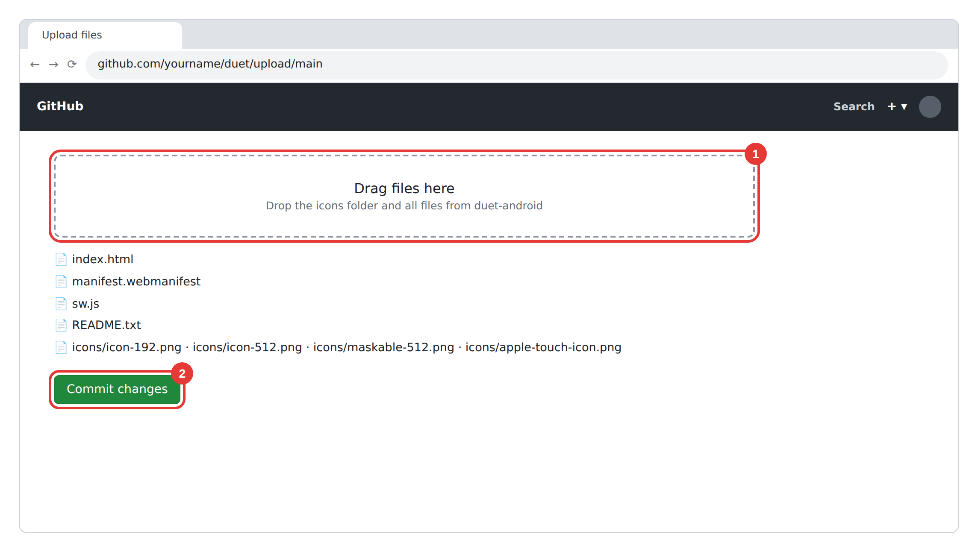
6 Settings → Pages → main / (root) → Save
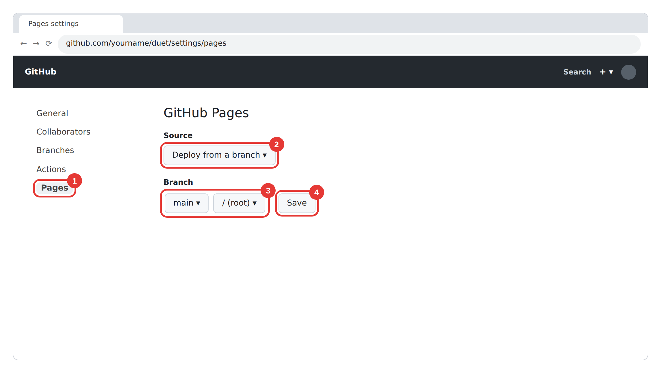

7 Wait 1–2 min → copy your link, send it to your phone
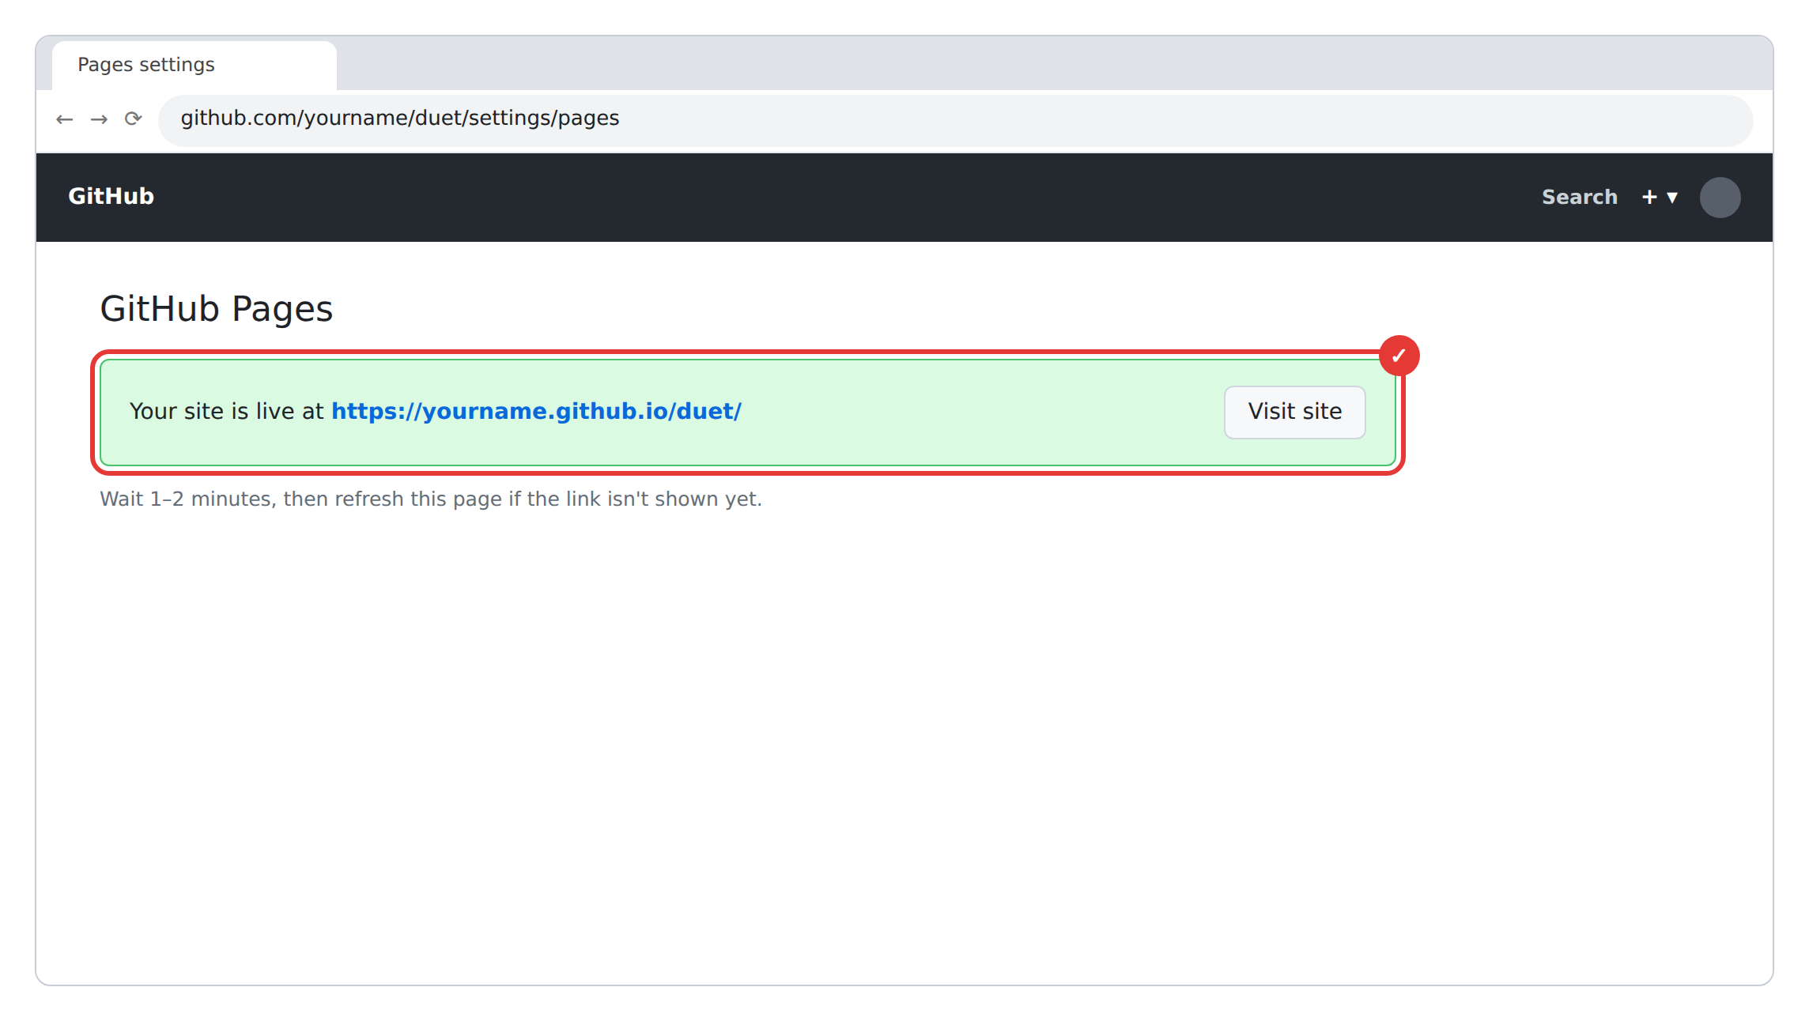

B. On your Android phone
8 Open the link in Chrome → Install app  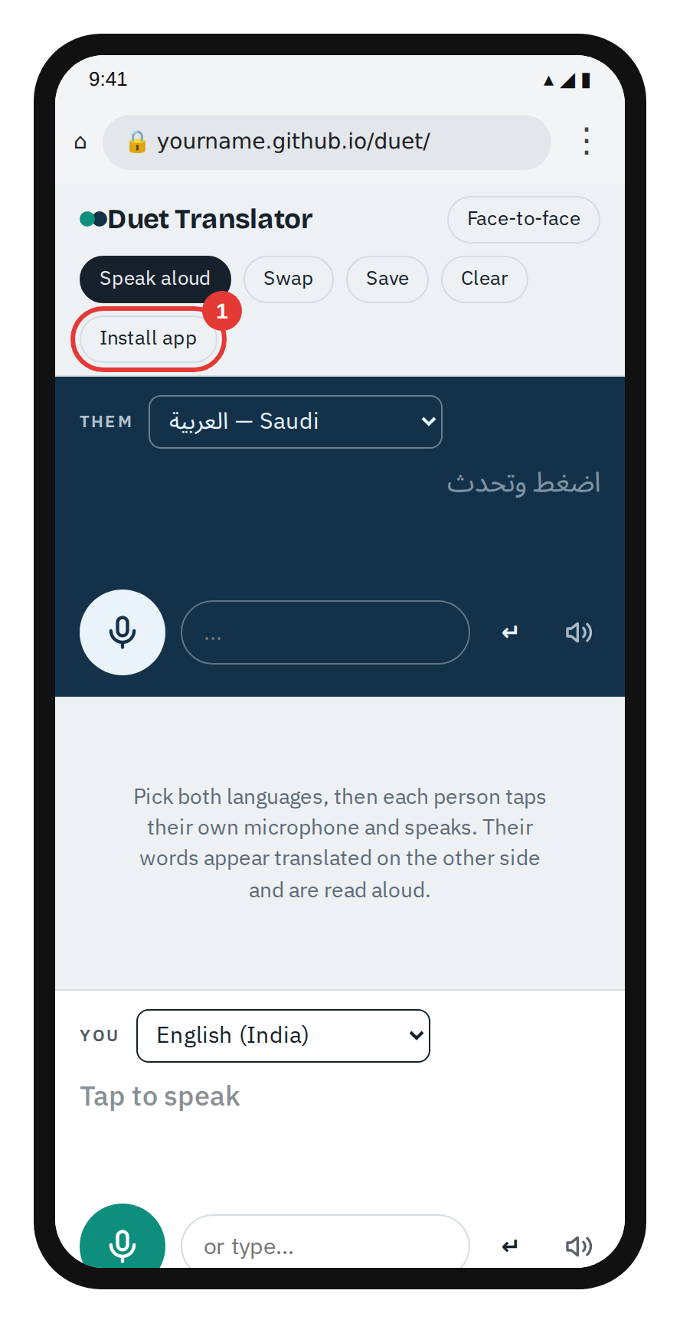 | 9 No button? ⋮ → Add to Home screen  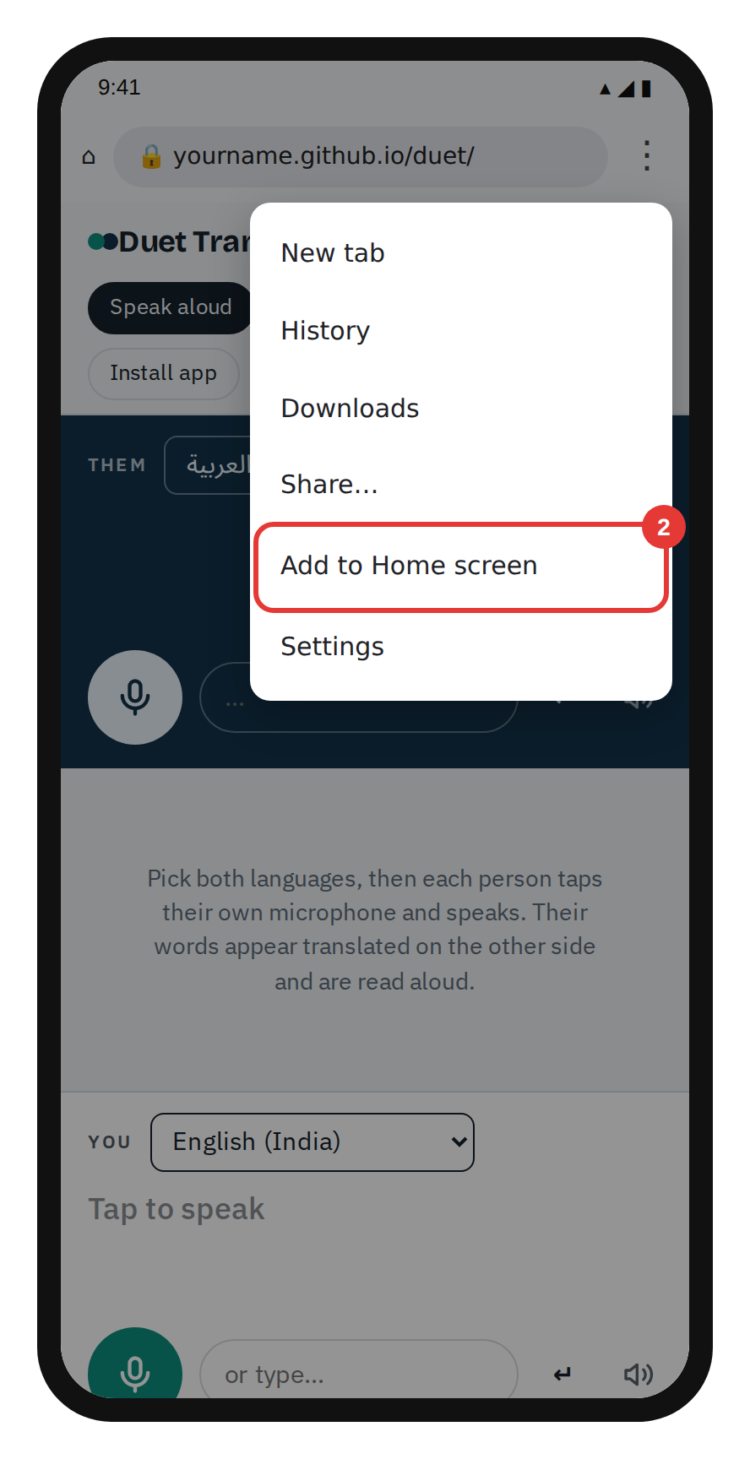

10 Tap Install  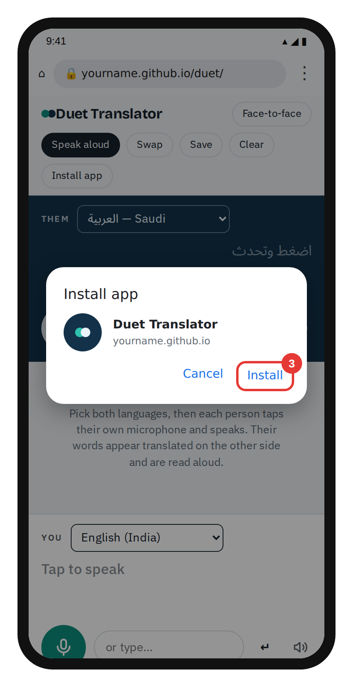 | 11 Open Duet from home screen  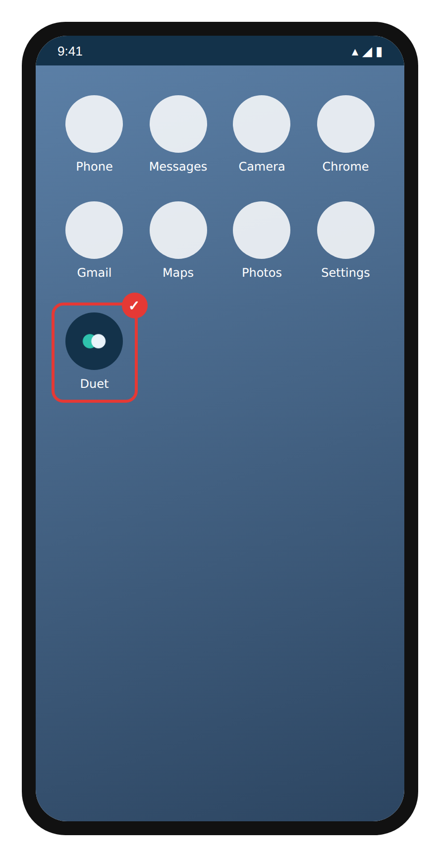

12 Tap a mic → Allow  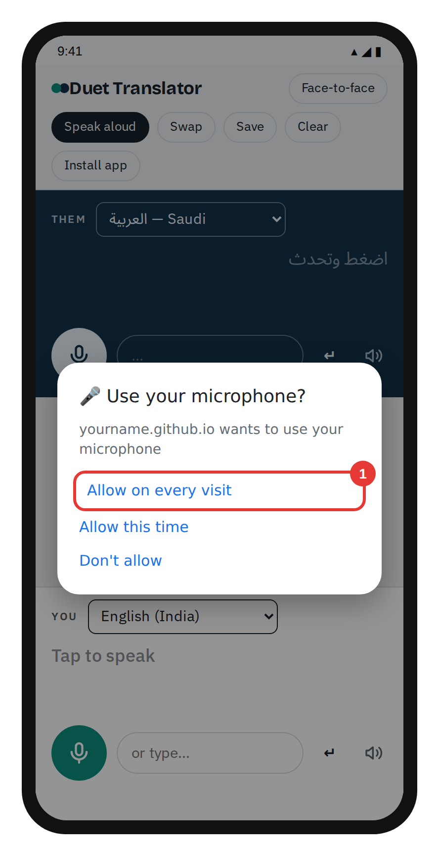 | 13 Face-to-face → each taps own mic  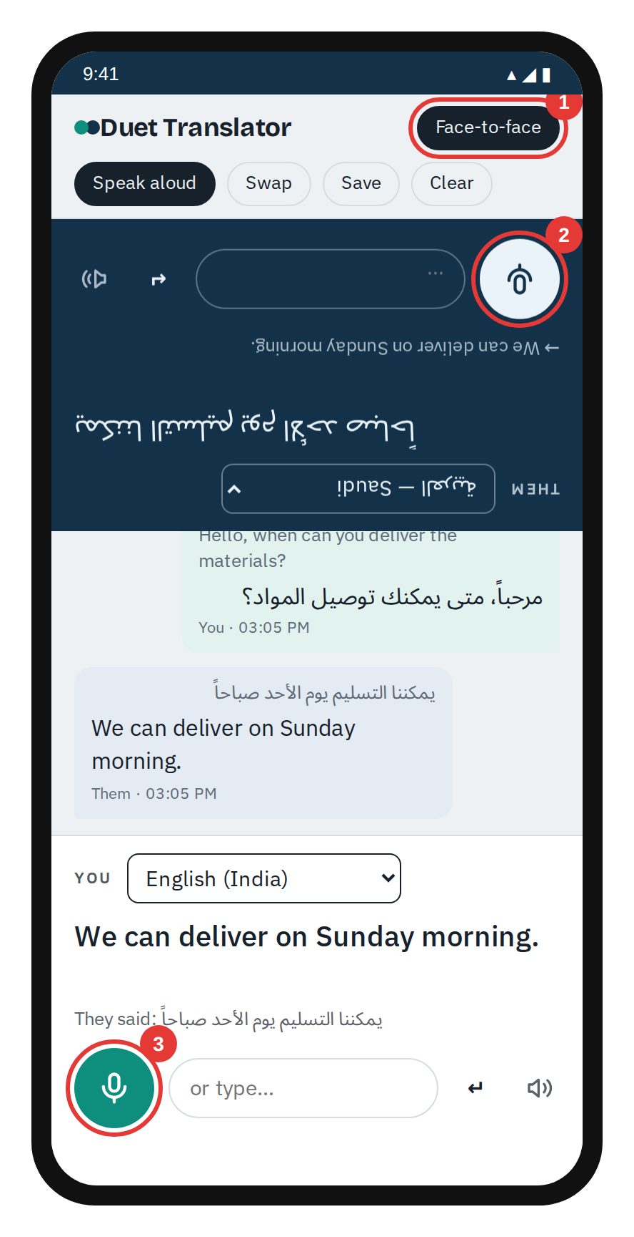
Needs internet · Open from the https link, not from the Downloads folder · Screens are simplified; yours may look slightly different

