**How to install expo in windows**

**Follow this link for references:** [**https://docs.expo.dev/workflow/expo-cli/**](https://docs.expo.dev/workflow/expo-cli/)

1. **Open terminal in window (win+R)**
2. **Type cmd**

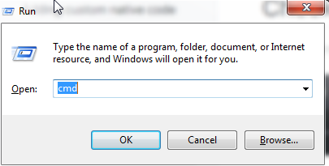

1. **Type the commands in terminal window**
2. **And follow the documentation:** [**https://docs.expo.dev/workflow/expo-cli/**](https://docs.expo.dev/workflow/expo-cli/)

* 