**WHAT IS README.md?**

**Purpose of readme:**

**For example: type a code in vs.and push a code in github.**

**Readme is used to explain the code like what was the purpose of the code.**

**Like user wants to give the integer.are integer are automatically generate in the code**

**Read.md means proper explaination in the given issue**

**How to open readme.md:**

**1.open vs code and search in right corner.and type README.md(type README in (CAPTIAL LETTER) and .md is (small letter) eg:README.md**

**2.And preview option is there in left corner up**

**You can view how to generate code in preview view what you type in readme.md file**

**3.#symbol used for heading:**

**## is used for sub heading:**

**### sub heading:**

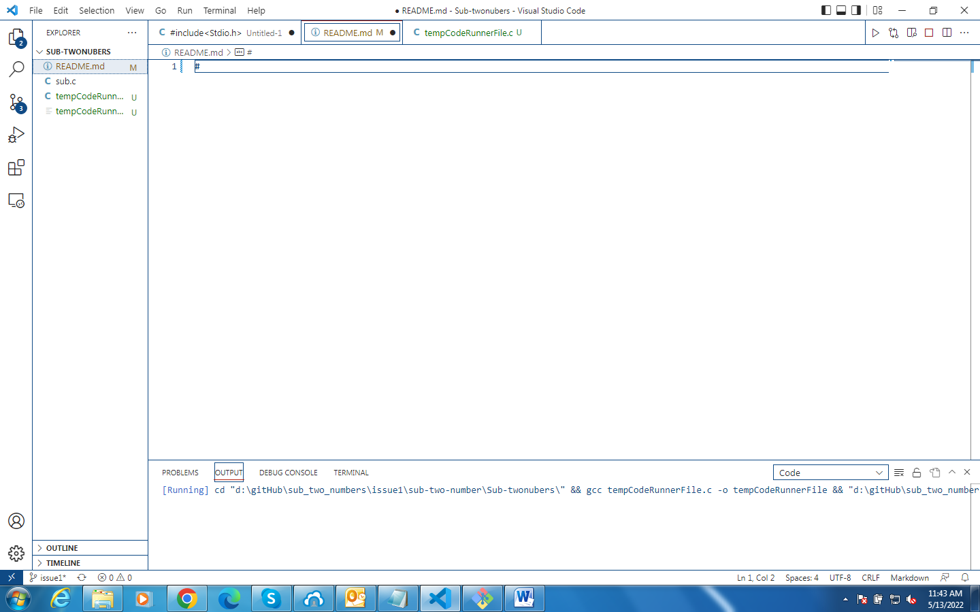

**README.MD COMMANDS:**

**REFERENCES LINK:** [**https://www.geeksforgeeks.org/what-is-readme-md-file/**](https://www.geeksforgeeks.org/what-is-readme-md-file/)

**How to add heading in README.md:-**

