**QUOTIENT AND REMINDER USING MCCI CODING:**

/*

Module:

Function:

        Computing quotient and reminder of a given number.

Copyright notice:

        This file copyright (C) 2022 by

        MCCI Corporation

        3520 Krums Corners Road

        Ithaca, NY 14850

        An unpublished work. All rights reserved.

        This file is proprietary information, and may not be disclosed or

        copied without the prior permission of MCCI Corporation.

Author:

        Athisankar, MCCI Corporation   May 2022

*/

#include <stdio.h>

/****************************************************************************\

|

|   Code.

|

\****************************************************************************/

int main()

    {

    printf("\n");

    printf("--------------------------------------------------------------------------------\n"); // for highlight

    printf("This is QUOTIENT and REMINDER v1.0.0\n");

    printf("--------------------------------------------------------------------------------\n");

    printf("\n");

    printf("It is used to find the quot and the rem of two numbers.\n\n");

    int div, divisor, quot, rem;

   printf("enter div");

    scanf("%d",&div);

    printf("enter divisor");

    scanf("%d",&divisor);

    quot = div/divisor;

    rem = div % divisor;

  printf("\n\n-----------------------------------------\n");//for output we use this line

    printf("quot=%d \n", quot);

    printf("rem=%d",rem);

    printf("\n\nPress any key to close the program!...\n");

    return 0;

    }

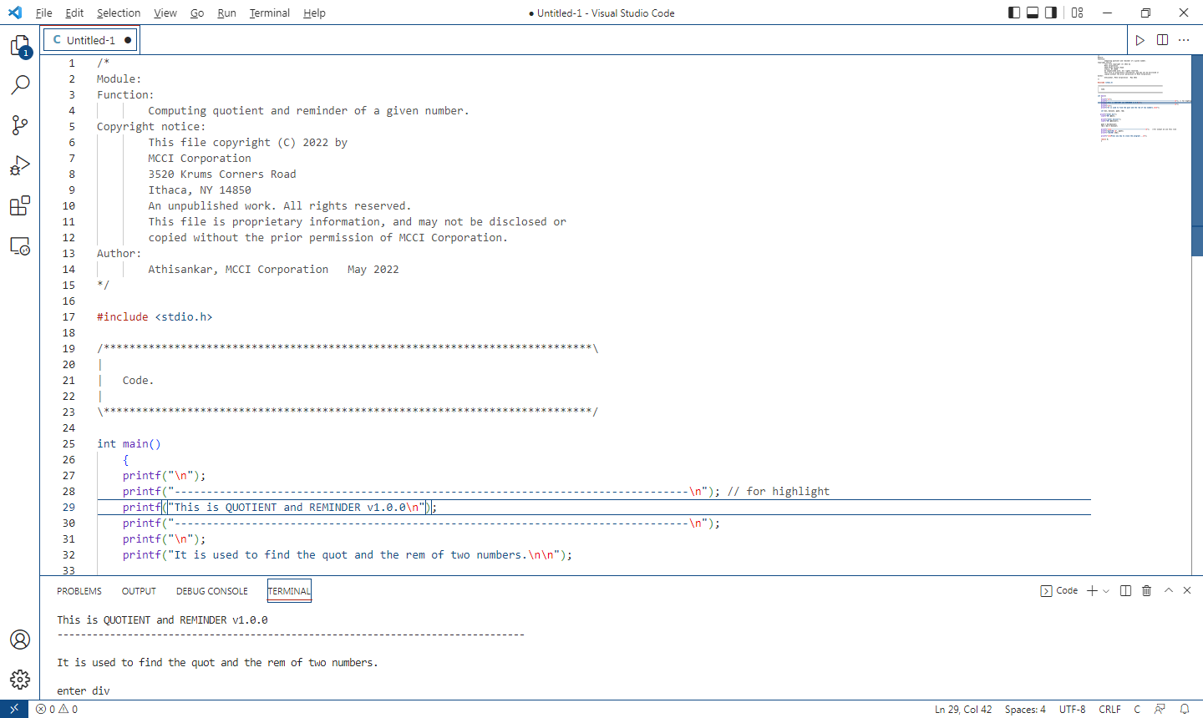

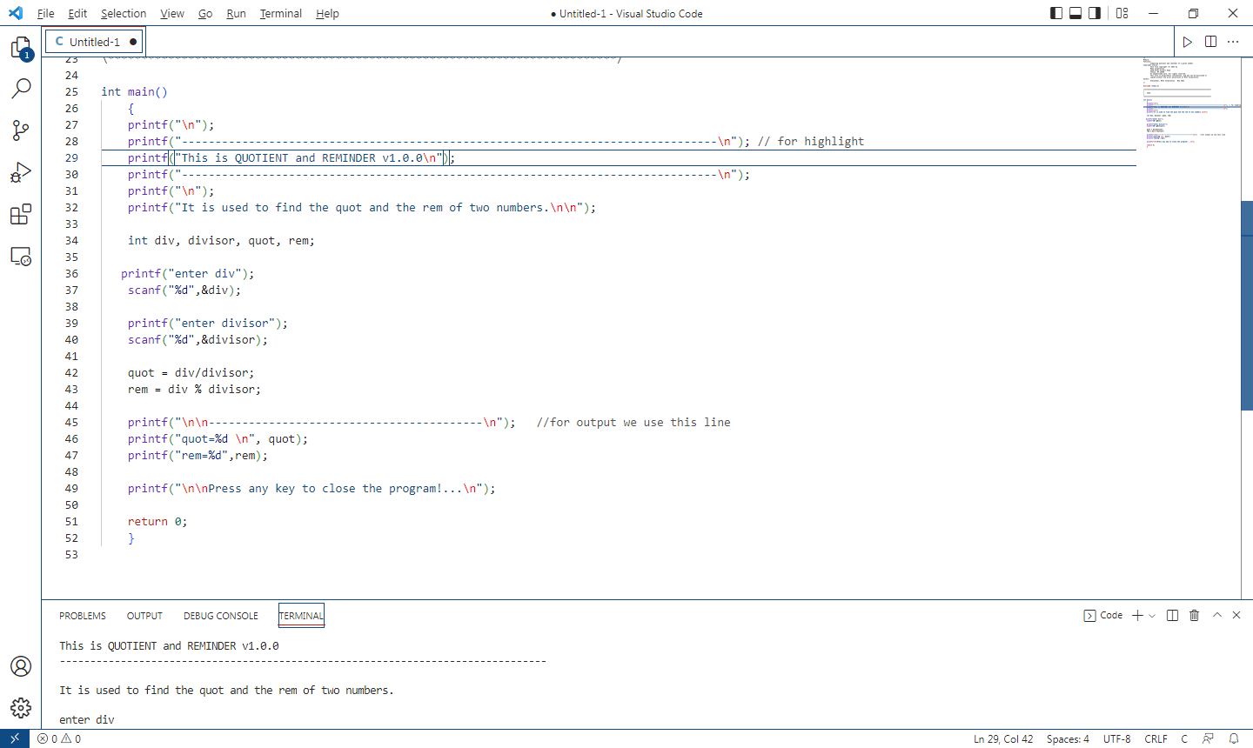

**OUTPUT:**

