**FOR LEARNING PURPOSE I REFER THIS LINK:**

<https://plantuml.com/activity-diagram-beta>

**If you want to run the plantum in vs code you want to add the extension of graphviz.**

**Issues face in Plantum:**

**First I didn’t install graphviz Extension in VS Code; Then I install the extension of Graphviz.**

**And do the following steps in Graphviz:**

1. It does not work on my config.

2. Select the graphviz extension that you have installed and open graphviz setting.

3. And change those settings in graphviz

**CHANGES IN GRAPHYIZ SETTING: in environment path:**

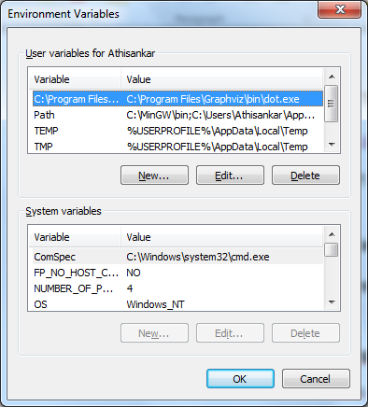

**🡪click new**

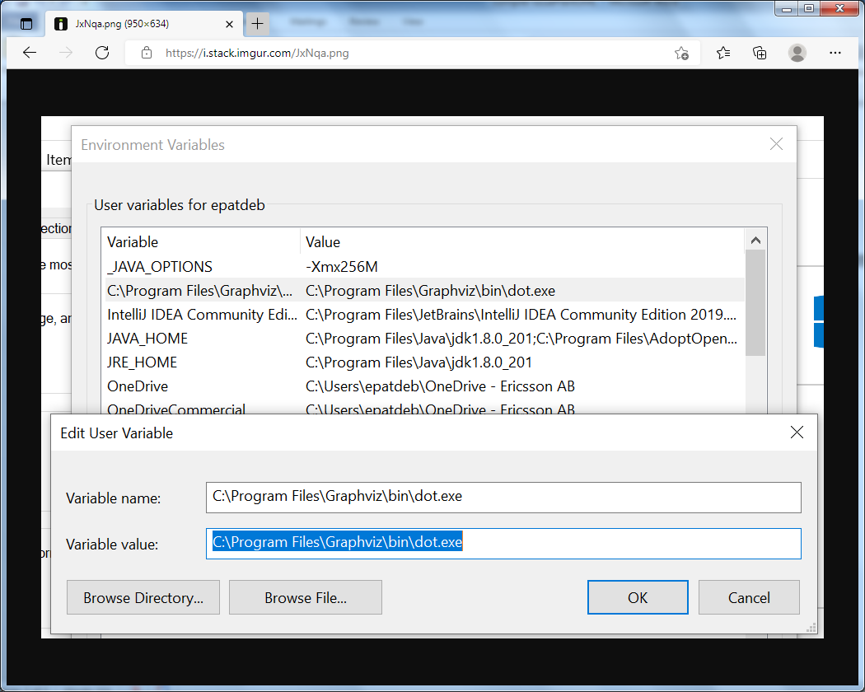

**And type this sources code in variable name and variable value:**

**I REFER THIS LINK FOR MY ISSUSE:**

<https://stackoverflow.com/questions/53856294/plantuml-extension-for-visual-studio-code-on-windows-only-working-with-sequence>