1. **First copy the URL in Github….**

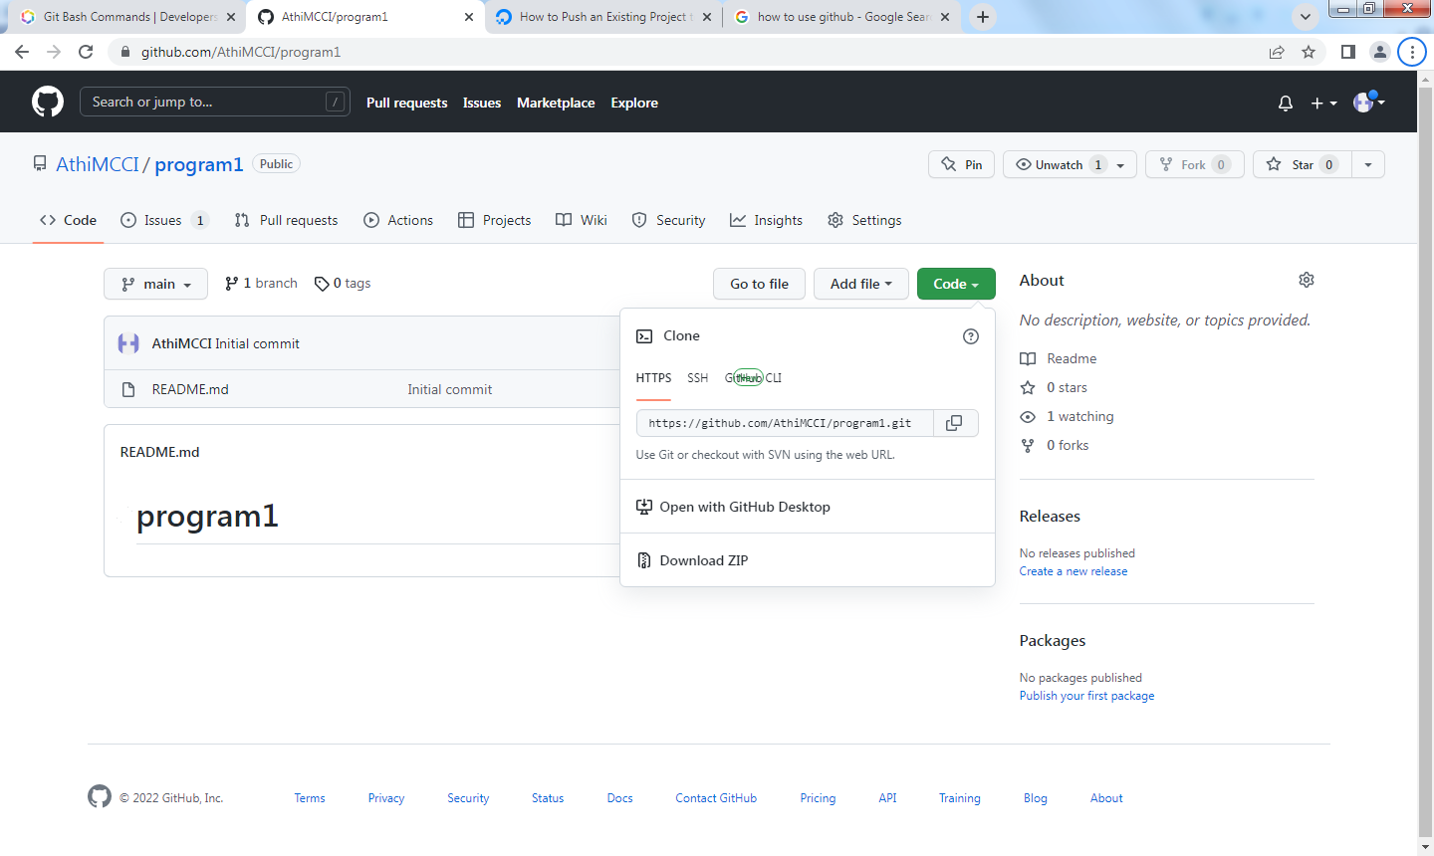

**2. Then Go TO FILE MANAGER folder and right click and open gitbash ..**

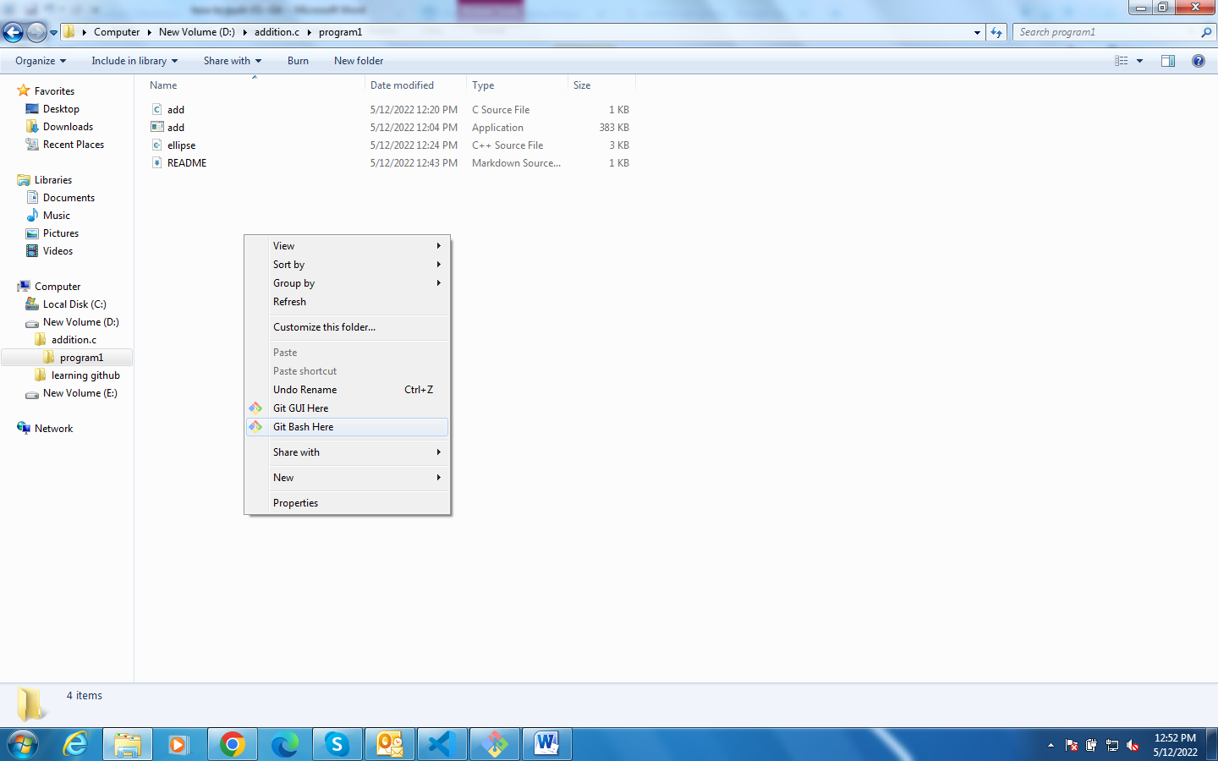

**3. AND TYPE A COMMAND ( GIT CLONE) AND PASTE THE URL LINK**

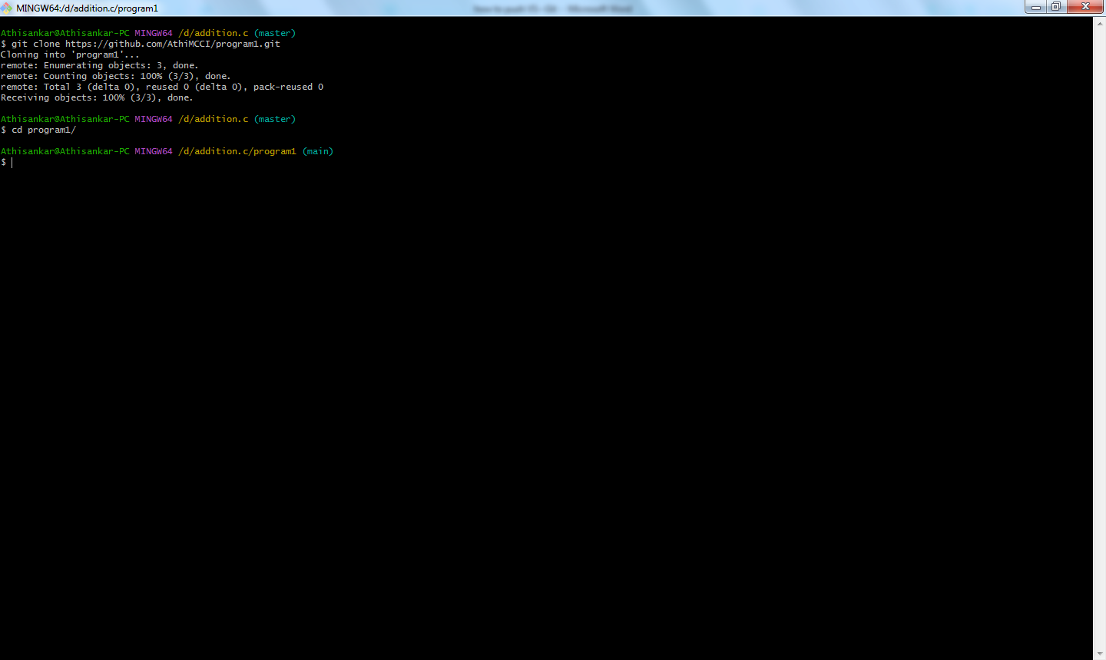

**COMMANDS TO FOLLOW in GITBASH:**

