**TASK 1: (NORMAL PROGRAM)**

**Hi Athisankar:**

**Write a C Program to Compute Quotient and Remainder.**

**Get Dividend and Divisor as command line input from user.**

**Display Reminder and Quotient on computing.**

**Make sure to follow the process:**

**1. Create Github repository for this task.**

**2. Create a flow chart**

**3. Share with supervisors**

**4. Start coding and get result**

**Let us know if you have any doubts.**

**Best Regards,**

**Dhinesh**

**README.MD FILE:**

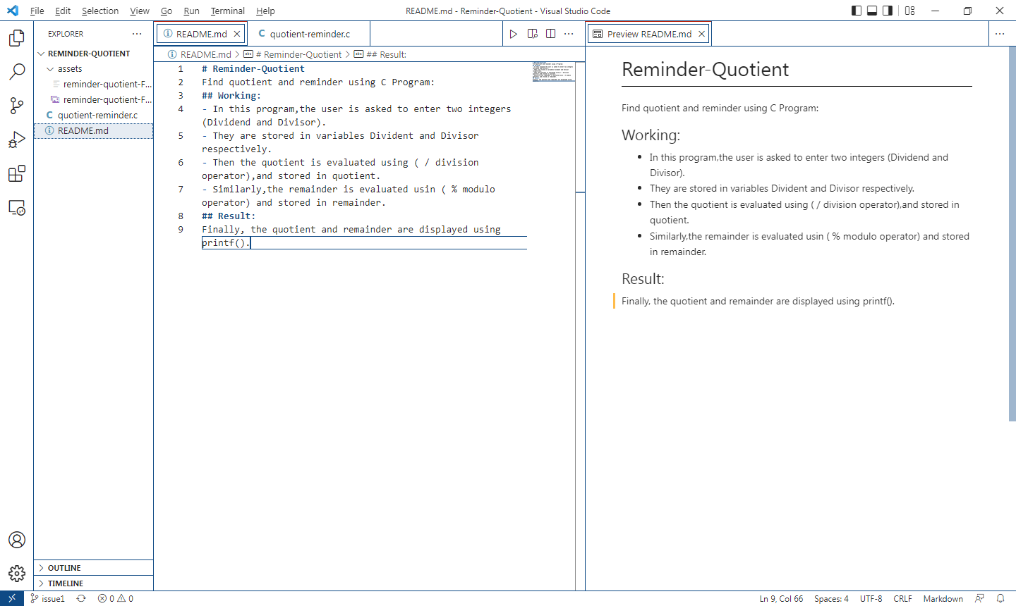

**PROGRAM:**

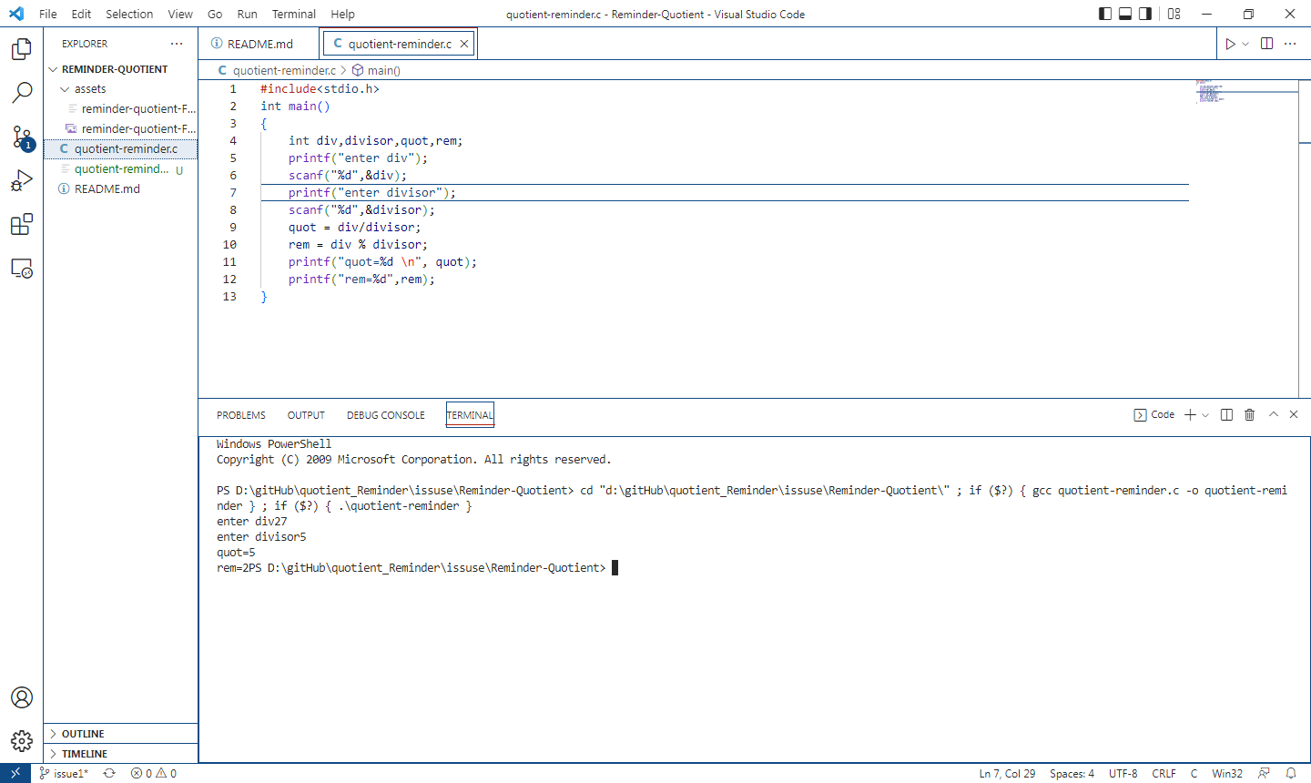

**USING PLANTUML FOR CODING:**

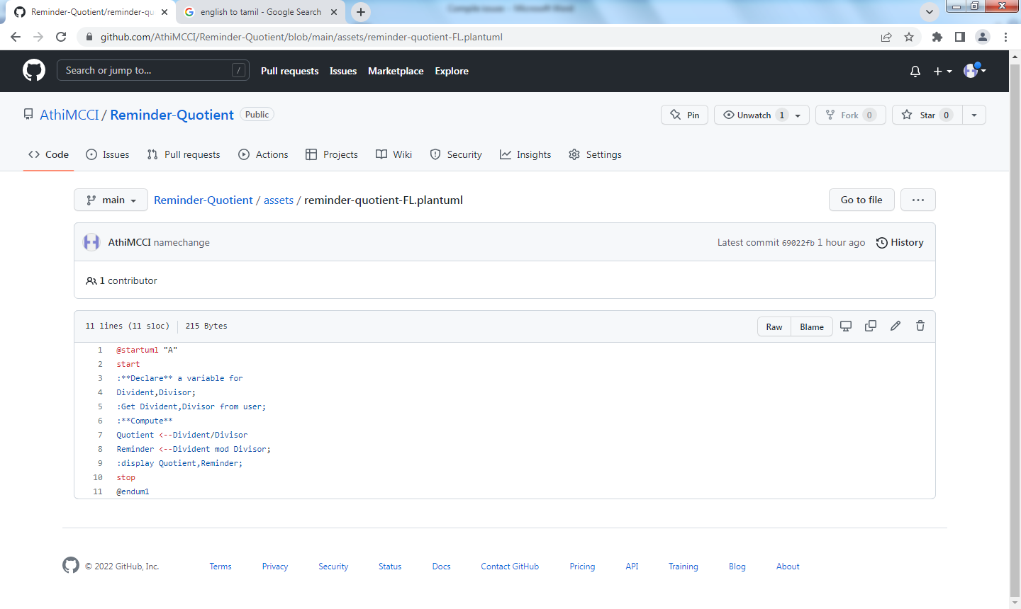

**USING PLANTML FOR FLOW CHAT:**

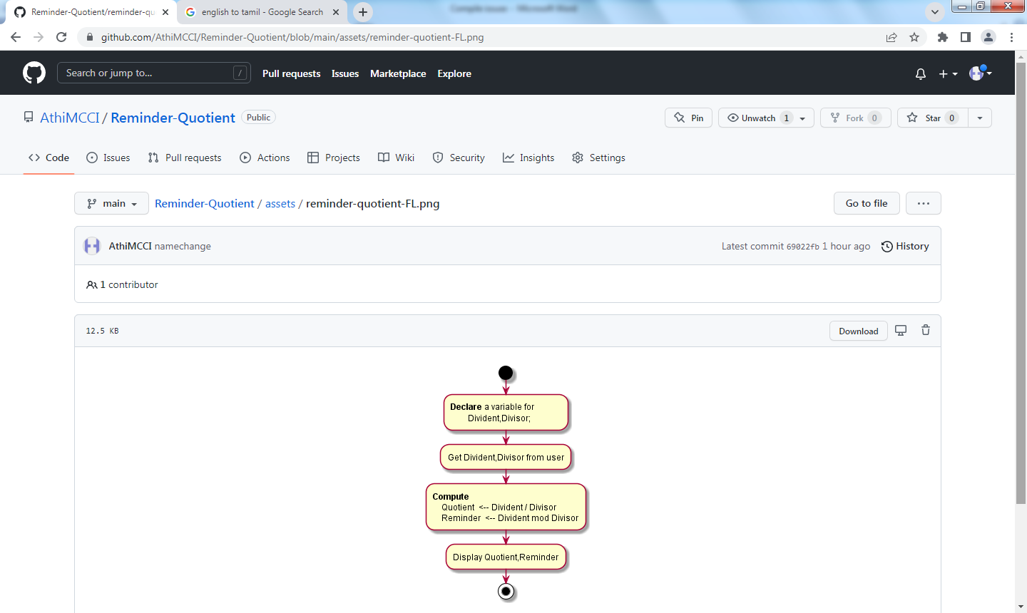

**RESULT:**

**FINISH-------------🡪PULL REQUEST LINK: (** [**https://github.com/AthiMCCI/Reminder-Quotient/pull/2**](https://github.com/AthiMCCI/Reminder-Quotient/pull/2) **)**

**USING MCCI STANDARD COADING FOR THIS PROGRAM:**

