ASSIGNMENT 2 | UPDATED PROJECT REPORT

ORION TRIAGE
Machine Learning for Cybersecurity Incident Classification and Triage
Submitted by: Mohamed Athif
Programme: B.Tech Computer Science and Engineering
Application model: CatBoost Candidate G with Random Forest fallback
Updated: 16 October 2026
GitHub repository: github.com/AthifSec/ORION-TRIAGE

Abstract
ORION TRIAGE is a human-supervised machine-learning application for cybersecurity incident triage. It uses a Microsoft GUIDE-derived dataset to classify incidents as Benign Positive, False Positive, or True Positive. The application supports CatBoost Candidate G, a row-level model that scores up to four source rows per incident and averages their class probabilities into one incident-level prediction. On a held-out set of 5,918 incidents, Candidate G achieved 81.02% accuracy, 77.99% macro F1, and 92.89% macro ROC-AUC under stable per-incident sampling. The former Random Forest pipeline remains available as a fallback. The Streamlit interface presents predictions, confidence values, routing suggestions, saved metrics, and analyst feedback logging. It does not automatically contain or close incidents.

1. Problem Statement
Security Operations Centre (SOC) analysts review large volumes of alerts and incident records. Each incident may be a genuine threat, a false alarm, or benign activity. Machine learning can help prioritize this work by proposing a class and confidence estimate, but these outputs must remain suggestions because incorrect triage can delay investigation or waste analyst time.

2. Objectives
- Prepare a GUIDE-derived dataset and group source rows into organization-scoped incidents.
- Train and evaluate incident-classification models using held-out incidents.
- Integrate CatBoost Candidate G into a Streamlit interface while retaining a fallback model.
- Present metrics, class probabilities, review routing, and an analyst-feedback audit workflow.

3. Dataset Description and Contents
The project uses a prepared sample derived from Microsoft GUIDE (Guided Response), a security incident dataset containing source evidence and the analyst-assigned IncidentGrade target. The saved split contains 29,588 incidents from 391,413 source rows: 23,670 training incidents and 5,918 held-out test incidents. Candidate G training used up to four evidence rows per training incident (81,528 prepared rows); evaluation reports one result per incident.
Target label | Interpretation in this project
BenignPositive | Positive finding assessed as benign or expected activity.
FalsePositive | Finding assessed as a false alarm.
TruePositive | Finding assessed as a genuine positive security finding.
Dataset contents include detector and alert information, MITRE techniques, evidence and entity types, account/device identifiers, network/email fields, registry and application attributes, file/resource information, operating-system metadata, antispam and suspicion indicators, and geographic fields. Incident IDs are used to group records, not as predictors; IncidentGrade is the target.

4. Preprocessing and Feature Design
- Composite incident key: Build IncidentKey from OrgId and IncidentId so IDs reused by different organizations are not merged.
- Label consistency: Check that records grouped into one incident have one IncidentGrade; conflicting labels must be resolved rather than silently collapsed.
- Leakage control: Keep IncidentGrade as the target. Incident identifiers and post-decision fields are excluded from predictors.
- Three engineered numerical features: AegisSourceRowCount counts all source rows, AegisUniqueAlertCount counts distinct AlertId values, and AegisUniqueDetectorCount counts distinct DetectorId values. Counts use all rows for the incident.
- 32 categorical evidence features: Features cover alert and detector identifiers, MITRE techniques, entity/evidence types, account/device/network/email fields, registry/application/file/resource attributes, operating system, antispam, suspicion, and geography.
- Missing values and types: Convert missing categorical values to the literal token __MISSING__ and categorical values to strings, matching training preprocessing.
Candidate G uses 35 features in this order: three engineered numeric counts followed by 32 categorical features.

5. Model Development

5.1 CatBoost Candidate G
Candidate G is a multi-class CatBoost model trained with 500 boosting iterations, tree depth 7, learning rate 0.05, L2 leaf regularization 8, and random seed 73 using CatBoost 1.2.10. Its saved model contains 500 trees and predicts BenignPositive, FalsePositive, or TruePositive.
Parameter | Saved value
Boosting iterations | 500
Tree depth | 7
Learning rate | 0.05
L2 leaf regularization | 8
Random seed | 73
Predictor count | 35
Saved trees | 500
Training incidents | 23,670

5.2 Incident-Level Inference
- Calculate the three incident counts from the complete input queue.
- Select up to four source rows per incident using a deterministic seed derived from that incident key. This prevents unrelated incidents from changing the selected rows for an existing incident.
- Normalize categorical values and missingness to match training.
- Predict probabilities for the selected rows and average them by incident. The largest averaged probability determines the suggested class and its confidence.

5.3 Fallback Model
The original Random Forest pipeline remains available if Candidate G is missing or cannot be loaded. Its saved 68.45% accuracy came from a different 2,000-incident test partition, so it is historical context rather than a direct head-to-head comparison with Candidate G.

6. Evaluation Design and Overall Results
The reserved holdout contains 5,918 incidents excluded from model training. The current app policy uses stable per-incident row sampling and aggregates probabilities to one prediction per incident. The saved results below were reproduced using this policy. The original global-shuffle evaluation also reproduced exactly, but stable-policy metrics are associated with the current deployment code.
Metric | Stable-policy result
Accuracy | 81.02%
Macro F1 | 77.99%
Macro precision | 82.45%
Macro recall / balanced accuracy | 75.77%
Macro ROC-AUC (OvR) | 92.89%
Held-out incidents | 5,918
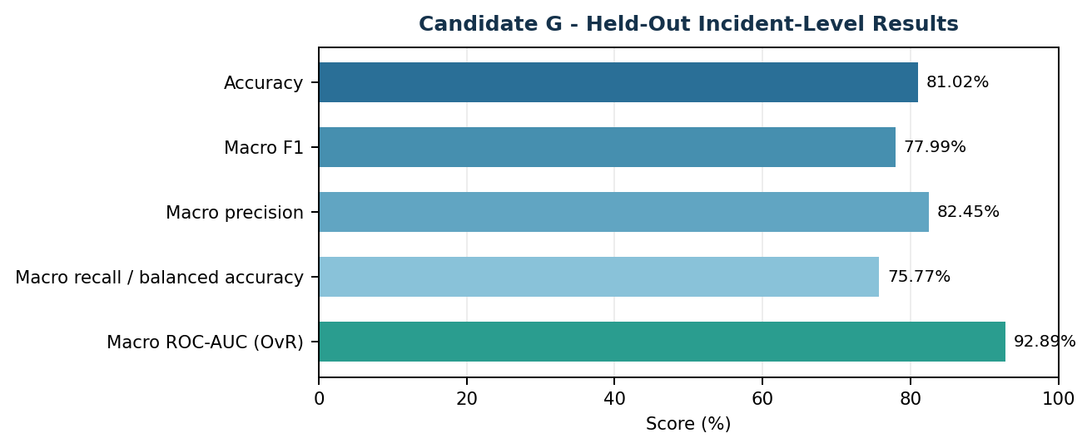
Figure 1. Overall Candidate G metrics under stable per-incident sampling.

Interpretation
Accuracy was 81.02%, while macro F1 was 77.99%, indicating useful overall classification performance across the three categories. Macro precision was 82.45%, macro recall was 75.77%, and macro ROC-AUC (one-vs-rest) was 92.89%. ROC-AUC describes how well scores rank classes across thresholds; it does not mean 92.89% of the final predictions are correct.
These are saved held-out metrics, not live accuracy measurements for the current 2,000-incident demo queue.

7. Per-Class Results and Discussion
Class-level results give a more detailed view than accuracy alone. Support indicates the number of held-out incidents belonging to each class.
Class | Precision | Recall | F1 score | Support
BenignPositive | 77.43% | 93.65% | 84.77% | 2,897
FalsePositive | 88.95% | 77.05% | 82.57% | 1,808
TruePositive | 80.66% | 56.39% | 66.38% | 1,213
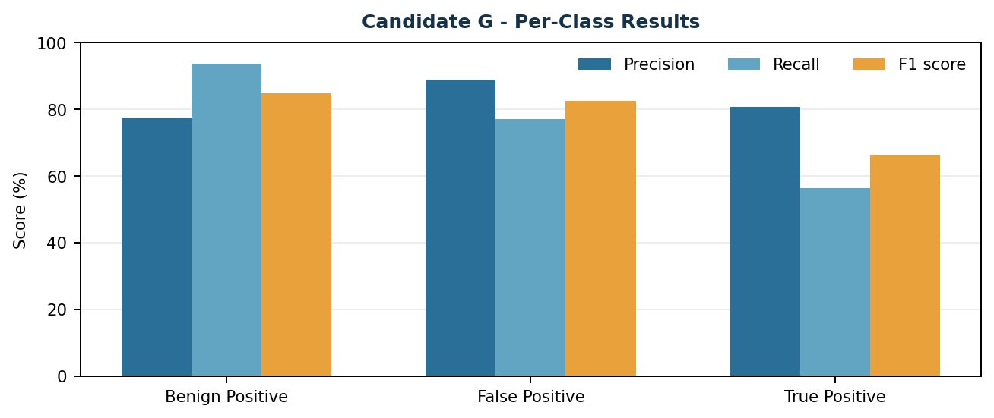
Figure 2. Precision, recall, and F1 score by incident class.

Main Findings
- BenignPositive had the highest recall at 93.65%; most incidents of this class were correctly recovered.
- FalsePositive recall was 77.05%, with 88.95% precision.
- TruePositive precision was 80.66%, but recall was 56.39%. Some genuine-positive incidents are therefore missed; this is the key class-level risk to monitor.

Limitations and Future Work
- The prepared sample may not generalize to other organizations, telemetry, or future attack patterns.
- The 0.65 review threshold is illustrative and has not been validated for production SOC operations.
- Candidate G cross-validation and threshold-trade-off tables are not yet populated in the metadata; the corresponding Model Health sections are consequently empty.
- The older local SHAP helper is disabled for Candidate G because it was designed for the aggregated Random Forest pipeline, not row-level probability averaging.
- Do not connect the prototype to automatic containment, remediation, or incident closure without separate operational validation and security review.

8. Application Workflow
- Upload a compatible CSV or select the available demo queue.
- Review incident-level verdicts, top-class probabilities, and routing according to the chosen uncertainty threshold.
- Investigate an incident and inspect its displayed feature summary and class-probability chart.
- When review is completed, record an analyst-adjudicated verdict and notes in the local feedback audit.
In the verified demo run, the app scored 2,000 incidents: 505 were routed to analyst review and 1,495 were displayed as high-confidence suggestions at threshold 0.65. These counts describe that queue and threshold, not test-set model accuracy.

Live Application: Incident Queue
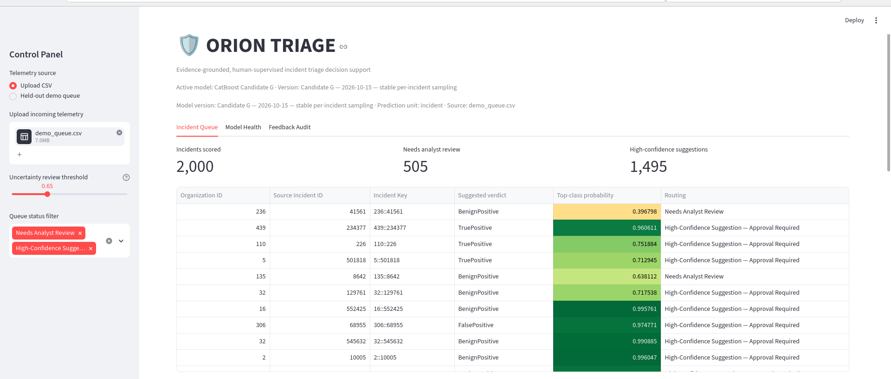
Figure 3. Live queue showing Candidate G as active, with 2,000 incidents scored, 505 routed to review, and 1,495 high-confidence suggestions.

9. Conclusion
ORION TRIAGE now integrates CatBoost Candidate G into a working Streamlit application while keeping the former Random Forest as a fallback. The saved model loaded locally with three classes, 35 features, and 500 trees; eight automated tests passed; and the live interface was verified using the demo queue. Candidate G’s results support continued academic and portfolio development, but the application remains human-supervised decision support.

References
[1] S. Freitas, J. Kalajdjieski, A. Gharib, and R. McCann, “AI-Driven Guided Response for Security Operation Centers with Microsoft Copilot for Security,” arXiv:2407.09017, 2024. https://arxiv.org/abs/2407.09017
[2] Microsoft, “Microsoft Security Incident Prediction (GUIDE) dataset,” Kaggle. https://www.kaggle.com/datasets/microsoft/microsoft-security-incident-prediction
[3] ORION TRIAGE source code and integration documentation. https://github.com/AthifSec/ORION-TRIAGE

10. Incident Investigation and Probabilities
The investigation view presents the selected incident’s engineered count features and categorical evidence summary alongside a human-review form. Analysts can choose an adjudicated verdict, add investigation notes, acknowledge review, and save a local audit record. The model output remains a suggestion.
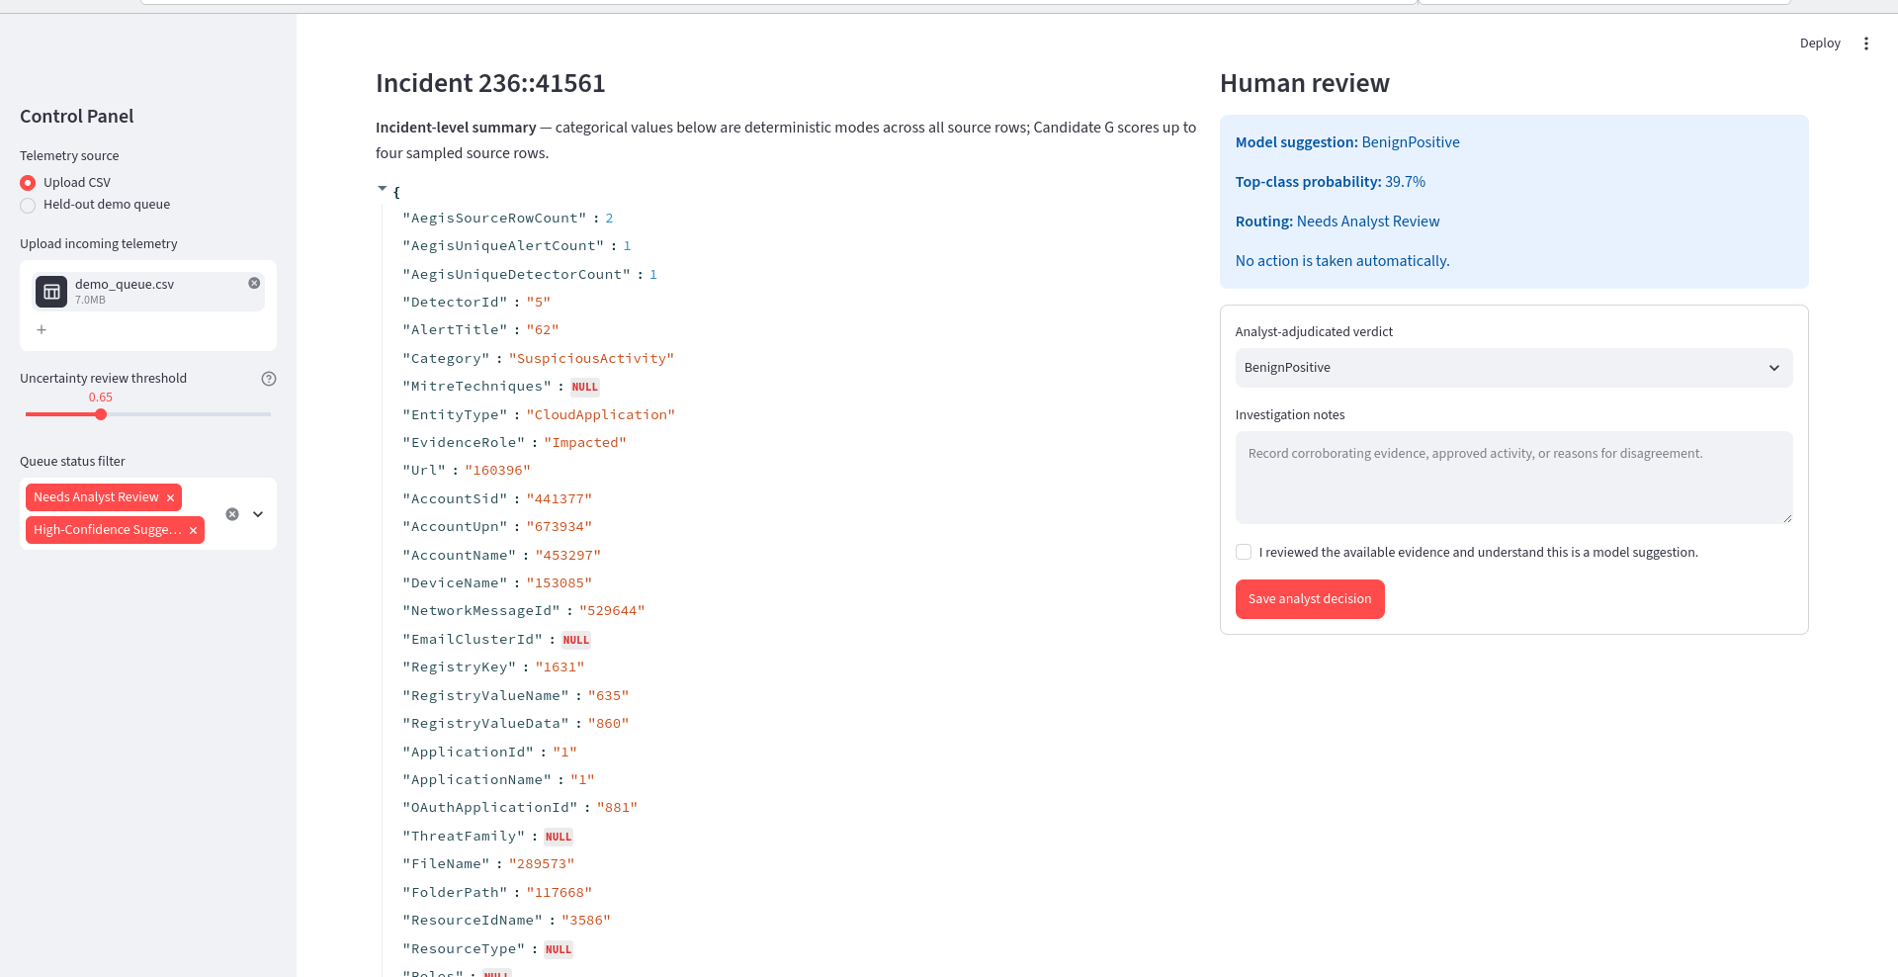
Figure 4. Incident-level summary and analyst-review form for the selected incident.

Class-Probability View
The probability chart displays Candidate G’s averaged class probabilities for the selected incident. The highest class probability is surfaced as the suggested verdict, while the uncertainty threshold determines whether it is routed for review.
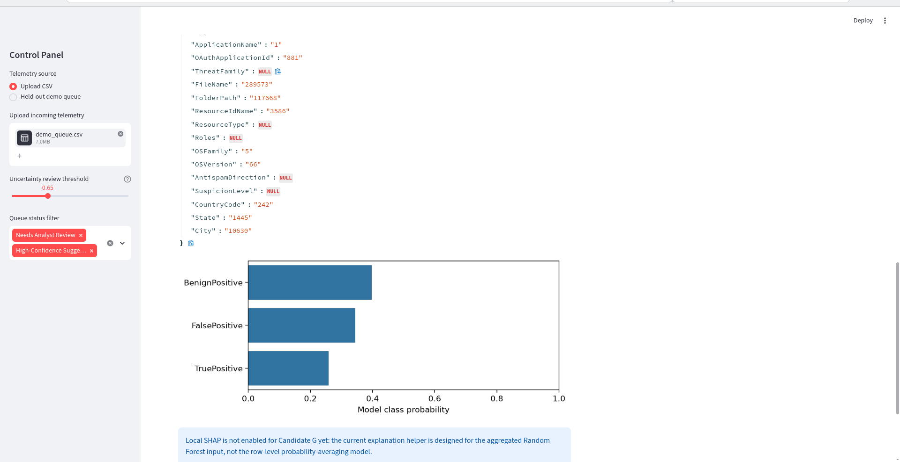
Figure 5. Class-probability chart; the interface notes that local SHAP is not enabled for Candidate G yet.

11. Model Health and Feedback Audit
The Model Health page reports the saved incident-level holdout scores, not real-time accuracy for incoming incidents. The current metadata does not include Candidate G cross-validation benchmarks or threshold trade-off measurements, so the interface explicitly reports that no benchmark table was saved and leaves the trade-off section blank.

Model Health
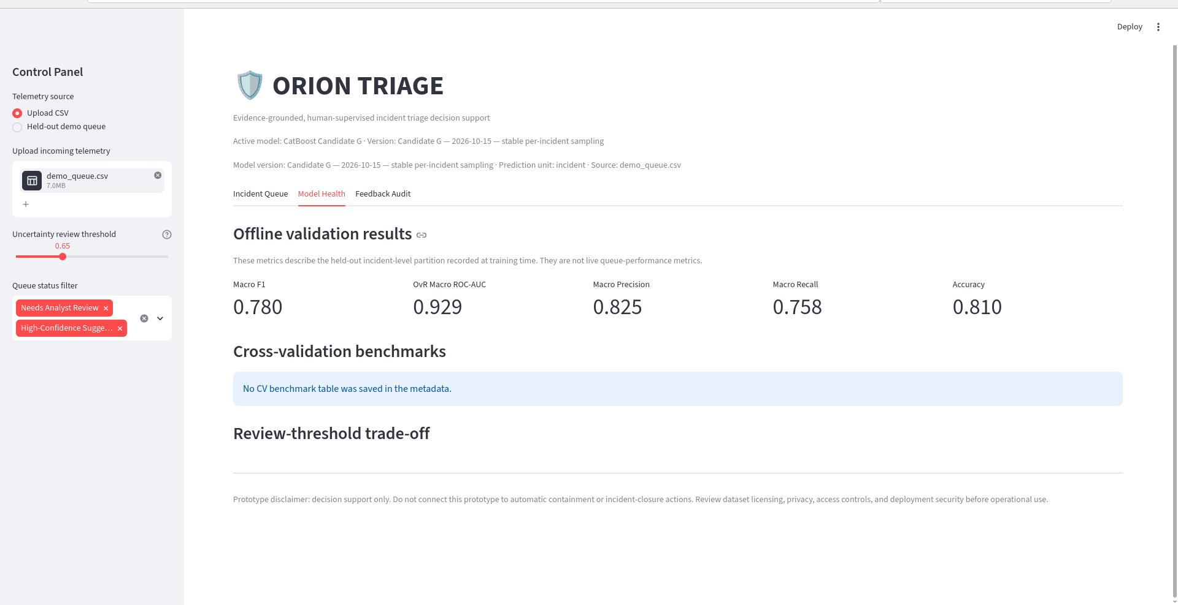
Figure 6. Model Health page showing macro F1 0.780, OvR macro ROC-AUC 0.929, macro precision 0.825, macro recall 0.758, and accuracy 0.810.

Feedback Audit
The local audit is initially empty because no analyst decisions have been submitted. After each completed review, the analyst-adjudicated verdict and notes can be saved for audit purposes. The current prototype does not automatically retrain from feedback.
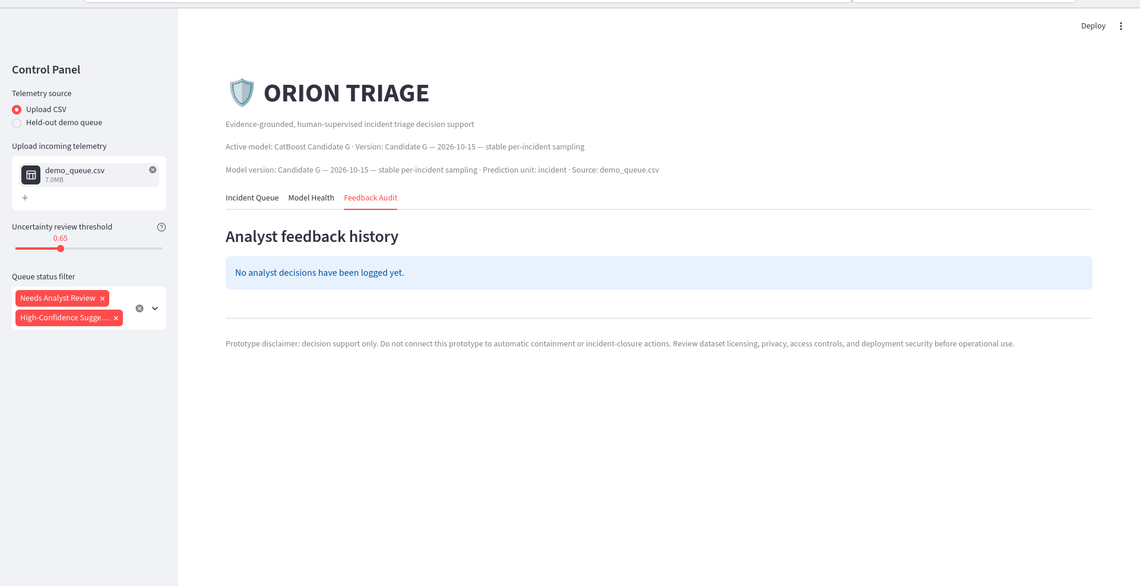
Figure 7. Feedback Audit before any review decisions are recorded.

