**MANUAL**

**Log In**

To start ProdErp program type your username and password according with your role and press login

If you are admin the Administrator’s Menu window will open or else the Simple User Menu window.

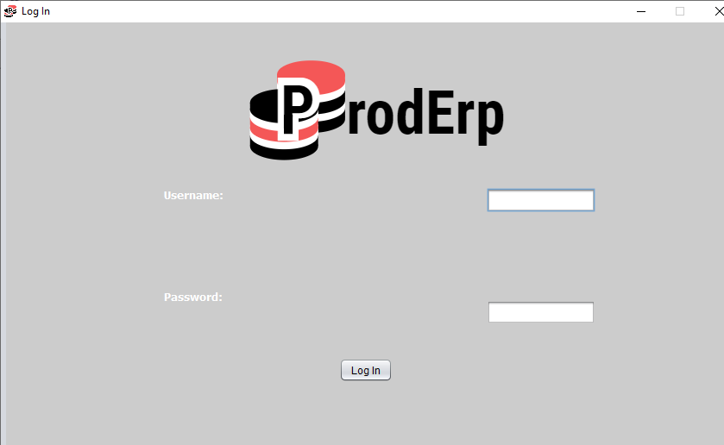

Administrator’s Menu

* Customers

Press Customers to open the Customer’s Menu. Now you can update, delete or add a customer by pressing the according button below or press the refresh icon to refresh the customer’s list.

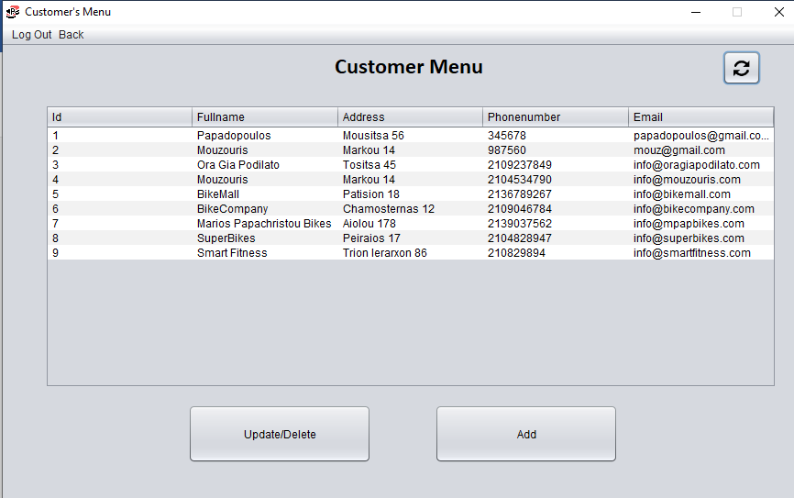

To update customer data choose a customer from the list on the right and change the information. Then press update.

*NOTE: You cannot change the customer’s id.

To delete a customer choose a customer from the list on the right and press delete.

Press cancel to exit Customer’s Edit Window.

To add a new customer type the customer’s data and then press save, or cancel to exit the window.

Press back to return to Administrator’s Menu.

* Suppliers

Press Suppliers to open the Supplier’s Menu. Now you can update, delete or add a supplier by pressing the according button below or press the refresh icon to refresh the supplier’s list.

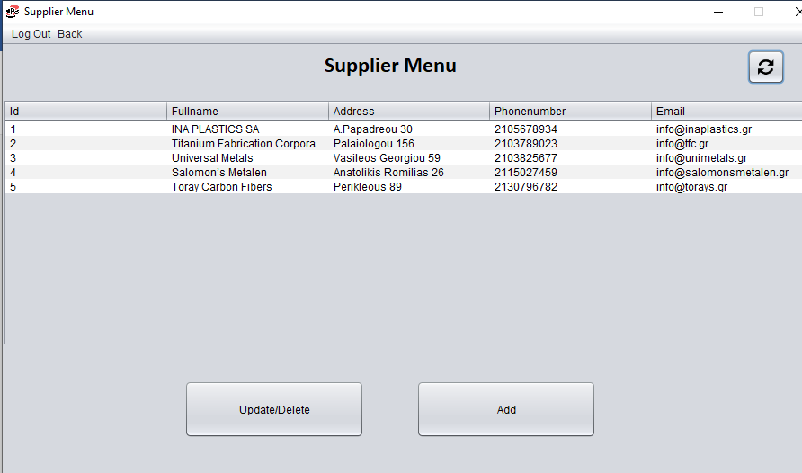

To update supplier data choose a supplier from the list on the right and change the information. Then press update.

*NOTE: You cannot change the supplier’s id.

To delete a supplier choose a supplier from the list on the right and press delete.

Press cancel to exit Supplier’s Edit window.

To add a new supplier type the supplier’s data and then press save, or cancel to exit the window.

Press back to return to Administrator’s Menu.

* Products

Press Products to open the Product’s Menu. Now you can update, delete or add a product by pressing the according button below or press the refresh icon to refresh the product’s list. You can also see the ingredients of each product and add or delete an ingredient.

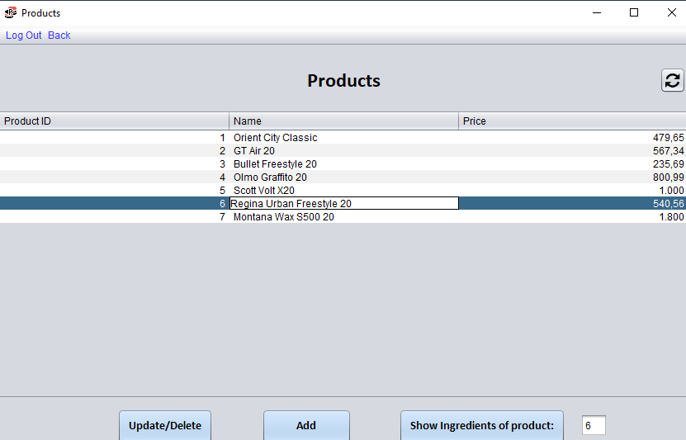

To update product data choose a product from the list on the right and change the information. Then press update.

*NOTE: You cannot change the product’s id.

To delete a product choose a product from the list on the right and press delete.

Press cancel to exit Edit Product window.

To add a new product type the product’s data and then press save, or cancel to exit the window.

To see and edit the ingredients of a product choose a product from the list above and press show ingredients of product.

To add a new ingredient press add, choose a name id and type the desired quantity. Before pressing save if you want to add more ingredients press add more ingredients. When you finish press save or cancel to exit the window.

To delete an ingredient press the delete button, select the id of the ingredient you want to delete and then press delete or cancel to exit the window.

Press back to return to Administrator’s Menu.

* Raw Materials

Press RawMaterials to open the RawMaterial’s Menu. Now you can update, delete or add a raw material by pressing the according button below or press the refresh icon to refresh the raw material’s list.

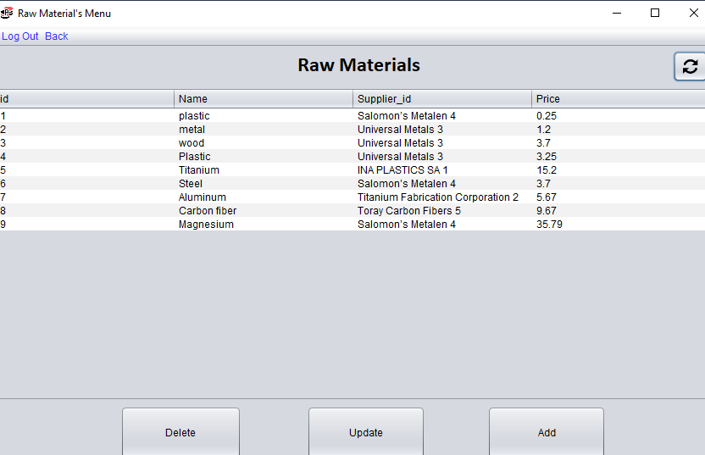

To update raw material data choose a raw material from the list on the right and change the information. Then press update, or cancel to exit the window.

*NOTE: You cannot change the raw material’s id.

To delete a raw material type the id of the raw material you want to delete and press delete, or cancel to exit the window.

To add a new raw material type the raw material’s data, choose a supplier id and then press save, or cancel to exit the window.

Press back to return to Administrator’s Menu.

* Storage

Press Storage to open the Storage Menu.

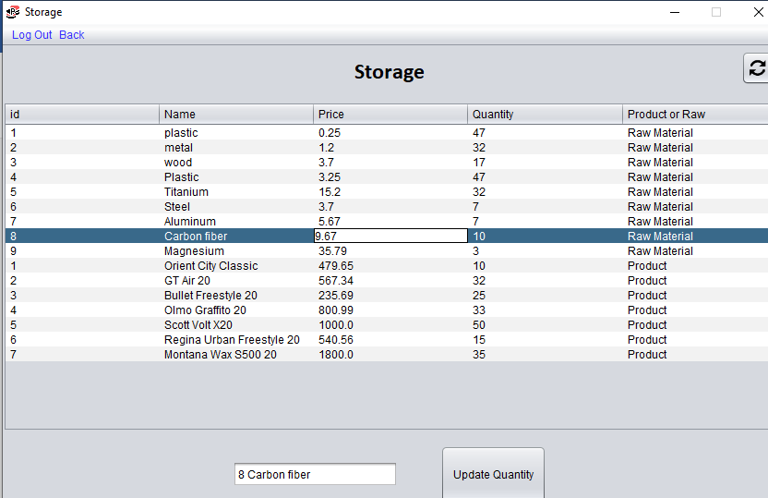

Now you can update the quantity of the products or the raw materials by choosing the product or raw material you want to edit from the list above and then pressing update quantity. Now type the quantity and press update, or cancel to exit the window.

Press the refresh icon to refresh the supplier’s list.

Press back to return to Administrator’s Menu.

* Orders

…………

* Add User

Press Add User to open Add User’s window.

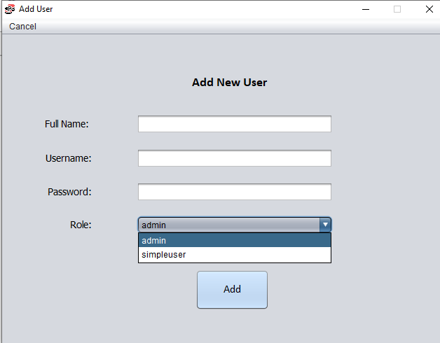

To create a new user (admin or simple) type the new user’s information and choose a role from the combo box. Press add to save the new user, or cancel to return to Administrator’s Menu.

* Delete User

Press Delete User to open Delete User’s window.

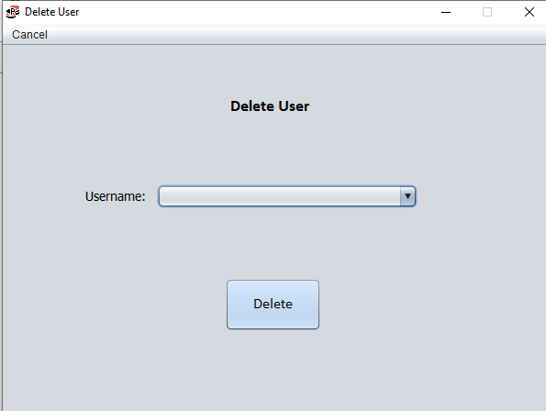

Choose a username from the combo box and the press delete, or cancel to return to Administrator’s Menu.

* Visit Our Website

Press the button Visit Our Website to open the web and transfer to the ProdErp website.

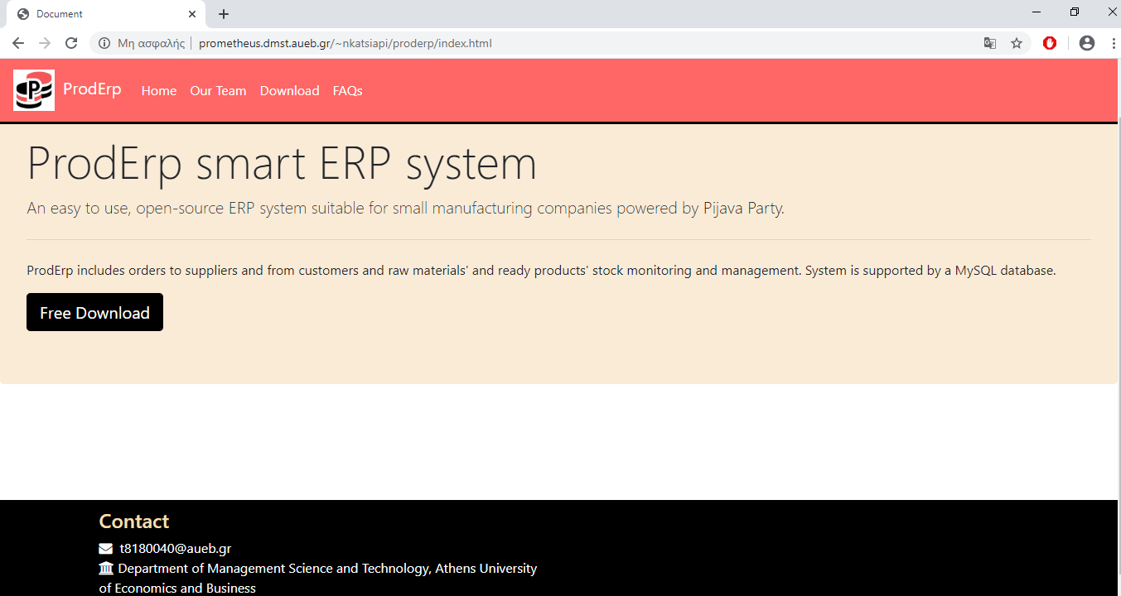

User’s Menu

* Customers

Press Customers to open the Customer’s Menu. Now you can update, delete or add a customer by pressing the according button below or press the refresh icon to refresh the customer’s list.

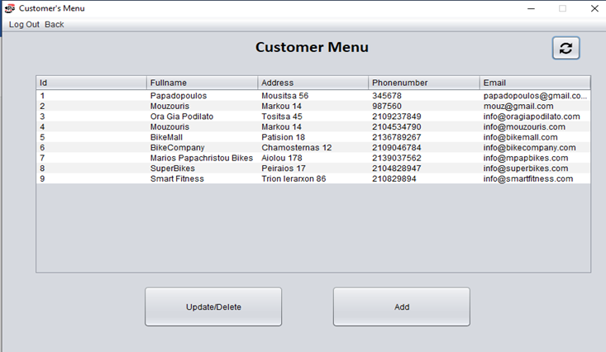

To update customer data choose a customer from the list on the right and change the information. Then press update.

*NOTE: You cannot change the customer’s id.

To delete a customer choose a customer from the list on the right and press delete.

Press cancel to exit Customer’s Edit Window.

To add a new customer type the customer’s data and then press save, or cancel to exit the window.

Press back to return to User’s Menu.

* Suppliers

Press Suppliers to open the Supplier’s Menu. Now you can update, delete or add a supplier by pressing the according button below or press the refresh icon to refresh the supplier’s list.

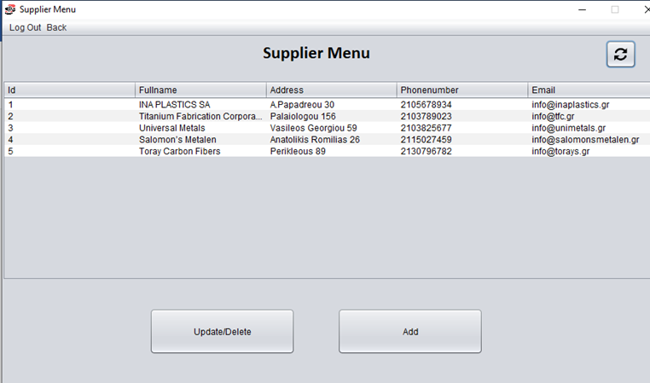

To update supplier data choose a supplier from the list on the right and change the information. Then press update.

*NOTE: You cannot change the supplier’s id.

To delete a supplier choose a supplier from the list on the right and press delete.

Press cancel to exit Supplier’s Edit window.

To add a new supplier type the supplier’s data and then press save, or cancel to exit the window.

Press back to return to User’s Menu.

* Products

Press Products to open the Product’s Menu. Now you can update, delete or add a product by pressing the according button below or press the refresh icon to refresh the product’s list. You can also see the ingredients of each product and add or delete an ingredient.

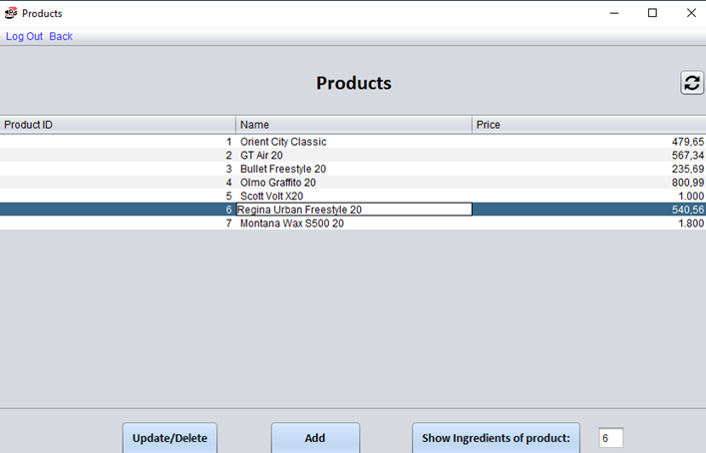

To update product data choose a product from the list on the right and change the information. Then press update.

*NOTE: You cannot change the product’s id.

To delete a product choose a product from the list on the right and press delete.

Press cancel to exit Edit Product window.

To add a new product type the product’s data and then press save, or cancel to exit the window.

To see and edit the ingredients of a product choose a product from the list above and press show ingredients of product.

To add a new ingredient press add, choose a name id and type the desired quantity. Before pressing save if you want to add more ingredients press add more ingredients. When you finish press save or cancel to exit the window.

To delete an ingredient press the delete button, select the id of the ingredient you want to delete and then press delete or cancel to exit the window.

Press back to return to User’s Menu.

* Raw Materials

Press RawMaterials to open the RawMaterial’s Menu. Now you can update, delete or add a raw material by pressing the according button below or press the refresh icon to refresh the raw material’s list.

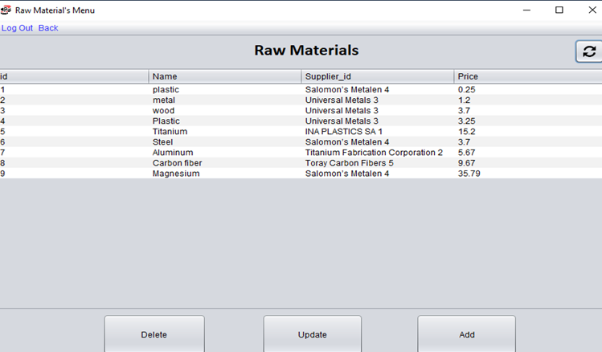

To update raw material data choose a raw material from the list on the right and change the information. Then press update, or cancel to exit the window.

*NOTE: You cannot change the raw material’s id.

To delete a raw material type the id of the raw material you want to delete and press delete, or cancel to exit the window.

To add a new raw material type the raw material’s data, choose a supplier id and then press save, or cancel to exit the window.

Press back to return to User’s Menu.

* Storage

Press Storage to open the Storage Menu.

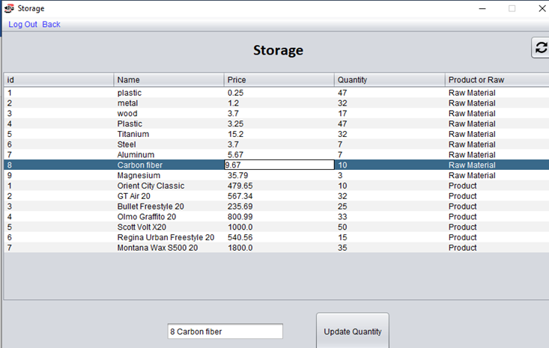

Now you can update the quantity of the products or the raw materials by choosing the product or raw material you want to edit from the list above and then pressing update quantity. Now type the quantity and press update, or cancel to exit the window.

Press the refresh icon to refresh the supplier’s list.

Press back to return to User’s Menu.

* Orders

……..

* Visit Our Website

Press the button Visit Our Website to open the web and transfer to the ProdErp website.

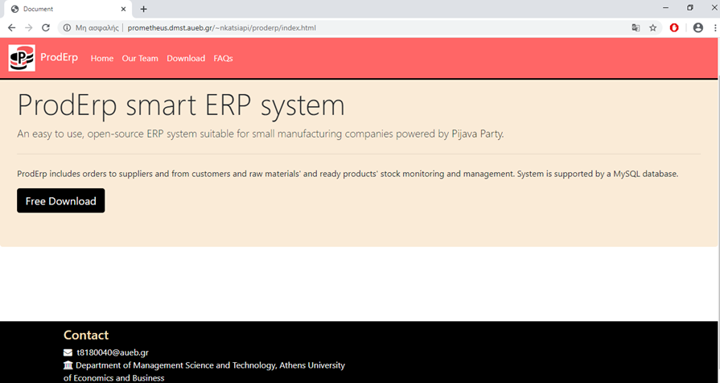

**Log Out**

Press Log Out to disconnect from the system and return to the LogIn window. To exit the program press X.