**Experiment No.: 3**

**Aim**

Familirization of linux commands

**CO2**

Perform system administration tasks

**Procedure**

1.pwd-To print working directory

$pwd

**Output Screenshot**



2.ls-Used to list the files and contents

$ls

**Output Screenshot**



(a).ls-R-Detailed view of sub directory

$ls-R

**Output Screenshot**

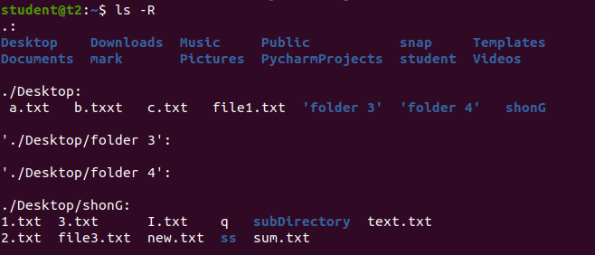

(b).ls-l-long listing of contents

$ls

**Output Screenshot**

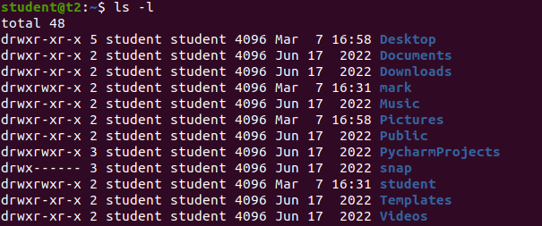

(c).ls-a-used to view hidden files

$ls-a

**Output Screenshot**

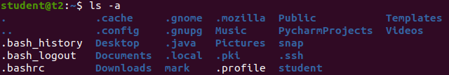

(d).ls-al-Detailed information can view along with hidden files.

$ls-al

**Output Screenshot**

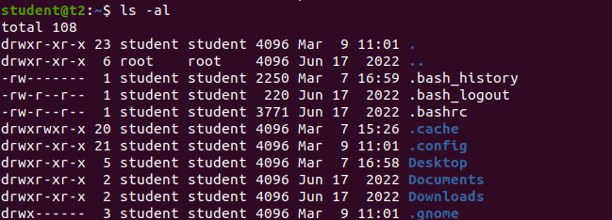

(e).ls-t-To list the files sorted in order of last modified.

$ls-t

**Output Screenshot**



3.mkdir-To make a new directory

$ls-t

**Output Screenshot**

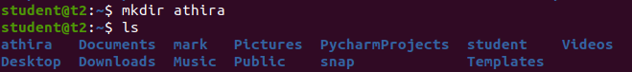

4.cd-To navigate through directory we used cd

$cd Athira

**Output Screenshot**

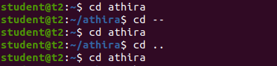

5.cd.. or cd-- -To move one directory up

$cd-- $cd..

**Output Screenshot**

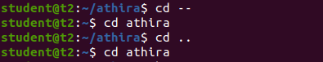

6.history-To view the history and commands which we have been executed for a long time.

$history

**Output Screenshot**

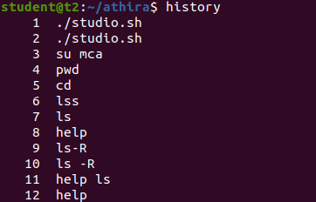

7.man-We can learn &understand with different commands write from the shell using man commands.

$manls

**Output Screenshot**

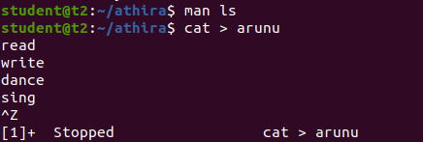

8.cat-To create a new file.

$cat > file name

**Output Screenshot**

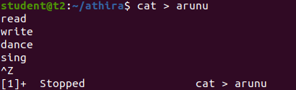

(a).cat filename-To display contents

$cat filename

**Output Screenshot**

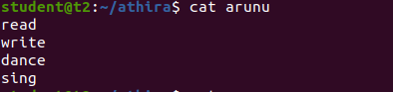

(b).cat>>-To append content to the file

$cat >> filename

**Output Screenshot**

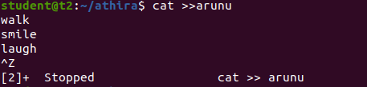

(c).cat-n-To display the the line number

$cat-n filename

**Output Screenshot**

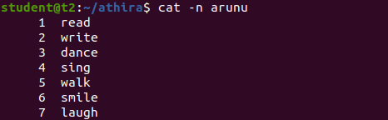

(d).cat-b-Removing the empty line numbering

$cat-b

**Output Screenshot**

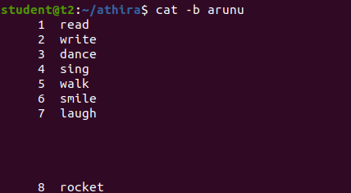

**Result**

The program was executed and the result was successfully obtained. Thus CO1 was obtained.