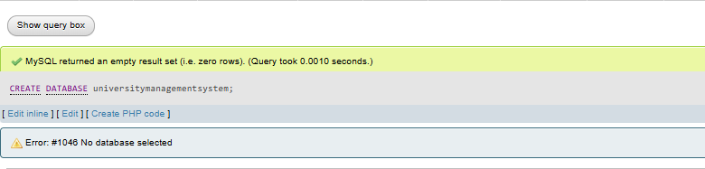
Table Courses
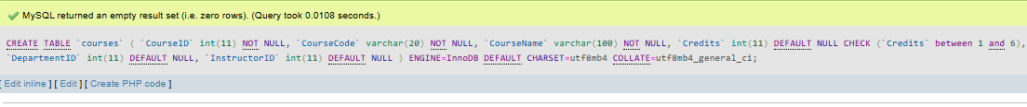
Table Department
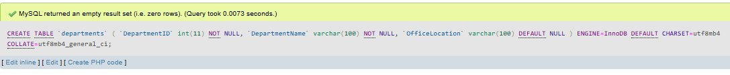
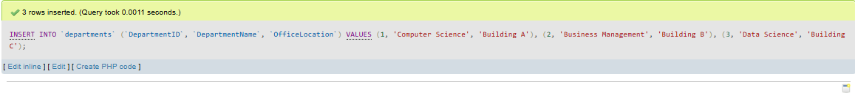
Table Enrollment
Table Instructions
Table Students
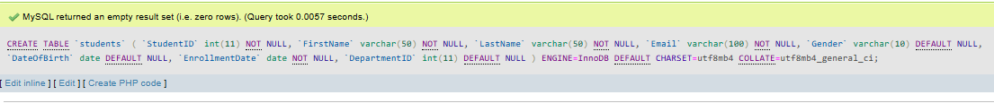
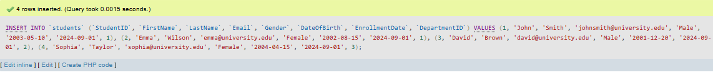
Index courses
Index departments
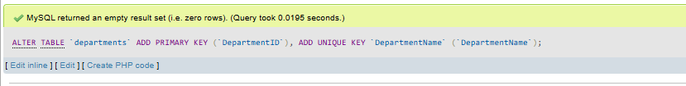
Index enrollments
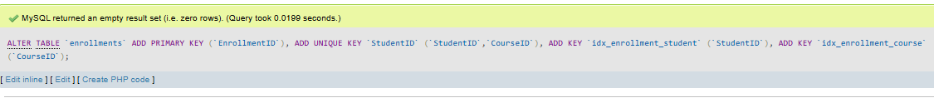
Index instructors
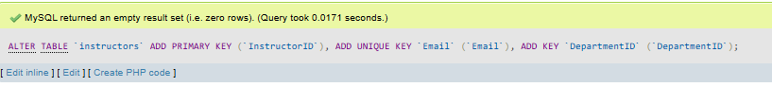
Index Students
Increment Courses
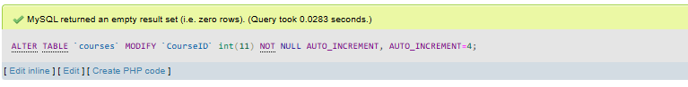
Increment Departments
Increment Enrollments
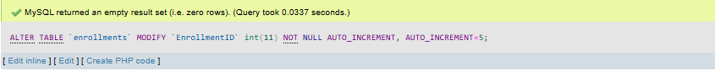
Increment Instructors
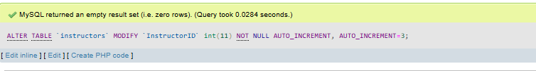
Increment Students
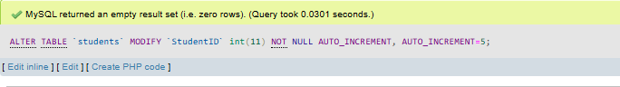
Constraints courses
Constraints enrollments
Constraints instructors
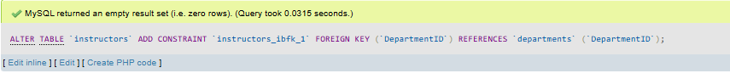
Constraints Students
