DESIGN AND IMPLEMENTATION OF A UNIVERSITY MANAGEMENT SYSTEM DATABASE USING SQL

Table of Contents
1. Introduction 3
2. System Design 3
2.1 Requirements Analysis 3
2.2 Entity Identification 3
2.3 Relationship Design 5
2.4 ER Diagram Explanation 6
2.5 Normalization 8
3. Implementation 8
3.1 Database Creation 9
3.2 Table Implementation 9
3.3 Primary and Foreign Keys 11
3.4 Constraints 12
3.5 Data Population 13
3.6 CRUD Operations 13
3.7 Indexing and Optimization 14
4. Results and Query Demonstration 15
5. Challenges and Solutions 18
6. Conclusion and Future Work 19
References 20
Appendix 22

1. Introduction
Database systems are a critical part of any organization today, whether they are used for storing, retrieving, or managing information. Lots of information is gathered at schools and universities, including academic records, enrolments, teaching staff, students, courses, and the activities of the various departments. Manual data handling can result in data duplication, data inconsistencies and problems getting accurate data in time. As a result, universities are adopting DBMS for improving the efficiency of their operations and to facilitate wise decision making.
The project is about the designing and implementing a relational database for a University Management System using SQL. The system will contain tables for students, instructors, departments, courses, and enrollments. The outcome is a system that is structured, scalable and reliable, provides better data correctness, reduces data redundancy, has efficient reporting capabilities and will be a platform for future growth and integration of other University services.

2. System Design

2.1 Requirements Analysis
The first step was to analyse the data needs in a university setting. A structured database was needed to efficiently manage the students, instructors, courses, departments, and enrollments (Azuddin et al., 2025). The main objectives were to create a secure vault for data, support academic functions, ensure data integrity, and enable reporting through SQL queries.

2.2 Entity Identification
Departments
The Departments entity contains information about a department in the university. Each department has its own department id, name and office address. Departments are the base of organizing students, teachers and courses (Naik and Gajjar, 2023).
Attributes:
- DepartmentID (Primary Key)
- DepartmentName
- OfficeLocation
Students
Students - Details about the students enrolled. Every student has his/her own ID number and is affiliated to a department.
Attributes:
- StudentID (Primary Key)
- FirstName
- LastName
- Email
- Gender
- DateOfBirth
- EnrollmentDate
- DepartmentID (Foreign Key)
Instructors
Information about academic staff members who teach courses are stored under the instructor’s entity.
Attributes:
- InstructorID (Primary Key)
- FirstName
- LastName
- Email
- HireDate
- DepartmentID (Foreign Key)
Courses
Courses is an entity where its information contains the information about the courses that are there in the University. Every course is allocated to a department and the course is instructed by an instructor (Zhang et al., 2021).
Attributes:
- CourseID (Primary Key)
- CourseCode
- CourseName
- Credits
- DepartmentID (Foreign Key)
- InstructorID (Foreign Key)
Enrollments
The Enrollments entity is used to record the relationship between the students and the courses. Student and Course may be in many-to-many relationship since one student can take multiple courses and one Course can enroll multiple students. This relationship is managed using the Enrollments table (Fu et al., 2023).
Attributes:
• EnrollmentID (Primary Key)
• StudentID (Foreign Key)
• CourseID (Foreign Key)
• EnrollmentDate
• Grade

2.3 Relationship Design
There are multiple relationships between the entities.
Department–Student Relationship
Students may be in multiple departments and each student is in only one department. It's a one-to-many relationship.
Department–Instructor Relationship
Several instructors can be a member in a department, and an instructor can only be a member in a department (Zheng et al., 2021).
Department–Course Relationship
Courses can be more than one within each department. Each course is associated with one department.
Instructor–Course Relationship
Multiple courses may be taught by one instructor. For every course, there is one instructor.
Student–Course Relationship
Courses may have multiple students and students may be enrolled in multiple courses. The relationship between the two is many to many and is realized with the Enrollments table.

2.4 ER Diagram Explanation
The Entity Relationship (ER) Diagram is a visual representation of the structure of the data base. Departments are the parent of students, instructors and courses. The Enrollments table is a linking table from students to courses.
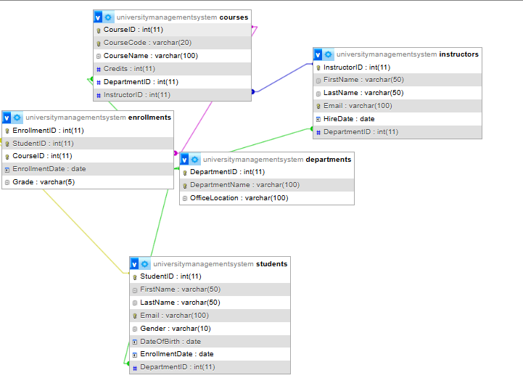
Figure 1: ERD Diagram
(Source: Obtained from Xampp)
The ER diagram makes the cardinality of relationships obvious and gives a blueprint as to how the relationship should be implemented. The primary keys are used to uniquely identify records, while foreign keys are used to connect tables and maintain referential integrity (Liu, Wang and Xiao, 2021).

2.5 Normalization
Normalization was done to ease the efficiency of the database and to reduce the redundancies.
First Normal Form (1NF)
No repeating groups and all data are stored in tables with atomic values. The values are stored in each column, with consistency.
Second Normal Form (2NF)
All non-key attributes are fully dependent on the primary keys. Partial dependencies were removed by splitting up the data into separate tables.
Third Normal Form (3NF)
Removed transitive dependencies. Details about departments are not duplicated in the Students, Instructors, or Courses tables, but will only be found in a departments table. This saves redundant data and simplifies maintenance (Markert et al., 2024).
The normalized structure guarantees that the data is consistent and avoids data duplication, and improves the performance of the database. Also, it can be extended and modified in the future without significant changes, since more entities and relationships can be added.

3. Implementation
The implementation was done by taking the conceptual design of the database and converting it to a working relational database in SQL. The database was created to help in the storage, retrieval, update and management of the University information. SQL was selected because it has a strong function and feature set to define the structure of the database, enforce constraints, and make efficient complex queries.
The process of implementation started by creating the database that is named as the UniversityManagementSystem. After designing the database environment, the tables were created, each corresponding to an entity discovered in the design phase of the system (Fan et al., 2021). There are tables for Departments, Students, Instructors, Courses, and Enrollments.

3.1 Database Creation
The CREATE DATABASE command is used to create the database. Once the database was created the USE statement to switch it as the currently selected database was used. This enabled the consolidation of all the data pertaining to the university in a single location (Chen, Gu and Ye, 2025).
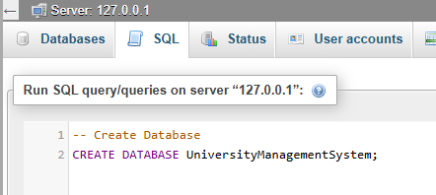
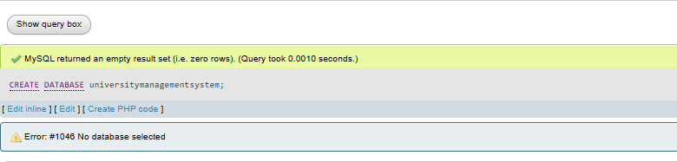
Figure 2: Database Creation
(Source: Obtained from Xampp)
The database schema was properly designed and had included aspects like scalability, maintainability etc. The tables were individually created and relationships established using a foreign key.

3.2 Table Implementation
Departments was created first since it's a parent table for a number of other entities. The attribute DepartmentID was made as primary key with an auto incremented value to ensure that the attribute always has a unique value. DepartmentName and OfficeLocation were other attributes.
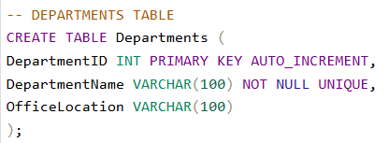
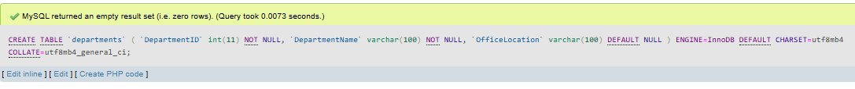
Figure 3: Department Table
(Source: Obtained from Xampp)
The subsequent table designed was the students table, which contains student information. The primary key was chosen as StudentID. Other properties such as FirstName, LastName, Email, Gender, DateOfBirth and EnrollmentDate were added to provide a full picture of student records. A foreign key relationship was established between the DepartmentID attribute and the departments to connect students and departments (Domínguez-Bolaño et al., 2024).
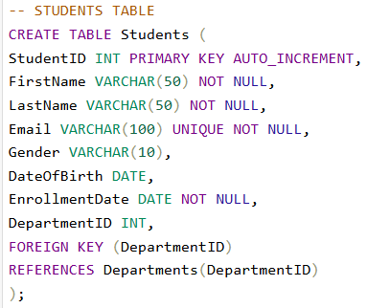
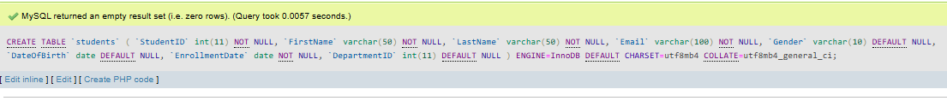
Figure 4: Students table
(Source: Obtained from Xampp)
Similarly, the Instructors table was designed to hold data for the academic staff. The primary key is InstructorID and the foreign key is DepartmentID to connect instructors with their departments.
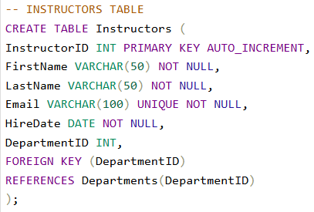
Figure 5: Instructors table
(Source: Obtained from Xampp)
Courses Table contains information about the courses that are available in the University. CourseID was set as the Primary Key, and CourseCode was made a UNIQUE constraint to prevent duplicate Courses. Foreign Key relationships are made between each Course and a Department and an Instructor.
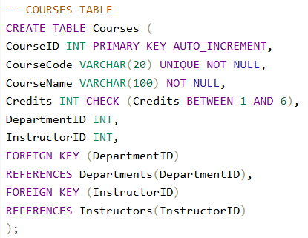
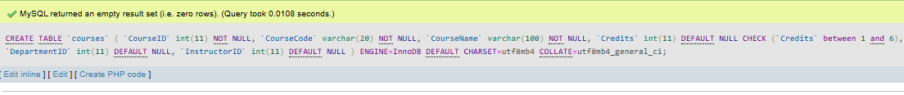
Figure 6: Courses table
(Source: Obtained from Xampp)
The Enrollments table was added to accommodate the many to many relationships between a student and a course. This table has EnrollmentID as its primary key, and StudentID and CourseID as foreign keys. Other properties such as EnrollmentDate and Grade provide comprehensive enrollment data.
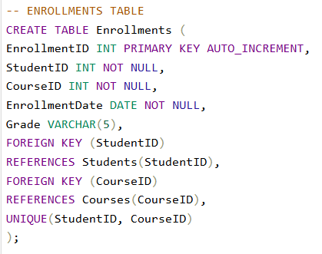
Figure 7: Enrollments table
(Source: Obtained from Xampp)

3.3 Primary and Foreign Keys
The primary keys are very important in uniquely identifying each record in each table. Every entity has a particular primary key property that may be efficiently indexed.
The primary keys of the database are:
- DepartmentID
- StudentID
- InstructorID
- CourseID
- EnrollmentID
Foreign keys can be used to specify relationships between tables and to enforce referential integrity. For example, on the students table, the DepartmentID value references the DepartmentID value in the Departments table. This implies that it is not possible for a student to be assigned to a department that does not exist (Yasin et al., 2022).
Likewise, CourseID and StudentID of Enrollments table are linked to their parent tables. These connections are consistent throughout the database and will not allow for bad data to be entered.

3.4 Constraints
A number of restrictions were put in place to maximize the quality and integrity of the data.
For the required information such as names, email addresses, course names, course enrolment dates, etc., the NOT NULL constraint was specified. Thus, incomplete records won't be stored in the database.
UNIQUE has been used for various applications such as CourseCode and Email. This will prevent data duplication and reduce data inconsistencies (Guo, 2022).
The CHECKing constraints were used to validate specific values. This included, among other things, only allowing course credits to be placed in a range of credits that were deemed appropriate for the course. This validation helps to ensure that the data is accurate and that input errors are minimised.
Foreign key constraints also ensure that the referenced value in the foreign key table is first inserted into the related parent tables.

3.5 Data Population
Once the database is created, sample data was added to each table. The departments, instructors, students, courses and enrollments were added in that order.
Realistic sample data was used, allowing the relationships between the data and functionality of the database to be tested. Multiple students are assigned to multiple departments, instructors to courses, and students to multiple courses (Khan, Huda and Zaman, 2022). This simulated an actual college environment and a true test of SQL operations.

3.6 CRUD Operations
The database supports all fundamental CRUD operations.
INSERT statements are used to create operations. Records of new students, new instructors and new courses can be added at any time as needed (Azuddin et al., 2025).
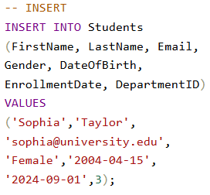
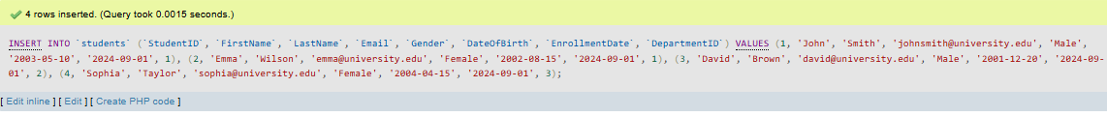
Figure 8: Create operations
(Source: Obtained from Xampp)
Read operations will use SELECT statements to get information from one or more tables. These are queries that are used for routine administrative activities such as accessing student records and compiling a list of courses.
UPDATE statements are used to implement update operations. Existing information, such as student contact, or course assignments, can be changed when things change.
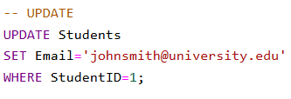

Figure 9: Update operations
(Source: Obtained from Xampp)
To delete invalid or outdated data and to maintain referential integrity with DELETE operations.
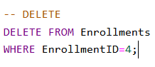

Figure 10: Delete operations
(Source: Obtained from Xampp)

3.7 Indexing and Optimization
Improved performance of databases by indexing. Frequently used data such as student e-mail addresses, course names, and course enrollment IDs were indexed to ensure fast query response.
Indexes enable the database management system to locate records in the system faster. This is especially true in the era of the increasing amount of data and information generated in the University over the years (Naik and Gajjar, 2023).
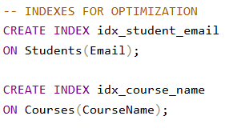
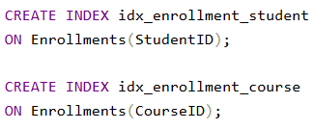
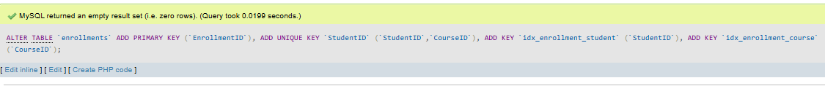
Figure 11: Indexing and Optimization
(Source: Obtained from Xampp)
Optimizations were also considered such as normalization, appropriate data types, and primary keys and foreign keys. This aids to improve responsiveness of the system and aids to future scalability.
Finally, the implementation proved to be successful, and the relational database system was able to effectively manage the university's operations. The database design guarantees that the data is stored accurately, constraints maintain data integrity, and advanced query processing and reporting are possible.

4. Results and Query Demonstration
A series of SQL Queries have been done in order to test the functioning of the database and to demonstrate the effectiveness of the design after the implementation of the University Management System database. The results confirmed the correctness of data saved in the database, efficiency in retrieving the data and relevance of reporting.
The first test that was performed was CRUD operations. New student, instructor, course and enrollment records were added to the database using INSERT statements. All relationships and constraints were found to be working properly after data was successfully inserted. An update operation was then executed to update the student data, demonstrating how the database can help maintain accurate and timely records. Also, DELETE was tested where enrollment was removed and good data management could be ensured without compromising the integrity of the database (Zhang et al., 2021).
Multiple SELECT statements were performed to get data from each table. These queries enabled the administrators to retrieve the information on student records, instructors, departments and courses. These results indicated that it was possible to access information rapidly and accurately.
For relational database functionality, JOIN queries were carried out on different tables. For example, student enrollment reports combined data from the students table, the Courses table and the Enrollments table. These queries provided detailed information about students' enrolment in specific courses and their performance in these courses.
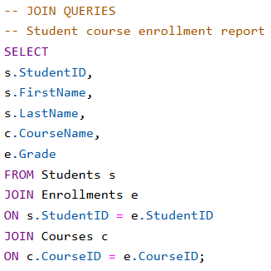
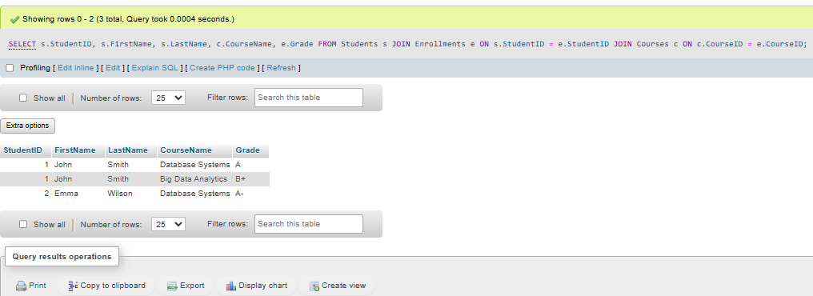
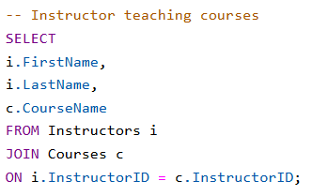
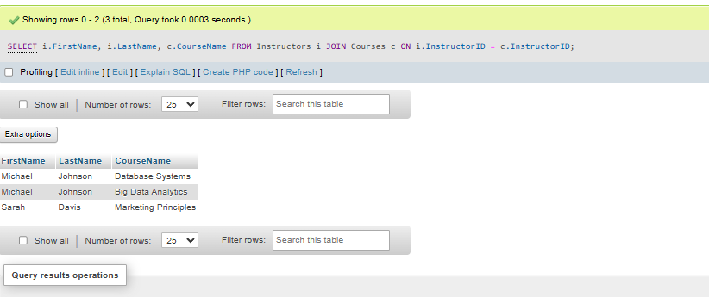
Figure 12: Join Queries
(Source: Obtained from Xampp)
Aggregate functions are added to facilitate reporting and decision making. The number of students, courses and enrollments in the system were computed using COUNT function. Department-level statistics (e.g., number of students per department) were derived by grouped functions. These reports can assist the university leaders in allocating resources and planning their academics.

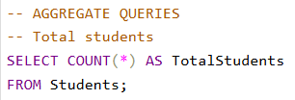
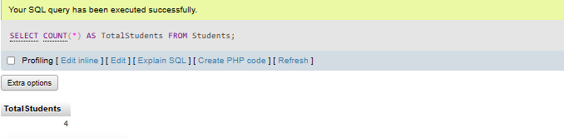
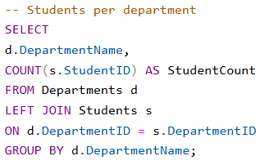
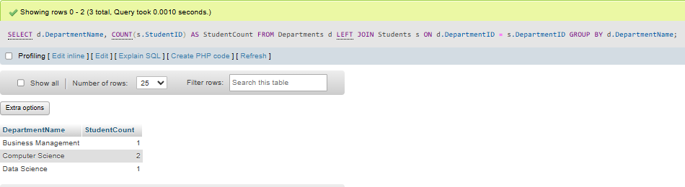
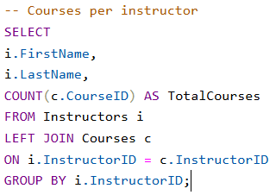
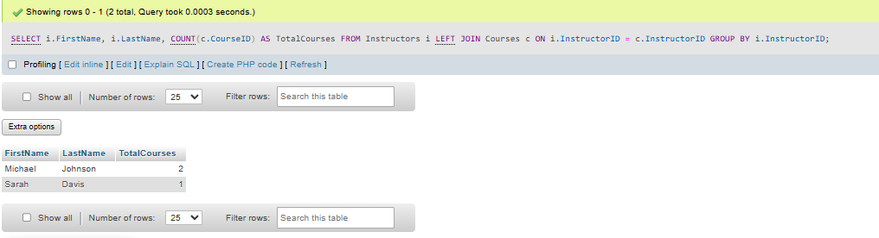
Figure 13: Aggregate functions Queries
(Source: Obtained from Xampp)
Advanced business queries were attempted as well. One query found the most popular course by adding up the numbers of enrolments in each course. A second search provided detailed grade reports of student performance in several courses. The data on the enrollment of the departments provided an insight into the academic demand of various departments (Fu et al., 2023).
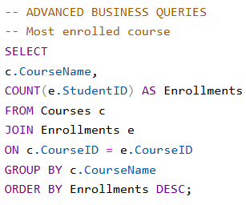
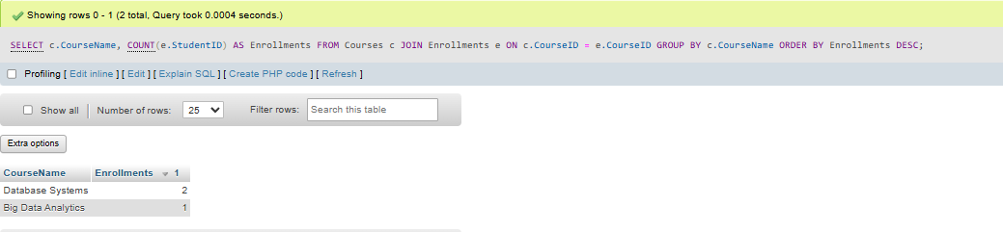
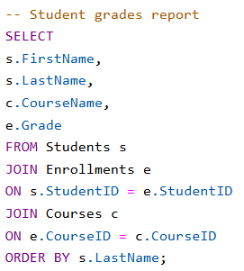
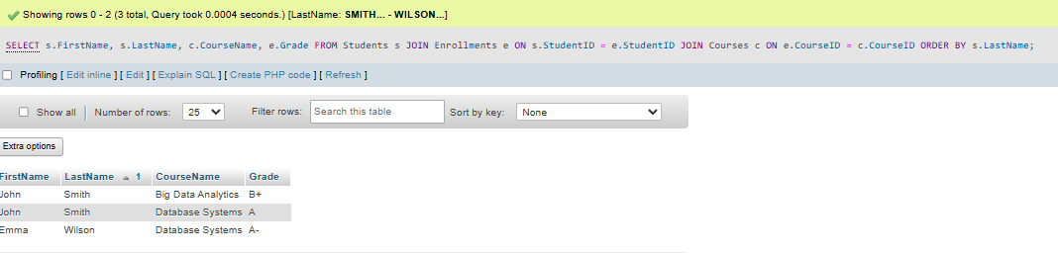
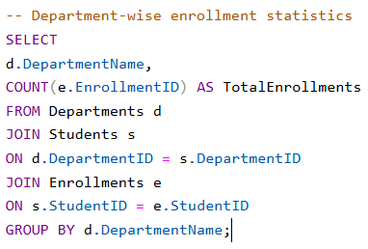
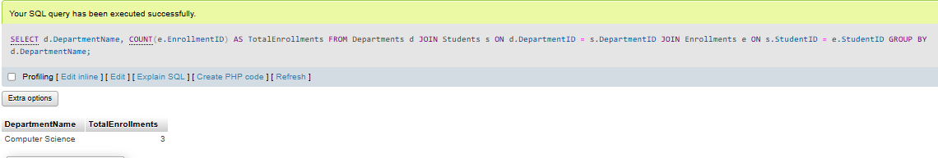
Figure 14: Advanced business queries
(Source: Obtained from Xampp)
The result represents that the University Management System database achieves desired outcomes. The database allows for accurate, consistent, and efficient operational processes and analytical reporting. The successful execution of CRUD operations, joins and aggregate functions show that the database can fulfill real-world requirements for university management.

5. Challenges and Solutions
The development of the database faced several challenges such as handling many-to-many relationships, ensuring data integrity, and minimizing data redundancy. A new table was added: Enrollments, which is a linkage table between students and courses, and will also give normalization. Tables were consistent with primary key, foreign key and constraints.

6. Conclusion and Future Work
This project has successfully developed a relational database for a management system at the University, using SQL. The system adopts a structured database design, with entities for students, instructors, departments, courses, and enrollments. The data in the database was ensured to be accurate and consistent by using key concepts such as normalization, primary keys, and foreign keys. The system was tested with different SQL operations such as CRUD operations, joins, and aggregate queries, to ensure its functionality and effectiveness. The system can be used to manage and report the academic data efficiently. Further elements could include attendance management, exam management, fee collection and analysis dashboards, and a better functioning and scaling of university processes.

References
Azuddin, M., Yusup, M., Setiyowati, H., Wibowo, S., Suwita, J., Basuki, S. and Astuti, E.D., 2025. Design and implementation of a relational database for an academic information system. International Transactions on Artificial Intelligence, 3(2), pp.171-180.
Chen, R., Gu, B. and Ye, Z., 2025. Design and implementation of big data-driven business intelligence analytics system. In Image Processing, Electronics and Computers (pp. 1219-1227). IOS Press.
Domínguez-Bolaño, T., Barral, V., Escudero, C.J. and García-Naya, J.A., 2024. An IoT system for a smart campus: Challenges and solutions illustrated over several real-world use cases. Internet of Things, 25, p.101099.
Fan, Z., Zhou, H., Chen, Z., Hong, D., Wang, Y. and Dong, Q., 2021. Design and implementation of scientific research big data service platform for experimental data managing. Procedia Computer Science, 192, pp.3875-3884.
Fu, Q., Lai, J., Zhong, T. and Ran, L., 2023. Design and implementation of clinical LIS360 laboratory management system based on AI technology. International Journal of Computational Intelligence Systems, 16(1), p.33.
Guo, H., 2022. Research on the construction of the quality evaluation model system for the teaching reform of physical education students in colleges and universities under the background of artificial intelligence. Scientific programming, 2022(1), p.6556631.
Khan, M.G., Huda, N.U. and Zaman, U.K.U., 2022. Smart warehouse management system: Architecture, real-time implementation and prototype design. Machines, 10(2), p.150.
Liu, J., Wang, C. and Xiao, X., 2021. Design and application of science and technology project management information system for educational institutes. Mobile Information Systems, 2021(1), p.2074495.
Markert, K.N., da Silva, G., Ames, D.P., Maghami, I., Williams, G.P., Nelson, E.J., Halgren, J., Patel, A., Santos, A. and Ames, M.J., 2024. Design and implementation of a BigQuery dataset and application programmer interface (API) for the US National Water Model. Environmental Modelling & Software, 179, p.106123.
Naik, S. and Gajjar, K., 2023. Applying and evaluating engagement and application-based learning and education (enable): A student-centered learning pedagogy for the course database management system. Journal of Education, 203(2), pp.410-422.
Yasin, A., Delaney, J., Cheng, C.T. and Pang, T.Y., 2022. The design and implementation of an IoT sensor-based indoor air quality monitoring system using off-the-shelf devices. Applied Sciences, 12(19), p.9450.
Zhang, F., Sun, G., Zheng, B. and Dong, L., 2021. Design and implementation of energy management system based on spring boot framework. Information, 12(11), p.457.

Appendix
https://github.com/Athira12-sh/University-Management-System-SQL-Database

