PATENTHUB-AI
INTELLIGENT ACADEMIC RESEARCH ECOSYSTEM

Mini Project Report Submitted by
ATHIRA BIJU

Reg. No.: AJC22MCA-I023

In Partial fulfillment for the Award of the Degree of
INTEGRATED MASTER OF COMPUTER APPLICATIONS

(INMCA)
APJ ABDUL KALAM TECHNOLOGICAL UNIVERSITY



AMAL JYOTHI COLLEGE OF ENGINEERING AUTONOMOUS

KANJIRAPPALLY
[Affiliated to APJ Abdul Kalam Technological University, Kerala. Approved by AICTE, Accredited by NAAC. Koovappally, Kanjirappally, Kottayam, Kerala – 686518]

2025-2026
DEPARTMENT OF COMPUTER APPLICATIONS AMAL JYOTHI COLLEGE OF ENGINEERING AUTONOMOUS KANJIRAPPALLY

CERTIFICATE
This is to certify that the Project report, “PATENTHUB-AI” is the bona fide work of ATHIRA BIJU (Regno: AJC22MCA-I023) carried out in partial fulfillment of the requirements for the award of the Degree of Integrated Master of Computer Applications at Amal Jyothi College of Engineering Autonomous, Kanjirappally, affiliated to APJ Abdul Kalam Technological University. The project was undertaken during the period from July 01, 2026 to October 30, 2026.

Ms. Meera Rose Mathew Ms. Meera Rose Mathew Internal Guide Coordinator

Dr. Bijimol T K
Head of the Department

DECLARATION

I hereby declare that the project report “PATENTHUB-AI” is a bona fide work done at Amal Jyothi College of Engineering Autonomous, Kanjirappally, affiliated to APJ Abdul Kalam Technological University, towards the partial fulfilment of the requirements for the award of the Integrated Master of Computer Applications (INMCA) during the period from July 01, 2026 to October 30, 2026.

Date: 30-10-2026 ATHIRA BIJU

KANJIRAPPALLY Reg: AJC22MCA-I023

ACKNOWLEDGEMENT

First and foremost, I thank God almighty for his eternal love and protection throughout the project. I take this opportunity to express my gratitude to all who helped me in completing this project successfully. It has been said that gratitude is the memory of the heart. With this in mind, I wish to express my sincere and heartfelt gratitude to our esteemed Director (Administration) Rev. Fr. Dr. Roy Abraham Pazhayaparampil and Principal Dr. Lillykutty Jacob for providing good faculty for guidance.

I owe a great depth of gratitude towards our Head of the Department Dr. Bijimol T K for helping us. I extend my whole hearted thanks to the project coordinator Ms. Meera Rose Mathew for her valuable suggestions and for overwhelming concern and guidance from the beginning to the end of the project. I would also express sincere gratitude to my guide Ms. Meera Rose Mathew for her inspiration and helping hand.

I thank our beloved teachers for their cooperation and suggestions that helped me throughout the project. I express my thanks to all my friends and classmates for their interest, dedication, and encouragement shown towards the project. I convey my hearty thanks to my family for the moral support, suggestions, and encouragement to make this venture a success.

ATHIRA BIJU

ABSTRACT

PatentHub AI is an intelligent patent pre-filing and management platform designed to simplify the patent preparation journey of inventors while supporting effective collaboration, supervision, and patent review. The platform provides multiple user roles—Inventor, Co-Inventor, Guide, Patent Expert, and Admin—with role-specific functionalities and access privileges.
Inventors can create and manage patent projects, document their inventions, conduct prior-art research, organize patent references, prepare patent claims and specifications, manage supporting documents and drawings, and track the overall progress of their patent projects. The platform provides AI-assisted research and analysis for innovation details, technical similarity, and prior-art exploration. Inventors can also manage tasks, comments, project activities, deadlines, and collaborate with other members within their patent workspace.
Co-Inventors can participate in assigned patent projects, contribute to invention documentation, review and collaborate on project information, manage assigned tasks, and communicate with other project members. Their access is controlled according to their project membership and assigned permissions, supporting secure and structured collaboration among inventors.
Guides can manage supervised patent projects, review invention details, monitor project progress, provide feedback, review claims and specifications, and identify issues that require attention before the project proceeds further. Their access is limited to projects and users under their supervision, enabling controlled academic and technical guidance.
Patent Experts can review patent projects from a patent-preparation perspective, examine claims, specifications, prior-art information, and filing readiness, and provide expert feedback. They can monitor pending reviews and identify issues that may require correction before filing preparation.
Administrators oversee the PatentHub AI ecosystem by managing users, organizations, projects, system activities, policies, reviews, and audit information. Organization-based administration also supports controlled user and policy management within individual organizations, while maintaining separation between different organizational environments.
PatentHub AI integrates artificial intelligence, prior-art research, patent documentation, claims and specification management, collaborative project management, role-based access control, review workflows, deadline tracking, and filing-readiness preparation into a unified platform. The system follows a structured workflow of Define → Research → Analyze → Draft → Review → Filing, providing inventors and supporting users with an organized, collaborative, and AI-assisted environment for patent pre-filing activities.

CONTENT

SL. NO | TOPIC | PAGE NO
1 | INTRODUCTION | 01
1.1 | PROJECT OVERVIEW | 02
1.2 | PROJECT SPECIFICATION | 02
2 | SYSTEM STUDY | 04
2.1 | INTRODUCTION | 05
2.2 | EXISTING SYSTEM | 05
2.3 | DRAWBACKS OF EXISTING SYSTEM | 07
2.4 | PROPOSED SYSTEM | 07
2.5 | ADVANTAGES OF PROPOSED SYSTEM | 08
3 | REQUIREMENT ANALYSIS | 09
3.1 | FEASIBILITY STUDY | 10
3.1.1 | ECONOMICAL FEASIBILITY | 10
3.1.2 | TECHNICAL FEASIBILITY | 11
3.1.3 | BEHAVIORAL FEASIBILITY | 11
3.1.4 | FEASIBILITY STUDY QUESTIONNAIRE | 12
3.2 | SYSTEM SPECIFICATION | 17
3.2.1 | HARDWARE SPECIFICATION | 17
3.2.2 | SOFTWARE SPECIFICATION | 17
3.3 | SOFTWARE DESCRIPTION | 17
3.3.1 | REACT.JS | 17
3.3.2 | NODE.JS | 18
3.3.3 | EXPRESS.JS
3.3.4 | MONGO DB
3.3.5 | JAVASCRIPT
3.3.6 | OPENAI API
4 | SYSTEM DESIGN | 19
4.1 | INTRODUCTION | 20
4.2 | UML DIAGRAM | 20
4.2.1 | USE CASE DIAGRAM | 21
4.2.2 | SEQUENCE DIAGRAM | 23
4.2.3 | STATE CHART DIAGRAM | 25
4.2.4 | ACTIVITY DIAGRAM | 26
4.2.5 | CLASS DIAGRAM | 28

4.2.6 | OBJECT DIAGRAM | 30
4.2.7 | COMPONENT DIAGRAM | 32
4.2.8 | DEPLOYMENT DIAGRAM | 34
4.3 | USER INTERFACE DESIGN USING FIGMA | 35
4.4 | DATABASE DESIGN | 37
5 | SYSTEM TESTING | 53
5.1 | INTRODUCTION | 54
5.2 | TEST PLAN | 54
5.2.1 | UNIT TESTING | 55
5.2.2 | INTEGRATION TESTING | 55
5.2.3 | VALIDATION TESTING | 56
5.2.4 | USER ACCEPTANCE TESTING | 56
5.2.5 | AUTOMATION TESTING | 56
5.2.6 | SELENIUM TESTING | 57
6 | IMPLEMENTATION | 66
6.1 | INTRODUCTION | 67
6.2 | IMPLEMENTATION PROCEDURE | 67
6.2.1 | USER TRAINING | 68
6.2.2 | TRAINING ON APPLICATION SOFTWARE | 68
6.2.3 | SYSTEM MAINTENANCE | 68
6.2.4 | HOSTING | 68
7 | CONCLUSION & FUTURE SCOPE | 72
7.1 | CONCLUSION | 73
7.2 | FUTURE SCOPE | 73
8 | BIBLIOGRAPHY | 74
9 | APPENDIX | 76
9.1 | SAMPLE CODE | 77
9.2 | SCREEN SHOTS | 84

List of Abbreviations

- AI : Artificial Intelligence
- API : Application Programming Interface
- CSS : Cascading Style Sheets
- DBMS : Database Management System
- HTML : HyperText Markup Language
- HTTP : HyperText Transfer Protocol
- IEEE : Institute of Electrical and Electronics Engineers
- JS : JavaScript
- JWT : JSON Web Token
- LLM : Large Language Model
- MLA : Modern Language Association
- MongoDB : Mongo Database
- NLP : Natural Language Processing
- PDF : Portable Document Format
- RAG : Retrieval-Augmented Generation
- UI : User Interface
- UML : Unified Modeling Language
- URL : Uniform Resource Locator
- UX : User Experience
- APA : American Psychological Association
- CRUD : Create, Read, Update, Delete

CHAPTER 1 INTRODUCTION

PROJECT OVERVIEW
PatentHub AI is an intelligent patent pre-filing and management platform designed to help inventors efficiently organize, develop, review, and track their patent activities through a centralized platform. It provides a structured environment for creating patent projects, documenting inventions, conducting prior-art research, preparing patent claims and specifications, managing supporting documents and drawings, and monitoring patent project progress. Inventors can record invention details such as the technical domain, problem statement, proposed solution, objectives, and technical information within their projects. The platform also provides features such as AI-assisted prior-art research, technical similarity analysis, innovation analysis, claim preparation, specification management, task management, deadline tracking, activity tracking, and filing-readiness monitoring. These features reduce the need to depend on multiple separate tools during different stages of the patent preparation process.
Alongside patent preparation and project organization, PatentHub AI supports collaboration and review between inventors, co-inventors, guides, and patent experts. Inventors can collaborate with co-inventors, assign tasks, share project information, and receive guidance and feedback during different stages of the patent workflow. Guides can monitor supervised patent projects, review project information, and provide feedback, while patent experts can review claims, specifications, prior-art information, and filing readiness. The admin and organization management features support the overall functioning of the platform through user management, organization-based access control, policy management, project monitoring, activity logs, reviews, and system administration. By bringing invention documentation, prior-art research, AI-assisted analysis, patent drafting, collaboration, review, and filing preparation together in one platform, PatentHub AI provides a more organized, efficient, and collaborative environment for managing patent pre-filing activities.

PROJECT SPECIFICATION

PatentHub AI is an intelligent patent pre-filing and management platform designed to help inventors efficiently plan, document, develop, review, and track their patent activities through a centralized platform. The system provides a structured environment where inventors can create patent projects, document invention details, conduct prior-art research, organize patent references, prepare patent claims and specifications, manage supporting documents and drawings, and monitor the progress of their patent projects. It also provides AI-assisted research and analysis, technical similarity analysis, innovation analysis, claim preparation, specification version management, tasks, comments, deadlines, activity tracking, and filing-readiness assessment. By bringing these activities together, PatentHub AI reduces the need to depend on multiple separate tools during different stages of the patent preparation process.
The system consists of 5 primary actors. They are:
Inventor
Inventors can register and log in to the system and manage their profiles. They can create and manage patent projects, document invention details, conduct prior-art research, and save relevant patent references. Inventors can use the AI-assisted features for innovation analysis, technical similarity analysis, and research support. They can also prepare and manage patent claims, specifications, documents, and drawings within their projects. Inventors can create tasks, track deadlines and project activities, collaborate with co-inventors, and monitor filing readiness throughout the patent preparation workflow.
Co-Inventor
Co-Inventors can participate in patent projects to which they have been assigned. They can access permitted project information, contribute to invention documentation, collaborate with other project members, manage assigned tasks, add comments, and participate in the development of patent-related content according to their assigned permissions. Their access is controlled based on project membership and role, allowing collaboration while maintaining appropriate access restrictions within the patent workspace.
Guide
Guides can manage and monitor patent projects under their supervision. They can access assigned projects, review invention details, monitor project progress, review patent claims and specifications, and provide guidance and feedback to inventors. Guides can also identify issues that require attention and monitor the completion of assigned tasks and review activities. Their access is restricted to the projects and users under their supervision, supporting controlled and structured guidance.
Patent Expert
Patent Experts can review patent projects and provide expert feedback during the patent preparation process. They can access assigned projects, examine invention information, prior-art research, patent claims, specifications, supporting documents, and filing-readiness information. Patent Experts can provide reviews and identify areas that require modification or further attention before filing preparation. Their access is controlled according to their assigned projects and permissions.

Administrator
Administrators are responsible for overseeing the overall PatentHub AI ecosystem. They can monitor system information, manage users and organizations, monitor patent projects and reviews, manage system policies, and access activity and audit information. Administrators can also oversee organization-based user management and policy assignments, monitor system activities, and maintain the overall functioning and security of the platform.
PatentHub AI provides a structured and centralized environment for patent pre-filing activities by combining invention documentation, prior-art research, AI-assisted analysis, claims and specification management, document and drawing management, collaboration, review workflows, deadline tracking, and filing-readiness preparation. The platform follows a structured workflow of Define → Research → Analyze → Draft → Review → Filing, helping inventors manage their patent journey more effectively, enabling guides and patent experts to provide organized guidance and review, and providing administrators with the necessary tools to manage and monitor the overall patent ecosystem.

CHAPTER 2 SYSTEM STUDY

INTRODUCTION
System analysis is an important phase in the development of PatentHub AI, as it involves identifying, gathering, and evaluating the requirements of inventors, co-inventors, guides, patent experts, and administrators. This phase helps in understanding the challenges faced during different stages of patent preparation and ensures that the proposed system addresses the actual needs of its users. Effective communication between users and developers is essential for understanding patent preparation workflows, documenting inventions, conducting prior-art research, preparing patent claims and specifications, managing supporting documents, and providing appropriate guidance and review. The system analysis process also helps identify the limitations of existing patent preparation practices and determine how an integrated digital platform can improve the organization, accessibility, collaboration, and efficiency of patent pre-filing activities.
Various techniques, including requirement gathering, user discussions, analysis of existing patent preparation practices, and feedback, were considered to understand the difficulties experienced by users. The study focused on identifying requirements related to patent project creation, invention documentation, prior-art research, patent reference organization, AI-assisted research and analysis, claim and specification preparation, document and drawing management, task and deadline management, project progress tracking, collaboration, review, and filing readiness. The requirements were analyzed and evaluated to ensure that the proposed features were practical, useful, and aligned with the expectations of the intended users. The findings from this study provided the foundation for designing PatentHub AI as a centralized patent pre-filing and management platform that supports inventors in managing their patent activities, enables co-inventors to collaborate, allows guides and patent experts to provide structured guidance and reviews, and provides administrators with the necessary tools to monitor and maintain the overall system.

EXISTING SYSTEM

Existing patent preparation activities are generally handled using multiple independent tools and platforms, each designed for a specific purpose. Inventors may use patent databases and search platforms for finding prior-art information, word processors for preparing patent descriptions and claims, cloud storage platforms for managing supporting documents and drawings, separate AI tools for research and analysis, and communication platforms for interacting with co-inventors, guides, and patent experts. Although these tools provide useful functionalities individually, they are not usually connected into a single patent preparation workflow. As a result, users need to switch between different applications to manage invention information, patent references, claims, specifications, documents, reviews, tasks, and collaboration. This fragmented approach can make it difficult to maintain an organized and continuous patent preparation workflow.
Existing patent research and documentation tools provide valuable support for individual patent-related activities, but they often have limitations in terms of integration, project-based organization, collaboration, review, and centralized access to patent resources. Invention information, prior-art references, patent documents, drawings, claims, specifications, and feedback may be distributed across different applications, making it difficult to maintain a clear relationship between a patent project and its associated resources. Guides and patent experts may also have limited visibility into project progress without using multiple communication and document-sharing tools. In addition, inventors may need to use separate applications for prior-art research, technical analysis, document preparation, collaboration, and filing-related activities. These limitations create a need for a centralized patent pre-filing ecosystem that connects the major activities involved in the patent preparation process.
PatentHub AI aims to address these limitations by providing an integrated platform where inventors can create patent projects, document inventions, conduct prior-art research, organize patent references, obtain AI-assisted research and analysis, prepare claims and specifications, manage documents and drawings, manage tasks and deadlines, and track filing readiness. The system also provides a structured collaboration and review environment where co-inventors can participate in projects, guides can supervise assigned projects, and patent experts can review patent-related information and provide feedback. Administrators can manage users, organizations, policies, projects, reviews, and system activities. Thus, the proposed system provides a more organized and connected approach to patent preparation compared with the fragmented use of multiple independent tools.

NATURAL SYSTEM STUDIED

The natural system study of PatentHub AI involves analysing the existing patent preparation process and understanding how inventors, co-inventors, guides, patent experts, and administrators interact with different stages of patent development. The study focuses on how inventors identify and document an invention, collect and organize prior-art information, prepare patent claims and specifications, manage supporting documents and drawings, track patent project activities, and seek guidance or expert review. It also examines the role of co-inventors in collaborative patent development, guides in supervising assigned projects, patent experts in reviewing patent-related information, and administrators in managing users, organizations, projects, policies, and system activities.
Another important aspect of the natural system study is understanding the difficulties caused by the use of multiple independent tools for different patent preparation activities. Invention details, patent references, claims, specifications, documents, drawings, tasks, deadlines, and feedback may be maintained separately, which can make the patent preparation process less organized and difficult to track. The study therefore considers the need for better organization, controlled access to patent information, effective collaboration between project members, structured review processes, and easier access to patent research resources. Data security and role-based access are also important considerations, as patent-related information should be accessible only to authorized users. The findings from this study help in identifying the practical requirements and challenges that PatentHub AI is designed to address.

DESIGNED SYSTEM STUDIED
The focus of PatentHub AI's system design is to create a centralized and efficient patent pre-filing and management ecosystem that supports invention documentation, prior-art research, AI-assisted analysis, patent drafting, collaboration, and review. The system consists of a user-friendly frontend for interaction, a backend for application processing and business logic, and a database for storing user, organization, project, patent reference, claim, specification, document, review, task, and other system information. The interface is designed to provide simple navigation through role-specific dashboards and patent project workspaces. Inventors can create patent projects, document invention details, conduct prior-art research, organize patent references, prepare claims and specifications, manage documents and drawings, track deadlines, collaborate with project members, and monitor filing readiness.The system also provides dedicated environments for collaboration, supervision, and patent review. Co-inventors can participate in assigned projects and contribute according to their permissions. Guides can manage supervised patent projects, review invention information, provide feedback, and monitor project progress. Patent experts can review claims, specifications, prior-art information, and filing readiness and provide expert feedback. The admin module supports system-wide activities such as user and organization management, policy management, project monitoring, review management, and activity tracking. Authentication and role-based access ensure that users can access only the functionalities and patent information appropriate to their roles. The designed system brings these activities together in a structured platform, helping inventors manage their patent journey more effectively while enabling co-inventors, guides, patent experts, and administrators to perform their respective responsibilities efficiently.

DRAWBACKS OF EXISTING SYSTEM

- Fragmented Patent Preparation Workflow: Inventors often depend on multiple separate applications for documenting inventions, searching prior art, preparing claims and specifications, managing documents, receiving AI assistance, and communicating with other project members. This makes the overall patent preparation process less organized and time-consuming.
- Limited Integration: Existing patent-related tools generally focus on specific activities and may not provide seamless integration between patent projects, invention details, prior-art references, claims, specifications, documents, reviews, tasks, and filing preparation.
- Difficulty in Organizing Patent Materials: Invention information, patent references, claims, specifications, drawings, documents, and other resources may be stored across different platforms. This makes it difficult for inventors to maintain a centralized and well-structured collection of patent materials.
- Lack of Centralized Patent Research Assistance: Inventors may need to use separate research databases and AI tools for prior-art exploration, technical similarity analysis, innovation analysis, and other research-related activities.
- Difficulty in Claim and Specification Management: Preparing and maintaining patent claims and detailed specifications using separate document tools can make version management, collaboration, review, and synchronization more difficult.
- Limited Collaboration and Review: Communication and feedback between inventors, co-inventors, guides, and patent experts may be handled through separate communication or document-sharing platforms. This can make it difficult to track reviews, feedback, modifications, and project progress in one place.
- Limited Patent Project Progress Tracking: Existing tools may not provide a complete view of a patent project, including invention documentation, research, claims, specifications, tasks, reviews, deadlines, and filing readiness.
- Access and Privacy Concerns: Sharing patent documents, invention information, and project details across multiple platforms can create difficulties in maintaining appropriate access control and protecting confidential patent-related information.

PROPOSED SYSTEM
The proposed PatentHub AI system aims to overcome the limitations of existing patent preparation tools by integrating essential patent-related activities into a single, centralized platform. The system provides inventors with an organized environment for creating patent projects, documenting inventions, conducting prior-art research, managing patent references, preparing claims and specifications, managing supporting documents and drawings, tracking tasks and deadlines, and obtaining AI-assisted research and analysis. Innovation analysis, technical similarity analysis, project activities, and filing-readiness information are provided within the patent workspace, reducing the need to switch between multiple independent applications.
The system also introduces a structured collaboration and review workflow where inventors can collaborate with co-inventors and receive guidance and feedback from guides and patent experts. Co-inventors can access assigned projects and contribute according to their permissions. Guides can access supervised projects, review patent information, provide feedback, and monitor project progress. Patent experts can review claims, specifications, prior-art information, and filing readiness and provide expert feedback. Administrators can manage users, organizations, policies, projects, reviews, and system activities. Role-based access helps ensure that users can access only the information and functionalities appropriate to their roles. By combining invention documentation, patent research, AI-assisted features, claims and specification management, collaboration, review, and filing preparation, PatentHub AI provides a more efficient and structured approach to patent pre-filing activities.

ADVANTAGES OF PROPOSED SYSTEM

- Centralized Patent Ecosystem: PatentHub AI brings patent projects, invention details, patent references, claims, specifications, documents, drawings, tasks, reviews, and filing-readiness activities into one platform.
- User-friendly Interface: A simple and organized interface with role-specific dashboards and patent project workspaces makes it easier for inventors, co-inventors, guides, patent experts, and administrators to use the system.
- Efficient Patent Project Organization: Inventors can organize invention information, research materials, claims, specifications, documents, and other patent-related resources under individual projects, making information easier to access and manage.
- AI-assisted Patent Research and Analysis: AI-assisted features provide support for prior-art research, technical similarity analysis, and innovation-related analysis within the patent project workspace.
- Prior-Art Research Support: Patent references can be searched, organized, and associated with patent projects, helping users maintain a structured collection of relevant research information.
- Claims and Specification Management: The system provides a structured environment for preparing and managing patent claims and specifications, including specification version management and review-related activities.
- Effective Collaboration: Inventors and co-inventors can collaborate within patent projects, while guides and patent experts can participate in the review and guidance process according to their assigned roles and permissions.
- Structured Review and Filing Readiness: Guides and patent experts can review patent projects and identify areas that require attention, while filing-readiness features help users track the completion of important pre-filing activities.
- Role-based Access and Privacy: Inventors, co-inventors, guides, patent experts, and administrators have separate access and responsibilities, helping protect patent information and ensuring controlled access to project resources.
- Task and Deadline Management: Users can manage project tasks and monitor important deadlines, helping maintain visibility over activities that need to be completed during the patent preparation process.
- Comprehensive Administrative Tools: Administrators can manage users and organizations, monitor projects and reviews, manage policies, and track system activities through centralized administrative features.
- Organized Patent Workflow: The system provides a structured workflow from Define → Research → Analyze → Draft → Review → Filing, helping users follow the major stages of patent pre-filing in an organized manner.

CHAPTER 3 REQUIREMENT ANALYSIS

FEASIBILITY STUDY
Feasibility refers to the practical extent to which a project can be successfully developed and implemented. A feasibility study evaluates whether the proposed solution is practical, cost-effective, technically achievable, and beneficial to its intended users. In the case of PatentHub AI: An AI-Powered Collaborative Patent Pre-Filing and Patent Management Platform, this study examines factors such as resource availability, software development costs, technological requirements, expected benefits, security requirements, and long-term maintenance needs. The feasibility study helps determine whether the proposed system is viable before proceeding with full-scale development.
Conducting a feasibility study for PatentHub AI involves analyzing the existing patent preparation process, evaluating the difficulties involved in invention documentation and patent research, and assessing the technological requirements needed to implement an AI-assisted patent management platform. The study considers development costs, user adoption, system scalability, data security, role-based access, AI service integration, payment infrastructure, and future enhancement possibilities. A comprehensive feasibility study supports informed decision-making and increases the likelihood of successful implementation.
Types of Feasibility:
- Economic Feasibility
- Technical Feasibility
- Behavioral Feasibility

Economical Feasibility
Economic feasibility determines whether the project is financially viable and capable of providing long-term value. This assessment considers the costs associated with software development, database infrastructure, AI service integration, cloud services, payment gateway integration, security, and system maintenance. It also evaluates the benefits offered to inventors, co-inventors, guides, patent experts, organizations, and administrators through improved patent project organization and collaboration.
The economic feasibility study includes the following aspects:
- Cost incurred in software development and deployment.
- Expenses required for requirement gathering, system analysis, implementation, and testing.
- Costs associated with database services, cloud infrastructure, AI API usage, and file storage.
- Costs associated with payment gateway and subscription infrastructure.
- Long-term maintenance and system enhancement costs.
The economic feasibility of PatentHub AI indicates that the project can be developed using widely available open-source technologies such as React.js, Node.js, Express.js, TypeScript, PostgreSQL, and Prisma ORM, reducing software licensing costs. AI services introduce operational expenses depending on usage, while services such as Cloudinary and Razorpay may introduce additional operational requirements. These costs are justified by the benefits gained through centralized patent project management, AI-assisted research, structured patent documentation, collaboration, and filing preparation. The system provides value by reducing manual effort and improving the organization of patent pre-filing activities.

Technical Feasibility
Technical feasibility evaluates whether the required technologies, tools, and resources are available to successfully develop and maintain the system within the given timeframe and budget. The technical feasibility study includes the following aspects:
- Evaluating the technical skills and expertise required for developing the system.
- Ensuring that the selected technologies are reliable, scalable, and well-supported.
- Verifying compatibility between AI services, databases, backend services, frontend technologies, and external integrations.
- Ensuring secure authentication, authorization, and organization-based access control.
- Ensuring that the system can accommodate future upgrades and enhancements.
PatentHub AI is technically feasible because it utilizes modern and widely adopted web technologies. The frontend is developed using React.js, TypeScript, Vite, and Tailwind CSS, while the backend is developed using Node.js, Express.js, and TypeScript. PostgreSQL is used as the relational database, with Prisma ORM providing structured database access and management. AI services are integrated through an AI provider to support patent-related research and analysis. JWT-based authentication, role-based authorization, organization-based multi-tenancy, and policy management provide controlled access to system resources.
The system can also integrate supporting technologies such as Cloudinary for file and media management, Razorpay for subscription and payment processing, and PDF generation tools for patent-related documents. The modular architecture allows additional AI services, patent research sources, and other system capabilities to be integrated in future versions.

Behavioral Feasibility
Behavioral feasibility examines how users will interact with the system and whether they are likely to accept and effectively utilize its features. It focuses on usability, user adaptability, accessibility, and overall satisfaction. The behavioral feasibility study includes the following aspects:
- Assessing user acceptance of AI-assisted patent research and analysis.
- Ensuring an intuitive and user-friendly interface.
- Providing efficient workflows for inventors, co-inventors, guides, patent experts, and administrators.
- Reducing the need to use multiple independent tools for patent preparation.
- Addressing concerns related to patent information privacy, document security, and system reliability.
PatentHub AI is designed with a simple and structured interface that allows users to create patent projects, document inventions, conduct prior-art research, manage claims and specifications, upload documents, collaborate with project members, and track project progress efficiently. Inventors benefit from reduced manual effort in organizing patent-related activities, while guides and patent experts gain better visibility into assigned projects and review activities. Role-based access and organization-level isolation help ensure that users access only the information relevant to their responsibilities.The platform promotes collaboration and improves the organization of patent pre-filing activities, making it suitable for inventors, co-inventors, guides, patent experts, organizations, and administrators

Feasibility Study Questionnaire

- How would the organization cope if this system was not implemented?

Without PatentHub AI, inventors would continue using multiple separate platforms for documenting inventions, searching prior art, preparing claims and specifications, managing patent documents, communicating with collaborators, and tracking patent activities. This can increase manual effort, make patent information difficult to organize, and reduce the efficiency of the overall patent preparation process.

What are the problems with current processes and how would a new system help alleviate these problems?

Current patent preparation activities often require users to switch between different tools for invention documentation, prior-art research, patent drafting, document management, collaboration, reviews, and filing preparation. PatentHub AI addresses these problems by providing a centralized platform where inventors can manage patent projects, research, claims, specifications, documents, tasks, reviews, and filing readiness in one place.

What direct contribution will the system make to the business objectives and requirements?

PatentHub AI contributes directly by:
- Improving patent project organization and productivity.
- Reducing the need to use multiple independent patent preparation tools.
- Providing AI-assisted support for patent research and analysis.
- Supporting prior-art research and technical similarity analysis.
- Simplifying claim and specification preparation.
- Supporting collaboration between inventors and co-inventors.
- Providing structured guide and patent expert reviews.
- Providing centralized patent project progress tracking.
- Supporting deadline and filing-readiness management.
- Providing organization-based user and policy management.
- Providing subscription and entitlement management for supported premium features.

- Can information be transferred to and from other organizational systems?
Yes. PatentHub AI uses a modular architecture that can be extended to integrate with external patent databases, AI services, cloud storage services, payment gateways, and other relevant systems. The current system provides integration capabilities for AI services, Cloudinary-based file management, and Razorpay-based payment processing, while its architecture allows future integration with additional patent research and institutional services

Does the system require technology that has not previously been used in the organization?

Yes, PatentHub AI uses technologies such as Artificial Intelligence, Large Language Models, AI-assisted technical analysis, semantic similarity analysis, and intelligent patent research support. It also uses modern web technologies, relational database management, secure authentication, organization-based multi-tenancy, and online payment integration to support the platform.

What must be supported by the system and what need not be supported?
Must Support:
- User authentication and role management for Inventor, Co-Inventor, Guide, Patent Expert, and Admin.
- Individual and organization-based account registration.
- Registration email OTP verification.
- Patent project creation and management.
- Invention information and technical detail management.
- Prior-art research and patent reference management.
- AI-assisted innovation and technical similarity analysis.
- Patent claim creation and management.
- Patent specification preparation and version management.
- Patent document and drawing management.
- Project tasks, comments, activities, and notifications.
- Guide and patent expert review workflows.
- Filing readiness assessment.
- Deadline tracking.
- Organization-based user and policy management.
- Role-based and organization-based access control.
- Subscription, free-trial, and entitlement management.
- Secure Razorpay payment processing for supported subscriptions.
- Administrative monitoring and audit activities.
Need Not Support / Future Enhancements:
- Direct submission of patent applications to government patent offices.
- Fully automated legal decision-making.
- Automated legal advice or guaranteed patentability decisions.
- Complete replacement of qualified patent professionals.
- Fully autonomous patent drafting without user review.
- Advanced international patent filing automation.
- Direct integration with every external patent database.
- Advanced patent valuation and commercialization prediction.

Project Overview

PatentHub AI is an AI-powered collaborative patent pre-filing and patent management platform developed to simplify and streamline the patent preparation process for inventors and supporting users. The platform integrates patent project management, invention documentation, prior-art research, AI-assisted technical analysis, claim management, specification preparation, document and drawing management, collaboration, reviews, deadline tracking, and filing-readiness assessment into a single web-based system.
Instead of relying on multiple independent tools for different patent preparation activities, users can perform essential patent-related tasks within one centralized platform. The system follows a structured workflow of Define → Research → Analyze → Draft → Review → Filing. The platform aims to improve patent project organization, enhance collaboration between inventors and supporting users, and provide intelligent assistance throughout the patent pre-filing lifecycle.

System Scope

The proposed system is designed as a comprehensive web application for inventors, co-inventors, guides, patent experts, organizations, and administrators involved in patent preparation and management.
It supports the major activities involved in the patent pre-filing workflow, including:
- Patent project creation.
- Invention documentation.
- Prior-art research.
- Patent reference management.
- AI-assisted technical and innovation analysis.
- Patent claim preparation.
- Specification preparation and version management.
- Patent document management.
- Drawing management.
- Collaboration and task management.
- Guide and patent expert reviews.
- Filing-readiness assessment.
- Deadline monitoring.
- Organization and policy management.
- Subscription and entitlement management.
The platform can be further extended with additional AI-powered patent research tools, external patent database integrations, advanced filing capabilities, and additional organizational features in future versions.

Target Audience

  - Primary Users: Inventors and co-inventors who want to document their inventions, conduct patent research, prepare patent-related documents, collaborate with project members, and track patent preparation activities through a unified platform.
  - Supporting Stakeholders: Guides, patent experts, organizations, academic institutions, innovation centers, and administrators who are involved in supervising, reviewing, managing, or monitoring patent projects.

Modules

User Modules:
- Patent Project Module: Allows inventors to create and manage patent projects, add invention details, define technical domains, set project information, and track patent project progress.
- Innovation Details Module: Allows users to document the invention, including the problem, proposed solution, objectives, technical details, and other relevant information.
- Prior-Art Research Module: Allows users to search and organize relevant patent references and examine technically similar patent information during the research stage.
- AI Analysis Module: Provides AI-assisted support for innovation analysis and technical similarity analysis within the patent project.
- Claims Management Module: Allows inventors to create, edit, organize, and manage patent claims and claim-related information.
- Specification Module: Provides a structured environment for preparing patent specifications, maintaining versions, reviewing changes, and synchronizing relevant information with patent documentation.
- Documents Module: Allows users to upload, organize, view, and manage supporting patent-related documents within their projects.
- Drawing Management Module: Supports management of patent drawings and related components associated with an invention.
- Tasks and Activities Module: Allows project members to create and manage tasks, comments, activities, notifications, and other project-related actions.
- Review Module: Allows projects to be submitted for guide and patent expert review and enables users to receive structured feedback.
- Filing Readiness Module: Helps users identify incomplete or pending patent preparation activities and monitor the readiness of a project for filing preparation.
- Deadline Module: Helps track important patent-related deadlines and project activities that require attention.
- Profile Management Module: Allows users to manage their permitted profile and account information.
Co-Inventor Modules:
- Co-Inventor Dashboard: Provides an overview of assigned projects, tasks, notifications, and collaboration activities.
- Assigned Projects Module: Allows co-inventors to access patent projects to which they have been assigned.
- Collaboration Module: Allows co-inventors to contribute to project information and communicate with other authorized project members.
- Task Management Module: Allows co-inventors to view and manage tasks assigned to them.
- Project Activity Module: Allows authorized co-inventors to participate in project activities and track relevant changes.
Guide Modules:
- Guide Dashboard: Provides an overview of supervised patent projects, pending reviews, projects requiring attention, and completed review activities.
- Supervised Projects Module: Allows guides to access patent projects assigned to them for supervision.
- Review Module: Allows guides to review invention information, claims, specifications, and other permitted project information and provide feedback.
- Progress Monitoring Module: Helps guides monitor the progress of supervised patent projects.
- Task and Attention Module: Allows guides to identify projects or activities that require attention.
Patent Expert Modules:
- Patent Expert Dashboard: Provides an overview of assigned patent projects, pending reviews, claim reviews, filing-readiness activities, and other review-related information.
- Patent Review Module: Allows patent experts to review assigned patent projects.
- Claim Review Module: Allows experts to examine patent claims and provide appropriate feedback.
- Research Review Module: Allows patent experts to examine prior-art research and related project information.
- Filing Readiness Module: Allows experts to review the readiness of assigned patent projects and identify areas requiring attention.
Admin Modules:
- Admin Dashboard: Provides an overview of users, organizations, patent projects, reviews, and system activities.
- User Management Module: Allows administrators to view and manage user accounts and their permitted roles.
- Organization Management Module: Allows organization administrators to manage organization-related users, projects, policies, and organizational information.
- Policy Management Module: Allows authorized administrators to create, assign, and manage organization policies.
- Patent Projects Module: Allows administrators to monitor patent projects and related system information according to their permissions.
- Review Management Module: Allows administrators to monitor relevant review activities.
- Activity and Audit Module: Allows administrators to monitor important system activities for administrative purposes.
- Billing and Subscription Module: Allows authorized organization administrators to manage available plans, trials, subscriptions, payments, and entitlements.

User Roles

- Inventor: Access patent projects, invention documentation, prior-art research, AI-assisted analysis, claims, specifications, documents, drawings, tasks, collaboration, reviews, deadlines, and filing-readiness features.
- Co-Inventor: Access assigned patent projects, collaborate with inventors, contribute to permitted project activities, manage assigned tasks, and participate according to assigned permissions.
- Guide: Manage supervised projects, review patent information, provide feedback, monitor project progress, and identify activities requiring attention.
- Patent Expert: Review assigned patent projects, examine claims, specifications, research information, and filing readiness, and provide expert feedback.
- Admin: Manage users, organizations, policies, patent projects, system activities, reviews, and other administrative functions according to assigned permissions.

System Owneship

The system is developed and maintained by the development team and is intended to be deployed and managed by organizations, educational institutions, innovation centers, research institutions, or other authorized organizations involved in patent preparation activities.
The organization operating the platform will be responsible for managing its users, maintaining appropriate data security, configuring organizational policies, managing subscriptions where applicable, and ensuring proper utilization of the platform.

Industry/ Domain
PatentHub AI belongs to the Technology, Intellectual Property, Innovation, and Patent Management domain, with applications in:
- Intellectual Property Management: For organizing invention information, patent projects, patent references, claims, specifications, and filing-related activities.
- Patent Research: For prior-art research, patent reference organization, technical similarity analysis, and AI-assisted research activities.
- Innovation Management: For documenting inventions, analyzing technical information, and managing innovation-related project activities.
- Collaborative Patent Preparation: For collaboration between inventors, co-inventors, guides, and patent experts.
- Patent Review and Supervision: For project reviews, feedback, filing-readiness assessment, and monitoring patent preparation progress.
- Organizational Administration: For user management, organization management, policy assignment, activity monitoring, and subscription management.

Data Collection Contacts

Stakeholder 1
Name: Dr. Soney C George
Role: Researcher
Contact: soneycgeorge@amaljyothi.ac.in

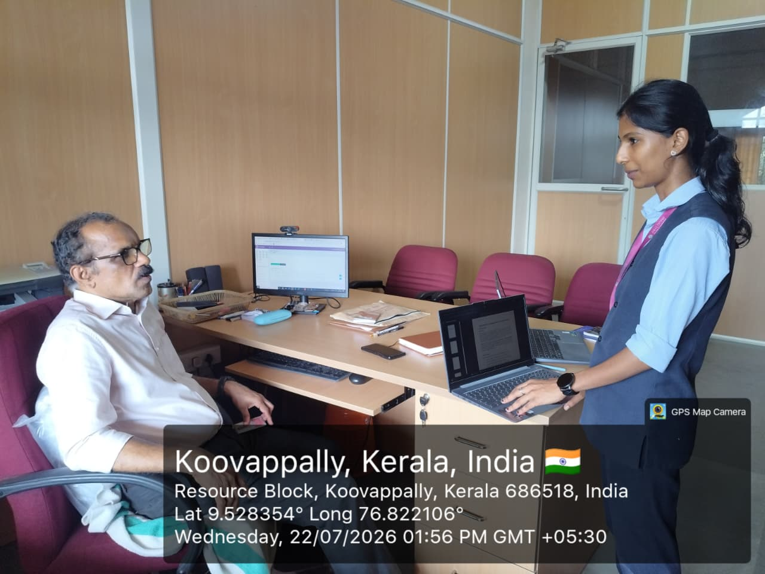
Fig 1: Data Collection for SCHOLARNEXUS

Stakeholder 2
Name: Aleena Joseph
Role: Student Scholar
Contact: aleenaj3758@gmail.com

Questionnaire for Data Collection

1. What challenges do you face while conducting academic research?
Managing invention information, conducting prior-art research, organizing patent references, preparing claims and specifications, managing supporting documents, and coordinating feedback with other people can be challenging when these activities are handled through multiple separate tools.
2. How do you currently manage research papers and references?
Invention details, patent references, documents, claims, specifications, and supporting materials are often maintained using separate documents, folders, cloud storage services, and other individual tools
3. Do you use multiple applications during your research process?
Yes. Different applications or platforms may be used for patent research, document preparation, file storage, communication, collaboration, and task management.
4. Would an AI assistant help you understand research papers more efficiently?
Yes. An AI-assisted system could help users organize technical information, support prior-art research, analyze technical similarity, and provide contextual assistance during patent preparation.
5. How useful would automatic research paper summarization be?
It would be useful because users could organize relevant patent references within the corresponding patent project instead of maintaining research information separately across multiple platforms.
6. Do you find it difficult to compare multiple research papers during literature review?
Yes. Reviewing and comparing technical information manually across multiple patent references can be time-consuming. A structured technical similarity analysis can help users organize this information more efficiently.
7. Which citation format do you use most frequently?
It is very important because claims and specifications form important parts of patent documentation. A centralized workspace can make preparation, version management, collaboration, and review easier.
8. How important is originality checking before submitting a research paper?
Collaboration is important because patent preparation may involve inventors, co-inventors, guides, and patent experts. A centralized review and feedback system can make communication and project tracking easier.
9. Would a centralized platform for faculty feedback improve your research process?
Yes. A centralized system that identifies incomplete activities, pending reviews, deadlines, and required preparation steps can help users understand the current status of a patent project.
10. Are existing research tools providing all these features in a single platform?
Many existing tools focus on individual activities such as patent searching, document preparation, file storage, or communication. Using multiple platforms can make the overall patent preparation process fragmented. PatentHub AI aims to bring the major pre-filing activities together within a single structured platform.

SYSTEM SPECIFICATION

Hardware Specification

Processor – Intel Core i3 or equivalent
RAM – 4 GB minimum, 8 GB recommended
Hard Disk – 500 GB (HDD or SSD preferred)

Software Specification

Front End | : | React.js, HTML5, CSS, Tailwind CSS
Build Tool | : | Vite
Back End | : | Node.js, Express.js
Database | : | MongoDB / MongoDB Atlas
ORM | : | Prisma
Authentication | : | JWT-based Authentication
AI Services | : | AI API / Gemini-based AI integration
File Management | : | Cloudinary
Payment Gateway | : | Razorpay
PDF Generation | : | jsPDF / server-side PDF generation
API Communication | : | REST APIs / Axios
Development Environment | : | Visual Studio Code
Version Control | : | Git
Client on PC | : | Windows 10 and above

SOFTWARE DESCRIPTION

React.js
React.js is a JavaScript library used for building interactive and dynamic user interfaces. It follows a component-based approach, which allows the application interface to be divided into reusable components.
React.js is used in PatentHub AI to develop role-specific dashboards, patent project workspaces, invention documentation interfaces, research pages, claim and specification interfaces, review screens, billing pages, and other interactive components. React.js supports efficient updating of the user interface when data changes. This makes it suitable for PatentHub AI, where users frequently interact with patent projects, research information, claims, specifications, tasks, reviews, and other patent-related information.

Node.js
Node.js is a JavaScript runtime environment that allows JavaScript to be executed on the server side. It is designed for building scalable and efficient web applications and is commonly used for developing backend services and APIs.
In PatentHub AI, Node.js is used to handle server-side operations such as user authentication, patent project management, prior-art research, claim management, specification management, document operations, review workflows, notifications, organization management, billing, and communication between the frontend and database..
3.2.3 Express.js
Express.js is a lightweight web application framework for Node.js. It provides features for creating server-side applications and RESTful APIs in a simple and organized manner.
Express.js is used in PatentHub AI to create backend API routes and handle requests from the frontend. It manages operations related to authentication, patent projects, patent references, claims, specifications, documents, reviews, organizations, policies, notifications, subscriptions, payments, and administrative functions.
3.2.4 PostgreSQL
PostgreSQL is an open-source relational database management system designed for storing and managing structured data. It provides features such as relational data modelling, constraints, indexing, transactions, and secure data management.
PostgreSQL is used in PatentHub AI to store information related to users, roles, organizations, patent projects, project members, tasks, documents, patent references, claims, specifications, reviews, deadlines, filing events, AI analysis records, policies, subscriptions, payments, and other system entities.
3.2.5 Prisma ORM
Prisma is a modern Object-Relational Mapping tool used for interacting with relational databases from TypeScript and JavaScript applications. It provides a strongly typed database client and simplifies database queries and schema management.
In PatentHub AI, Prisma is used to connect the Node.js backend with the PostgreSQL database. It manages database models and relationships associated with users, organizations, patent projects, claims, specifications, reviews, deadlines, subscriptions, payments, and other system data
3.2.6 OpenAI API
The OpenAI API provides artificial intelligence capabilities that can be integrated into software applications. It can be used for generating and processing natural-language responses and assisting users with AI-based tasks. In ScholarNexus AI, the OpenAI API is used to provide AI-assisted research functionality, including the AI Research Assistant and AI-assisted writing support. These features help students obtain research-related assistance and support the development of their academic research work.
3.2.7 JWT Authentication
JSON Web Token (JWT) is a token-based authentication mechanism commonly used for securely transmitting authenticated user information between a client and server.
PatentHub AI uses JWT-based authentication to maintain authenticated user sessions and identify the user's role and organization context. This supports role-based authorization and organization-based access control, ensuring that users can access only the resources and functionalities permitted to them.
3.2.8 Artificial Intelligence API
The AI API provides artificial intelligence capabilities that can be integrated into software applications to process natural-language and technical information.
In PatentHub AI, AI services are used to provide AI-assisted patent research and analysis capabilities. These include innovation-related analysis, technical similarity analysis, contextual assistance, and other supported AI functions. The AI features are designed as assistance tools within the patent preparation workflow and do not replace professional legal evaluation or guarantee patentability.

CHAPTER 4 SYSTEM DESIGN

INTRODUCTION
The development of any software system begins with the system design phase. A well-planned design is essential for developing an efficient, reliable, and user-friendly system. System design involves defining the architecture, components, processes, interactions, and data requirements of the proposed system in sufficient detail for implementation. Regardless of the software development model used, the design phase provides the technical foundation for developing the system and helps ensure that the requirements identified during system analysis are properly translated into system functionalities.
ScholarNexus AI undergoes a systematic design process to organize its different modules and user interactions effectively. The design focuses on providing separate functionalities and access privileges for Students, Faculty, and Administrators. It defines how users interact with research projects, research papers, research works, AI-assisted features, supervision, and administrative functions. The system design also provides a clear representation of the application's structure and interactions, which helps developers understand and implement the system efficiently.

UML DIAGRAM
A Unified Modeling Language (UML) is a standardized modelling language used to visualize, specify, design, and document software systems. UML provides a common visual representation of the structure and behaviour of a software application. It is not a programming language such as Java, C++, or JavaScript; instead, it is a modelling language that helps developers and stakeholders understand the system before and during implementation. UML diagrams can be used to represent different aspects of a software system. The commonly used UML diagrams include:
- Class diagram
- Object diagram
- Use case diagram
- Sequence diagram
- Collaboration diagram
- Activity diagram
- State chart diagram
- Deployment diagram
- Component diagram

USE CASE DIAGRAM

A use case diagram is a graphical representation that shows how different users interact with the functionalities of a system. In the context of ScholarNexus AI, the use case diagram provides a high-level representation of the interactions between Students, Faculty, Administrators, and the system. It helps identify and organize the major functional requirements of the application from the users' perspective and provides a clear understanding of the scope of the system.
The use case diagram of ScholarNexus AI is developed using Unified Modelling Language (UML). It represents the major activities performed by each user role, including research project management, research paper management, AI-assisted research support, citation generation, faculty supervision, research work review, user management, project monitoring, and system statistics.

A use case diagram consists of four key components:
System Boundary: The system boundary encloses all the functionalities provided by the ScholarNexus AI application. It defines the scope of the system and separates the system functionalities from external actors.
Actors:
- Student: A student interacts with the system to create and manage research projects, organize research papers, develop research works, use AI-assisted research features, generate citations, and track research activities.
- Faculty: A faculty member interacts with the system to manage supervision requests, view assigned students and their projects, review research works and papers, monitor student progress, and provide feedback.
- Admin: An administrator is responsible for managing users, verifying faculty members, monitoring research projects and papers, publishing announcements, maintaining system activities, and viewing reports and statistics.

Use Cases: These represent the specific actions that actors can perform within ScholarNexus AI.
- Authentication: Allows users to register and securely log in to the system according to their assigned role.
- Manage Research Projects: Students can create, view, update, and manage their research projects.
- Manage Research Papers: Students can upload, organize, view, and manage reference research papers within their projects.
- AI Research Assistant: Provides AI-assisted support for research-related queries and academic activities.
- Research Work Management: Allows students to create and develop different types of research works within their projects.
- Literature Summary and Comparison: Supports students in understanding and comparing collected research papers.
- Citation Generation: Generates citations for research papers using academic styles such as APA, MLA, Chicago, and IEEE.
- Faculty Supervision: Allows students to submit supervision requests and interact with their assigned faculty members.
- View Assigned Projects: Faculty members can access the projects of students assigned to them.
- Review Research Works: Faculty members can review student research works and provide general or section-level feedback.
- Monitor Student Progress: Faculty members can monitor the research progress and activities of their assigned students.
- Manage Users: Administrators can manage student and faculty user accounts and their statuses.
- Manage Projects and Papers: Administrators can monitor research projects and research papers within the system.
- View System Statistics: Administrators can view system-level statistics, reports, and analytics.
Relationships: Relationships in the use case diagram represent the interactions between the actors and the corresponding functionalities of ScholarNexus AI. They show which system features are accessible to Students, Faculty, and Administrators.
By representing these interactions through a use case diagram, ScholarNexus AI provides a clear overview of the functional requirements and responsibilities of each user role. This helps in understanding the system structure, improving planning, and supporting efficient implementation of the academic research ecosystem.
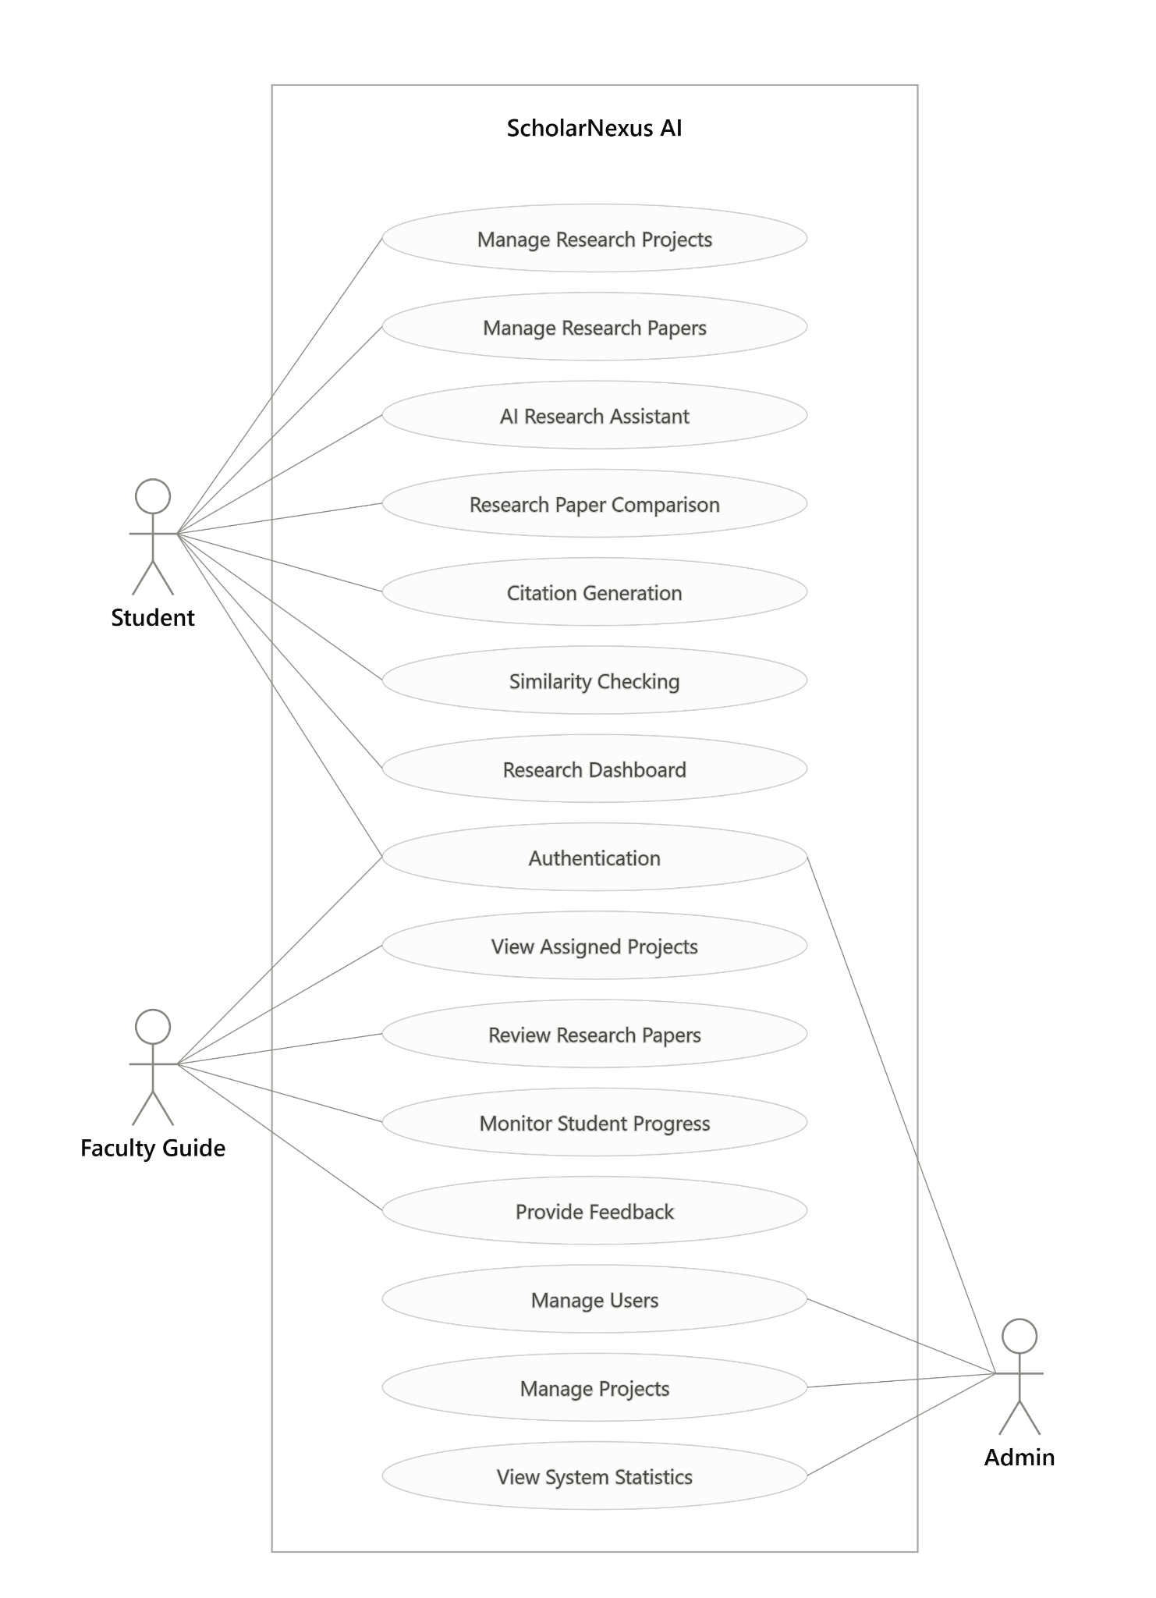

Fig 2: Use case diagram for SCHOLARNEXUS

SEQUENCE DIAGRAM

A sequence diagram is a type of interaction diagram that represents the chronological sequence of interactions between various components of a system. It visually demonstrates how different elements within a system communicate through a series of messages. These diagrams are sometimes referred to as event scenarios or event scenario diagrams. In software engineering, sequence diagrams are widely used to define and understand the requirements of both new and existing systems. They help in visualizing object control relationships and detecting systematic issues.

Sequence Diagram Notations

- Actors
In UML (Unified Modelling Language), an actor represents a role that interacts with the system and its components. Actors are usually external entities such as human users, external systems, or other components that interact with the system. In a UML sequence diagram, actors are represented using a stick person notation. A sequence diagram can have multiple actors, depending on the scenario being modelled.

Lifelines
A lifeline in a sequence diagram is a vertical dashed line that represents the lifespan of an object participating in the interaction. Each lifeline corresponds to an individual participant and is labelled with the name of the participant. The lifeline extends vertically from the participant’s activation point to its deactivation point, showing the timeline of interactions within the system.

Messages
Messages are one of the most essential components of sequence diagrams, representing the interactions and communication between objects or system components. Additionally, guards are used to model conditions and apply restrictions on message flow.

Guards
Guards in UML are conditions that control the flow of messages in a sequence diagram. They define constraints or conditions that must be met before a message is sent. This feature is important for software developers, as it indicates any limitations or conditions associated with a system process.

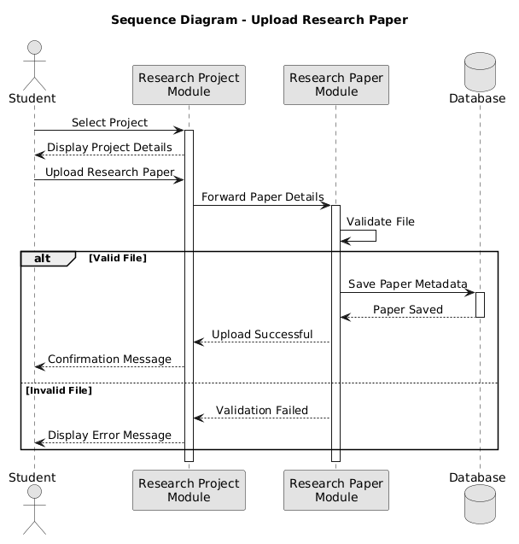
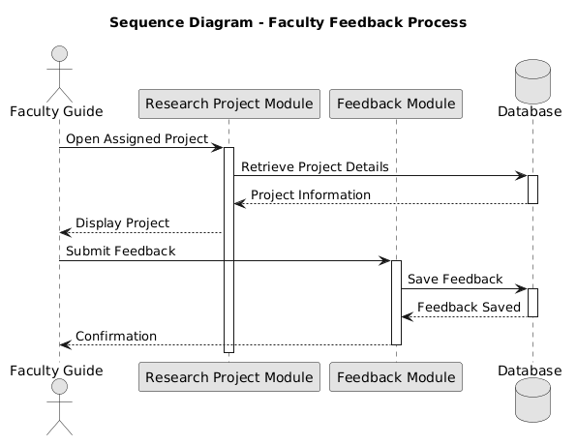

Fig 3: Sequence diagram for SCHOLARNEXUS

State Chart Diagram
A state diagram is a visual representation, often created using the Unified Modeling Language (UML), that shows the different states that an object can exist in and how it can transition between those states It includes various elements such as:
      - Initial State - This state represents the starting point of the system or object and is denoted by a solid black circle.
      - State - This element describes the current state of the system or object at a specific point in time and is represented by a rectangle with rounded corners.
      - Transition - This element shows the movement of the system or object from one state to another and is represented by an arrow.
      - Signal - A message caused by an event sent to a state, causing a transition to occur.
      - Final State - The State Chart Diagram ends with a Final State element
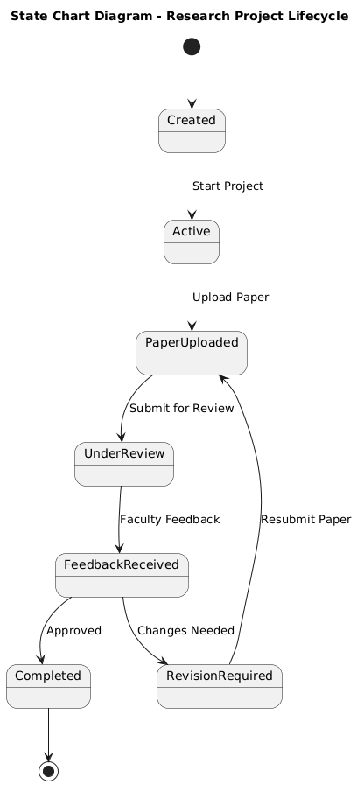

Fig 4: State chart diagram for SCHOLARNEXUS

Activity Diagram
An activity diagram is a visual representation of a workflow that shows how one activity leads to another. An activity is referred to as a system operation, and one operation leads to another in the control flow. A flow can be parallel, concurrent, or branched, and activity diagrams use various functions such as branching, joining, etc., to manage all types of flow control. Activity diagrams are a type of behavior diagram that shows the behavior of a system. They show the flow of control from the start point to the end point and show the different decision paths that exist during the execution of the activity.
The key components of an activity diagram are:
      - Initial node - A starting point of the activity diagram, denoted by a black circle.
      - Activity - A task or action performed by the system or entity, represented by a rectangle with rounded corners.
      - Control flow - It represents the sequence of activities or actions performed by the system or entity, represented by an arrow.
      - Decision node - A decision or branching point in the activity flow, denoted by a diamond shape.
      - Merge node - Used to merge multiple branches of the activity flow into a single flow, represented by a diamond shape with a plus sign inside.
      - Fork node - Used to split the activity flow into multiple parallel flows, represented by a solid black circle with multiple arrows.
      - Join node - Used to join multiple parallel flows back into a single flow, represented by a solid black circle with multiple arrows pointing towards it.
      - Final node - The end point of the activity diagram, denoted by a black circle with a dot inside.
      - Object flow - Represents the flow of objects or data between activities, represented by a dashed arrow.
Activity diagrams are useful in ScholarNexus AI for understanding and documenting complex workflows involving Students, Faculty, and Administrators. They help clarify the sequence of operations, identify decision points and alternative paths, understand parallel activities, and communicate system behaviour effectively to developers and stakeholders. They also provide a clear foundation for implementing and testing the different processes of the system.

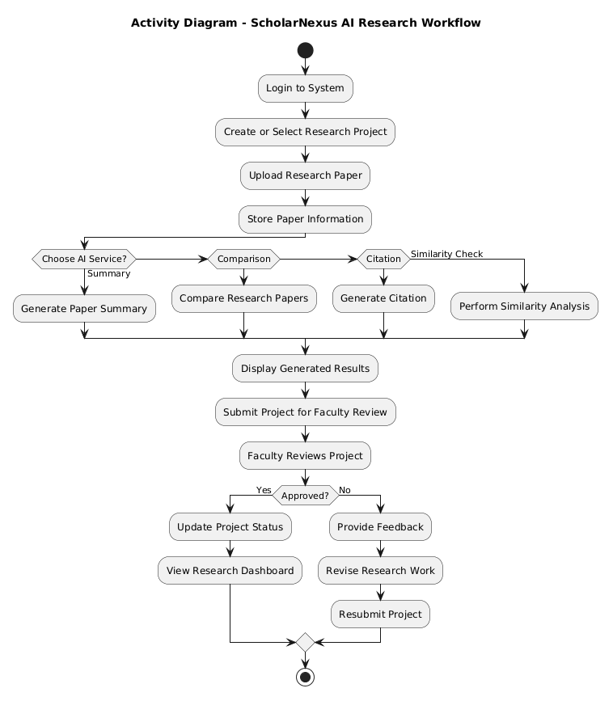

Fig 5: Activity diagram for SCHOLARNEXUS

Class Diagram
A class diagram is a fundamental part of UML that visually represents the structure of a system, including its classes, attributes, methods, and relationships. It provides a blueprint for object-oriented modeling and can be directly translated into programming code or used for database design. Class diagrams help developers understand object interactions, inheritance structures, and dependencies within the system. They consist of several key components:
      - Class: It is a blueprint or template for creating objects and is represented as a rectangle with the class name, attributes, and methods.
      - Interface: It is a collection of abstract methods that specify a contract between a class and the outside world. It is represented as a circle with the interface name inside.
      - Object: It is an instance of a class with state and behavior. It is represented as a rectangle with the object name inside.
      - Association: It is a relationship between two classes that represents a connection or link and is represented as a line with optional directionality, multiplicity, and role names.
      - Aggregation: It is a part-whole relationship where the whole (aggregator) is composed of parts (aggregates) and is represented as a diamond shape on the aggregator side.
      - Composition: It is a stronger form of aggregation where the parts cannot exist without the whole and is represented as a filled diamond shape on the aggregator side.
      - Inheritance: It is a relationship between a superclass and its subclasses that represents an "is-a" relationship and is represented as a line with an open arrowhead pointing from the subclass to the superclass.
      - Multiplicity: It represents the number of instances of a class that can be associated with another class and is represented as a range of values near the association or aggregation line.

The ScholarNexus AI class diagram represents the major entities involved in the academic research ecosystem, including users, research projects, research papers, research works, tasks, notes, supervision requests, reviews, notifications, announcements, and activity records. The User class acts as a central entity with different roles such as Student, Faculty, and Admin. Students can create research projects, organize reference papers, develop research works, manage tasks and notes, and request faculty supervision. Faculty members can manage assigned students, review research works, provide feedback, and monitor research progress. Administrators can manage users, verify faculty registrations, monitor projects and papers, publish announcements, and view system activities and reports.

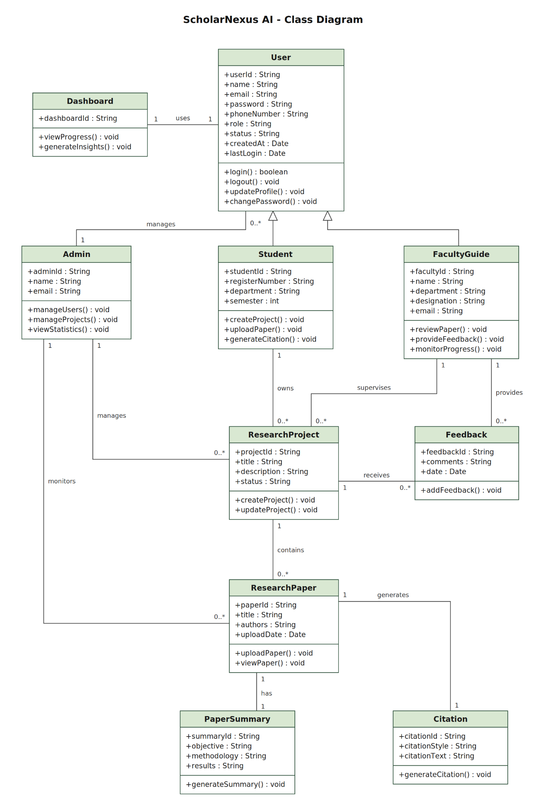
Fig 6: Class diagram for SCHOLARNEXUS

Object Diagram
Object diagrams and class diagrams are closely related in object-oriented modeling. Object diagrams are instances of class diagrams and represent a snapshot of the system at a given moment in time. Both diagrams use similar notation and concepts to depict the structure of a system. While class diagrams define the overall system architecture, including its classes, attributes, and methods, object diagrams illustrate specific objects and their interactions at a particular moment.

An object diagram is a UML structural diagram that visualizes instances of classes and their relationships. The primary components of an object diagram include:
      - Object: An instance of a class representing a real-world entity in the system.
      - Class: A blueprint defining attributes and methods used to create objects.
      - Link: A relationship between objects, representing associations or connections.
      - Attribute: A property of an object that describes its state.
      - Value: A specific setting or instance of an attribute.
      - Operation: A behavior or function that an object can perform.
      - Multiplicity: Defines the number of instances that can be associated with another class.

In the ScholarNexus AI object diagram, objects such as a student, faculty guide, research project, research paper, research work, feedback, citation, and paper summary can be represented as instances of their corresponding classes. These objects demonstrate how a student is associated with a research project and how the project is connected with research papers and research works. A faculty guide can be associated with the assigned research project and provide feedback on the student's research activities.
The object diagram can also illustrate the relationship between a research paper and its associated paper summary and citation. For example, a particular research paper object may have specific values for its title, authors, and upload date, while its corresponding paper summary and citation objects contain their respective generated information. This provides a clear view of the actual data and relationships maintained within the system at a particular moment.
Thus, the object diagram of ScholarNexus AI helps in understanding how the system's classes are instantiated and how their objects are interconnected during research activities. It provides a practical representation of the system structure and complements the class diagram by showing the actual state of the research ecosystem.

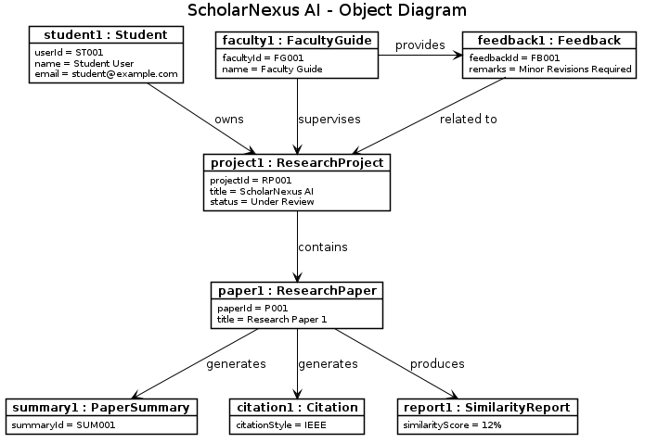

Fig 7: Object diagram for SCHOLARNEXUS

Component Diagram
A component diagram in UML represents the major software components of a system and shows how they are connected and interact with each other. It provides a simple view of the system architecture and helps in understanding how different modules work together to provide the required functionality.
The main components of a component diagram include:
- Component: A modular part of the system that provides a specific functionality.
- Interface: Defines the services provided or required by a component.
- Connector: Shows communication or data exchange between components.
- Dependency: Represents a relationship where one component depends on another component.
In the ScholarNexus AI component diagram, the User Interface (React Frontend) acts as the main interaction layer through which students, faculty members, and administrators access the system. The frontend communicates with the major components such as Authentication, Research Project Management, Research Paper Management, AI Research Assistant, Citation Generator, Faculty Collaboration, and Dashboard & Reporting.
The Node.js and Express backend processes requests from these components and communicates with the MongoDB database for storing and retrieving user, project, research paper, research work, review, and other system data. This component-based structure provides a clear separation of responsibilities and helps ScholarNexus AI maintain an organized, modular, and scalable architecture.

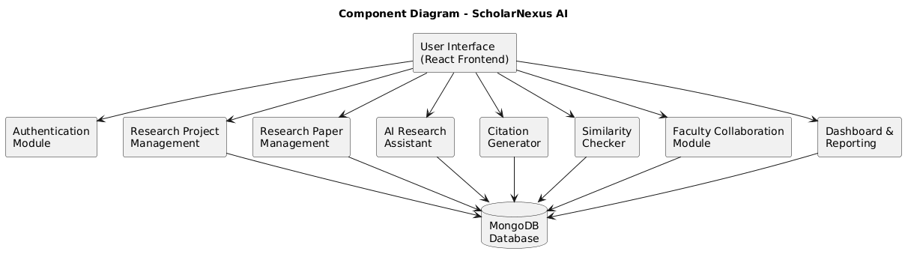

Fig 8: Component diagram for SCHOLARNEXUS

Deployment Diagram
A deployment diagram is a type of UML diagram that represents the physical or virtual environment in which a software system is deployed. It shows the nodes, devices, servers, and communication paths involved in running the system. The diagram helps to understand how the software components are distributed across different nodes and how these nodes communicate with each other.
In the ScholarNexus AI deployment diagram, students, faculty members, and administrators access the system through a web browser over the internet. The React frontend provides the user interface, while the Node.js and Express.js backend server processes user requests and handles application operations. The backend communicates with the MongoDB Atlas database to store and retrieve user information, research projects, research papers, research works, reviews, and other system data. This deployment structure separates the user interface, application processing, and database layers, providing an organized architecture for ScholarNexus AI. It also supports maintainability and scalability by allowing the frontend, backend, and database services to operate as separate components while communicating through the network

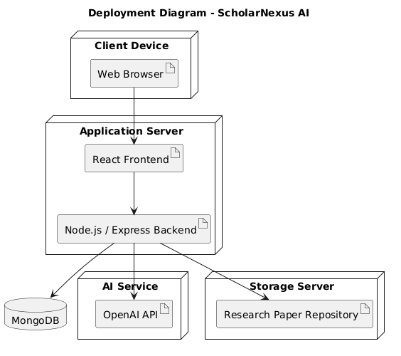

Fig 9: Deployment diagram for SCHOLARNEXUS

USER INTERFACE DESIGN USING FIGMA
Form Name: Register Form
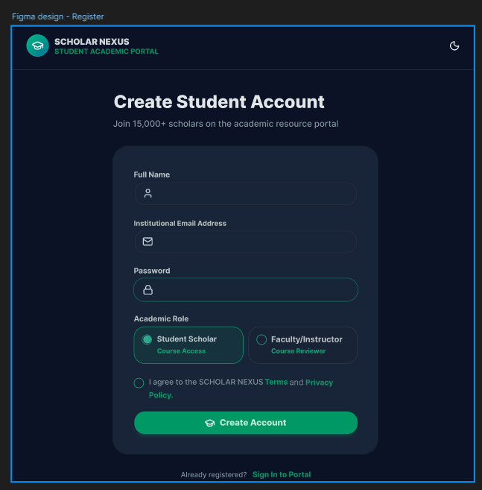
Fig 10 : Registration Form Design

Form Name: Login Form
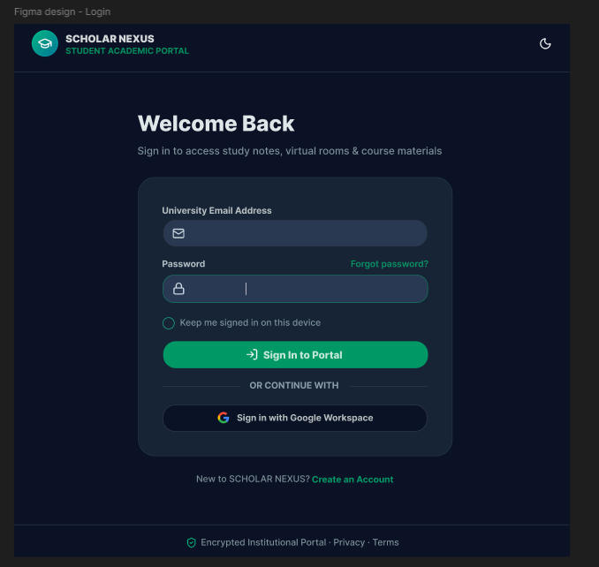
Fig 11: Login Form Design

Form 3: Profile Update Form
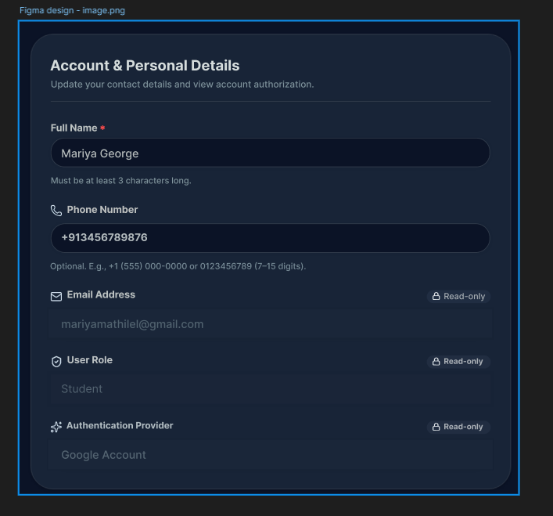
Fig 12: Profile Update Form Design

Form 4: Create New Project Form

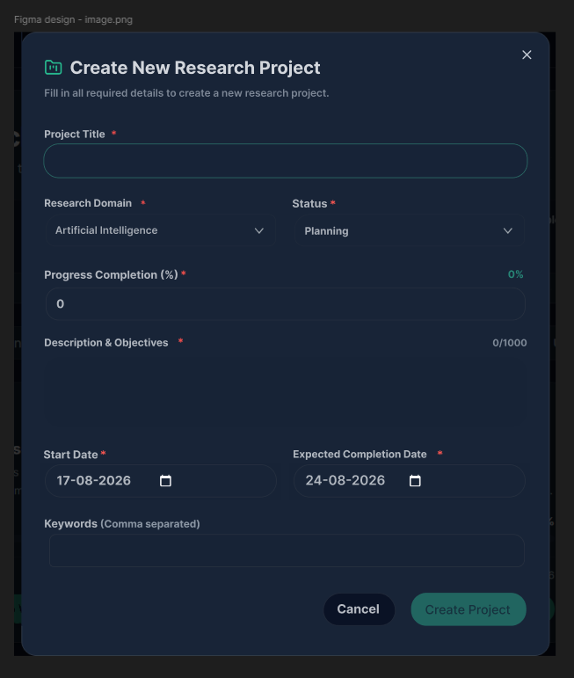
Fig 13: Create New Project Form Design

DATABASE DESIGN
A database is a structured collection of information designed to store, organize, retrieve, and update data efficiently while maintaining data security. In ScholarNexus AI, the database is designed to manage information related to students, faculty members, administrators, research projects, research papers, research works, tasks, notes, supervision requests, reviews, notifications, announcements, and system activities.
The database design process consists of two stages. The first stage, known as information-level design, involves identifying user requirements and determining the data required by different modules of the system. The second stage, known as physical-level design, converts the conceptual database structure into a format suitable for the selected database management system. ScholarNexus AI uses MongoDB as its database, where information is organized into collections based on the functional requirements of the system. The database design also focuses on maintaining data integrity, consistency, security, and controlled access. Relationships between users, research projects, research papers, research works, supervision requests, and reviews are maintained using appropriate identifiers. This structured database design allows ScholarNexus AI to efficiently manage academic research information while supporting future modifications and expansion of the system.

MongoDB Database Management System
MongoDB is a widely used open-source NoSQL database management system that stores data in flexible, JSON-like documents. Unlike relational databases that organize information into tables and rows, MongoDB organizes information into collections and documents. Each document can contain different fields according to the requirements of the stored data, making MongoDB suitable for applications where data structures may evolve over time.
ScholarNexus AI uses MongoDB to store information generated by its different modules. The users collection stores student, faculty, and administrator information, while the projects collection stores research project details. Other collections are used for research papers, research works, tasks, notes, supervision requests, reviews, announcements, notifications, and activity logs. Relationships between these collections are maintained using identifiers such as project IDs, research work IDs, and user email addresses.
MongoDB provides flexibility and scalability for ScholarNexus AI because research-related information can contain different types of content and may change as the system develops. The document-based structure also allows the application to efficiently retrieve information required by student, faculty, and administrator dashboards.

Data Organization
The Data organization is an important part of database design because properly structured data reduces unnecessary duplication and makes information easier to retrieve and maintain. In ScholarNexus AI, data is divided into separate collections according to the functionality of the system.
The major collections include:
- users – Stores student, faculty, and administrator information.
- projects – Stores research project details.
- papers – Stores reference research paper information.
- research_work – Stores research papers, conference papers, review papers, proposals, reports, and other research documents.
- tasks – Stores project-related tasks and their status.
- notes – Stores research-related notes.
- supervision_requests – Stores requests between students and faculty members.
- reviews – Stores faculty reviews and feedback on research works.
- announcements – Stores announcements created by administrators.
- notifications – Stores notifications delivered to users.
- activity_logs – Stores records of important activities performed within the system.
This organization allows each collection to represent a specific area of the ScholarNexus AI system while maintaining logical relationships between related documents.
Data Integrity and Consistency
Data integrity ensures that the information stored in the database remains accurate and consistent. In ScholarNexus AI, identifiers such as projectId, researchWorkId, and user email are used to associate related documents across collections. For example, research papers are associated with their respective research projects, while reviews are associated with the relevant research work and faculty member.
Role-based access is also used to maintain controlled access to information. Students can access their own research projects and activities, faculty members can access projects and research works assigned to them, and administrators can manage system-wide information according to their privileges.
Data Structure and Flexibility
MongoDB's document-based structure allows ScholarNexus AI to store different types of research information without requiring a rigid relational table structure. This is particularly useful because research works can have different types and sections, such as abstracts, introductions, methodologies, results, and conclusions.
The flexible structure also allows new fields and functionalities to be introduced as the platform evolves without requiring major changes to the overall database architecture.

Sanitization
Data sanitization is the process of validating and cleaning data received from external sources before storing or processing it. In ScholarNexus AI, users provide information through registration forms, profile forms, research project forms, paper uploads, research work content, tasks, notes, supervision requests, and reviews. User-provided information must be validated before being stored in MongoDB. Appropriate validation helps prevent invalid or malicious input from affecting the application. Authentication information is also handled securely, with passwords stored in hashed form rather than as plain text. Sanitization and validation are therefore important for maintaining the security, reliability, and consistency of information stored within the ScholarNexus AI database.

Indexing
Indexing is a database technique used to improve the speed of data retrieval. An index allows the database to locate frequently searched information more efficiently instead of examining every document in a collection. In ScholarNexus AI, indexing can be applied to frequently accessed fields such as user email, role, project identifiers, research work identifiers, and other fields commonly used for searching and filtering. Proper indexing helps improve the performance of operations such as retrieving a student's projects, identifying assigned faculty members, loading research papers belonging to a project, and retrieving notifications for a user. Effective indexing is particularly important as the number of users, research projects, papers, and research works increases. It helps maintain efficient database operations while supporting the scalability of the ScholarNexus AI platform.

TABLE DESIGN

- Users Collection

Sl. No. | Field Name | Data Type | Description of the field
1 | _id | ObjectId | Unique user ID
2 | name | String | User full name
3 | email | String | User email address
4 | password | String | Encrypted password
5 | role | String | Student / Faculty / Admin
6 | provider | String | Authentication provider
7 | profileImage | String | Profile picture URL
8 | phone | String | Contact number
9 | institution | String | College or university
10 | department | String | Academic department
11 | designation | String | Faculty designation
12 | facultyId | String | Faculty identification number
13 | researchInterests | Array | Research interests
14 | approvalStatus | String | Pending / Approved / Rejected
15 | status | String | Active / Deleted
16 | createdAt | Date | Registration date
17 | updatedAt | Date | Last updated date

- Research Projects Collection

Sl.No. | Field Name | Data Type | Description of the field
1 | _id | ObjectId | Unique project ID
2 | userEmail | String | Student email
3 | title | String | Research project title
4 | description | String | Project description
5 | abstract | String | Project abstract
6 | domain | String | Research domain
7 | facultyId | String | Assigned faculty reference
8 | faculty | String | Assigned faculty name
9 | facultyEmail | String | Faculty email
10 | supervisionStatus | String | Supervision status
11 | status | String | Planning / Under Review / Ongoing / Completed
12 | progress | Number | Project completion percentage
13 | startDate | Date | Project start date
14 | expectedCompletionDate | Date | Expected completion date
15 | keywords | Array | Project keywords
16 | createdAt | Date | Project creation date
17 | updatedAt | Date | Last updated date

- Research Papers Collection

Sl. No. | Field Name | Data Type | Description of the field
1 | _id | ObjectId | Unique paper ID
2 | projectId | ObjectId | Associated project
3 | userEmail | String | Uploading student's email
4 | title | String | Research paper title
5 | authors | String | Author names
6 | publicationYear | String | Year of publication
7 | journalOrConference | String | Journal or conference name
8 | doi | String | Digital Object Identifier
9 | abstract | String | Paper abstract
10 | keywords | Array | Academic keywords
11 | url | String | PDF file location
12 | fileData | String | Stored PDF document data
13 | uploadDate | Date | Paper upload date
14 | summary | String | Extracted paper summary
15 | aiSummary | Object | Structured AI-generated summary
16 | createdAt | Date | Record creation date
17 | updatedAt | Date | Last updated date

- Research Work Collection

Sl. No. | Field Name | Data Type | Description of the field
1 | _id | ObjectId | Unique research work ID
2 | projectId | ObjectId | Associated project
3 | studentId | String | Student reference
4 | studentEmail | String | Student email
5 | studentName | String | Student name
6 | title | String | Research document title
7 | templateType | String | Research Paper / Research Proposal
8 | abstract | String | Research work abstract
9 | keywords | Array | Research keywords
10 | sections | Array | Research document sections
11 | reviewStatus | String | Pending Review / Reviewed
12 | feedback | String | Faculty feedback
13 | lastSaved | Date | Last saved date
14 | createdAt | Date | Creation date
15 | updatedAt | Date | Last updated date

- Reviews Collection

Sl. No. | Field Name | Data Type | Description of the field
1 | _id | ObjectId | Unique review ID
2 | projectId | ObjectId | Associated project
3 | projectTitle | String | Research project title
4 | studentId | String | Student reference
5 | studentName | String | Student name
6 | studentEmail | String | Student email
7 | facultyId | String | Faculty reference
8 | facultyName | String | Faculty name
9 | documentId | ObjectId | Submitted document reference
10 | documentTitle | String | Submitted document title
11 | fileType | String | Document type
12 | feedback | String | Faculty comments
13 | status | String | Pending Review / Reviewed
14 | requestedAt | Date | Review request date
15 | reviewedAt | Date | Review completion date
16 | createdAt | Date | Review creation date
17 | updatedAt | Date | Last updated date

- Supervision Requests Collection

Sl. No. | Field Name | Data Type | Description of the field
1 | _id | ObjectId | Unique supervision request ID
2 | projectId | ObjectId | Research project reference
3 | projectTitle | String | Research project title
4 | studentId | String | Student reference
5 | studentName | String | Student name
6 | studentEmail | String | Student email
7 | facultyId | String | Faculty reference
8 | facultyName | String | Faculty name
9 | facultyEmail | String | Faculty email
10 | domain | String | Research domain
11 | abstract | String | Project abstract
12 | message | String | Supervision request message
13 | status | String | Pending / Approved / Rejected
14 | facultyRemarks | String | Faculty remarks
15 | requestedAt | Date | Request date
16 | respondedAt | Date | Response date
17 | createdAt | Date | Creation date
18 | updatedAt | Date | Last updated date

- Tasks Collection

Sl. No. | Field Name | Data Type | Description of the field
1 | _id | ObjectId | Unique task ID
2 | userEmail | String | User email
3 | projectId | ObjectId | Associated project
4 | projectTitle | String | Research project title
5 | title | String | Task title
6 | description | String | Task description
7 | priority | String | Low / Medium / High / Urgent
8 | status | String | Pending / In Progress / Completed
9 | dueDate | Date | Task due date
10 | createdAt | Date | Task creation date
11 | updatedAt | Date | Last updated date

- Notes Collection

Sl. No. | Field Name | Data Type | Description of the field
1 | _id | ObjectId | Unique note ID
2 | userEmail | String | User reference
3 | projectId | ObjectId | Associated project
4 | title | String | Note title
5 | content | String | Note content
6 | createdAt | Date | Note creation date
7 | updatedAt | Date | Last updated date

- Notifications Collection

Sl. No. | Field Name | Data Type | Description of the field
1 | _id | ObjectId | Unique notification ID
2 | userId | ObjectId | Recipient user reference
3 | title | String | Notification title
4 | message | String | Notification message
5 | type | String | Info / Success / Warning
6 | isRead | Boolean | Read status
7 | createdAt | Date | Notification date

- Announcements Collection

Sl. No. | Field Name | Data Type | Description of the field
1 | _id | ObjectId | Unique announcement ID
2 | title | String | Announcement title
3 | message | String | Announcement content
4 | createdBy | String | Creator of announcement
5 | targetRole | String | Target user role
6 | createdAt | Date | Announcement date
7 | updatedAt | Date | Last updated date

- Activity Logs Collection

Sl. No. | Field Name | Data Type | Description of the field
1 | _id | ObjectId | Unique activity log ID
2 | userId | ObjectId | User who performed the activity
3 | userEmail | String | User email
4 | action | String | Activity performed
5 | module | String | Module where activity occurred
6 | description | String | Activity description
7 | projectId | ObjectId | Related project
8 | createdAt | Date | Activity timestamp

CHAPTER 5 SYSTEM TESTING

INTRODUCTION
System testing is the process of evaluating a complete software system to verify that it functions according to the specified requirements. It is an important stage of software development that helps identify errors, verify system functionality, and ensure that the developed system meets the expected user requirements.
In ScholarNexus AI, system testing is performed to verify the functionality of the Student, Faculty, and Admin modules and their interaction with the backend and database. The testing process covers important functionalities such as user registration and login, research project management, reference paper management, research work creation, AI-assisted features, literature summaries and comparisons, citation generation, tasks and notes, faculty supervision, research work reviews, announcements, user management, faculty approval, activity logs, and reports and analytics.
Different testing techniques are used to verify the reliability and correctness of ScholarNexus AI. Functional testing verifies whether each feature performs according to its requirements. Integration testing checks the interaction between different modules and system components. Validation testing evaluates the complete system using different input conditions. User acceptance testing verifies whether the system is understandable and suitable for its intended users. Automation testing is used to execute repetitive web-based test cases efficiently and identify regression issues.
The main objectives of system testing are:
- To verify that all system functionalities operate as specified.
- To identify and correct errors in the system.
- To verify proper interaction between different modules.
- To validate input processing and system outputs.
- To verify role-based access for Student, Faculty, and Admin users.
- To ensure that existing functionality continues to work after modifications.
- To verify the usability and reliability of the system.
System testing therefore helps ensure that ScholarNexus AI is functioning correctly and is ready for practical use.

TEST PLAN

A test plan outlines the series of steps required to carry out different testing methodologies. It describes the testing activities to be performed for ScholarNexus AI and defines the areas of the system that need to be verified. The developers are responsible for testing the individual components of the system to ensure that each component performs its intended function correctly.
For ScholarNexus AI, the test plan covers the major modules and workflows of the system, including user authentication, research project management, reference paper management, research work, AI-assisted features, literature-related functions, citation generation, tasks and notes, faculty supervision, reviews and feedback, and administrative functions. The testing process is carried out using suitable test data and expected results to identify errors and verify the correctness of the system.
The levels of testing include:
- Unit Testing
- Integration Testing
- Data Validation Testing
- Output Testing
- Automation Testing
- Selenium Testing

Unit Testing
Unit testing concentrates verification efforts on individual software components or modules, which represent the smallest testable units of the software. The component-level design is used as a guide for testing important control paths and identifying faults within each module. Unit testing verifies that individual components perform their intended functions correctly before they are integrated with other parts of the system. Individual components such as user authentication, registration, project operations, research work, reference paper management, tasks and notes, citation generation, supervision requests, reviews, and administrative functions are tested separately. The interfaces of these components are tested to ensure that data enters and exits the software unit correctly. Input validation and stored data are also checked to ensure that information remains consistent during processing. Boundary conditions are tested to verify that the system handles valid limits and invalid inputs correctly. Error-handling paths are also tested to ensure that appropriate responses are provided when an error occurs. Unit testing therefore helps identify errors within individual modules before they affect the integrated system.

Integration Testing
Integration testing is a methodical approach for creating the program's structure while also carrying out tests to find interface issues. The goal is to construct a program structure that has been determined by design using unit tested components. The program as a whole is tested. Correction is challenging since the size of the overall program makes it challenging to isolate the causes. As soon as these mistakes are fixed, new ones arise, and the process repeats itself in an apparently unending cycle. All of the modules were integrated after unit testing was completed in the system to check for any interface inconsistencies. A distinctive program structure also developed when discrepancies in program structures were eliminated.

Validation Testing or System Testing

The testing process concludes at this stage. This phase involves evaluating the entire system, including all forms, code, modules, and class modules. This type of testing is commonly referred to as system testing or black-box testing. The black-box testing approach primarily focuses on verifying the functional requirements of the software. For example, using black-box testing, a software engineer can design sets of input conditions to thoroughly test every program requirement. Black-box testing aims to identify the following types of issues: erroneous or missing functions, interface errors, data structure or external data access errors, performance issues, initialization errors, and termination errors.

Output Testing or User Acceptance Testing
The system under consideration is tested for user acceptance to ensure that it meets the firm’s needs. The software should maintain alignment with the intended system and involve user feedback during development, making necessary modifications as required. This process is carried out with respect to the following aspects:
      - Input Screen Designs
      - Output Screen Designs
The above testing is conducted using various types of test data. The preparation of test data plays a vital role in system testing. Once the test data is prepared, the system is tested using this data. During testing, errors identified through test data are addressed, and corrections are made accordingly. These corrections are documented to ensure the system's accuracy and reliability.

Automation Testing
Software and other computer products are tested automatically to ensure that they comply with the required guidelines. Essentially, it is a test to verify that the software functions exactly as intended. Automation testing helps identify errors, defects, and other issues that may arise during the development of the system. This type of testing can be conducted at any time and involves analyzing the software using predefined test scripts and sequences. After execution, automation testing summarizes the findings, allowing the results to be reviewed and compared with previous test runs to track system performance and detect possible regressions.

Selenium Testing
Selenium is an open-source tool that automates web browsers and is widely used for testing web applications. It provides a unified interface that allows users to create test scripts in various programming languages, including Python, Java, C#, Ruby, and JavaScript. Selenium testing is used in the system to automate web application testing and verify important user workflows through browser interactions. It helps test functions such as login, navigation, profile operations, project-related activities, and other web-based features. As a free and open-source tool, Selenium improves the efficiency of web application testing and helps ensure that the application functions correctly during repeated test execution.

Test Case 1: Login Test Code
# Generated by Selenium IDE
import pytest
import time
import json
from selenium import webdriver
from selenium.webdriver.common.by import By
from selenium.webdriver.common.action_chains import ActionChains
from selenium.webdriver.support import expected_conditions
from selenium.webdriver.support.wait import WebDriverWait
from selenium.webdriver.common.keys import Keys
from selenium.webdriver.common.desired_capabilities import DesiredCapabilities

class TestLogin():
def setup_method(self, method):
self.driver = webdriver.Chrome()
self.vars = {}

def teardown_method(self, method):
self.driver.quit()

def test_login(self):
# Test name: Login
# Step # | name | target | value
# 1 | open | / |
self.driver.get("http://localhost:8080/")
# 2 | setWindowSize | 1056x802 |
self.driver.set_window_size(1056, 802)
# 3 | click | css=.sm\3Ainline |
self.driver.find_element(By.CSS_SELECTOR, ".sm\\3Ainline").click()
# 4 | click | id=email |
self.driver.find_element(By.ID, "email").click()
# 5 | type | id=email | mariyamathilel@gmail.com
self.driver.find_element(By.ID, "email").send_keys("mariyamathilel@gmail.com")
# 6 | click | id=password |
self.driver.find_element(By.ID, "password").click()
# 7 | type | id=password | wwwwwwwww
self.driver.find_element(By.ID, "password").send_keys("wwwwwwwww")
# 8 | click | css=.bg-emerald-600 |
self.driver.find_element(By.CSS_SELECTOR, ".bg-emerald-600").click()
Screenshot
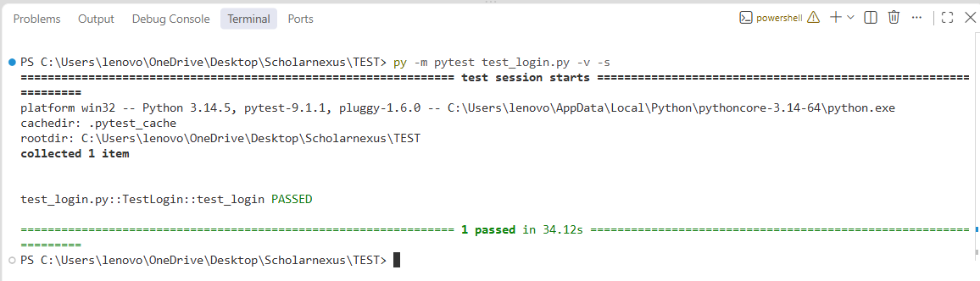

Fig 14: Tested login successfully
Test Report

Test Case 1
Project Name: SCHOLARNEXUS
Login Test Case
Test Case ID: Test_1 |  |  | Test Designed By: Mariya George
Test Priority(Low/Medium/High):High |  |  | Test Designed Date: 09-09-2026
Module Name: Login Page |  |  | Test Executed By : Ms Meera Rose Mathew
Test Title : Verify Login with valid username and  password |  |  | Test Execution Date: 09-09-2026
Description: Login page test
Pre-Condition :User has valid username and password
Step | Test Step | Test Data | Expected  Result | Actual  Result | Status(Pass/  Fail)
1 | Navigate to  the login page |  | Display the  login page | Login Page  displayed | Pass
2 | Valid username  entered | mariyamathilel@gmail.com | User should enter the dashboard | User entered the dashboard | Pass
3 | Valid password  entered | wwwwwwwww | User should enter the dashboard | User entered the dashboard | Pass
4 | Click on  login button
Post-Condition: Username and password is checked with database values for successful login.

Test Case 2: Add Note Test

Code
# Generated/modified from Selenium IDE recording
import pytest
import time
from selenium import webdriver
from selenium.webdriver.common.by import By
from selenium.webdriver.support.ui import WebDriverWait
from selenium.webdriver.support import expected_conditions as EC

class TestAddNote():
def setup_method(self, method):
self.driver = webdriver.Chrome()
self.vars = {}
self.wait = WebDriverWait(self.driver, 15)
def teardown_method(self, method):
self.driver.quit()
def test_addNote(self):
self.driver.get("http://localhost:8080/")
self.driver.set_window_size(1051, 797)
self.wait.until(

EC.element_to_be_clickable(
(By.CSS_SELECTOR, ".sm\\3Ainline")
)
).click()
email = self.wait.until(
EC.visibility_of_element_located((By.ID, "email"))
)
email.click()
email.send_keys("mariyamathilel@gmail.com")

password = self.wait.until(
EC.visibility_of_element_located((By.ID, "password"))
)
password.click()
password.send_keys("wwwwwwwww")

login_button = self.wait.until(
EC.element_to_be_clickable(
(By.CSS_SELECTOR, ".bg-emerald-600")
)
)
login_button.click()
self.wait.until(
lambda driver: "/login" not in driver.current_url
)

tasks_notes = self.wait.until(
EC.element_to_be_clickable(
(By.LINK_TEXT, "Tasks & Notes")
)
)
tasks_notes.click()
notes_icon = self.wait.until(
EC.element_to_be_clickable(
(By.CSS_SELECTOR, ".lucide-sticky-note")
)
)

notes_icon.click()
add_note_button = self.wait.until(
EC.element_to_be_clickable(
(By.CSS_SELECTOR, ".shadow-md")
)
)

add_note_button.click()
title = self.wait.until(

EC.visibility_of_element_located(
(By.CSS_SELECTOR, ".space-y-1\\.5:nth-child(1) > .py-1")
)
)
title.click()
title.send_keys("Review")
content = self.wait.until(
EC.visibility_of_element_located(
(By.CSS_SELECTOR, ".min-h-\\[60px\\]")
)
)
content.click()
content.send_keys("Add note testing")
save_button = self.wait.until(
EC.element_to_be_clickable(
(By.CSS_SELECTOR, ".text-primary-foreground:nth-child(2)")
)
)
save_button.click()

Screenshot

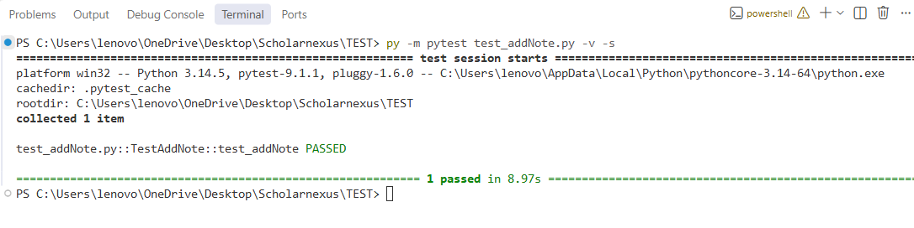
Fig 14: Tested addNote successfully

Test Report

Test Case 2
Project Name: SCHOLARNEXUS
Add Note Test Case
Test Case ID: Test_2 |  |  | Test Designed By: Mariya George
Test Priority(Low/Medium/High):  Medium |  |  | Test Designed Date: 10-09-2026
Module Name: Add Note Page |  |  | Test Executed By : Ms Meera Rose Mathew
Test Title : Adding a note to the Notes section |  |  | Test Execution Date: 10-09-2026
Description: Adding note page test
Pre-Condition : Enter any note
Step | Test Step | Test Data | Expected  Result | Actual  Result | Status(Pass/  Fail)
1 | Navigate to  the login page |  | Display the login page | Login Page displayed | Pass
2 | Valid username  entered | mariyamathilel@gmail.com |  | User entered the dashboard | Pass
3 | Valid password  entered | wwwwwwwww | User should enter the dashboard
4 | Click on login  button
5 | Navigate to add note page |  | Adding Note page should be  visible | Adding Note page is visible. | Pass
6 | A new note is entered | Review | Note should be successfully added and it should be displayed in  the list. | Note added and displayed. | Pass
7 | Click on the  + button
Post-Condition: A new note should be entered.

Test Case 3: Citation Generator test

Code
# Generated by Selenium IDE
import pytest
import time

from selenium import webdriver
from selenium.webdriver.common.by import By
from selenium.webdriver.support import expected_conditions as EC
from selenium.webdriver.support.wait import WebDriverWait

class TestCitationGenerator():

def setup_method(self, method):
self.driver = webdriver.Chrome()
self.vars = {}
self.wait = WebDriverWait(self.driver, 20)

def teardown_method(self, method):
self.driver.quit()

def test_citationGenerator(self):

self.driver.get("http://localhost:8080/")
self.driver.set_window_size(1056, 802)

self.driver.find_element(
By.CSS_SELECTOR,
".sm\\3Ainline"
).click()

email = self.wait.until(
EC.element_to_be_clickable(
(By.ID, "email")
)
)
email.click()
email.send_keys("mariyamathilel@gmail.com")

self.wait.until(
lambda driver:
driver.find_element(By.ID, "email").get_attribute("value")
== "mariyamathilel@gmail.com"
)

password = self.wait.until(
EC.element_to_be_clickable(
(By.ID, "password")
)
)
password.click()
password.send_keys("wwwwwwwww")

self.wait.until(
lambda driver:
len(
driver.find_element(
By.ID,
"password"
).get_attribute("value")
) > 0
)

login_button = self.wait.until(
EC.element_to_be_clickable(
(By.CSS_SELECTOR, ".bg-emerald-600")
)
)

login_button.click()

self.wait.until(
lambda driver:
"/login" not in driver.current_url
)

workspace_button = self.wait.until(
EC.element_to_be_clickable(
(By.CSS_SELECTOR, ".shadow-md")
)
)

workspace_button.click()

self.wait.until(
EC.presence_of_element_located(
(By.TAG_NAME, "body")
)
)

citation_tab = self.wait.until(
EC.element_to_be_clickable(
(
By.XPATH,
"//button[contains(normalize-space(.), 'Citation Generator')]"
)
)
)

citation_tab.click()

self.wait.until(
lambda driver:
"Citation Generator" in
driver.find_element(
By.TAG_NAME,
"body"
).text
)

paper_dropdown = self.wait.until(
EC.element_to_be_clickable(
(
By.CSS_SELECTOR,
".w-full:nth-child(3)"
)
)
)

paper_dropdown.click()

paper_option = self.wait.until(
EC.element_to_be_clickable(
(
By.CSS_SELECTOR,
".bg-muted:nth-child(2)"
)
)
)

paper_option.click()

format_button = self.wait.until(
EC.element_to_be_clickable(
(
By.CSS_SELECTOR,
".hover\\3A.bg-primary\\/90"
)
)
)

format_button.click()

self.wait.until(
lambda driver:
any(
text in driver.find_element(
By.TAG_NAME,
"body"
).text
for text in [
"APA Citation Format",
"MLA Citation Format",
"Chicago Citation Format",
"IEEE Citation Format"
]
)
)

print(
"\nCitation Generator test reached generated citation successfully."
)

Screenshot

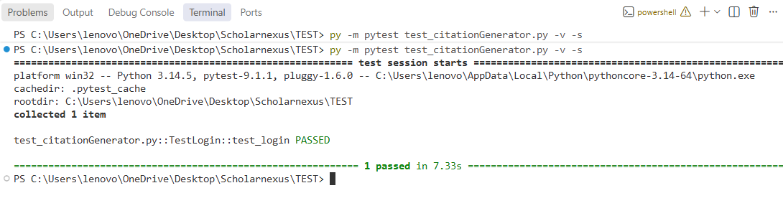

Fig 15: Tested citation generator successfully

Test Report

Test Case 3
Project Name: SCHOLARNEXUS
Login Test Case
Test Case ID: Test_3 |  |  | Test Designed By: Mariya George
Test Priority(Low/Medium/High):High |  |  | Test Designed Date: 09-09-2026
Module Name: Citation Generator Page |  |  | Test Executed By : Ms Meera Rose Mathew
Test Title : Verify Login with valid username and  password |  |  | Test Execution Date: 09-09-2026
Description: Login page test
Pre-Condition :User has valid username and password
Step | Test Step | Test Data | Expected Result | Actual Result | Status (Pass/Fail)
1 | Navigate to the login page |  | Login page should be displayed | Login page displayed | Pass
2 | Enter valid username | mariyamathilel@gmail.com | Username should be accepted | Username entered successfully | Pass
3 | Enter valid password | wwwwwwwww | Password should be accepted | Password entered successfully | Pass
4 | Click on login button |  | User should enter the dashboard | User entered the dashboard | Pass
5 | Open Project Workspace |  | Project workspace should be displayed | Project workspace displayed | Pass
6 | Navigate to Citation Generator |  | Citation Generator page should be visible | Citation Generator page is visible | Pass
7 | Select a research paper from the dropdown | Research paper | Selected paper should be displayed for citation generation | Research paper selected successfully | Pass
8 | Select a citation format | APA / MLA / Chicago / IEEE | Citation should be generated in the selected format | Citation generated successfully | Pass
9 | Verify the generated citation | Generated citation | Generated citation should be displayed correctly | Generated citation displayed | Pass
Post-Condition: A citation should be generated for the selected research paper in the chosen citation format.

Test Case 4: Profile updation Code
# Generated by Selenium IDE
import pytest
import time
from selenium import webdriver
from selenium.webdriver.common.by import By
from selenium.webdriver.common.action_chains import ActionChains
from selenium.webdriver.support import expected_conditions
from selenium.webdriver.support.wait import WebDriverWait

class TestProfileUpdate():
def setup_method(self, method):
self.driver = webdriver.Chrome()
self.vars = {}

def teardown_method(self, method):
self.driver.quit()

def test_profileUpdate(self):
self.driver.get("http://localhost:8080/")
self.driver.set_window_size(1056, 802)

self.driver.find_element(
By.CSS_SELECTOR,
".sm\\3Ainline"
).click()

self.driver.find_element(
By.ID,
"email"
).click()
self.driver.find_element(
By.ID,
"email"
).send_keys("mariyamathilel@gmail.com")

self.driver.find_element(
By.ID,
"password"
).click()
self.driver.find_element(
By.ID,
"password"
).send_keys("wwwwwwwww")

self.driver.find_element(
By.CSS_SELECTOR,
".bg-emerald-600"
).click()

time.sleep(3)

WebDriverWait(
self.driver,
15
).until(
expected_conditions.presence_of_element_located(
(By.TAG_NAME, "body")
)
)

profile_trigger = WebDriverWait(
self.driver,
15
).until(
expected_conditions.presence_of_element_located(
(
By.CSS_SELECTOR,
"[class*='sm:inline-block']"
)
)
)

ActionChains(
self.driver
).move_to_element(profile_trigger).perform()

time.sleep(1)

WebDriverWait(
self.driver,
10
).until(
expected_conditions.element_to_be_clickable(
(
By.CSS_SELECTOR,
"[class*='sm:inline-block']"
)
)
).click()

time.sleep(1)

my_profile = WebDriverWait(
self.driver,
15
).until(
expected_conditions.element_to_be_clickable(
(
By.XPATH,
"//*[normalize-space()='My Profile']"
)
)
)

my_profile.click()

full_name = WebDriverWait(
self.driver,
15
).until(
expected_conditions.visibility_of_element_located(

(By.ID, "fullName")
)
)

full_name.click()
full_name.clear()
full_name.send_keys("Mariya Georgeh")

save_button = WebDriverWait(
self.driver,
15
).until(
expected_conditions.element_to_be_clickable(
(By.CSS_SELECTOR, ".shadow")
)
)

save_button.click()

time.sleep(2)

print("\nProfile Update test completed successfully.")

Screenshot

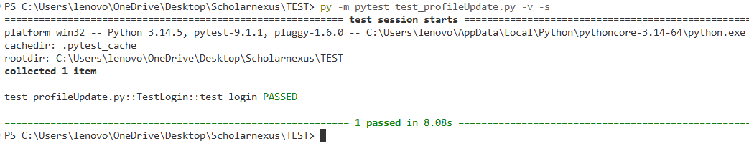
Fig 16: Test profile update successfully

Test Report

Test Case 4
Project Name: SCHOLARNEXUS
Profile Updation Test Case
Test Case ID: Test_4 | Test Designed By: Mariya George
Test Priority(Low/Medium/High):High | Test Designed Date: 09-09-2026
Module Name: Update profile | Test Executed By : Ms Meera Rose Mathew
Test Title:Profile updation of the user | Test Execution Date: 09-09-2026

Description: Profile updation
Pre-Condition : Username and profile details can be updated.
Step | Test Step | Test Data | Expected Result | Actual  Result | Status(Pass/  Fail)
1 | Navigate to  the login page |  | Display the login  page | Login Page displayed | Pass
2 | Valid  username entered | mariyamathilel@gmail.com | User should enter the dashboard | User entered the dashboard | Pass
3 | Valid  password entered | wwwwwwwww | User should enter the dashboard | User entered the dashboard | Pass
4 | Click on login  button |  | User should enter the dashboard | User entered the dashboard | Pass
5 | Navigate to the  Profile |  | Profile updation page should be visible | Profile updation  page is visible | Pass
 | Updation |  | Profile updation page should be visible
 | Page |  | Profile updation page should be visible
6 | Change username | Mariya Georgeh | User should successful ly  update profile and updated content should be  visible | User update the profile successfully | Pass
7 | Click on |  |  | and update
 | update  profile |  |  | content is visible
Post-Condition: Username and profile details can be entered.

CHAPTER 6 IMPLEMENTATION

INTRODUCTION
The implementation phase of a project is where the conceptual design is transformed into a functional system. It is considered the most crucial stage in developing a successful new system, as it ensures that the system operates as intended, providing users with confidence in its reliability and accuracy. The primary focus of this phase is user documentation and training. Typically, system conversion occurs either during or after user training. Implementation involves turning a newly designed system into an operational one, effectively putting it into use.
During this phase, the user department bears the majority of the workload, experiences the most disruption, and has the greatest impact on the existing system. If implementation is not carefully planned and managed, it can lead to confusion and chaos. This phase includes all steps required to transition from the old system to the new one. The new system may entirely replace an existing manual or automated system, or it may be a modified version of an existing system designed for improved functionality. To meet organizational needs, a properly implemented system must be reliable and well-structured.
System implementation refers to the process of deploying and using the newly developed system. It includes all procedures involved in transitioning from the old system to the new one. The system can only be fully implemented after thorough testing and confirmation that it meets the required standards. System personnel assess the system's feasibility before deployment. The more complex the system, the more detailed the system analysis and design effort required to ensure successful implementation. The three key aspects of this phase are education and training, system testing, and changeover.
The implementation phase involves the following tasks:
- Careful planning.
- Investigation of the system and constraints.
- Design of methods to achieve a smooth changeover.

IMPLEMENTATION PROCEDURES
Software implementation involves the complete deployment of the software package in its intended environment, ensuring that it functions as required and meets its intended applications. Often, individuals or organizations that may not be the end users of the system commission software development projects. Initially, users may have concerns about adopting the new software, so it is important to minimize resistance by ensuring the following:
- Users understand the benefits of transitioning to the new system.

- Confidence in the software is established through proper support and training.
- Comprehensive guidance is provided to help users become comfortable with the application. Before interacting with the system, users should be aware that the server program must be running to view the results. If the server object is not active, the system’s core processes will not function as expected. Proper instructions and system readiness are essential to ensure a smooth implementation and user experience.

User Training
The purpose of user training is to prepare users to test and adapt to the system. Those involved must have confidence in their ability to contribute to the system’s goals and the expected benefits of the computer-based system. As systems become more complex, the need for training increases. Through user training, users learn how to enter data, handle error messages, query the database, access routines for generating reports, and perform other essential tasks.

Training on the Application Software

The user must first receive essential basic training on computer awareness, followed by instruction on the new application software. This training will cover the fundamental principles of using the new system, including how the screens function, the type of help displayed, common errors encountered during data entry, how each entry is validated, and how to modify entered data. When providing training on the application, it should focus on the specific information required by the user or group to operate the system or a particular component effectively.

System Maintenance
Maintenance is a crucial yet often challenging aspect of system development. The maintenance phase of the software lifecycle is when the software is actively in use and continues to serve its intended purpose. Once a system is successfully implemented, it must be properly maintained to ensure its smooth operation. System maintenance plays a vital role in the software development life cycle, allowing the system to adapt to changes in its environment. However, software maintenance goes beyond just fixing errors—it involves enhancements, optimizations, and ensuring long-term reliability.

Hosting
Hosting refers to the process of storing and securing a project on an online platform, making it accessible over the internet. Web hosting specifically refers to the hosting of websites, allowing

projects that were previously stored and maintained locally to be deployed on online hosting platforms. This enables users to access the website from anywhere using the internet.

IIS (Internet Information Services) – Windows 11 Hosting
IIS is a built-in Windows tool used to host websites on your computer. You can make your website accessible online using a domain and port forwarding.
Steps to host a project using IIS:
      - Enable IIS from Windows Features.
      - Download and set up PHP support.
      - Create a new website in IIS and assign port 443 (HTTPS).
      - Apply an SSL certificate to secure the site.
      - Set the website folder path.
      - Set up DDNS and configure subdomain using CNAME record.
      - Do port forwarding for port 443 in your router.

Procedure for hosting a website using IIS:
Step 1: Enable IIS
Go to Control Panel → Programs → Turn Windows features on or off → Enable Internet Information Services.

Step 2: Download PHP
Download PHP and extract it to a folder (e.g., C:\php). Set this path in IIS → Handler Mappings.

Step 3: Create Website in IIS
Open IIS Manager → Right-click Sites → Add Website. Set: Site Name
Physical Path (project folder) Binding: HTTPS → Port 443

Step 4: Apply SSL Certificate
Assign SSL certificate for HTTPS in the site’s bindings.

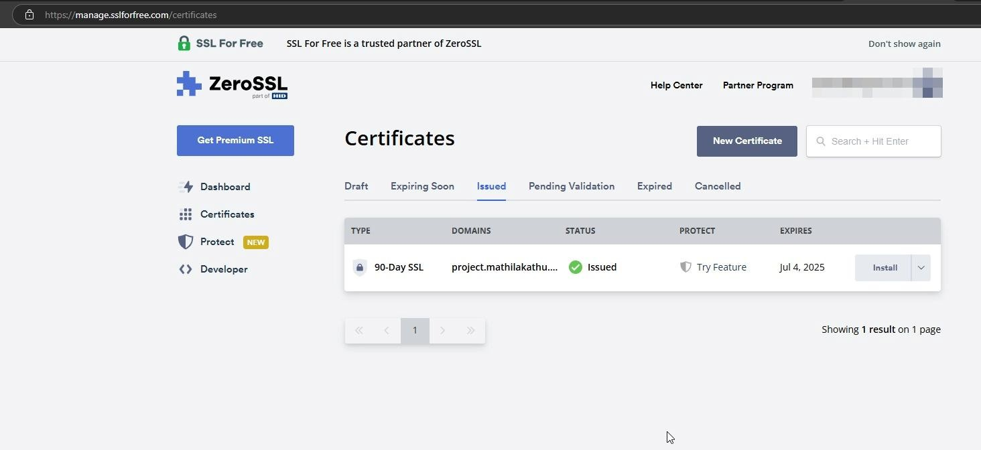
Fig 17: Assigned SSL certificate

Step 5: Set up DDNS and Domain Use a DDNS (like No-IP).
In your domain settings, add a CNAME record: Subdomain: project
Points to: your DDNS domain.

Step 6: Port Forwarding
Forward port 443 to your system’s local IP in router settings.

Hosted Website:
Hosted Link: https://project.mathilakathu.co.in Hosted Link QR Code:


Fig 18: QR code

Screenshot:
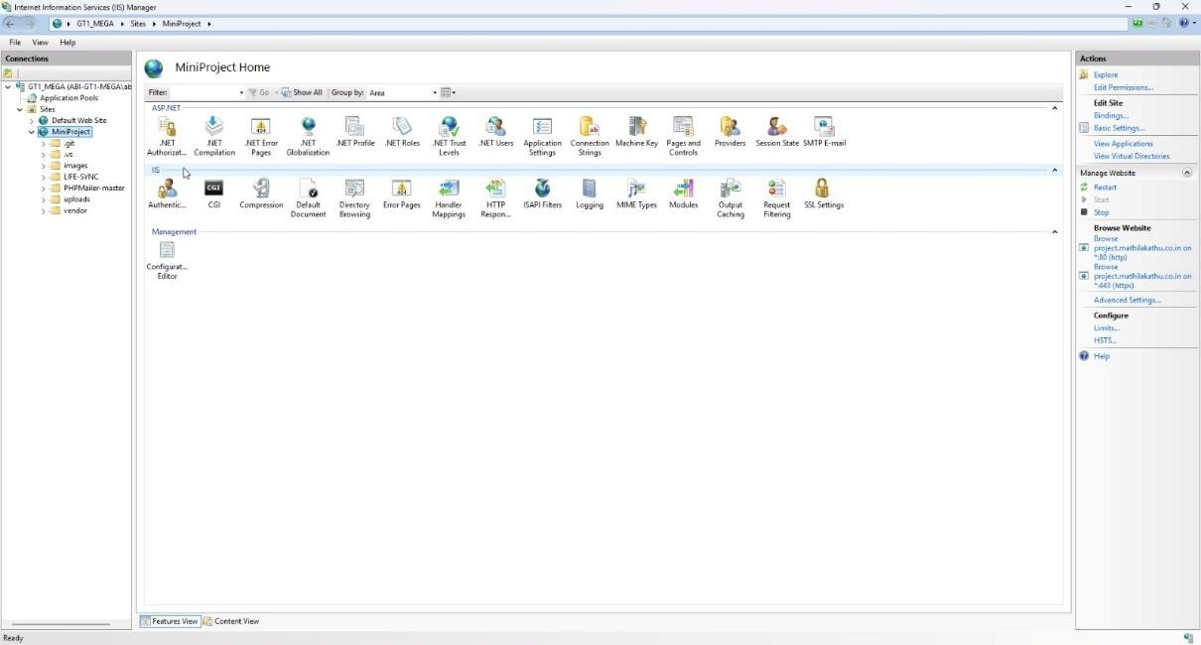
Fig 19: Hosting

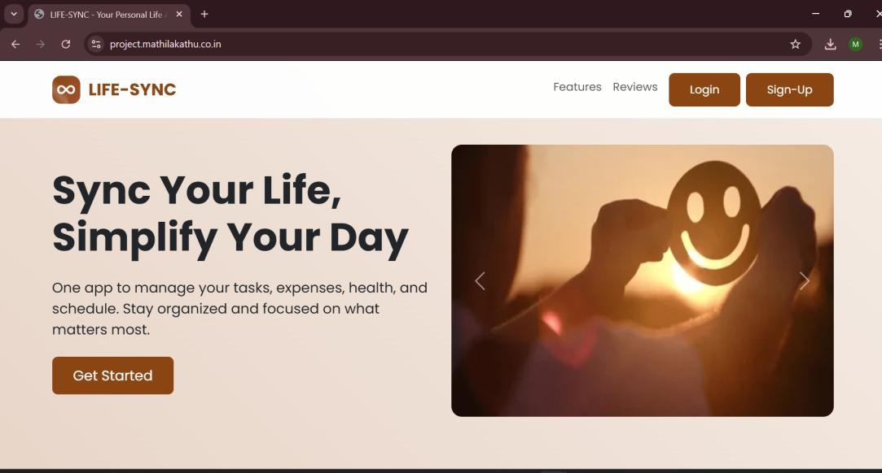
Fig 20: Hosted website

CHAPTER 7 CONCLUSION AND FUTURE SCOPE

CONCLUSION
The ScholarNexus AI web application successfully brings together essential academic research activities, providing students and research scholars with a structured platform to organize, develop, and track their research work. With features such as research projects, reference paper management, research work creation, AI Research Assistant, literature summaries and comparisons, citation generation, tasks, notes, and project activities, the system helps improve research organization and productivity. The faculty supervision features also allow students to connect with faculty, receive guidance, and obtain feedback on their research work.
Faculty members can manage supervision requests, assigned students, research projects, research papers, reviews, and feedback through their dedicated modules. The admin panel provides essential system management features such as user management, faculty verification, project and paper monitoring, announcements, activity logs, and reports and analytics. These features provide a structured environment for managing academic research activities while maintaining role-based access.
The project was successfully completed within the allotted time and tested to ensure that the implemented modules meet the specified functional requirements. While there is always scope for further enhancement, the application provides a strong foundation for organized academic research, AI-assisted support, effective faculty supervision, and centralized research management.

FUTURE SCOPE

- Research Paper Discovery – Integrate academic databases and digital libraries to help users discover, search, and collect relevant research papers directly within the platform.
- AI-Powered Literature Review – Develop AI-based assistance for generating structured literature reviews from collected and relevant research papers.
- Research Gap Identification – Introduce AI-based analysis to identify possible research gaps, unexplored areas, and potential research directions from the available literature.
- Collaborative Research Writing – Enable students and faculty to collaboratively create, edit, review, and comment on research documents.
- Advanced Research Recommendations – Provide personalized recommendations for relevant papers, research topics, references, and research directions based on the user's research project.

- Enhanced Document Editing – Introduce advanced research document editing features with improved formatting, templates, version control, and document organization.
- Integration with Academic Platforms – Extend the system by integrating with external academic databases, digital libraries, institutional repositories, and other research platforms.
- Mobile and Desktop Application – Develop cross-platform mobile and desktop applications to provide convenient access to research activities from different devices.
- Research Progress Analytics – Introduce advanced analytics and visualizations to help students and faculty monitor research progress, completed work, pending activities, and project timelines.
- Institutional Integration – Integrate the platform with institutional academic systems to support centralized research coordination, student records, and faculty supervision workflows.

CHAPTER 8 BIBLIOGRAPHY

REFERENCES:

- Cody Lindley, JavaScript Enlightenment, First Edition, based on JavaScript 1.5, ECMA-262 Edition.
- Maxine Sheerin and John Allsopp, Complete CSS Guide, O’Reilly Media, September 2012.
- IEEE Std 1016, Recommended Practice for Software Design Descriptions.
- Gary B. Shelly and Harry J. Rosenblatt, System Analysis and Design, 2009.
- Roger S. Pressman, Software Engineering: A Practitioner’s Approach, 1994.
- Ian Sommerville, Software Engineering, 10th Edition, Pearson Education.
- MongoDB Documentation, MongoDB Inc., official documentation for MongoDB database concepts and operations.
- React Documentation, Meta Platforms, official documentation for React library and application development.
- Node.js Documentation, OpenJS Foundation, official documentation for Node.js development.
- Express.js Documentation, official documentation for developing web applications and APIs.

WEBSITES:
- https://www.perplexity.ai
- https://scholar.google.com
- https://www.semanticscholar.org
- https://www.crossref.org
- https://www.citationmachine.net
- https://www.mybib.com
- https://www.connectedpapers.com
- https://www.w3schools.com
- https://www.geeksforgeeks.org
- https://www.mongodb.com
- https://react.dev
- https://nodejs.org
- https://www.selenium.dev

CHAPTER 9 APPENDIX

Sample Code
server.ts
import "./lib/error-capture";
import { consumeLastCapturedError } from "./lib/error-capture";
import { renderErrorPage } from "./lib/error-page";
import { handleApiRequest } from "./server/db";

type ServerEntry = {
fetch: (request: Request, env: unknown, ctx: unknown) => Promise<Response> | Response;
};
let serverEntryPromise: Promise<ServerEntry> | undefined;

async function getServerEntry(): Promise<ServerEntry> {
if (!serverEntryPromise) {
serverEntryPromise = import("@tanstack/react-start/server-entry").then(
(m) => (m.default ?? m) as ServerEntry,
);
}
return serverEntryPromise;
}
// h3 swallows in-handler throws into a normal 500 Response with body
// {"unhandled":true,"message":"HTTPError"} — try/catch alone never fires for those.
async function normalizeCatastrophicSsrResponse(response: Response): Promise<Response> {
if (response.status < 500) return response;
const contentType = response.headers.get("content-type") ?? "";
if (!contentType.includes("application/json")) return response;

const body = await response.clone().text();
if (!isH3SwallowedErrorBody(body)) return response;

console.error(consumeLastCapturedError() ?? new Error(`h3 swallowed SSR error: ${body}`));
return new Response(renderErrorPage(), {
status: 500,
headers: { "content-type": "text/html; charset=utf-8" },
});
}

function isH3SwallowedErrorBody(body: string): boolean {
try {
const payload = JSON.parse(body) as { unhandled?: unknown; message?: unknown };
return payload.unhandled === true && payload.message === "HTTPError";
} catch {
return false;
}
}

export default {
async fetch(request: Request, env: unknown, ctx: unknown) {
const url = new URL(request.url);

if (url.pathname.startsWith("/api")) {
try {
return await handleApiRequest(request, url);
} catch (error) {
console.error(error);
return new Response(JSON.stringify({ error: "Internal server error." }), {
status: 500,
headers: { "content-type": "application/json" },
});
}
}

try {
const handler = await getServerEntry();
const response = await handler.fetch(request, env, ctx);
return await normalizeCatastrophicSsrResponse(response);
} catch (error) {
console.error(error);
return new Response(renderErrorPage(), {
status: 500,
headers: { "content-type": "text/html; charset=utf-8" },
});
}
},
};

dashboard.tsx
import { createFileRoute } from "@tanstack/react-router";
import { useEffect, useState, useMemo } from "react";
import {
Activity,
AlertCircle,
ArrowUpRight,
Bell,
BookMarked,
BookOpen,
Bot,
Calendar,
CheckCircle2,
Clock,
Eye,
FileText,
FolderKanban,
GitCompareArrows,
GraduationCap,
Inbox,
LineChart,
Megaphone,
MessageSquare,
Network,
Pencil,
Plus,
Quote,
Send,
Settings,
Sparkles,
Target,
TrendingUp,
Users,
} from "lucide-react";
import { DashboardLayout } from "@/components/dashboard-layout";
import { getHomePathForRole, getUserSession, getUserDisplayName, UserSession } from "@/lib/session";
import { EmptyState } from "@/components/empty-state";
import { Card, CardContent, CardHeader, CardTitle } from "@/components/ui/card";
import { Button } from "@/components/ui/button";
import { Badge } from "@/components/ui/badge";
import { Progress } from "@/components/ui/progress";
import { Tabs, TabsList, TabsTrigger, TabsContent } from "@/components/ui/tabs";
import { Input } from "@/components/ui/input";
import { Skeleton } from "@/components/ui/skeleton";

export const Route = createFileRoute("/dashboard")({
head: () => ({
meta: [
{ title: "Dashboard — ScholarNexus AI" },
{
name: "description",
content:
"Your intelligent research command center: projects, papers, AI insights, and collaboration in one place.",
},
],
}),
component: DashboardPage,
});

export type ProjectStatus = "Planning" | "In Progress" | "Under Review" | "Completed" | "On Hold";

export interface Project {
id: string;
_id?: string;
userEmail: string;
title: string;
description: string;
domain: string;
status: ProjectStatus;
progress: number;
startDate: string;
expectedCompletionDate: string;
faculty?: string;
createdAt: string;
updatedAt: string;
}

const STATUS_VARIANTS: Record<string, { label: string; className: string; icon: typeof Clock }> = {
Planning: {
label: "Planning",
className: "bg-blue-500/10 text-blue-500 border-blue-500/20 dark:bg-blue-500/15 dark:text-blue-400",
icon: Clock,
},
"In Progress": {
label: "In Progress",
className: "bg-amber-500/10 text-amber-600 border-amber-500/20 dark:bg-amber-500/15 dark:text-amber-400",
icon: TrendingUp,

},
"Under Review": {
label: "Under Review",
className: "bg-purple-500/10 text-purple-600 border-purple-500/20 dark:bg-purple-500/15 dark:text-purple-400",
icon: AlertCircle,
},
Completed: {
label: "Completed",
className: "bg-emerald-500/10 text-emerald-600 border-emerald-500/20 dark:bg-emerald-500/15 dark:text-emerald-400",
icon: CheckCircle2,
},
"On Hold": {
label: "On Hold",
className: "bg-slate-500/10 text-slate-600 border-slate-500/20 dark:bg-slate-500/15 dark:text-slate-400",
icon: Clock,
},
};

const quickActions = [
{
title: "Start New Project",
desc: "Initialize a dedicated research workspace",
icon: Plus,
href: "/projects?create=true",
gradient: "from-blue-600/20 to-indigo-600/20 border-blue-500/30 hover:border-blue-500/60",
iconBg: "bg-blue-500/15 text-blue-400",
},
{
title: "Research Projects",
desc: "Browse and open active research workspaces",
icon: FolderKanban,
href: "/projects",
gradient: "from-purple-600/20 to-pink-600/20 border-purple-500/30 hover:border-purple-500/60",
iconBg: "bg-purple-500/15 text-purple-400",
},
{
title: "Faculty Directory",
desc: "Explore mentors and academic advisors",
icon: GraduationCap,
href: "/faculty",
gradient: "from-emerald-600/20 to-teal-600/20 border-emerald-500/30 hover:border-emerald-500/60",
iconBg: "bg-emerald-500/15 text-emerald-400",
},
{
title: "Notifications",
desc: "Stay updated on reviews & announcements",
icon: Bell,

href: "/notifications",
gradient: "from-amber-600/20 to-orange-600/20 border-amber-500/30 hover:border-amber-500/60",
iconBg: "bg-amber-500/15 text-amber-400",
},
{
title: "Account Settings",
desc: "Manage your profile & preferences",
icon: Settings,
href: "/settings",
gradient: "from-cyan-600/20 to-sky-600/20 border-cyan-500/30 hover:border-cyan-500/60",
iconBg: "bg-cyan-500/15 text-cyan-400",
},
];

function DashboardPage() {
const [user, setUser] = useState<UserSession | null>(() => {
if (typeof window !== "undefined") {
return getUserSession();
}
return null;
});

const [projects, setProjects] = useState<Project[]>([]);
const [announcements, setAnnouncements] = useState<any[]>([]);
const [loadingProjects, setLoadingProjects] = useState(true);

useEffect(() => {
if (typeof window === "undefined") return;

const session = getUserSession();
if (!session) {
window.location.href = "/login";
return;
}

if (session.role === "faculty") {
window.location.href = "/faculty-dashboard";
return;
}

if (session.role === "admin") {
window.location.href = "/admin";
return;
}

setUser(session);

fetch(`/api/projects?email=${encodeURIComponent(session.email)}`)
.then((res) => (res.ok ? res.json() : []))
.then((data) => {
if (Array.isArray(data)) {

setProjects(data);
} else {
setProjects([]);
}
})
.catch((err) => {
console.error(err);
setProjects([]);
})
.finally(() => setLoadingProjects(false));

fetch("/api/announcements")
.then((res) => (res.ok ? res.json() : []))
.then((data) => {
if (Array.isArray(data)) {
setAnnouncements(data.filter((a) => a.targetAudience === "All" || a.targetAudience === "Students" || a.targetAudience === "Student"));
}
})
.catch(() => {});
}, []);

if (typeof window !== "undefined" && !user) {
return null;
}

const safeProjects = useMemo(() => (Array.isArray(projects) ? projects : []), [projects]);

const activeProjects = useMemo(
() => safeProjects.filter((p) => p && (p.status === "Planning" || p.status === "In Progress")),
[safeProjects]
);
const reviewProjects = useMemo(
() => safeProjects.filter((p) => p && p.status === "Under Review"),
[safeProjects]
);
const completedProjects = useMemo(
() => safeProjects.filter((p) => p && p.status === "Completed"),
[safeProjects]
);

const overallAvgProgress = useMemo(() => {
if (safeProjects.length === 0) return 0;
const sum = safeProjects.reduce((acc, p) => acc + (Number(p.progress) || 0), 0);
return Math.round(sum / safeProjects.length);
}, [safeProjects]);

const upcomingDeadline = useMemo(() => {
const sorted = [...safeProjects]
.filter((p) => p.expectedCompletionDate)
.sort((a, b) => new Date(a.expectedCompletionDate).getTime() - new

Date(b.expectedCompletionDate).getTime());
return sorted[0] || null;
}, [safeProjects]);

const mostRecentProject = useMemo(() => {
if (safeProjects.length === 0) return null;
const sorted = [...safeProjects].sort((a, b) => {
const timeA = new Date(a.updatedAt || a.createdAt || 0).getTime();
const timeB = new Date(b.updatedAt || b.createdAt || 0).getTime();
return timeB - timeA;
});
return sorted[0] || null;
}, [safeProjects]);

const computedStats = [
{
label: "Active Projects",
icon: FolderKanban,
value: loadingProjects ? "…" : activeProjects.length,
hint: `${safeProjects.length} total projects active`,
color: "text-blue-500",
bg: "bg-blue-500/10 border-blue-500/20",
},
{
label: "Reference Papers",
icon: BookOpen,
value: "0",
hint: "Collected reference literature",
color: "text-amber-500",
bg: "bg-amber-500/10 border-amber-500/20",
},
{
label: "Research Documents",
icon: Pencil,
value: "1",
hint: "Student academic writing documents",
color: "text-purple-500",
bg: "bg-purple-500/10 border-purple-500/20",
},
{
label: "Faculty Feedback",
icon: MessageSquare,
value: safeProjects.filter((p) => p.faculty && p.faculty !== "Independent Research").length,
hint: "Supervisors & advisors assigned",
color: "text-emerald-500",
bg: "bg-emerald-500/10 border-emerald-500/20",
},
];

const formatDate = (dateStr?: string) => {

if (!dateStr) return "";
try {
const d = new Date(dateStr);
return isNaN(d.getTime())
? dateStr
: d.toLocaleDateString(undefined, { month: "short", day: "numeric", year: "numeric" });
} catch {
return dateStr;
}
};

// Generate Activity Timeline based on real database records
const recentActivities = useMemo(() => {
const activities: Array<{
id: string;
title: string;
desc: string;
timestamp: string;
type: "create" | "update" | "faculty" | "milestone";
icon: typeof Plus;
iconBg: string;
}> = [];

safeProjects.forEach((p) => {
if (p.createdAt) {
activities.push({
id: `create-${p.id || p._id}`,
title: `Project Established: "${p.title}"`,
desc: `Domain: ${p.domain} • Status: ${p.status}`,
timestamp: p.createdAt,
type: "create",
icon: FolderKanban,
iconBg: "bg-blue-500/15 text-blue-400",
});
}
if (p.faculty && p.faculty !== "Independent Research") {
activities.push({
id: `faculty-${p.id || p._id}`,
title: `Faculty Advisor Assigned: ${p.faculty}`,
desc: `Assigned to research project "${p.title}"`,
timestamp: p.updatedAt || p.createdAt,
type: "faculty",
icon: GraduationCap,
iconBg: "bg-emerald-500/15 text-emerald-400",
});
}
if (Number(p.progress) > 0) {
activities.push({
id: `progress-${p.id || p._id}`,
title: `Progress Milestone Updated (${p.progress}%)`,
desc: `Project "${p.title}" reached ${p.progress}% completion`,

timestamp: p.updatedAt || p.createdAt,
type: "milestone",
icon: TrendingUp,
iconBg: "bg-purple-500/15 text-purple-400",
});
}
});

return activities
.sort((a, b) => new Date(b.timestamp).getTime() - new Date(a.timestamp).getTime())
.slice(0, 5);
}, [safeProjects]);

return (
<DashboardLayout>
<div className="mx-auto flex max-w-[1400px] flex-col gap-8 pb-10">
{/* 1. Welcome Section */}
<section className="relative overflow-hidden rounded-2xl border border-border bg-card p-6 md:p-8 shadow-sm">
<div className="absolute inset-0 grid-neural opacity-30 dark:opacity-20" aria-hidden />
<div
className="absolute -right-24 -top-24 h-72 w-72 rounded-full bg-primary/10 blur-3xl"
aria-hidden
/>
<div
className="absolute -bottom-24 -left-16 h-64 w-64 rounded-full bg-accent/20 blur-3xl"
aria-hidden
/>

<div className="relative flex flex-col gap-6 lg:flex-row lg:items-center lg:justify-between">
<div className="max-w-2xl space-y-3">
<Badge className="gap-1.5 rounded-full border-none bg-accent/15 px-3 py-1 text-xs font-medium text-foreground hover:bg-accent/20">
<Sparkles className="h-3.5 w-3.5 text-primary" /> ScholarNexus Academic Command Center
</Badge>
<h1 className="text-2xl font-bold tracking-tight text-foreground md:text-3xl lg:text-4xl">
Welcome back, {getUserDisplayName(user)}! 👋
</h1>
<p className="text-sm leading-relaxed text-muted-foreground md:text-base">
Advance your academic journey. Synthesize literature insights, track project milestones, and collaborate with faculty advisors in one intelligent workspace.
</p>

<div className="flex flex-wrap gap-3 pt-2">
<Button
onClick={() => (window.location.href = "/projects?create=true")}
className="gap-2 rounded-xl bg-primary px-5 py-2.5 font-medium text-primary-foreground shadow-sm transition-all hover:bg-primary/90 hover:shadow"
>
<Plus className="h-4 w-4" /> Start New Research Project
</Button>
<Button
variant="outline"
onClick={() => (window.location.href = "/projects")}
className="gap-2 rounded-xl border-border bg-card hover:bg-muted"
>
<FolderKanban className="h-4 w-4 text-primary" /> Browse Projects ({safeProjects.length})
</Button>
</div>
</div>

{/* Visual Focus Widget */}
<div className="grid gap-3 sm:grid-cols-2 lg:w-[380px]">
<div className="rounded-2xl border border-border/80 bg-background/60 p-4 backdrop-blur-md transition-all hover:border-primary/40">
<div className="flex items-center gap-2 mb-2">
<div className="grid h-8 w-8 place-items-center rounded-xl bg-primary/15 text-primary">
<Target className="h-4 w-4" />
</div>
<span className="text-xs font-semibold text-muted-foreground">Overall Milestone</span>
</div>
<p className="text-xl font-bold text-foreground">{overallAvgProgress}% Avg Progress</p>
<Progress value={overallAvgProgress} className="mt-2 h-1.5 rounded-full" />
</div>

<div className="rounded-2xl border border-border/80 bg-background/60 p-4 backdrop-blur-md transition-all hover:border-primary/40">
<div className="flex items-center gap-2 mb-2">
<div className="grid h-8 w-8 place-items-center rounded-xl bg-amber-500/15 text-amber-500">
<Calendar className="h-4 w-4" />
</div>
<span className="text-xs font-semibold text-muted-foreground">Next Target Date</span>
</div>
<p className="text-sm font-semibold text-foreground truncate">
{upcomingDeadline
? formatDate(upcomingDeadline.expectedCompletionDate)
: "No pending target"}
</p>
<p className="mt-1 text-[0.7rem] text-muted-foreground truncate">
{upcomingDeadline ? upcomingDeadline.title : "All timelines clear"}
</p>
</div>
</div>
</div>
</section>

{/* 2. Continue Working Section */}
{mostRecentProject && (

<section className="relative overflow-hidden rounded-2xl border border-primary/30 bg-gradient-to-br from-primary/10 via-card to-card p-6 shadow-sm">
<div className="flex flex-col md:flex-row md:items-center justify-between gap-4">
<div className="space-y-2">
<Badge variant="outline" className="rounded-full border-primary/30 bg-primary/15 text-primary text-xs font-semibold">
⚡ Continue Working
</Badge>
<h3 className="text-xl font-bold text-foreground">{mostRecentProject.title}</h3>
<p className="text-xs text-muted-foreground line-clamp-1 max-w-2xl">
{mostRecentProject.description || "No description provided."}
</p>
<div className="flex flex-wrap items-center gap-4 text-xs pt-1">
<span className="text-muted-foreground">Domain: <strong className="text-foreground font-medium">{mostRecentProject.domain || "General"}</strong></span>
<span className="text-muted-foreground">Status: <strong className="text-foreground font-medium">{mostRecentProject.status}</strong></span>
<span className="text-muted-foreground">Progress: <strong className="text-primary font-bold">{mostRecentProject.progress || 0}%</strong></span>
{mostRecentProject.faculty && (
<span className="text-muted-foreground">Mentor: <strong className="text-foreground font-medium">{mostRecentProject.faculty}</strong></span>
)}
</div>
</div>
<Button
onClick={() => (window.location.href = `/projects/${mostRecentProject._id || mostRecentProject.id}`)}
className="shrink-0 gap-2 rounded-xl bg-primary text-primary-foreground font-semibold shadow-md hover:bg-primary/90"
>
<FolderKanban className="h-4 w-4" /> Open Workspace <ArrowUpRight className="h-4 w-4" />
</Button>
</div>
</section>
)}

{/* 3. Dashboard Overview (Summary Cards) */}
<section className="grid gap-4 sm:grid-cols-2 lg:grid-cols-4">
{computedStats.map((s) => (
<Card
key={s.label}
className="group surface-elevated relative overflow-hidden rounded-2xl border-border bg-card/70 p-5 backdrop-blur-md transition-all duration-200 hover:-translate-y-1 hover:border-primary/40 hover:shadow-lg"
>
<div className="flex items-start justify-between gap-4">
<div className="space-y-1">
<p className="text-xs font-semibold uppercase tracking-wider text-muted-foreground">
{s.label}
</p>
<p className="text-3xl font-bold tracking-tight text-foreground">{s.value}</p>
<p className="flex items-center gap-1 text-[0.725rem] text-muted-foreground pt-1">
<TrendingUp className="h-3 w-3 text-primary" /> {s.hint}
</p>
</div>

<div className="space-y-3">
<h4 className="text-xs font-semibold uppercase tracking-wider text-muted-foreground">
Active Milestone Phases
</h4>
{[
{ phase: "Literature Review & Synthesis", progress: safeProjects.length > 0 ? 80 : 0 },
{ phase: "Methodology & Framework Setup", progress: safeProjects.length > 0 ? 60 : 0 },
{ phase: "Data Collection & Experiments", progress: safeProjects.length > 0 ? 40 : 0 },
{ phase: "Analysis & Manuscript Draft", progress: safeProjects.length > 0 ? 25 : 0 },
].map((item) => (
<div key={item.phase} className="space-y-1">
<div className="flex items-center justify-between text-xs">
<span className="font-medium text-foreground">{item.phase}</span>
<span className="text-muted-foreground font-semibold">{item.progress}%</span>
</div>
<Progress value={item.progress} className="h-1.5 rounded-full" />
</div>
))}
</div>
</CardContent>
</Card>

{/* 4. Recent Activity Timeline Card */}
<Card className="surface-elevated rounded-2xl border-border p-6 flex flex-col justify-between">
<CardHeader className="p-0 pb-4">
<CardTitle className="flex items-center gap-2 text-lg font-bold">
<Activity className="h-5 w-5 text-primary" /> Recent Activity Timeline
</CardTitle>
<p className="text-xs text-muted-foreground">
Recent research events, project updates, and mentor assignments.
</p>
</CardHeader>
<CardContent className="p-0">
{recentActivities.length === 0 ? (
<div className="flex flex-col items-center justify-center rounded-2xl border border-dashed border-border py-10 px-4 text-center">
<Inbox className="h-8 w-8 text-muted-foreground mb-2" />
<p className="text-xs text-muted-foreground">
No recent activity yet. Create a research project to start tracking your timeline!
</p>
</div>
) : (
<div className="relative space-y-4 pl-6 pt-1">

<span className="absolute left-2.5 top-2 bottom-2 w-0.5 bg-border" aria-hidden />
{recentActivities.map((act) => {
const ActIcon = act.icon;
return (
<div key={act.id} className="relative flex items-start gap-3">
<div className={`absolute -left-[1.65rem] top-0.5 grid h-6 w-6 place-items-center rounded-full border border-border bg-card text-xs shadow-sm`}>
<ActIcon className="h-3.5 w-3.5 text-primary" />
</div>
<div className="min-w-0 flex-1 space-y-0.5">
<p className="text-xs font-bold text-foreground line-clamp-1">{act.title}</p>
<p className="text-[0.725rem] text-muted-foreground leading-normal">{act.desc}</p>
<p className="text-[0.675rem] text-muted-foreground/80">{formatDate(act.timestamp)}</p>
</div>
</div>
);
})}
</div>
)}
</CardContent>
</Card>
</div>
</div>
</DashboardLayout>
);
}

Screen Shots
Landing Page

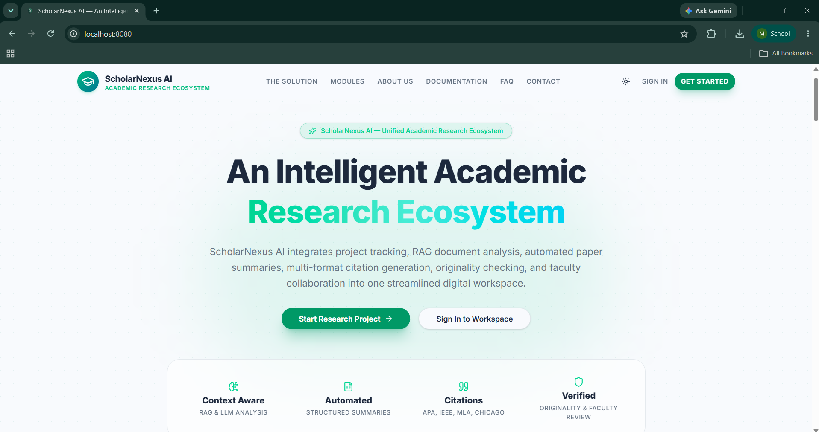
Fig 21: Landing Page

Login Page:

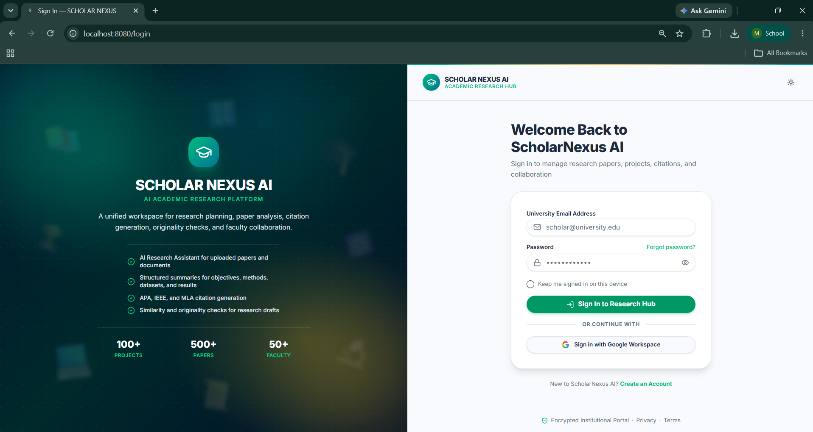
Fig 22: Login Page

Student Dashboard:

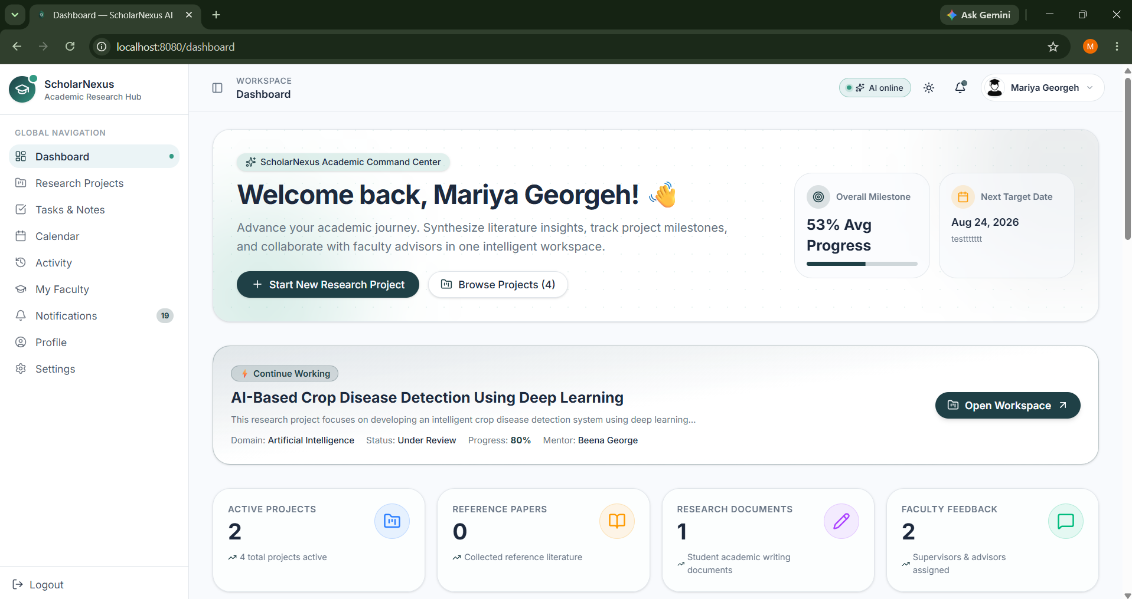

Fig 23: Student Dashboard Page

Research Roadmap:

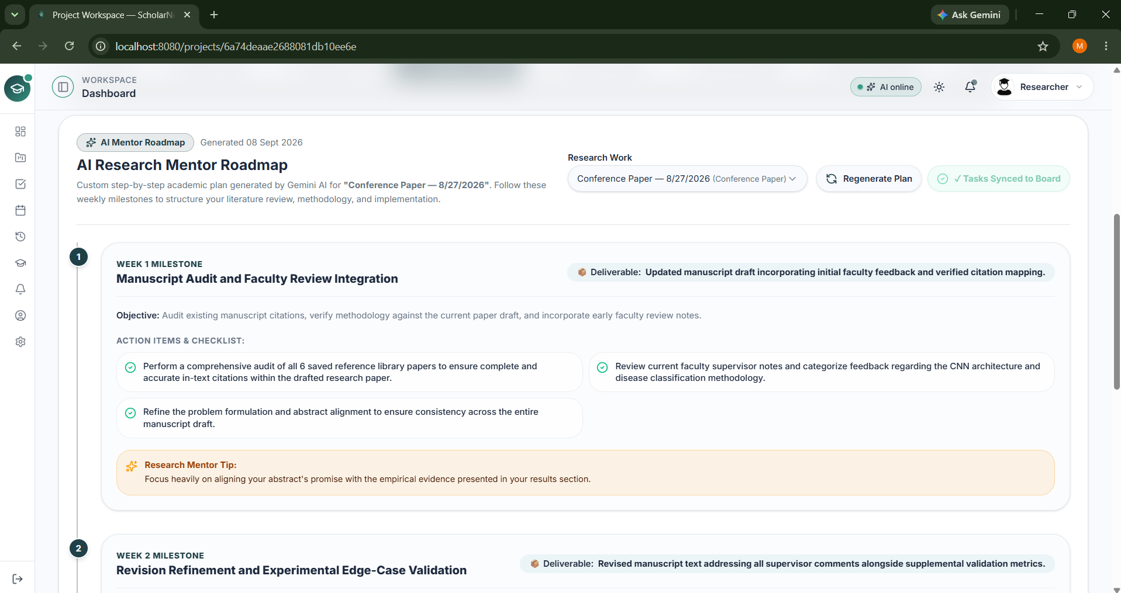

Fig 24: Research Roadmap Generator Page

Faculty Dashboard:

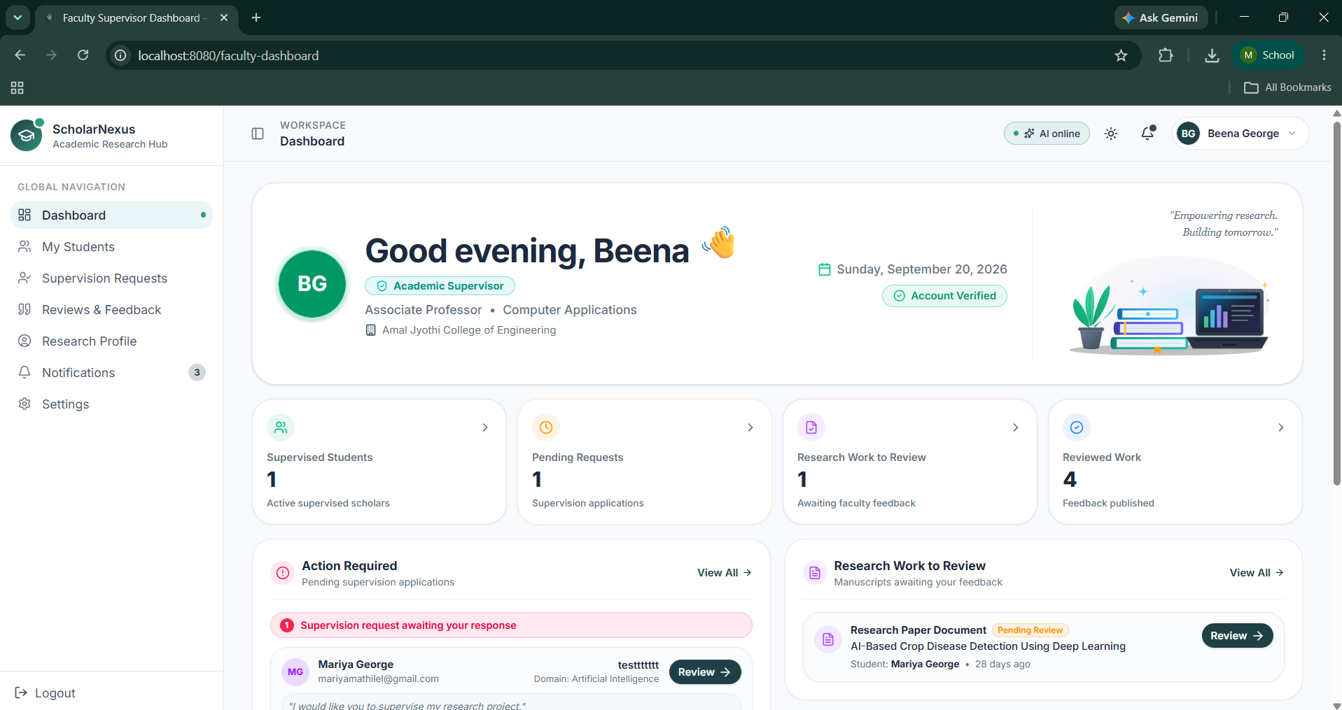

Fig 25: Faculty Landing Page

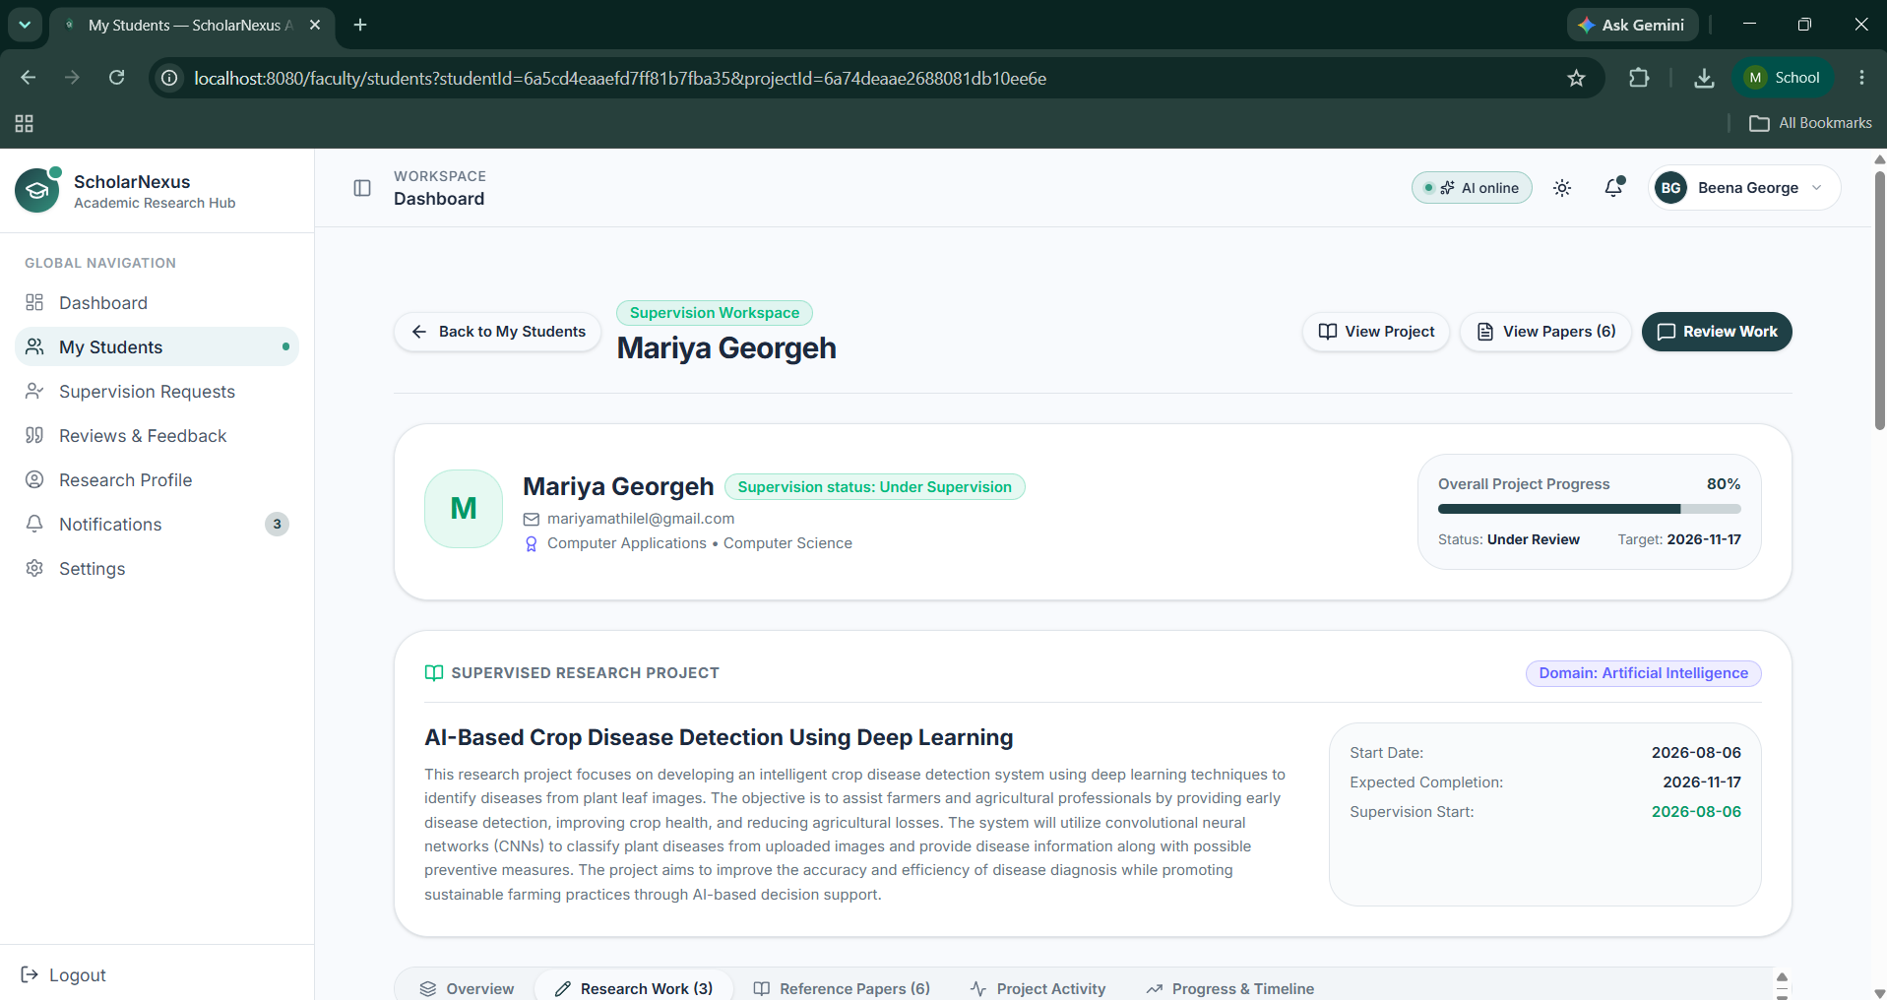

Fig 26: View Student Workspace Page

Admin Dashboard:

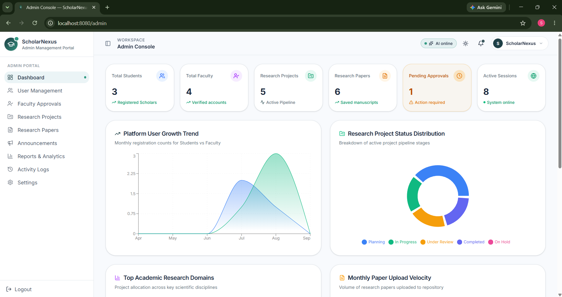

Fig 25: Admin Dashboard Page

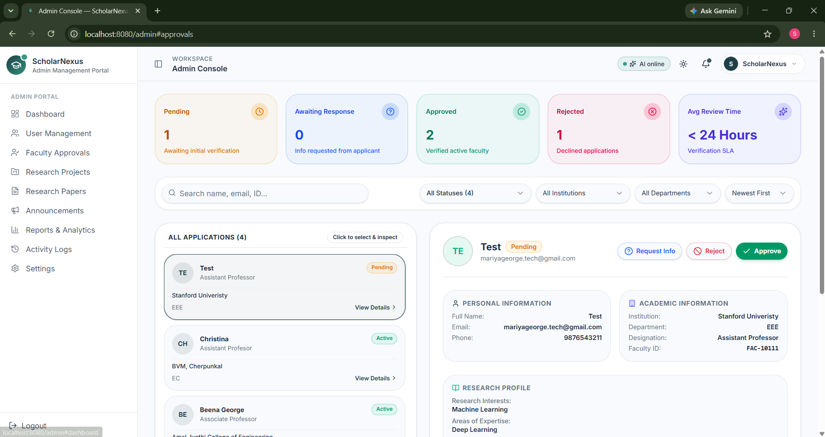

Fig 26: Faculty Approval Page

