StudyInSchool

AN INDUSTRIAL INTERNSHIP TRAINING REPORT

Submitted by

ATHIRA V AJIT
17BLC1163

ECM3099 – INDUSTRIAL INTERNSHIP

in partial fulfillment for the award of the degree of

BACHELOR OF TECHNOLOGY

in

ELECTRONICS AND COMPUTER ENGINEERING



October, 2020

School of Electronics Engineering

DECLARATION BY THE CANDIDATE

I hereby declare that the Industrial Internship Report entitled “StudyInSchool” submitted by me to VIT University, Chennai in partial fulfillment of the requirement for the award of the degree of Bachelor of Technology in Electronics and Computer Engineering is a record of bonafide industrial training undertaken by me under the supervision of Mr. Vaibhav Gupta. I further declare that the work reported in this report has not been submitted and will not be submitted, either in part or in full, for the award of any other degree or diploma in this institute or any other institute or university.

Chennai Athira V Ajit

Date: 20-10-2020 Signature of the Candidate



School of Electronics Engineering

BONAFIDE CERTIFICATE

This is to certify that the Industrial Internship Report entitled “StudyInSchool” submitted by ATHIRA V AJIT (17BLC1163) to VIT, Chennai in partial fulfillment of the requirement for the award of the degree of Bachelor of Technology in Electronics and Computer Engineering is a record of bonafide industrial internship undertaken by him/her fulfills the requirements as per the regulations of this institute and in my opinion meets the necessary standards for submission. The contents of this report have not been submitted and will not be submitted either in part or in full, for the award of any other degree or diploma in this institute or any other institute or university.

Signature of the Examiner Signature of the Examiner
Date: Date:

Head of the Department (B. Tech ECM)

ACKNOWLEDGEMENT

I wish to thank those who were involved in the successful completion of my internship at Krux Prokon Pvt Ltd, starting from the deputy general manager to Mr. Vaibhav Gupta, Co-founder, Krux Prokon Pvt.Ltd , for giving me the opportunity and freedom to learn as per my interests; and the entire staff of the company for their support and positivity which made my internship a worthwhile experience. I would also like to thank my parents, for being my motivation to take up this internship and last, but not the least, the faculty and management at Vellore Institute of Technology (VIT), Chennai, for providing me with such an avenue to help realize how interesting it is to work in today’s industry. It is my proud privilege to express my profound gratitude to the Dean of SENSE, Dr.Sivasubramanian.A and Program Chair Dr.D.Thiripurasundari for providing me this valuable opportunity to have industrial exposure.

ATHIRA V AJIT
(17BLC1163)

TABLE OF CONTENTS
Chapter No. | Title |  | Page No.
 | Declaration
 | Certificate
 | Bonafide certificate
 | Acknowledgement
 | Table of contents
 | List of Figures
 | Abstract
1 | Introduction |  | 1
 | 1.1 | About the Company | 1
 | 1.2 | About the in plant Training | 1
2 | StudyInSchool |  | 2
 | 2.1 | Objective | 2
 | 2.2 | Technologies | 2
3 | NodeJS |  | 5
 | 3.1 NodeJS  3.2 Advantages of NodeJS  3.3 NodeJS Express  3.4 Reason to choose NodeJS in the given project |  | 5  5  7  7
4 | MongoDB  4.1 MongoDB  4.2 Basic CRUD operations  4.3 Reason to choose MongoDB in the given project |  | 8  8  8  8
5 | Conclusion |  | 10
6 | References |  | 11

LIST OF FIGURES

Figure No. | Title | Page No.
1 | NodeJS | 5
2. | Npm Downloads | 6
3. | Mongodb vs MySQL (select all documents) | 9
4. | Mongodb vs MySQL (select one document) | 9

ABSTRACT

The given project entitled StudyInSchool is a platform designed for parents to apply to numerous schools of their choice using a single application. The products to ease the pain of filling numerous forms to different schools in order to get children enrolled in a particular school. We help parents in making the right decision using our different tools like compare, shortlist and review schools.

CHAPTER 1

INTRODUCTION

1.1About the Company

Krux Prokon Private LTD is a Non-govt company, incorporated on 25 Feb, 1980. It's a private unlisted company and is classified as'company limited by shares'. Company is registered in Delhi (Delhi) Registrar Office. Krux Prokon Private LTD registered address is 18/12 Wea Pusa Lanekarol Bagh New Delhi Dl 110006 In.

1.2 About the In-Plant Training
StudyinSchool is an upcoming brand under the umbrella company, Krux Prokon Pvt. Ltd. The intent is to create technology products to assist parents in enrolling their children to their dream schools.
Reference Link
https://studyinschool.com/

CHAPTER 2
STUDYINSCHOOL
  - Objective
The project aims to eradicate the extremely tiring admission process for schools nowadays. Today along with children, parents also have to undergo various rounds of interviews and tests before enrolling their child into a particular school. Hence a single portal, which will help to apply to numerous schools, will ease the burden off the shoulders of these parents.
The steps for a particular parent to select the best school are defined in five steps by us.
- Search
- Compare
- Shortlist
- Apply
- Enrol
  - Technologies
- NodeJS
Node.js is an open-source, cross-platform, back-end, JavaScript runtime environment that executes JavaScript code outside a web browser. Node.js lets developers use JavaScript to write command line tools and for server-side scripting—running scripts server-side to produce dynamic web page content before the page is sent to the user's web browser. Consequently, Node.js represents a "JavaScript everywhere" paradigm, unifying web-application development around a single programming language, rather than different languages for server- and client-side scripts.
- MongoDB
MongoDB is a cross-platform document-oriented database program. Classified as a NoSQL database program, MongoDB uses JSON-like documents with optional schemas. MongoDB is developed by MongoDB Inc. and licensed under the Server Side Public License
- JavaScript
JavaScript often abbreviated as JS, is a programming language that conforms to the ECMAScript specification. JavaScript is high-level, often just-in-time compiled, and multi-paradigm. It has curly-bracket syntax, dynamic typing, prototype-based object-orientation, and first-class functions.
Alongside HTML and CSS, JavaScript is one of the core technologies of the World Wide Web. JavaScript enables interactive web pages and is an essential part of web applications. The vast majority of websites use it for client-side page behavior, and all major web browsers have a dedicated JavaScript engine to execute it.
As a multi-paradigm language, JavaScript supports event-driven, functional, and imperative programming styles. It has application programming interfaces (APIs) for working with text, dates, regular expressions, standard data structures, and the Document Object Model (DOM). However, the language itself does not include any input/output (I/O), such as networking, storage, or graphics facilities, as the host environment (usually a web browser) provides those APIs
- Ajax
Ajax (short for "Asynchronous JavaScript and XML") is a set of web development techniques using many web technologies on the client side to create asynchronous web applications. With Ajax, web applications can send and retrieve data from a server asynchronously (in the background) without interfering with the display and behavior of the existing page. By decoupling the data interchange layer from the presentation layer, Ajax allows web pages and, by extension, web applications, to change content dynamically without the need to reload the entire page. In practice, modern implementations commonly utilize JSON instead of XML.
Ajax is not a single technology, but rather a group of technologies. HTML and CSS can be used in combination to mark up and style information. The webpage can then be modified by JavaScript to dynamically display—and allow the user to interact with—the new information. The built-in XMLHttpRequest object, or since 2017 the new "fetch()" function within JavaScript, is commonly used to execute Ajax on webpages, allowing websites to load content onto the screen without refreshing the page. Ajax is not a new technology, or different language, just existing technologies used in new ways.
- jQuery
jQuery is a JavaScript library designed to simplify HTML DOM tree traversal and manipulation, as well as event handling, CSS animation, and Ajax. It is free, open-source software using the permissive MIT License. As of May 2019, jQuery is used by 73% of the 10 million most popular websites. Web analysis indicates that it is the most widely deployed JavaScript library by a large margin, having at least 3 to 4 times more usage than any other JavaScript library.
jQuery's syntax is designed to make it easier to navigate a document, select DOM elements, create animations, handle events, and develop Ajax applications. jQuery also provides capabilities for developers to create plug-ins on top of the JavaScript library. This enables developers to create abstractions for low-level interaction and animation, advanced effects and high-level, theme able widgets. The modular approach to the jQuery library allows the creation of powerful dynamic web pages and Web applications.

CHAPTER 3
NodeJS
3.1 NodeJS
Node.js is an open-source, cross-platform, back-end, JavaScript runtime environment that executes JavaScript code outside a web browser.
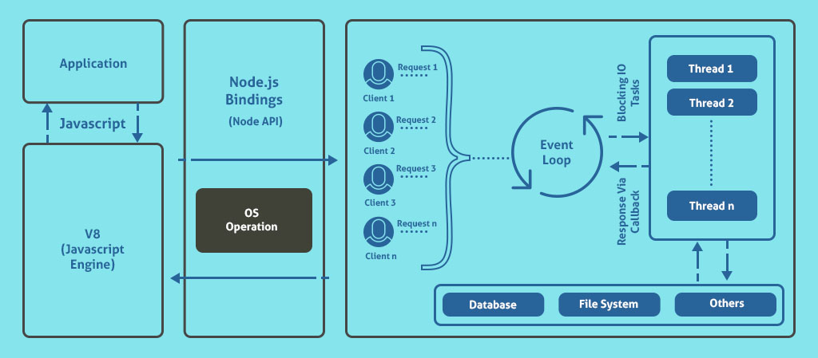
Fig a

Node.js uses a non-blocking I/O model. In simple terms, Node.js can handle multiple actions or requests at the same time with better efficiency as compared to other languages. Node.js works in asynchronous processes. It frees the memory in terms of memory blocks when the process doesn’t need it and allocates it to another process to complete its task in the meanwhile.
3.2 Advantages of NodeJS
1. Fast and Scalable
Node.js uses single-threading to process requests rather than the traditional multi-threading. This saves a ton of computing speed and space. While the request is on hold for certain requirements to fulfill in, other requests can be processed simultaneously. This boosts the overall computing capacity of the server. The Event loop in Node.js helps it in carrying out a large number of asynchronous processes at the same time. Actions such as writing, reading, or modifying the database can be completed in a shorter period of time using Node.js.
LinkedIn switched from Ruby on Rails to Node.js to cater to their increasing incoming traffic. They not only catered to that need but also reduced their servers from 30 to 3. Likewise, PayPal doubled the request rates per second after introducing Node.js in their framework.
2. Dynamic NPM
NPM stands for Node.js Package Module. It allows packages from different environments to collaborate with the existing environment.
Node.js is open-sourced. This makes Node.js and its package managers faster, robust and consistent in terms of performance and development. It has the largest number of modules online, more than 60000. This number competes against Ruby on Rails and is expected to surpass in no time. With increased coders’ involvement with the community too, is growing larger and
stronger.
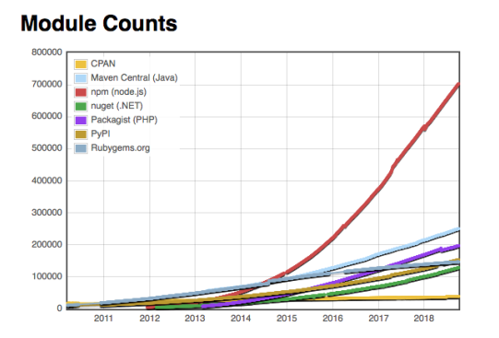
Fig b

3. Rapid Prototyping and Increased Productivity
Jeff Harrel, the Director of Engineering at PayPal says “ Node.Js powers our web applications and has allowed our teams to move much faster in bringing their designs to life”.
3.3 NodeJS Express
Express is a minimal and flexible Node.js web application framework that provides a robust set of features for web and mobile applications. Express.js simplifies development and makes it easier to write secure, modular and fast applications. You can do all that in plain old Node.js, but some bugs can (and will) surface, including security concerns (eg. not escaping a string properly). It also provides a lot of libraries for handling sessions, redis thus helping the development team to focus on creating the solution to the problem statement than get overworked with configurations for these.
3.4 Reason to choose NodeJS in the current project
Being a start-up time is priceless factor for us as well as man-power. The main objective is to bring our idea to the audience as soon as possible. Keeping in mind our requirements of user data security, website with fastest page speed, NodeJS became one of our most trusted options due to the fact that it provides lightweight technology, helps us provide MVP (minimum viable product), simple deployments, scalability and last but not least it is a matured and well tested tool.

CHAPTER 4
MONGODB
4.1 MongoDB
MongoDB is a cross-platform document-oriented database program. Classified as a NoSQL database program, MongoDB uses JSON-like documents with optional schemas.
4.2 Basic CRUD operations
1. Create
db.products.insertOne({item : “card”,qt:15,stock:false })
db.products.insertMany([
{item : “card1”,qt:15, stock:false },
{item : “card2”,qt:16 stock:false }
{item : “card3”,qt:17 stock:false }
])
2. Read
db.products.find({qt:{$gt :15}})
3. Update
db.products.updateOne({_id : 1 },{$set:{qty:19}})
db.products.updateMany({qt:{$gt :15}},{$set : {stock: false}})
4. Delete
db,products.deleteOne({_id : ObjectId(“5f69feffa1a1d34d00373458”)})
db,products.deleteMany({qt:{$gt :15}})
4.3 Reasons to choose MongoDB in the current project
Main reason being the amount of speed required in retrieving the documents. The main priority in our project is to make the retrieval operations extremely fast since the business listing page would be the main point where our customers will interact with our site. Currently we have 22,000 + schools in our database consisting of all CBSE and ISC schools in India. We also planned to include all state and IGCSE schools in the future which again will lead to higher amount of data in the database. Hence we had decided to move to NoSQL databases and MongoDB allows geospatial queries and is text-search enabled along with being one of the most sought after databases in the industry.
We did a bit of research and these particular graphs helped us reach to our conclusions.
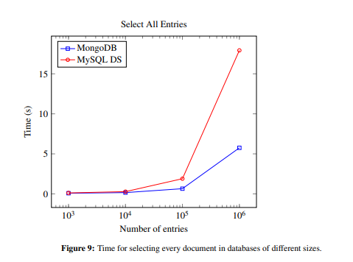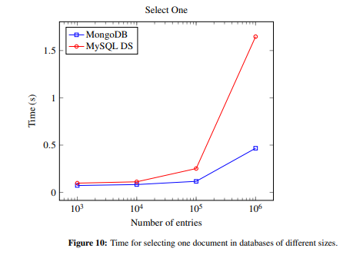
Fig c Fig d

In most of our operations we will have to select a single ,or a set of values hence from the above two graphs MongoDB became the best choice to move forward.
Another one reason was MongoDB was preferred along with NodeJS Express.

CHAPTER 5
CONCLUSION

5.1 Conclusion
This product will make the application process much easier and faster. It will prove as tool to also help schools have an online profile which will help them stand out among their peers as the competition among schools are becoming high as days pass by. This tool will also help parents and students who are searching for schools get verified information about the schools which will hold a major role in molding their child’s future.

REFERENCES
- https://docs.mongodb.com/manual/crud/
- https://en.wikipedia.org/wiki/JQuery
- https://en.wikipedia.org/wiki/Ajax_(programming)
- https://en.wikipedia.org/wiki/JavaScript
- https://en.wikipedia.org/wiki/MongoDB
- https://en.wikipedia.org/wiki/Node.js
- https://www.diva-portal.org/smash/get/diva2:1161166/FULLTEXT01.pdf
- https://www.toptal.com/nodejs/why-the-hell-would-i-use-node-js
- https://cubettech.com/resources/blog/combining-nodejs-and-nosql-why-mongodb-is-the-best-choice/

