**CASES:**

* July 1, 2016 a 9 year old girl in Hyderabad was killed along with two other members of her family while coming back from her first day at school. The incident took place near Nagarjuna circle. The speeding car was being driven by then 20-year-old R Shravil, an engineering student, who had been drinking with his friends, which included minors, at the TGI Friday pub near KBR park. The accused had a blood alcohol content (BAC) of 63.25 mg, more than twice the permissible limit of 30 mg.

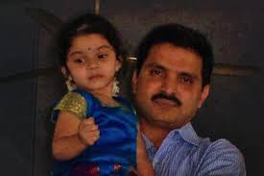

*9 year old victim*

* On November 9,2018 , drunk driving claimed another life and left a young girl with brain injuries and possible loss of vision in New Delhi. The accused woman at the wheel, Shivani Malik, 22year-old woman was found heavily drunk and lost control of her car which jumped over a divider on the Punjabi Bagh flyover around 11:30pm before ramming three cars.

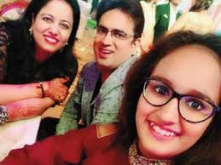

*The victim on the left and her injured daughter on the right*

* YouTube Link: <https://www.youtube.com/watch?v=3xerHeF_T84>
* On August 18,2019 at least seven pedestrians were injured after a drunk driver drove his car onto a pavement at HSR Layout locality on Sunday.

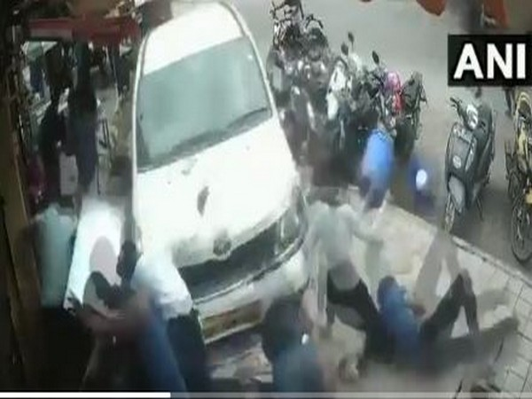

* Mumbai: Two killed after drunk lawyer, driving on wrong side, rams taxi

Inebriated lawyer in Audi on wrong side of expressway hits taxi with family returning home after celebrating son’s exam results.

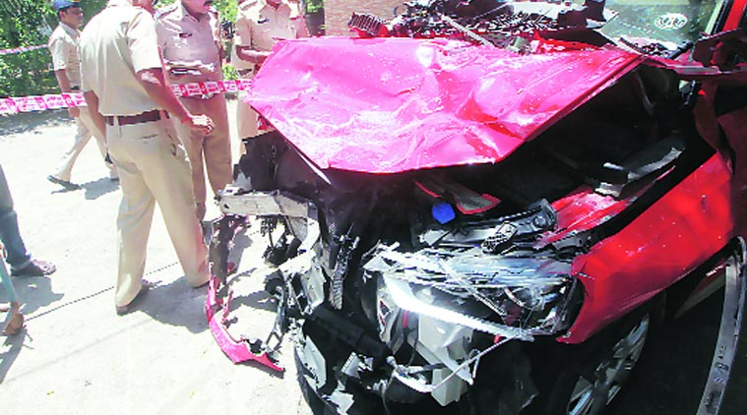

**NUMBERS**

Drunken driving is driving under influence (DUI) in some states and driving while intoxicated (DWI) in others. Such incidents cause almost one third of all traffic accidents and are considered to be among the most serious of driving offences.

As per the National statistics, an average of nearly 12,000 people die every year and an average of nine lakh people get arrested in DWI incidents. The offenders largely belong to the age group of 30 to 40 years.

However, strengthening the laws can never be the only solution; people should also make a conscious choice of not driving while being intoxicated. As well as at a point when technology is helping tackle most of the problems occurring in the day to day activities finding a solution to tackle this is of at most importance.

As per the information received from police department of States/UTs, thenumber of road accidentsunder the drunken driving category of traffic violationduring last three calendar years i.e.2015 to 2017is as under:-

|  |  |  |  |
| --- | --- | --- | --- |
| **Year** | **Road Accidents due to  Intake of Alcohol** | **Total number of Road**  **Accidents** | **%  share of total road  accident** |
| 2015 | 16,298 | 5,01,423 | 3.3 |
| 2016 | 14,894 | 4,80,652 | 3.1 |
| 2017 | 14,071 | 4,64,910 | 3.0 |

State-wise details of the same is given below:

|  |  |  |  |  |
| --- | --- | --- | --- | --- |
| **S.No** | **States/UTs** | **Road Accidents under drunken driving category 2015** | **Road Accidents under drunken driving category 2016** | **Road Accidents under drunken driving category  2017** |
| 1 | **Andhra Pradesh** | 490 | 128 | 2064 |
| 2 | **Arunachal Pradesh** | 22 | 15 | 19 |
| 3 | **Assam** | 611 | 352 | 373 |
| 4 | **Bihar** | 1457 | 593 | 0 |
| 5 | **Chhattisgarh** | 227 | 145 | 86 |
| 6 | **Goa** | 6 | 3 | 10 |
| 7 | **Gujarat** | 361 | 64 | 65 |
| 8 | **Haryana** | 1092 | 529 | 180 |
| 9 | **Himachal Pradesh** | 50 | 72 | 214 |
| 10 | **Jammu & Kashmir** | 375 | 47 | 1 |
| 11 | **Jharkhand** | 1518 | 543 | 801 |
| 12 | **Karnataka** | 298 | 396 | 169 |
| 13 | **Kerala** | 49 | 133 | 133 |
| 14 | **Madhya Pradesh** | 2665 | 3083 | 1049 |
| 15 | **Maharashtra** | 1345 | 226 | 863 |
| 16 | **Manipur** | 0 | 71 | 44 |
| 17 | **Meghalaya** | 137 | 35 | 132 |
| 18 | **Mizoram** | 15 | 27 | 16 |
| 19 | **Nagaland** | 2 | 13 | 157 |
| 20 | **Orissa** | 972 | 1255 | 1533 |
| 21 | **Punjab** | 118 | 317 | 129 |
| 22 | **Rajasthan** | 667 | 673 | 421 |
| 23 | **Sikkim** | 30 | 12 | 32 |
| 24 | **Tamil Nadu** | 818 | 531 | 1833 |
| 25 | **Telangana** | 42 | 202 | 163 |
| 26 | **Tripura** | 13 | 5 | 11 |
| 27 | **Uttarakhand** | 6 | 40 | 56 |
| 28 | **Uttar Pradesh** | 2403 | 4633 | 3336 |
| 29 | **West Bengal** | 413 | 462 | 16 |
| 30 | **A & N Islands** | 30 | 27 | 13 |
| 31 | **Chandigarh** | 8 | 9 | 10 |
| 32 | **D & N Haveli** | 6 | 0 | 1 |
| 33 | **Daman & Diu** | 7 | 7 | 12 |
| 34 | **Delhi** | 40 | 164 | 124 |
| 35 | **Lakshadweep** | 0 | 0 | 0 |
| 36 | **Puducherry** | 5 | 82 | 5 |
|  | **Total** | **16298** | **14894** | **14071** |

SOURCE: <https://pib.gov.in/Pressreleaseshare.aspx?PRID=1577134>

**Article regarding drunk driving.**

The report Road Accidents in India 2015 puts the number of accidents caused by drivers under the influence of alcohol as well as the fatalities much higher — 3.3 per cent of all road accidents and 4.6 per cent of all fatalities from road accidents.

That translates to 6,755 deaths annually or more than 18 deaths every day across the country.

What’s more, the Ministry report has further broken down the figures into accidents and deaths caused by the driver’s fault.

This further pushes up the numbers — 4.2 of all accidents caused due to the driver’s fault and 6.4 per cent of all such deaths was due to the consumption of alcohol by the driver.

SOURCE:

<https://www.thehindubusinessline.com/economy/policy/drunk-driving-is-a-bigger-problem-than-statistics-show/article9616180.ece/amp/#aoh=15783043591031&referrer=https%3A%2F%2Fwww.google.com&amp_tf=From%20%251%24s>

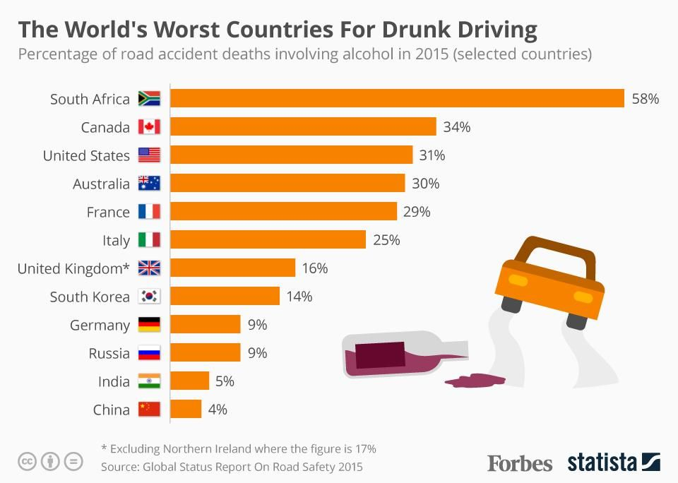

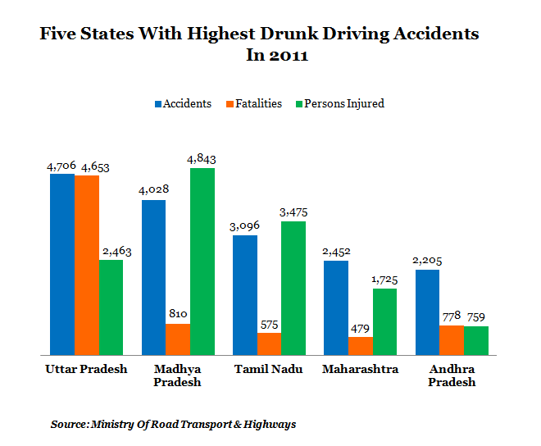

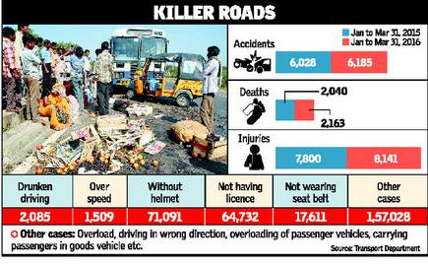

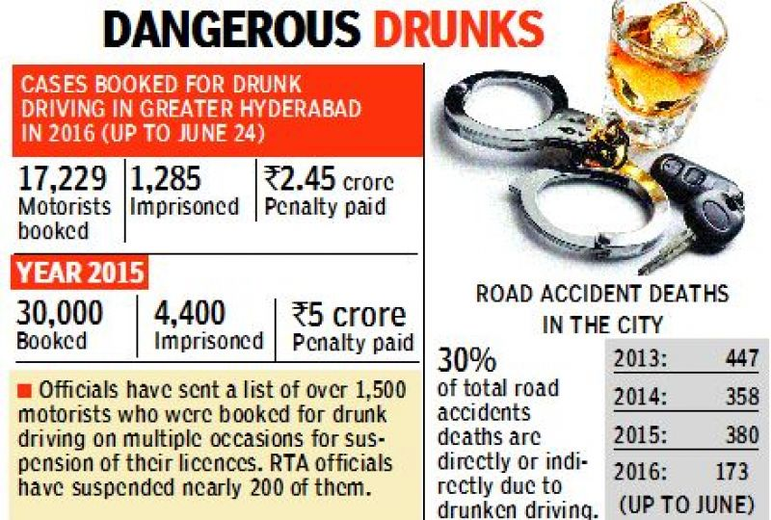

*Hyderabad drunk and drive statistics.*