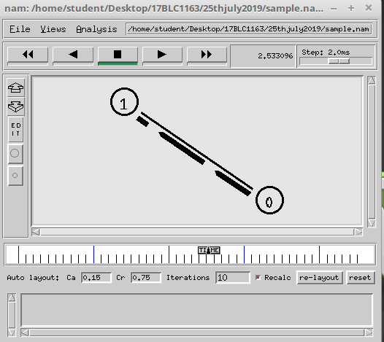

**C:\Users\Athira.V.Ajit\Downloads\l4.png**

**Here**

**Number of received packets =801**

**Number of generated packets=801**

**Number of dropped packet=0**

**Hence the pdr ratio:801/801 =1**

**The network description table.**

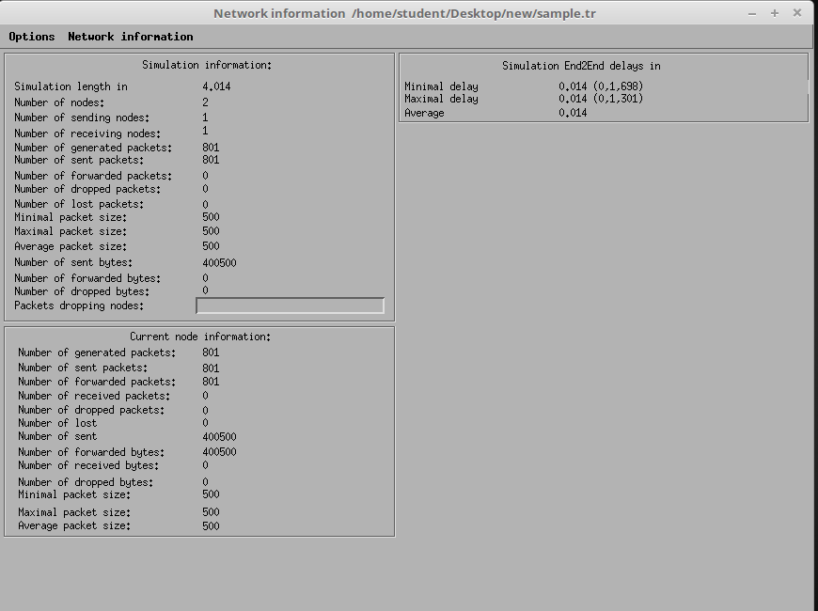

**Graph denoting the number packets received.**

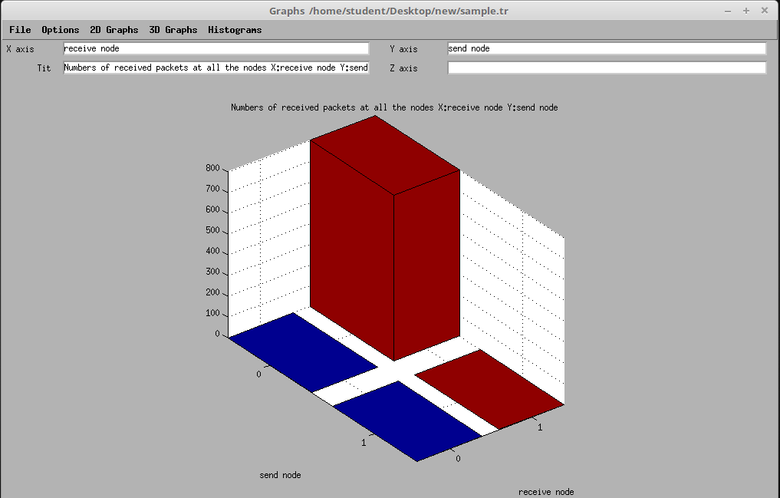

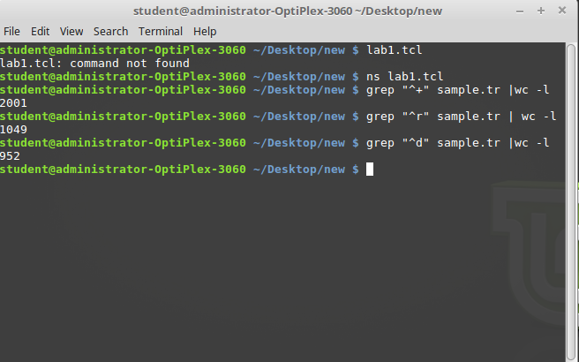

**Here**

**Number of received packets =1049**

**Number of generated packets=2001**

**Number of dropped packet=952**

**Hence the pdr ratio:1049/2001 =0.524**

**Network information table**

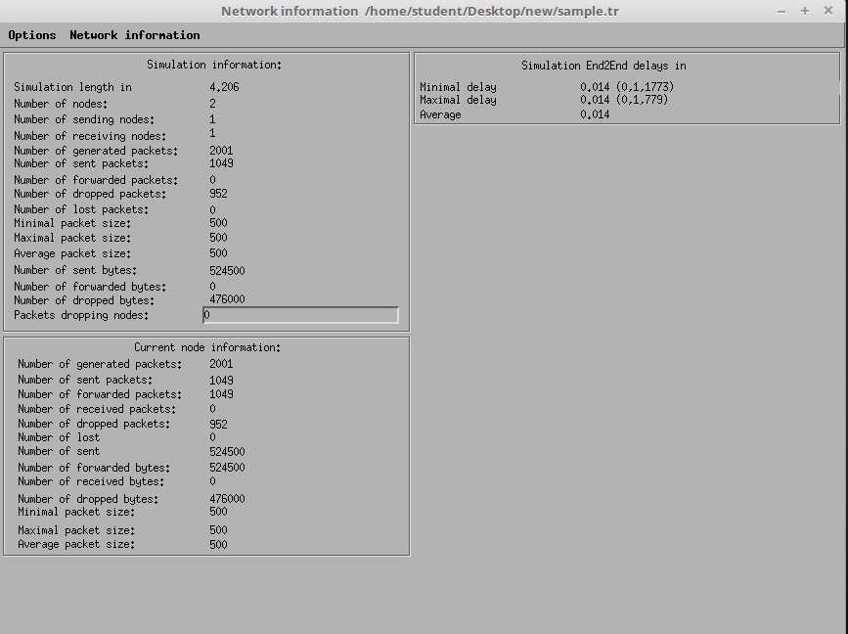

**No of received packets**

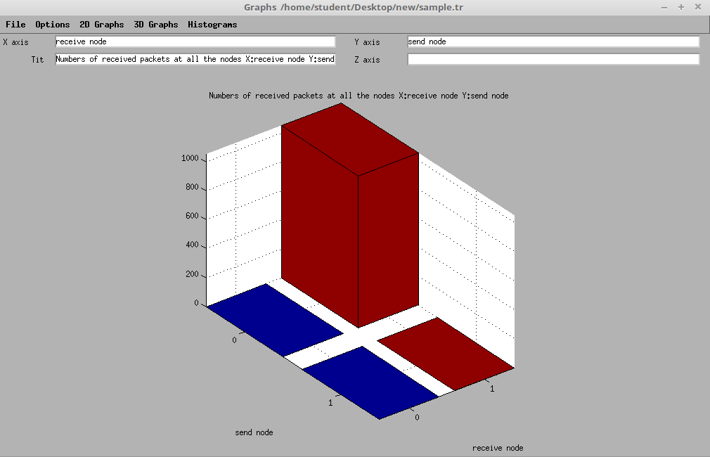

**No of dropped packets**

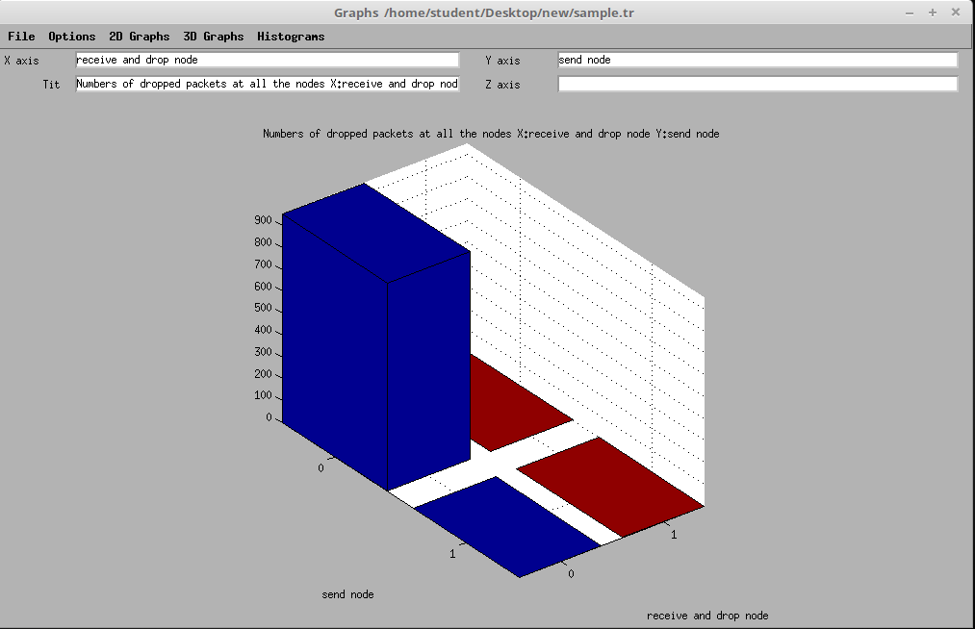

**Throughput of receiving packets.**

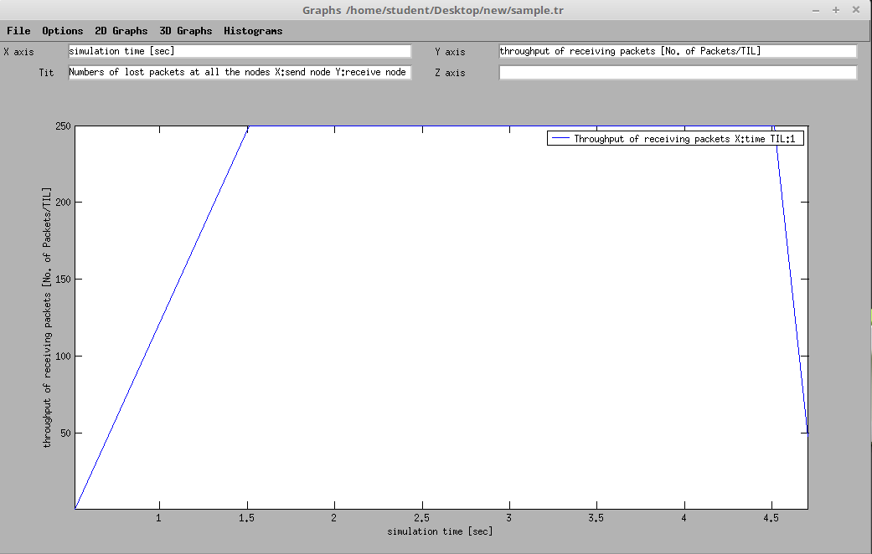

**Throughput of sending packets at node 0.**

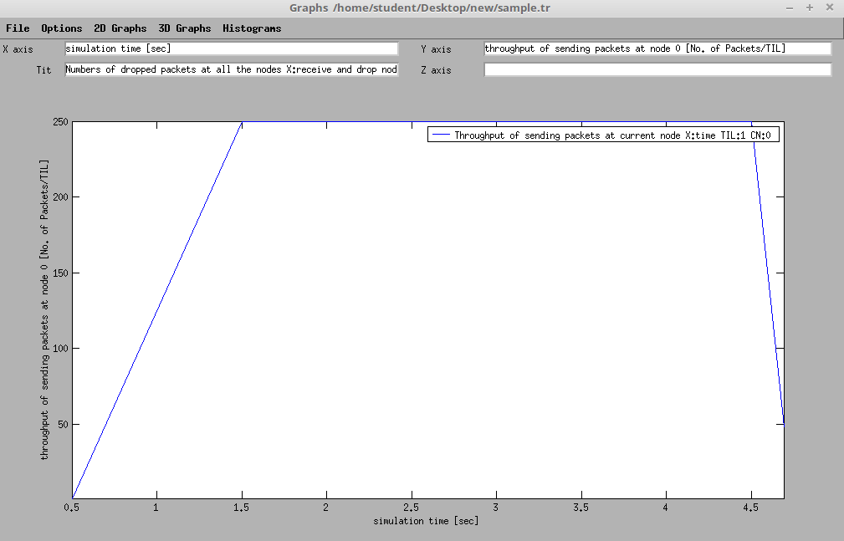

**Throughput of generating packets at node0**

