Data Science & Machine Learning: Lab Cycle 3

Mathplotlib
Demonstrate creating various types of charts and plots using functions in mathplotlib library

1.Sarah bought a new car in 2001 for $24,000. The dollar value of her car changed each year as shown in the table below.
Value of Sarah's Car
Year Value
2001 $24,000
2002 $22,500
2003 $19,700
2004 $17,500
2005 $14,500
2006 $10,000
2007 $ 5,800
Represent the following information using a line graph with following style properties
- X- axis - Year
Y –axis - Car Value
- title –Value Depreciation (left Aligned)
- Line Style dashdot and Line-color should be red
- point using * symbol with green color and size 20
Subplot() provides multiple plots in one figure.

Code:
import matplotlib.pyplot as plt
import numpy as np
xpoints = np.array([2001, 2002,2003,2004,2005,2006,2007])
ypoints = np.array([24000, 22500,19700,17500,14500,10000,5800])
plt.plot(xpoints, ypoints, '*g',ms = 20)
plt.plot(xpoints, ypoints, ':r')

leg = plt.legend(title="Value Depreciation ")
leg._legend_box.align = "left"

plt.show()

output:
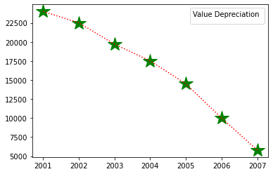

2.Following table gives the daily sales of the following items in a shop
Day | Mon | Tues | Wed | Thurs | Fri
Drinks | 300 | 450 | 150 | 400 | 650
Food | 400 | 500 | 350 | 300 | 500

Use subplot function to draw the line graphs with grids(color as blue and line style dotted) for the above information as 2 separate graphs in two rows
- Properties for the Graph 1:
- X label- Days of week
- Y label-Sale of Drinks
- Title-Sales Data1 (right aligned)
- Line –dotted with cyan color
- Points- hexagon shape with color magenta and outline black

- Properties for the Graph 2:
- X label- Days of Week
- Y label-Sale of Food
- Title-Sales Data2 ( center aligned)
- Line –dashed with yellow color
- Points- diamond shape with color green and outline red

code:
import matplotlib.pyplot as plt
import numpy as np

#plot 1:
x = np.array(['mon', 'tue', 'wed', 'thur','fri'])
y = np.array([300, 450, 150, 400,65])

plt.subplot(1, 2, 1)

plt.title("Sales Data1")
plt.xlabel("Days of week")
plt.ylabel("Sale of Drinks")
plt.plot(x,y,':c')
plt.plot(x,y,'Hm',mec = 'k')

plt.grid(color = 'blue', linestyle = 'dotted')
#plot 2:
c = np.array(['mon', 'tue', 'wed', 'thur','fri'])
v = np.array([400, 500, 350, 300,500])
plt.subplot(1, 2, 2)
plt.title("Sales Data2")
plt.xlabel("Days of Week")
plt.ylabel("Sale of Food")

plt.plot(c,v,'--y')
plt.plot(c,v,'Dg',mec = 'r')

plt.grid(color = 'blue', linestyle = 'dotted')
plt.show()

output:
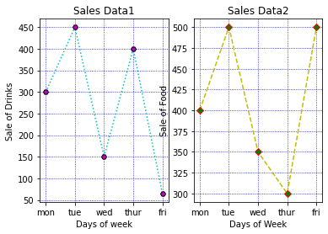

3.Create scatter plot for the below data:(use Scatter function)
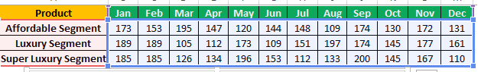

Create scatter plot for each Segment with following properties within one graph
- X Label- Months of Year with font size 18
- Y-Label- Sales of Segments
- Title –Sales Data
- Color for Affordable segment- pink
- Color for Luxury Segment- Yellow
- Color for Super luxury segment-blue
code:

import matplotlib.pyplot as plt
import numpy as np

plt.title("Sales Data")
plt.xlabel("Months of Year")
plt.ylabel("Sales of Segments")

x = np.array([173,153,195,147,120,144,148,109,174,130,172,131])
y = np.array([173,153,195,147,120,144,148,109,174,130,172,131])
plt.scatter(x,y, color = 'hotpink')

x = np.array([185,185,126,134,196,153,112,133,200,145,167,110])
y = np.array([185,185,126,134,196,153,112,133,200,145,167,110])
plt.scatter(x,y, color = 'yellow')

x = np.array([185,185,126,134,196,153,112,133,200,145,167,110])
y = np.array([185,185,126,134,196,153,112,133,200,145,167,110])
plt.scatter(x,y, color = 'blue')

plt.show()

output

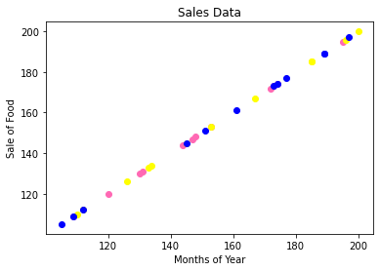

4.Display the above data using multiline plot( 3 different lines in same graph)
- Display the description of the graph in upper right corner(use legend())
- Use different colors and line styles for 3 different lines
code:

# importing package
import matplotlib.pyplot as plt
import numpy as np
# create data
x = [1,2,3,4,5]
y = [3,3,3,3,3]
z = [4,4,4,4,4]
# plot lines
plt.plot(x, y, label = "line 1")
plt.plot(y, x, label = "line 2")
plt.plot(z, x, label = "line 3")
plt.legend()
plt.show()
output
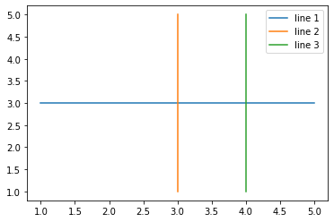

5. 100 students were asked what their primary mode of transport for getting to school was. The results of this survey are recorded in the table below. Construct a bar graph representing this information.

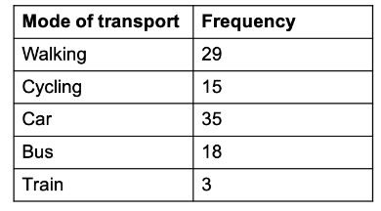
Create a bar graph with
- X axis -mode of Transport and Y axis ‘frequency’
- Provide appropriate labels and title
- Width .1, color green
code:

import matplotlib.pyplot as plt
import numpy as np

x = np.array(["walking", "cycling", "car", "bus", "train"])
y = np.array([29, 15, 35, 18, 3])
plt.title("Transport survey record")
plt.xlabel("mode of Transport")
plt.ylabel("frequency")

plt.bar(x, y,color = "green", width = 0.1)
plt.show()

output

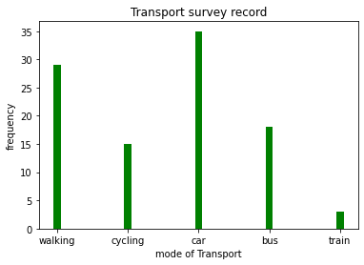

6. We are provided with the height of 30 cherry trees.
The height of the trees (in inches): 61, 63, 64, 66, 68, 69, 71, 71.5, 72, 72.5, 73, 73.5, 74, 74.5, 76, 76.2, 76.5, 77, 77.5, 78, 78.5, 79, 79.2, 80, 81, 82, 83, 84, 85, 87.Create a histogram with a bin size of 5
code:

import matplotlib.pyplot as plt
height = [61,63,64,66,68,69,71,71.5,72,72.5,73,73.5,74,74.5,76,76.2,76.5,77,77.5,78,78.5,79,79.2,80,81,82,83,84,85,87
]
plt.hist(height, edgecolor='red', bins=5)
plt.show()

output
