**Inbuilt Data Structures**

**Basic Coding Questions**

Problem Statement 1

**Solution:**

filenames = ['view.jpg','bear.jpg','ball.png']

filenames.insert(0,'phone.jpg')

filenames.remove('ball.png')

print(filenames)

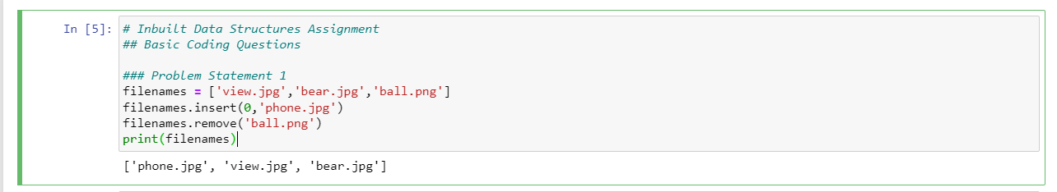

Problem Statement 2

**Solution:**

L = [1,2,3,4,5,6,7,8,9,10]

L.sort()

min_num = L[0]

max_num = L[-1]

sum_nums = 0

for i in L:

sum_nums+=i

avg_list = sum_nums/len(L)

print("Min:{}, Max:{}, Avg:{}".format(min_num,max_num,avg_list))

**Intermediate Coding Questions**

Problem Statement 1

**Solution:**

L = [1,1,1,1,2,2,3,3,3,3,4,5]

L2 = []

for item in L:

if item not in L2:

L2.append(item)

print(L2)

Problem Statement 2

**Solution:**

L = [1,2,3,4,[4,3]]

num_in = int(input("Enter a number: "))

if num_in in L[4]:

print("Input number: {} exists in inner-list: {}".format(num_in,L[4]))

else:

print("Input number: {} does not exist in inner-list: {}".format(num_in,L[4]))

**Advanced Coding Questions**

Problem Statement 1

**Solution:**

numbers_nested = [[1,-1,2],[0,-5,3,5,-2],[1,2,1,0,-2,-3]]

L2 = []

for item in numbers_nested:

for subitem in item:

if subitem > 0:

L2.append(subitem)

print(L2)

Problem Statement 2

**Solution:**

L = [[1,2,3],[4,5,6,3],[-1,-2,-10,5,8]]

sum_of_item_avg = 0

for item in L:

avg_item = sum(item)/len(item)

print("Average of list item: {} is: {}".format(item,avg_item))

sum_of_item_avg+=avg_item

print("Sum of average of list items is: {}".format(sum_of_item_avg))

