Faculty of Engineering, Environment and Computing
EEC 7086CEM –
7086CEM Data Management Systems
Student name : Athira Kannamparambil Asakumar
SID : 12612035

DATABASE MANAGEMENT

Part A:

ER diagram of Coventry Medical Group (CMG)

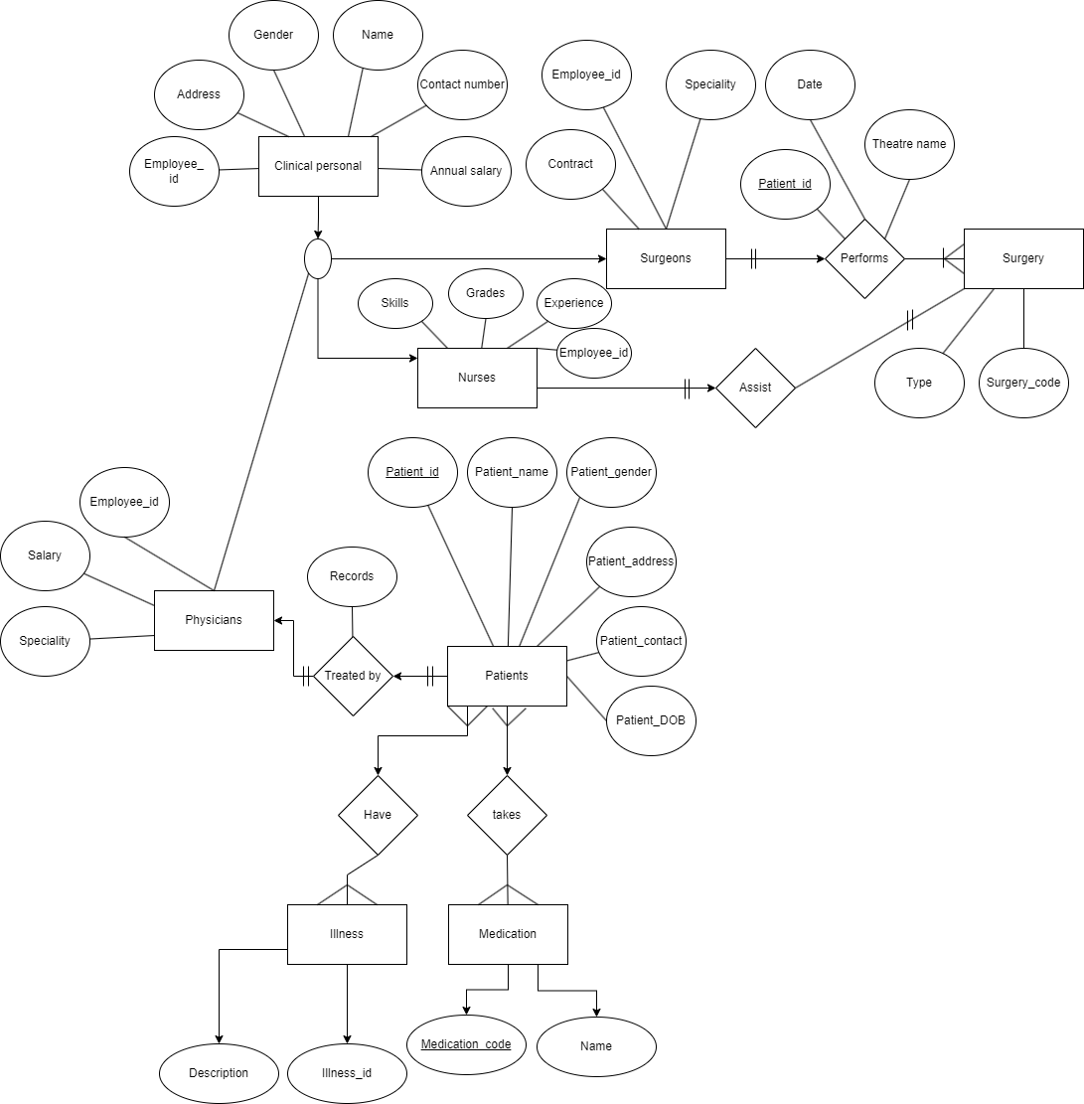

Relational Schema

Clinical Personnel (Employee Id, Name, Address, Gender, Contact Number, Annual Salary)
Physicians (Employee_id, salary,speciality)
Surgeons (Employee_id, Specialty, Contract)
Nurses (Employee_id, Grades, Skills, Experience)
Treated By (Record)
Performs (Patient_id, Date, Theatrename)
Patients (Patient_Id, Patient_Name, Patient_gender, Patient_DOB, Patient_Contact, Patient_Address)
Medication (Medication code, Name)
Illness (Illness id, Description)
Have (Illness code, Patient Number)
Surgery (Type, Surgery Code)
Nursery Assign (Surgery Code, Employee Number)

Part B: SQL programming

Creation of tables and adding values

- Creation of Table User
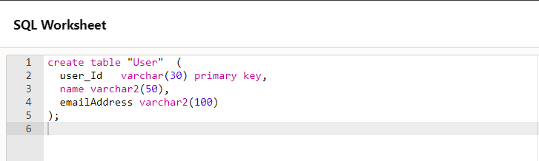

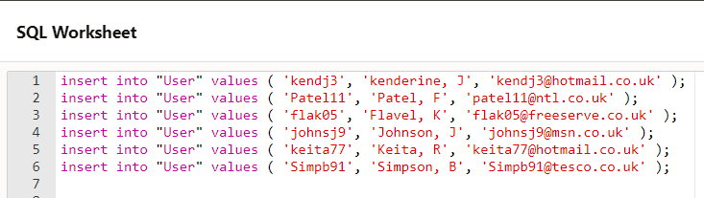
- Adding values to table User

- To confirm I have ran - select * from User
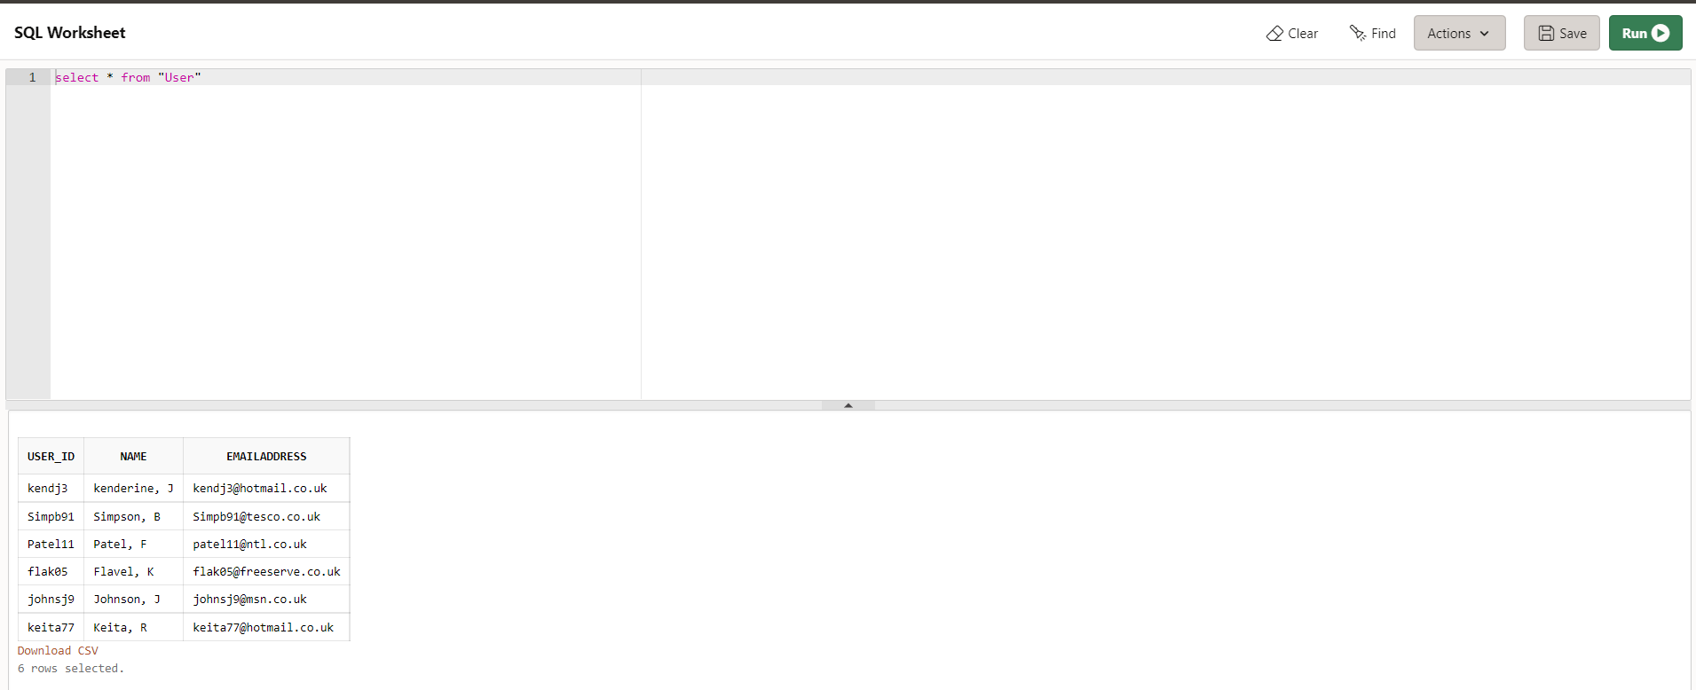

- Creation of table Music
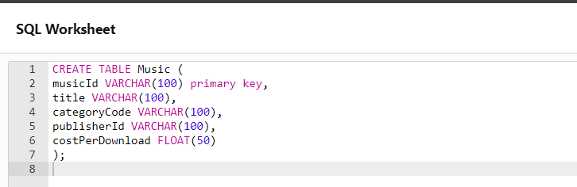

- Adding values to Music table

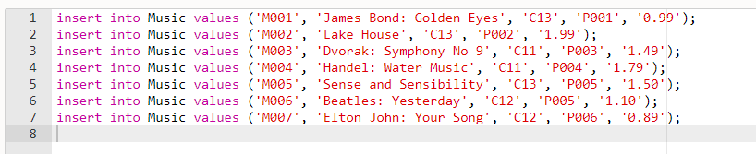

- To confirm table I have ran select query

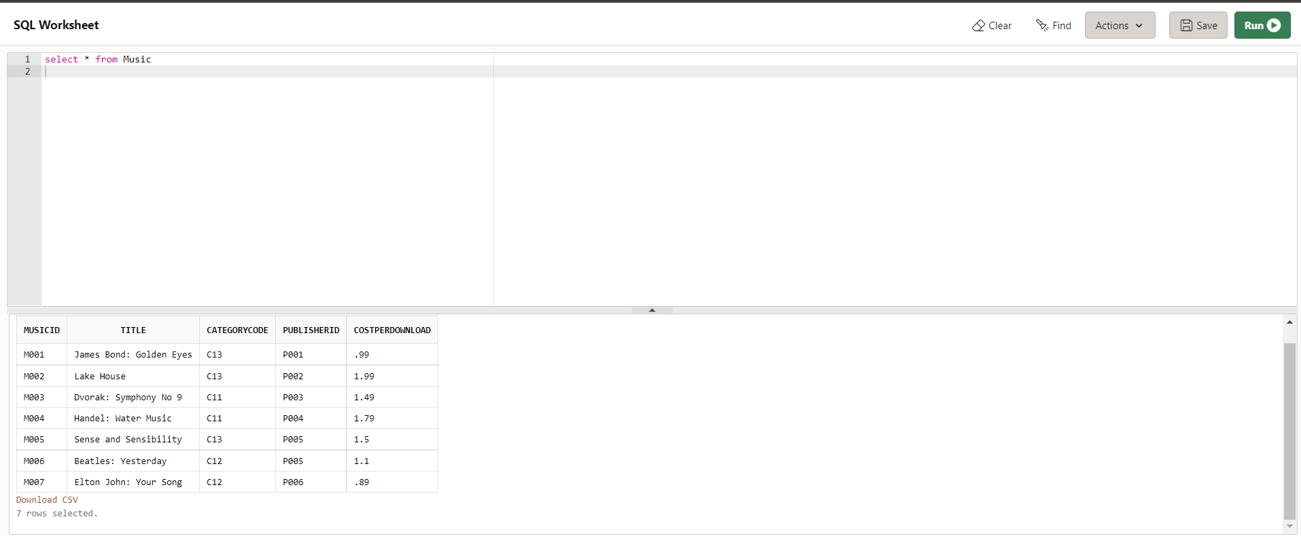

- To confirm schema below query executed.
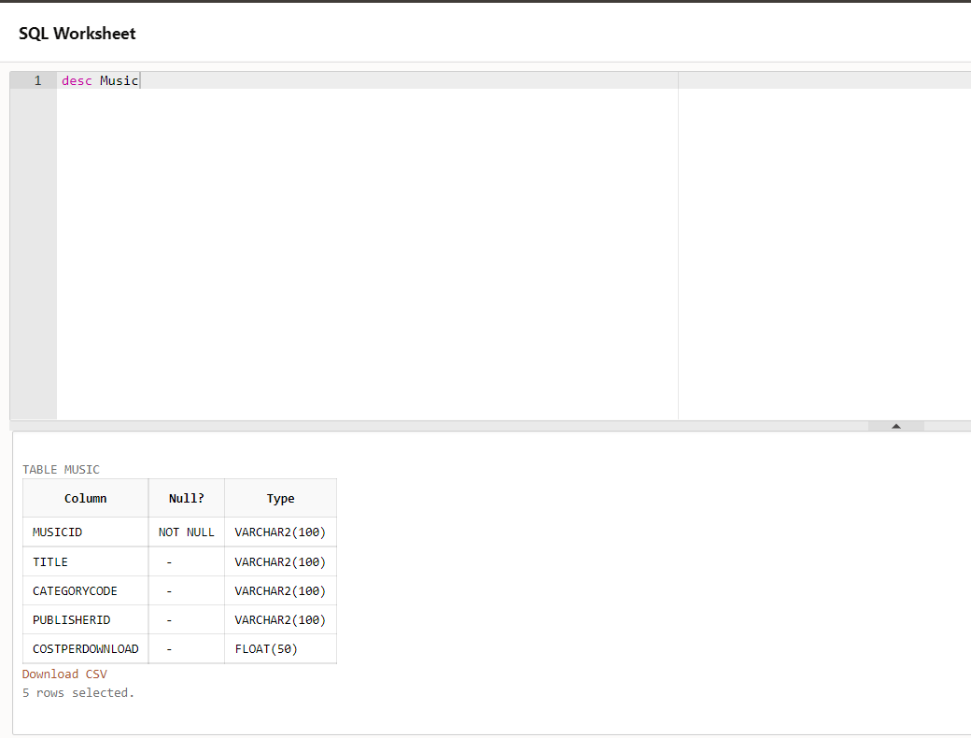

- Create table MusicDownload
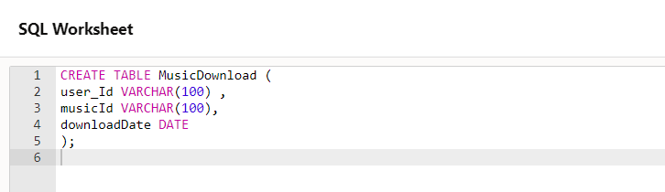

- Adding values to table MusicDownload
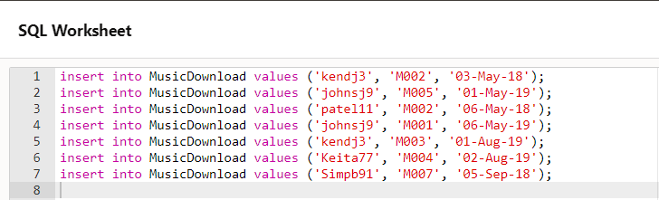

- Display table MusicDownload
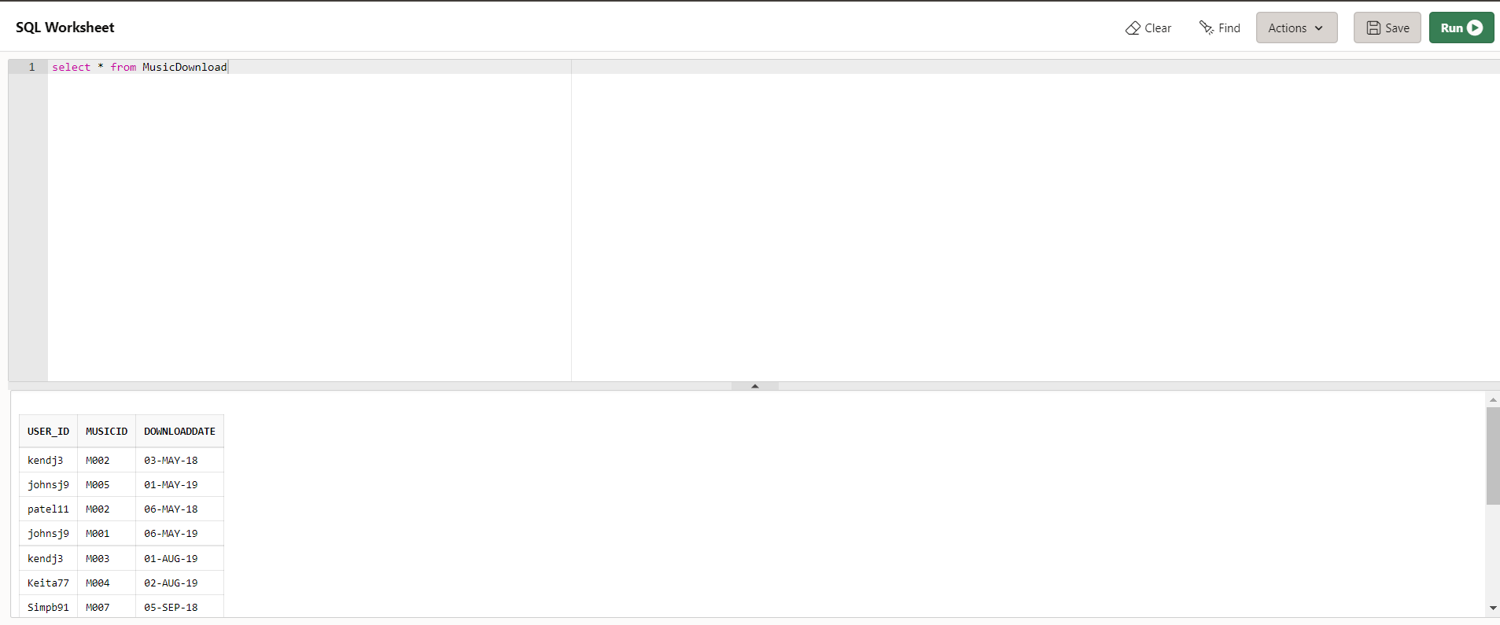

- Confirm schema
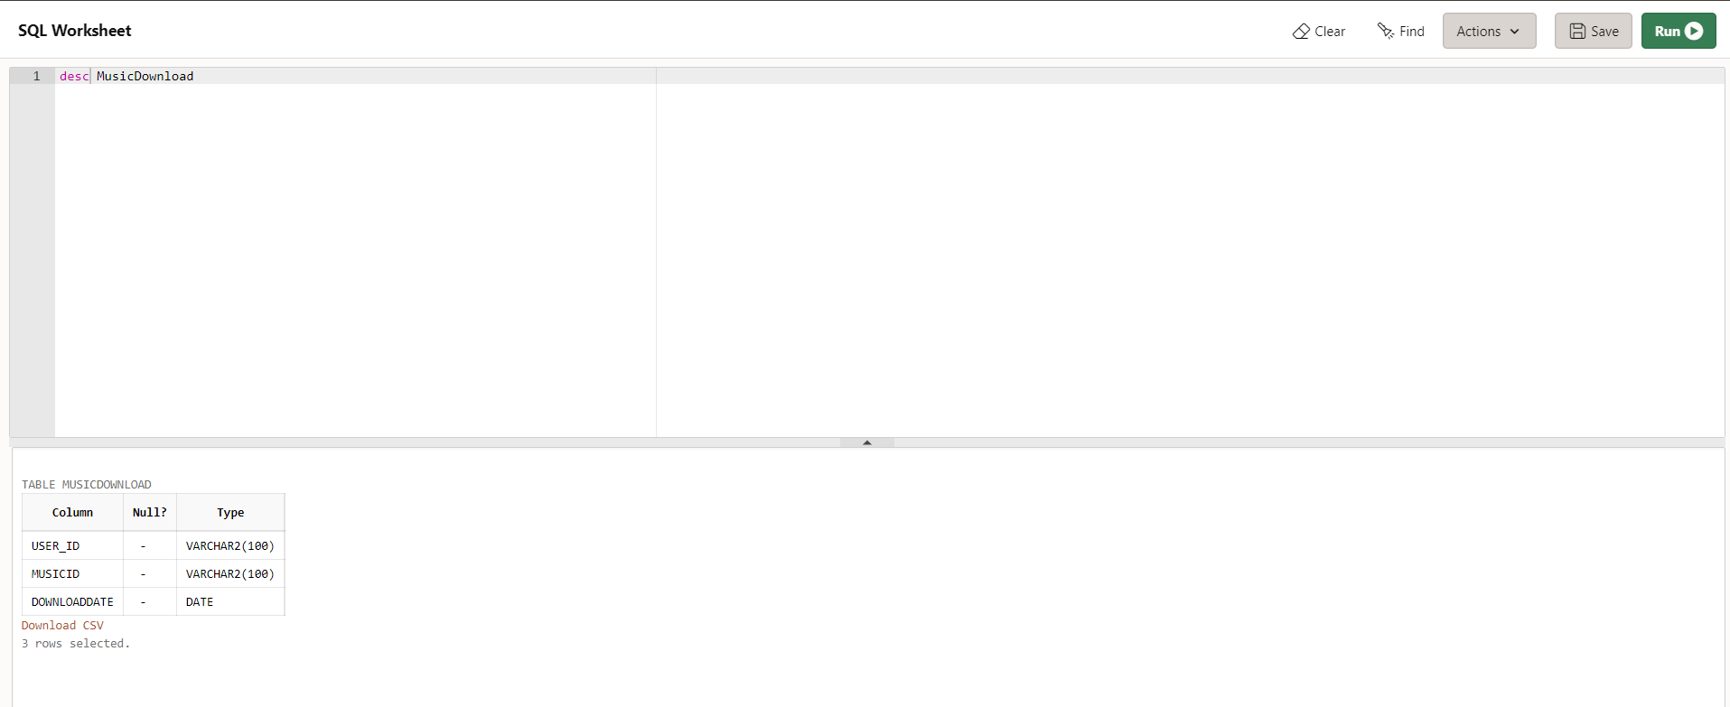

- Creation of table Categories
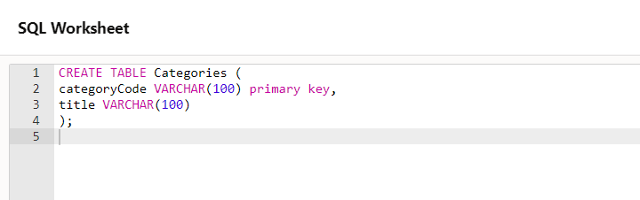

- Adding values to Categories
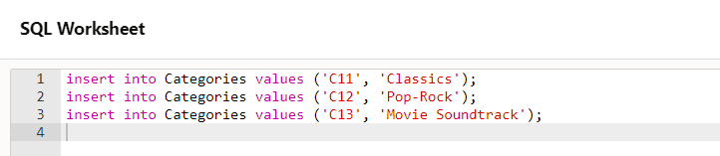

- Display table Categories
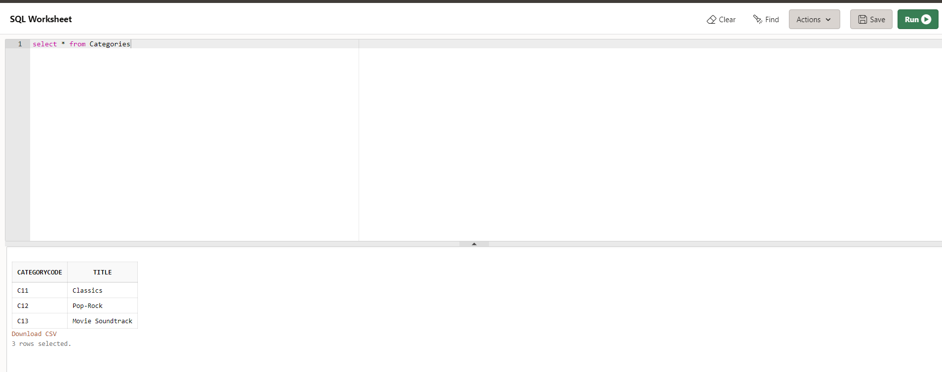

- Confirm schema of table Categories
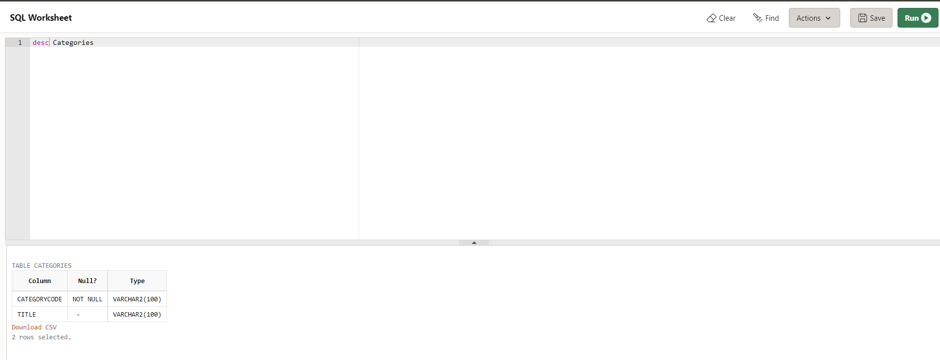

- Create table Publisher
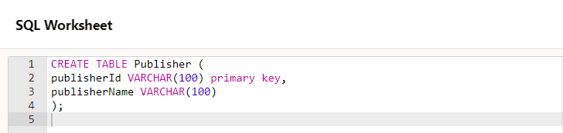

- Adding values to table Publisher
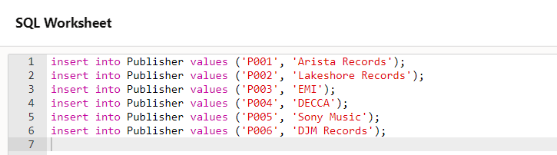

- Display table Publisher
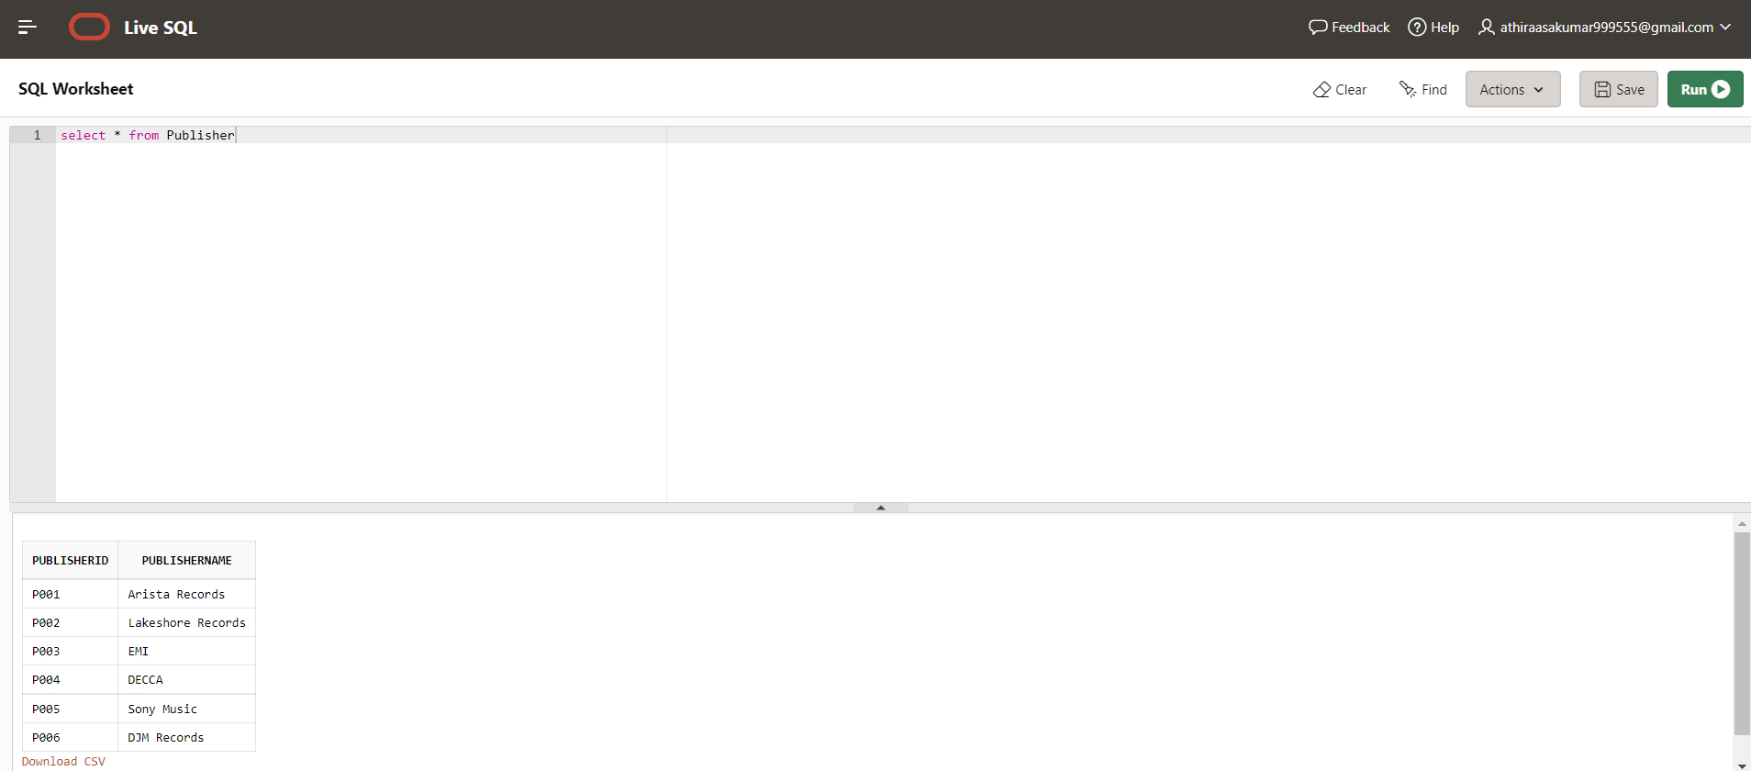

- Confirm schema of table Publisher
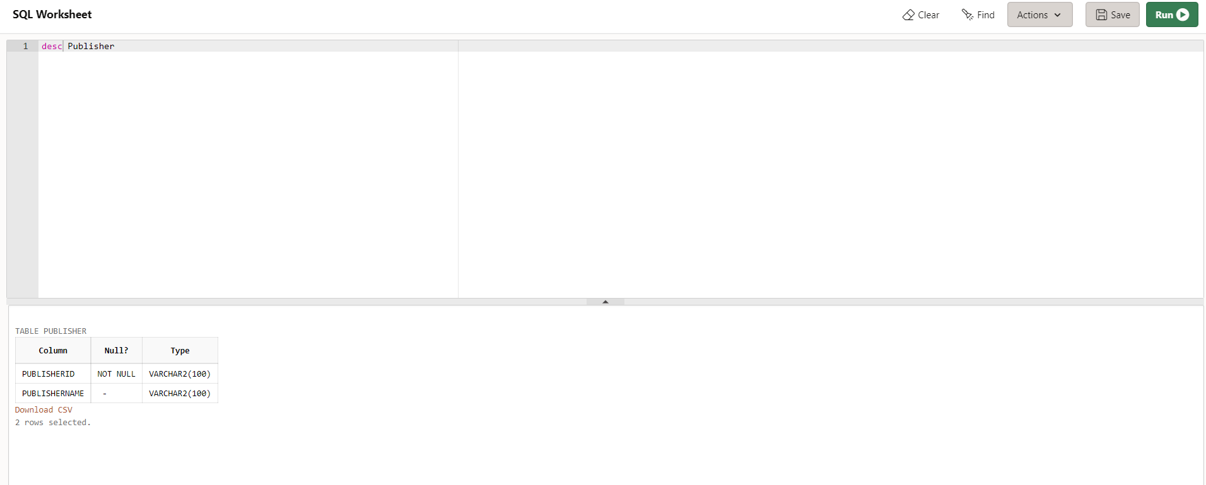

(All the queries are attached to appendix.)
- SQL statements Queries
  - The music id, the title and the publisher name of all the music in the database, ordered by title.

    - Query text
select Music.musicId,Music.title, Publisher.publisherName
from Publisher
inner join Music
on Publisher.publisherId=Music.publisherId
order by Music.title;

    - Solution
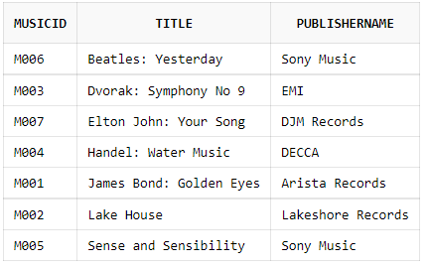

    - Execution of the statement
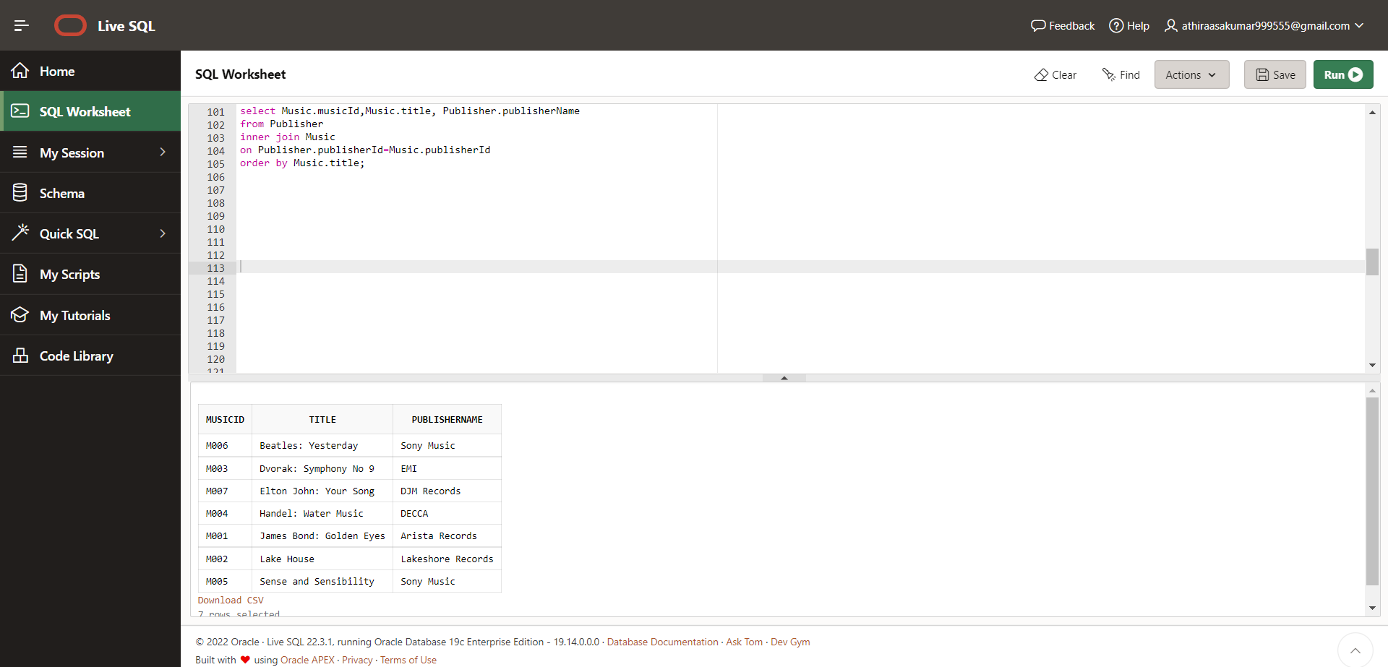
    - Evidence
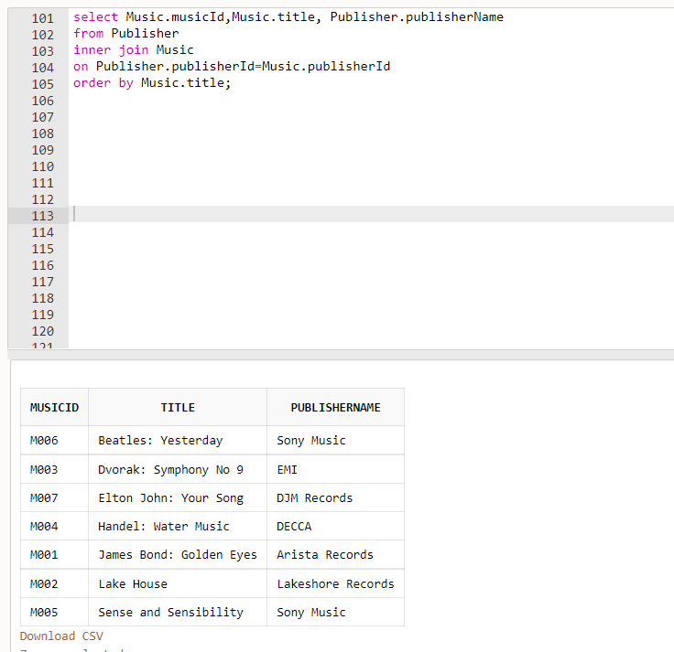

  - Name of the users who downloaded the ‘Classics’ category of music
    - Query Text
SELECT "User".user_Id, "User".name, Categories.title FROM "User"
JOIN MusicDownload ON "User".user_Id = MusicDownload.user_Id
JOIN Music ON MusicDownload.musicId = Music.musicId
JOIN Categories ON Music.categoryCode = Categories.categoryCode
WHERE Categories.categoryCode = (select categoryCode from Categories where title ='Classics');

    - Solution
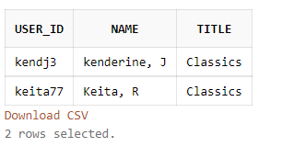
    - Execution of the statement
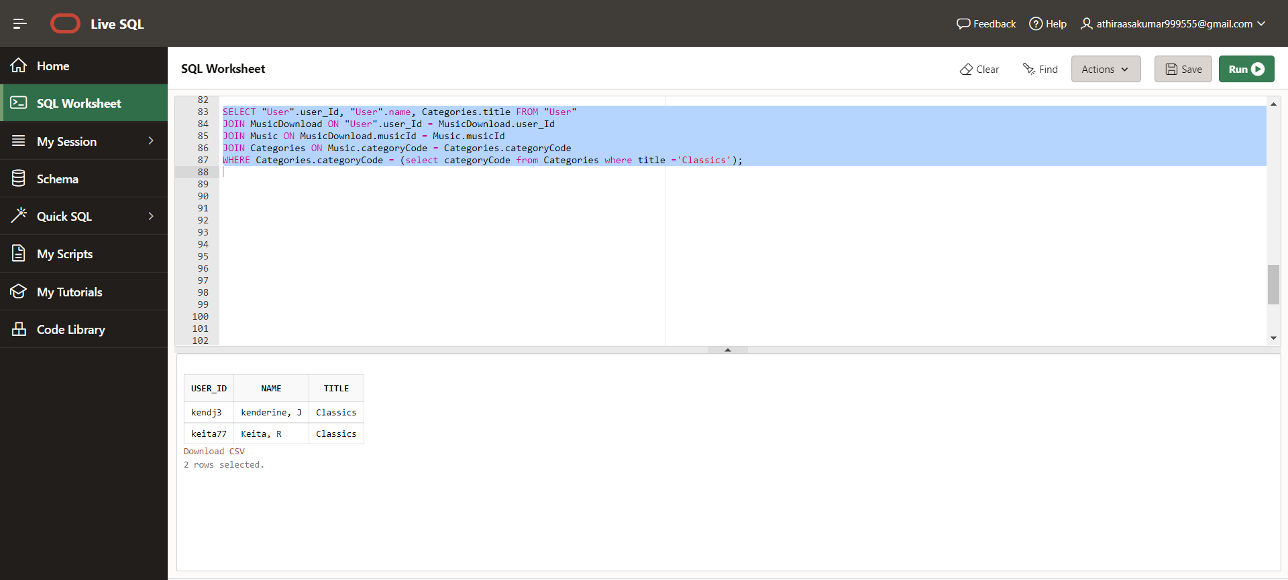
    - Evidence
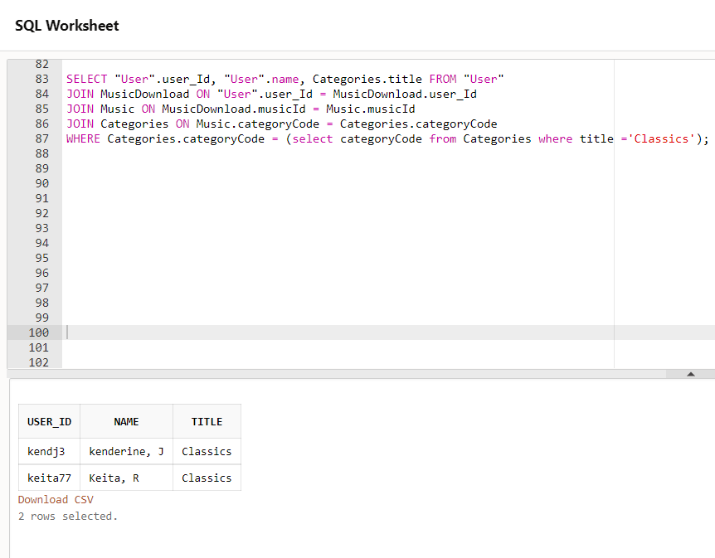
  - No of downloads
    - Query Text
select Categories.title, COUNT(MusicDownload.musicId)
FROM Categories
Inner join Music
on Music.categoryCode=Categories.categoryCode
INNER JOIN MusicDownload
ON Music.musicId=MusicDownload.musicId
GROUP BY Categories.title;

    - Solution
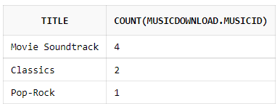

    - Execution of statement
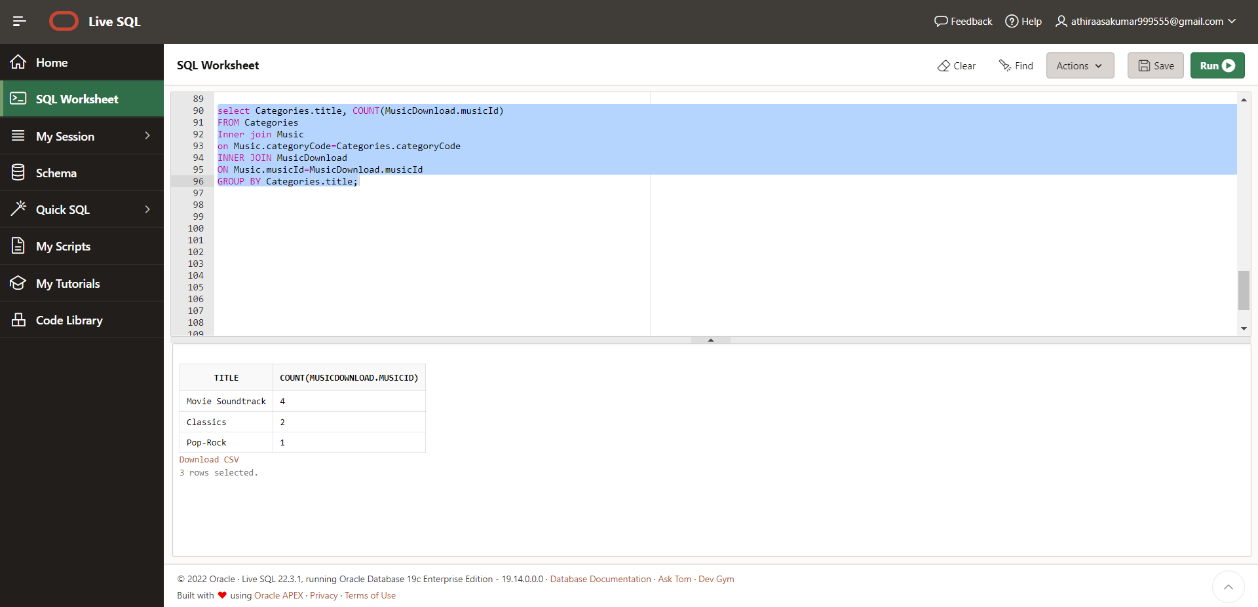

    - Evidence
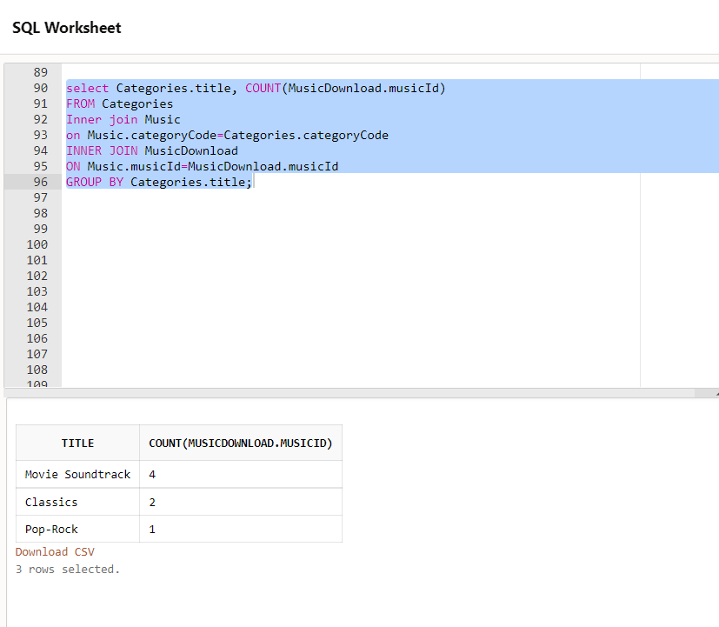

  - Downloads greater than 1
    - Query Text
SELECT categoryCode, count(categoryCode)
FROM Music
GROUP BY categoryCode
HAVING count(categoryCode)>1;
    - Solution
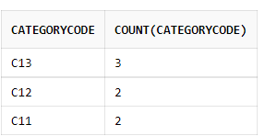

    - Execution of the statement

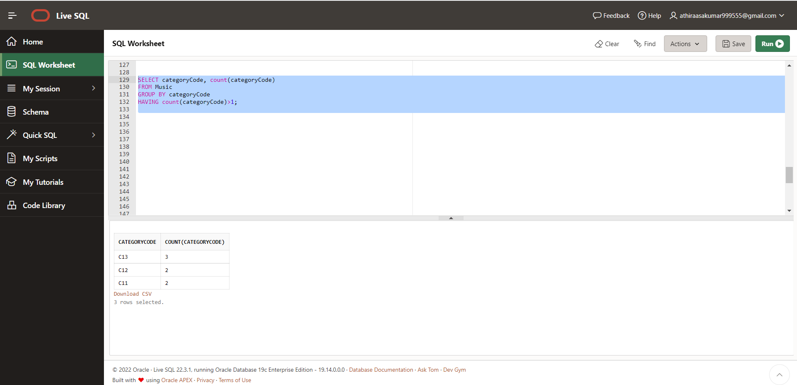

    - Evidence
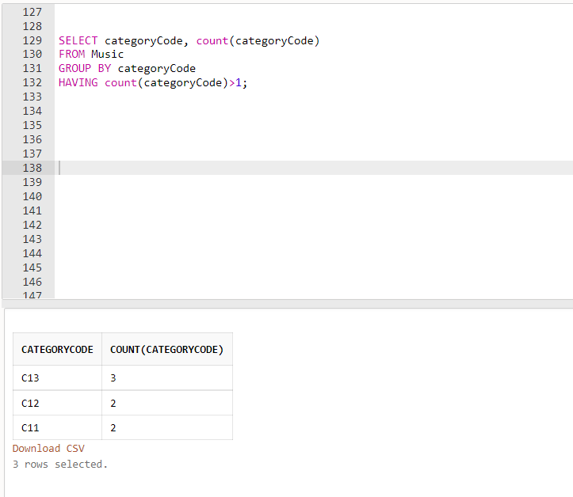

Part C

- Question 1
  - Query to create table
CREATE TABLE Flight_Data (Year INT,
Month SMALLINT,
Day_of_month INT,
Day_of_week SMALLINT,
Departure_time INT,
Actual_Departure_time INT,
Arrival_time INT,
Carrier INT UNIQUE,
Flight_Number VARCHAR(10),
Departure_Delay INT,
Arrival_Delay INT,
Cancellation CHAR,
Weather_Delay INT)

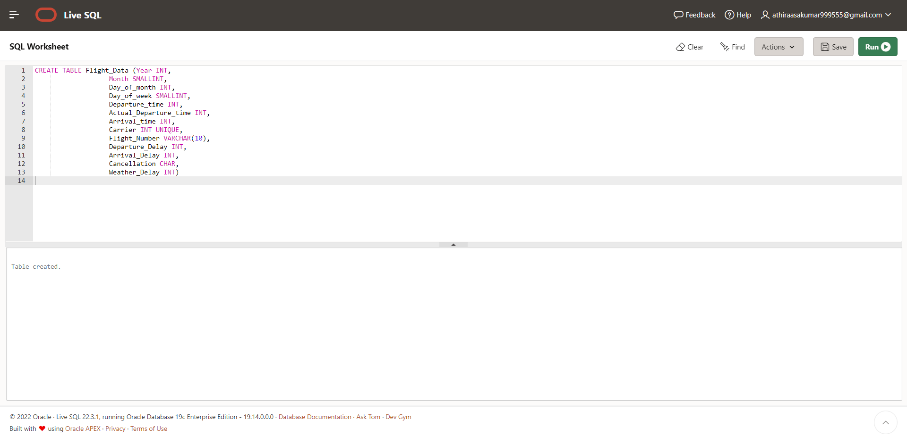

  - The SQL query to find how many flights for each carrier were delayed. (The SQL statements do not need to be implemented in Oracle.)

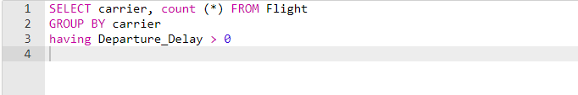

- Using the map reduce technique, we successfully address this issue and calculate the number of delayed flights for each airline.
To address the issue, the sample data is necessary:

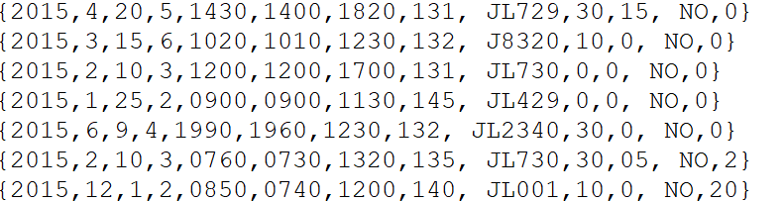

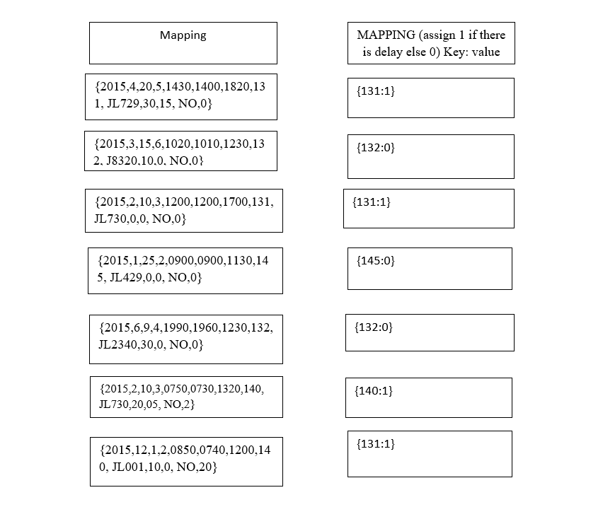

A programming approach called MapReduce allows for the concurrent and distributed processing of massive amounts of data. The word "map" refers to how the value is mapped to a key-value pair, and after some processing, the key-value pairs are reduced to correspond to the value, giving us a speedier output.

Assume that the data is kept in a database as text files using json-like storage that can hold all the data at once. Using map reduce, we can separate and reduce the data until we can determine the number of delayed flights.

In our example, information is gathered from many sources, including the flights that were delayed in relation to the given flight arrival and departure timings. The back story explains that this data is compiled into a single folder and handled by the parallel processing template Mapreduce. The total delay reported by each flight on a recognised day is calculated at the map phase using the departure and arriving delays of each flight. There, during the limiting phase, the overall delay
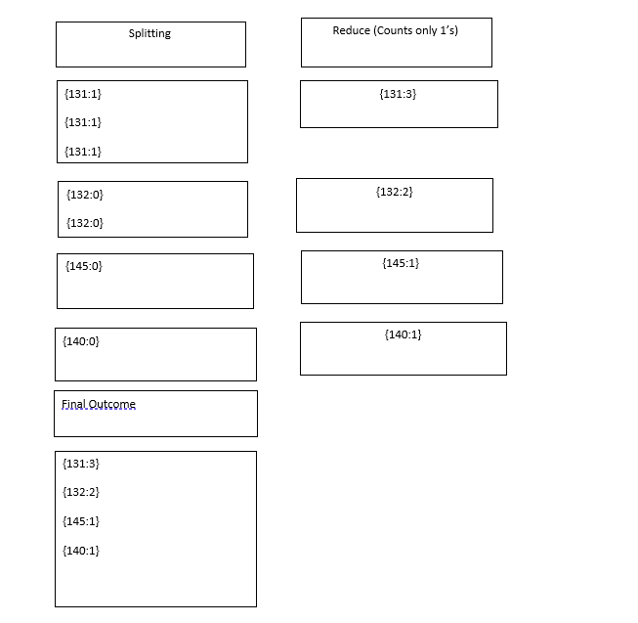

The figure shows how many flights each airline has experienced delays with.

Part D : Research Report

As a result of the article provided online, I am able to learn how Big Data is affecting traditional relational databases. In the article, the author describes having to switch from RDBMS to No-SQL databases.
Nosql is a style of managing databases that may be applied to a variety of information standards, including investment tools, composer, axial, and map designs. Non-relational, scattered, adaptive, and totally scalable are the characteristics of a nosql-specific database. It can be described as a distributed archive in essence. The document can contain facts like who owns a particular plot of land or convey an obligation.

Nosql terminologies lack substance because database management systems are flexible. In spite of the fact that the SQL language's syntax and structure are standardized across manufacturers with only minor variations between operators.
With nosql databases, public keys, database schema, and manuscript structures are all available; this flexibility facilitates agile development and expandability. Data sets in SQL databases are table-based, with each row and column correlated serially. Revisions are made whenever new information is received.
When data points are always growing, nosql datasets are the preferred route because database systems are centralized and cannot be partitioned or sharded. Due to the fact that nosql datasets are capable of resizing from side to side, adding additional data centers to support growing pressure is simple. This makes nosql the best choice when data sets are always growing.
Society and help: The sql server community is large and has been around for more than 40 years. Access to support experts is also simple. Almost all pcs handle them as well. There are collections or components in several scripting languages that can be used to immediately interface with Datasets. Nosql dbms techniques are often fresh and call for more advanced administration abilities.
Oracle, SQL, mysql, and Postgresql are rdbms examples. Mercury, Mongo, Query, Neo4j, Ruby, and other technologies are components of no-SQL platforms.
NoSQL is quicker in this regard since it makes use of a greater number of "mini models" that make data availability simpler. Due to the utilisation of data from many columns, business intelligence with several table joins and sub-queries may experience significant delays. Ongoing configuration is required to help these employees thrive through data archiving and storage. Performance-wise, NoSQL (MongoDB) outperforms SQL systems with a few notable exceptions (Aboutorabi et al., 2015)
Due to RDMBS's centralization, the constant needs for the overall outcome, and NoSQL's generic adaptability, decentralised and internet systems are chosen by enterprises providing services to clients across geographies.
RDBMS is challenged with a variety of distinct problems in large and expanding systems (Jing Han et al., 2011) database programmes.
RDBMS is challenged with a variety of distinct problems in large and expanding systems (Jing Han et al., 2011) Because they provide full functionality, which is both a necessity for banking institutions and a crucial performance criterion for financial organisations, database systems are the top choice for these institutions. Furthermore, since NoSQL lacks a structure, adding any additional customer account information on the fly seems to be more manageable, and changing the online platforms chosen is simple and effective. Additionally, the number of transactions on a given day may be extremely accidental given any occasion like festivals.
Database systems are appropriate for studying sociological statistics as well as comprehending client-specific data, payment networks, login information, and other necessary data. For example, it is most suitable for storing Session and checkout process data in a series of keys as the volume of information is slight, but quick notifications are essential Corporation programmes are handled by Browsers, and rapid advances that improve the company's productivity. Data throughout Dbms can be saved proficiently as they offer multiple data organisation processes inside the domains of finance.
Administrative fees mixed combined quicker purchase increase user happiness. As a result, BFSI businesses should adopt splitter technology by providing clients with a distributed payment alternative. Bankers may be able to offer a better rate of interest, establish new exchanges, and engage in direct competition with forward-thinking financial technology companies by providing enough depositors and hence a more onerous pricing.

Conclusion

Although technology has altered how money is distributed globally, certain practical issues can necessitate system revisions. In pools that process several types of mortgage applications, factors including bond yields, property condition, and potential cash reserves are taken into consideration. All institutional customers can now accomplish this task online using a variety of order tactics, but it will take some time for this full technology to advance.

References

Aboutorabi, S.H. et al. (2015) “Performance evaluation of SQL and mongodb databases for big e-commerce data,” 2015 International Symposium on Computer Science and Software Engineering (CSSE) [Preprint].
Puangsaijai, W. and Puntheeranurak, S. (2017) “A comparative study of relational database and key-value database for Big Data Applications,” 2017 International Electrical Engineering Congress (iEECON) [Preprint].

Appendix

Part B Code:
create table "User" (
user_Id varchar(30) primary key,
name varchar2(50),
emailAddress varchar2(100)
);

insert into "User" values ( 'kendj3', 'kenderine, J', 'kendj3@hotmail.co.uk' );

insert into "User" values ( 'Patel11', 'Patel, F', 'patel11@ntl.co.uk' );
insert into "User" values ( 'flak05', 'Flavel, K', 'flak05@freeserve.co.uk' );
insert into "User" values ( 'johnsj9', 'Johnson, J', 'johnsj9@msn.co.uk' );
insert into "User" values ( 'keita77', 'Keita, R', 'keita77@hotmail.co.uk' );
insert into "User" values ( 'Simpb91', 'Simpson, B', 'Simpb91@tesco.co.uk' );

select * from "User";

CREATE TABLE Music (
musicId VARCHAR(100) primary key,
title VARCHAR(100),
categoryCode VARCHAR(100),
publisherId VARCHAR(100),
costPerDownload FLOAT(50)
);

insert into Music values ('M001', 'James Bond: Golden Eyes', 'C13', 'P001', '0.99');
insert into Music values ('M002', 'Lake House', 'C13', 'P002', '1.99');
insert into Music values ('M003', 'Dvorak: Symphony No 9', 'C11', 'P003', '1.49');
insert into Music values ('M004', 'Handel: Water Music', 'C11', 'P004', '1.79');
insert into Music values ('M005', 'Sense and Sensibility', 'C13', 'P005', '1.50');
insert into Music values ('M006', 'Beatles: Yesterday', 'C12', 'P005', '1.10');
insert into Music values ('M007', 'Elton John: Your Song', 'C12', 'P006', '0.89');

select * from Music

CREATE TABLE MusicDownload (
user_Id VARCHAR(100) ,
musicId VARCHAR(100),
downloadDate DATE
);

insert into MusicDownload values ('kendj3', 'M002', '03-May-18');
insert into MusicDownload values ('johnsj9', 'M005', '01-May-19');
insert into MusicDownload values ('patel11', 'M002', '06-May-18');
insert into MusicDownload values ('johnsj9', 'M001', '06-May-19');
insert into MusicDownload values ('kendj3', 'M003', '01-Aug-19');
insert into MusicDownload values ('keita77', 'M004', '02-Aug-19');
insert into MusicDownload values ('Simpb91', 'M007', '05-Sep-18');

select * from MusicDownload

CREATE TABLE Categories (
categoryCode VARCHAR(100) primary key,
title VARCHAR(100)
);

insert into Categories values ('C11', 'Classics');
insert into Categories values ('C12', 'Pop-Rock');
insert into Categories values ('C13', 'Movie Soundtrack');

select * from Categories

CREATE TABLE Publisher (
publisherId VARCHAR(100) primary key,
publisherName VARCHAR(100)
);

insert into Publisher values ('P001', 'Arista Records');
insert into Publisher values ('P002', 'Lakeshore Records');
insert into Publisher values ('P003', 'EMI');
insert into Publisher values ('P004', 'DECCA');
insert into Publisher values ('P005', 'Sony Music');
insert into Publisher values ('P006', 'DJM Records');

select * from Publisher

select Music.musicId,Music.title, Publisher.publisherName
from Publisher
inner join Music
on Publisher.publisherId=Music.publisherId
order by Music.title;

SELECT "User".user_Id, "User".name, Categories.title FROM "User"
JOIN MusicDownload ON "User".user_Id = MusicDownload.user_Id
JOIN Music ON MusicDownload.musicId = Music.musicId
JOIN Categories ON Music.categoryCode = Categories.categoryCode
WHERE Categories.categoryCode = (select categoryCode from Categories where title ='Classics');

select Categories.title, COUNT(MusicDownload.musicId)
FROM Categories
Inner join Music
on Music.categoryCode=Categories.categoryCode
INNER JOIN MusicDownload
ON Music.musicId=MusicDownload.musicId
GROUP BY Categories.title;

SELECT categoryCode, count(categoryCode)
FROM Music
GROUP BY categoryCode
HAVING count(categoryCode)>1;

