LAB 4
DYNAMIC PROGRAMMING VISUALIZATIONS

Student Name | Athira J
Roll No. | 2401201018
Course / Semester | BCA / 5th
Subject | Design and Analysis of Algorithms

Smart Optimization Assistant Using Dynamic Programming

1. Introduction
This document presents the visual outputs generated for the Lab 4 Dynamic Programming algorithms. Heatmaps show the values stored in the DP tables, while bar charts compare execution time, memory usage, and the number of subproblems.

LCS DP Table Heatmap
The heatmap represents the LCS length stored for each pair of prefixes of the two input strings. Higher values appear with stronger color intensity.
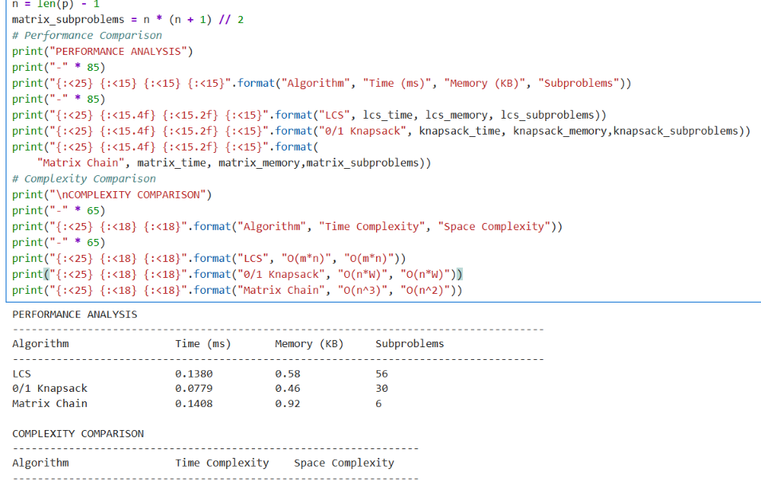

0/1 Knapsack DP Table Heatmap
The heatmap displays the maximum profit obtained for each item prefix and capacity value.
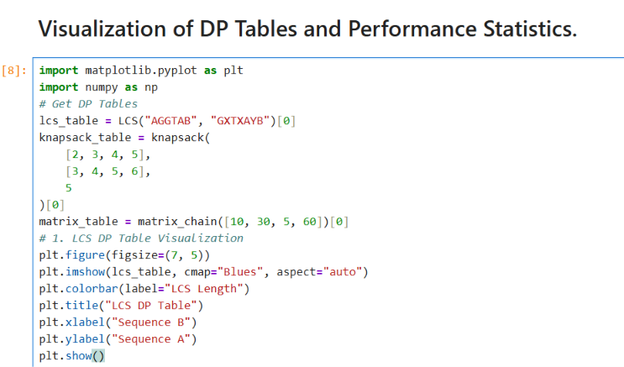

Matrix Chain Multiplication Cost Heatmap
The heatmap represents the minimum scalar multiplication cost for matrix intervals. The table is upper triangular because only intervals with a valid starting and ending matrix are considered.
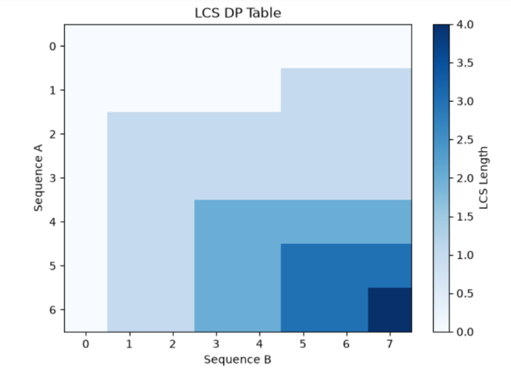

Execution Time Comparison
The bar chart compares the measured execution time of LCS, Knapsack, and Matrix Chain Multiplication in milliseconds.
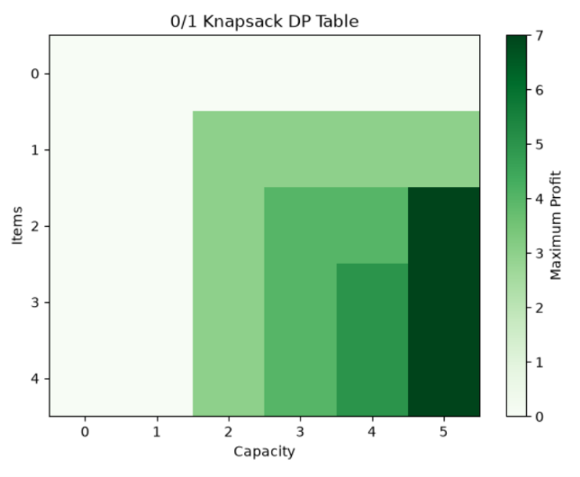

Memory Usage Comparison
The bar chart compares peak traced Python memory usage, measured in KB, for the three algorithms.
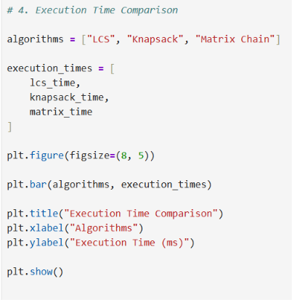

Subproblems Solved Comparison
The bar chart compares the number of DP states or intervals counted for each algorithm using the sample inputs.
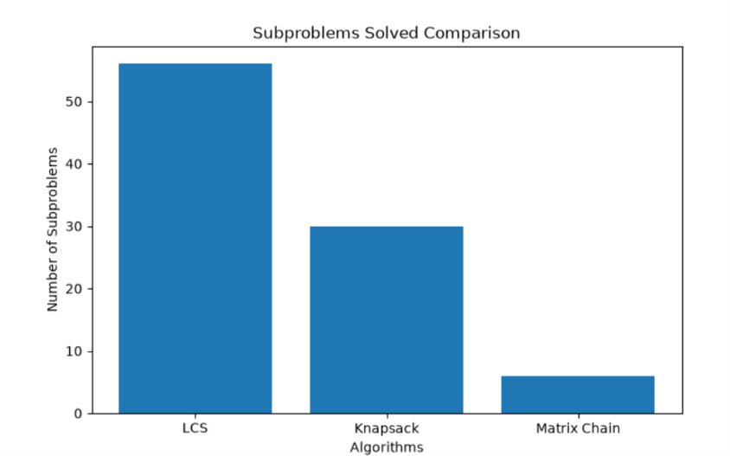

2. Overall Observation
The visualizations provide a quick comparison of the three algorithms. The DP heatmaps illustrate how solutions are built from smaller states. The performance charts show the measured results for the particular sample inputs and computer used. Execution time and memory measurements may vary across runs and systems.

https://github.com/AthiraJoy555/DAA_Lab_4

