LAB 3 — VISUALIZATIONS
Resource Allocation, Activity Timeline, Huffman Tree, and Performance Graphs
Student Name | Athira J
Roll No. | 2401201018
Course / Semester | BCA / 5th
Subject | Design and Analysis of Algorithms

Githhub - Upload files · AthiraJoy555/Lab_3

1. Objective
To create and interpret visualizations for the three greedy algorithms, including the fractional knapsack resource allocation chart, activity selection timeline, Huffman tree representation, execution-time comparison, and peak-memory comparison.

2. Fractional Knapsack — Resource Allocation Chart
The chart illustrates the selected weight from each item when the knapsack capacity is 50. Items are processed in descending value-to-weight ratio: Item 1 contributes 10 weight units, Item 2 contributes 20, and Item 3 contributes the remaining 20. Their value contributions are 60, 100, and 80, respectively, for a total of 240.
plt.figure(figsize=(5, 5))
plt.bar(labels, weights)
plt.title("Fractional Knapsack Resource Allocation")
plt.xlabel("Items")
plt.ylabel("Weight Selected")
plt.tight_layout()
plt.show()

Code explanation
plt.figure creates the drawing area. plt.bar displays one bar for each item. The x-axis identifies items, while the y-axis represents the selected weight. The title and axis labels make the chart readable, and tight_layout reduces clipping.
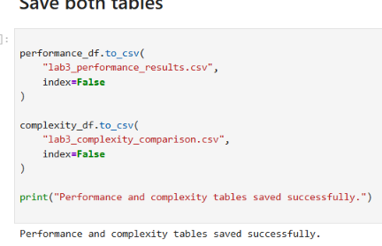
Figure 1. Resource allocation chart and printed allocation details.

3. Activity Selection — Timeline Visualization
Each horizontal bar shows a selected activity from its start time to its finish time. The four chosen activities are (1, 2), (3, 4), (5, 7), and (8, 9). Since the intervals do not overlap, the visualization supports the algorithm's selected count of four.
fig, ax = plt.subplots(figsize=(4, 4))
for i, (start, finish) in enumerate(selected):
ax.barh(i, finish - start, left=start, height=0.5)
ax.text((start + finish) / 2, i, f"{start}-{finish}",
ha="center", va="center")
ax.set_yticks(range(len(selected)))
ax.set_yticklabels([f"Activity {i + 1}" for i in range(len(selected))])
ax.set_xlabel("Time")
ax.set_title("Selected Activities Timeline")
ax.grid(axis="x", linestyle="--", alpha=0.5)
plt.tight_layout()
plt.show()

Code explanation
barh draws horizontal bars. The left argument positions each bar at its start time and the width is finish minus start. Text labels show the interval on each bar. The x-axis represents time and the y-axis identifies each selected activity.
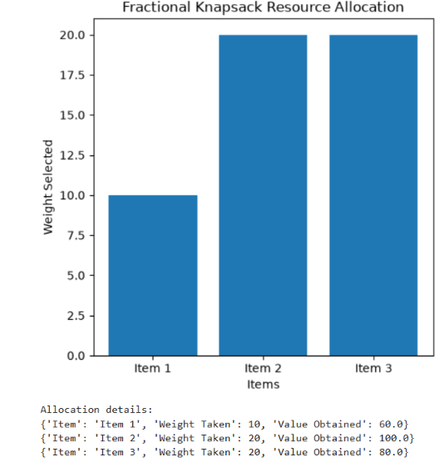
Figure 2. Selected activities timeline.
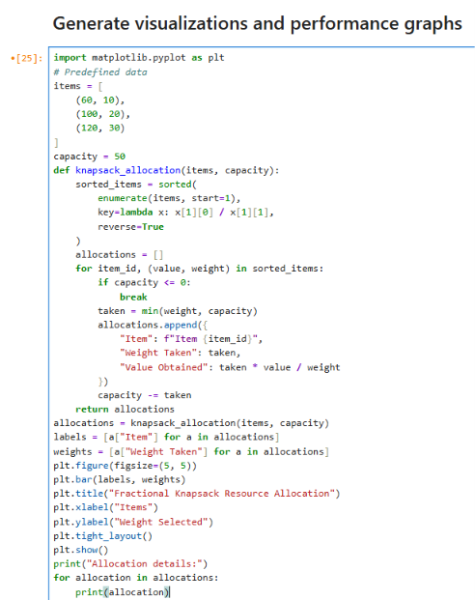
Figure 3. Activity timeline visualization code and output.

4. Huffman Tree Representation
The Huffman tree represents the merges performed by the min-heap. Leaves show characters and their frequencies; internal nodes show combined frequencies. The edge labels 0 and 1 indicate the bits along each branch. A character's Huffman code is the sequence of edge labels from the root to its leaf.
For the text 'aaabbc', the frequencies are a = 3, b = 2, and c = 1. The shown tree gives a one-bit code to a and two-bit codes to b and c, for a total of 3×1 + 2×2 + 1×2 = 9 bits.
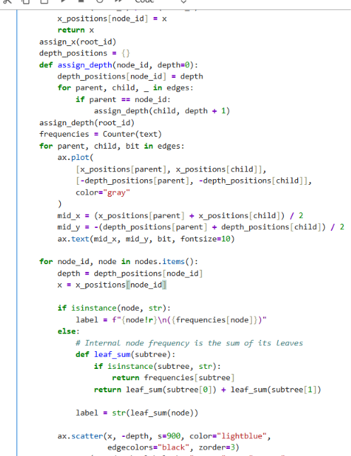
Figure 4. Huffman tree visualization for 'aaabbc'.
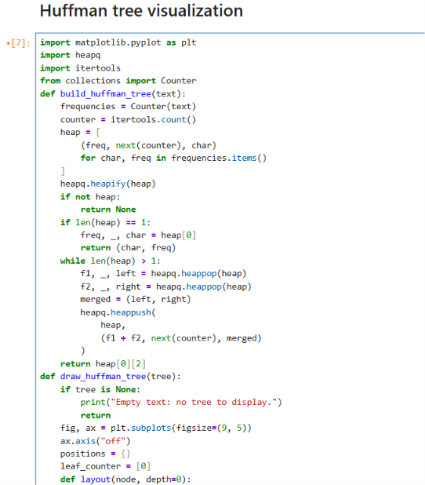
Figure 5. Huffman tree construction code.

5. Execution-Time Comparison Graph
The bar chart compares the measured execution time of Fractional Knapsack, Activity Selection, and Huffman Compression. In the supplied run, the approximate times are 0.000118 s, 0.000329 s, and 0.000816 s. Tiny runtimes can be affected by timer resolution, system load, and Python overhead.
plt.figure(figsize=(4, 4))
plt.bar(
performance_df["Algorithm"],
performance_df["Execution Time (seconds)"]
)
plt.title("Execution Time Comparison")
plt.xlabel("Greedy Algorithm")
plt.ylabel("Execution Time (seconds)")
plt.xticks(rotation=15)
plt.tight_layout()
plt.show()
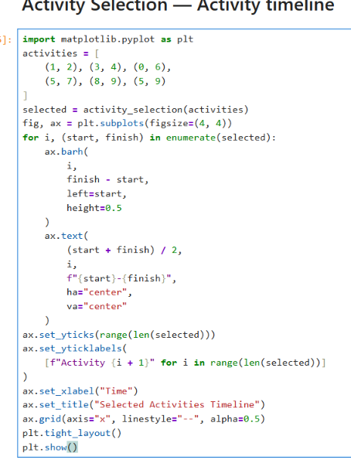
Figure 6. Execution-time comparison graph.

6. Peak Memory Usage Comparison Graph
The memory chart compares peak Python-tracked allocation measured with tracemalloc. The screenshot shows approximately 0.234375 KB for Fractional Knapsack, 0.226562 KB for Activity Selection, and 9.697266 KB for Huffman Compression. This is traced allocation within Python, not the total RAM used by the entire interpreter or operating system.
plt.figure(figsize=(4, 4))
plt.bar(
performance_df["Algorithm"],
performance_df["Peak Memory (KB)"]
)
plt.title("Peak Memory Usage Comparison")
plt.xlabel("Greedy Algorithm")
plt.ylabel("Peak Memory (KB)")
plt.xticks(rotation=15)
plt.tight_layout()
plt.show()
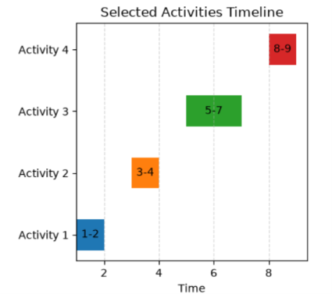
Figure 7. Peak memory usage comparison graph.

7. Overall Interpretation
The resource chart shows how capacity is distributed, the timeline shows compatibility among selected activities, and the Huffman tree illustrates how frequency-based merging creates prefix codes. The two performance graphs compare the measured resource use for one specific set of inputs. These visualizations complement the algorithm explanations and complexity table, but small-input measurements should not be generalized to large datasets.

8. Conclusion
The visualizations make the greedy decisions easier to inspect. The knapsack chart shows capacity allocation, the activity timeline confirms non-overlapping intervals, the Huffman tree shows code construction, and the performance graphs compare observed runtime and memory allocation.
https://github.com/AniketChauhan10

