**1.0 UML Diagram**

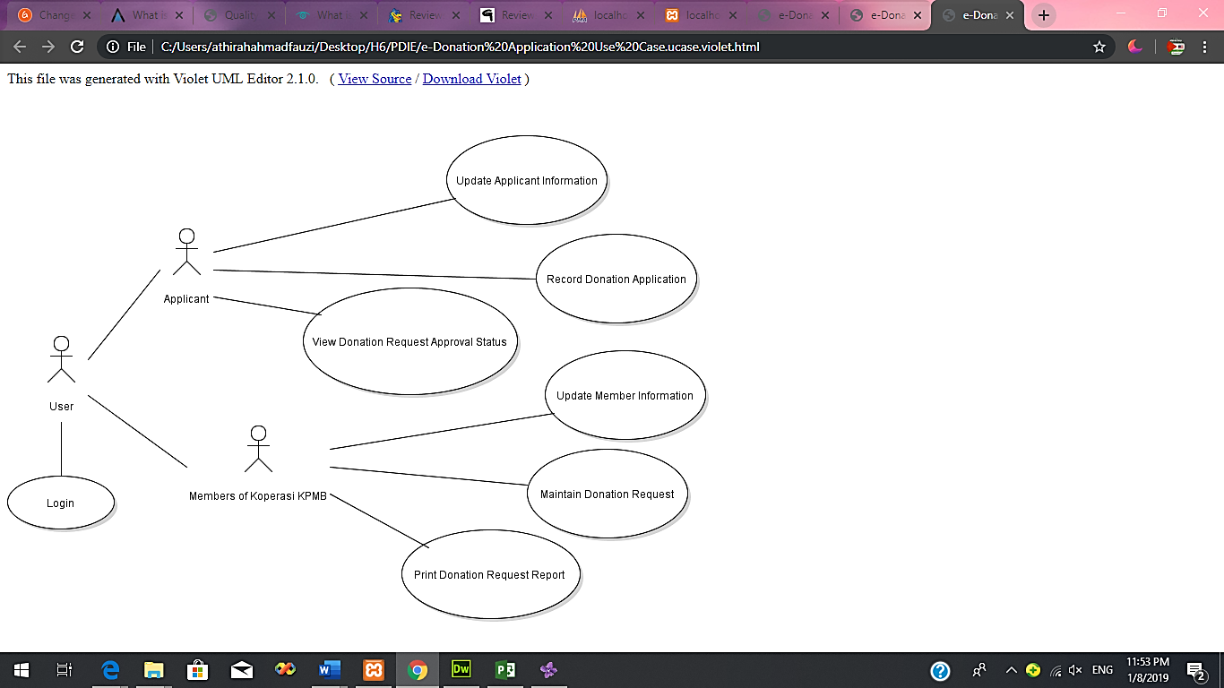 **1.1 Use Case Diagram**

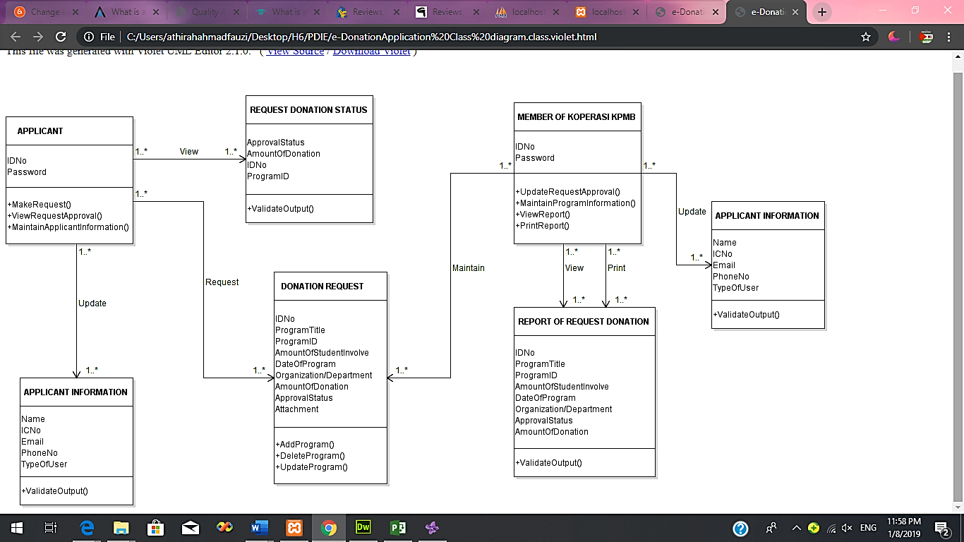 **1.2 Class Diagram**

**1.3 Sequence Diagram**

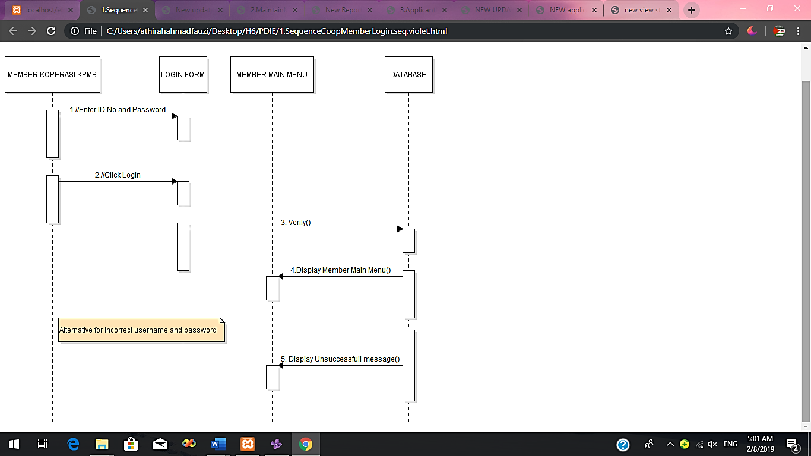 **a. Member- Login**

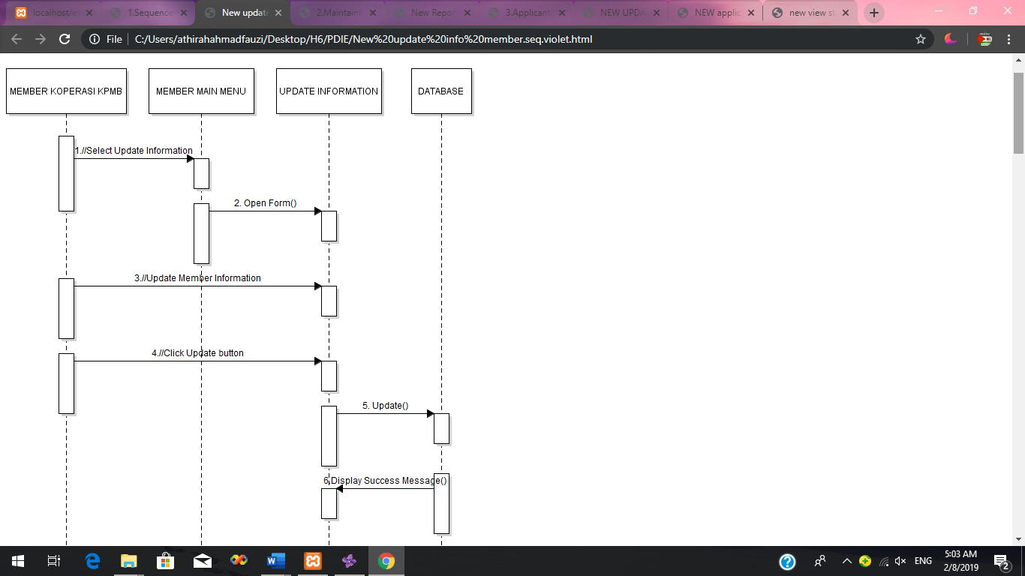 **b. Member- Update Information**

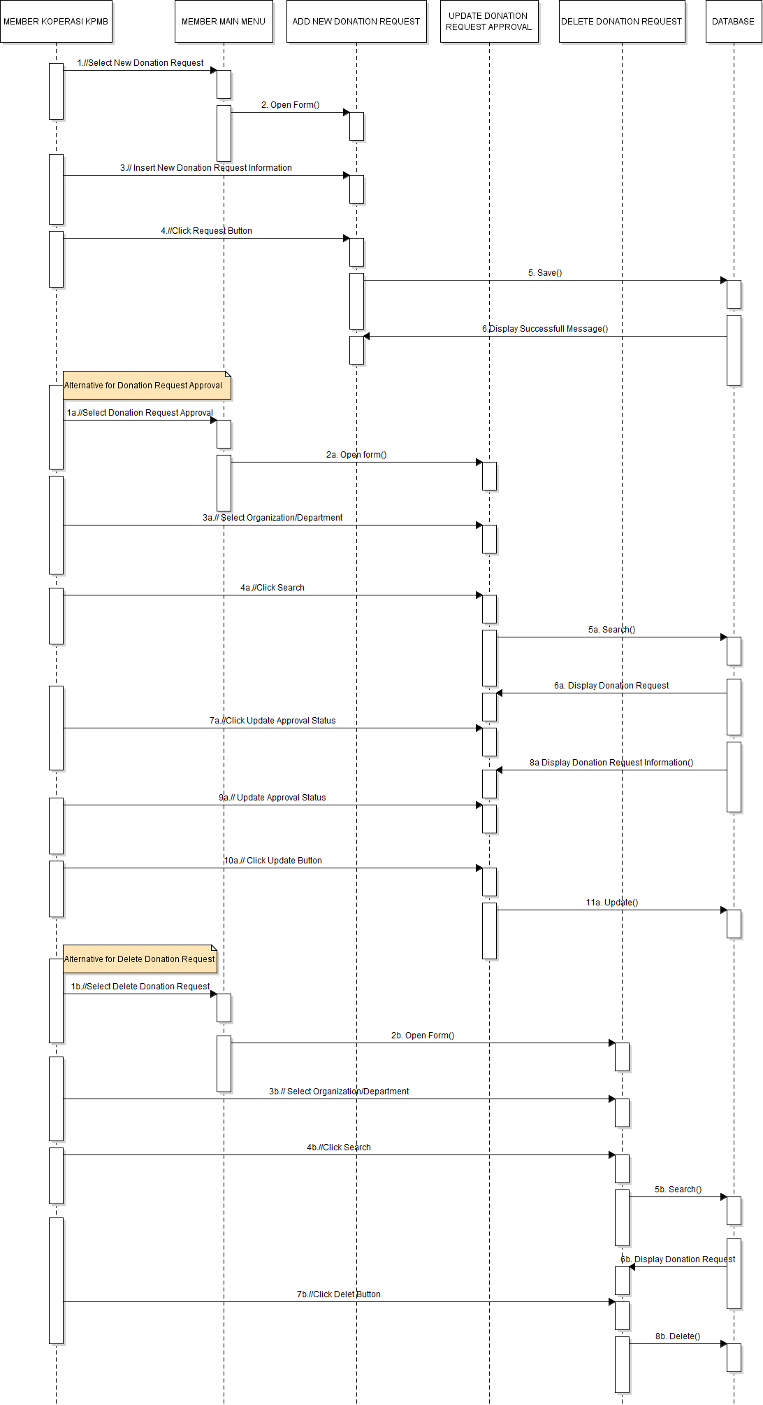**c. Member- Maintain Donation Request**

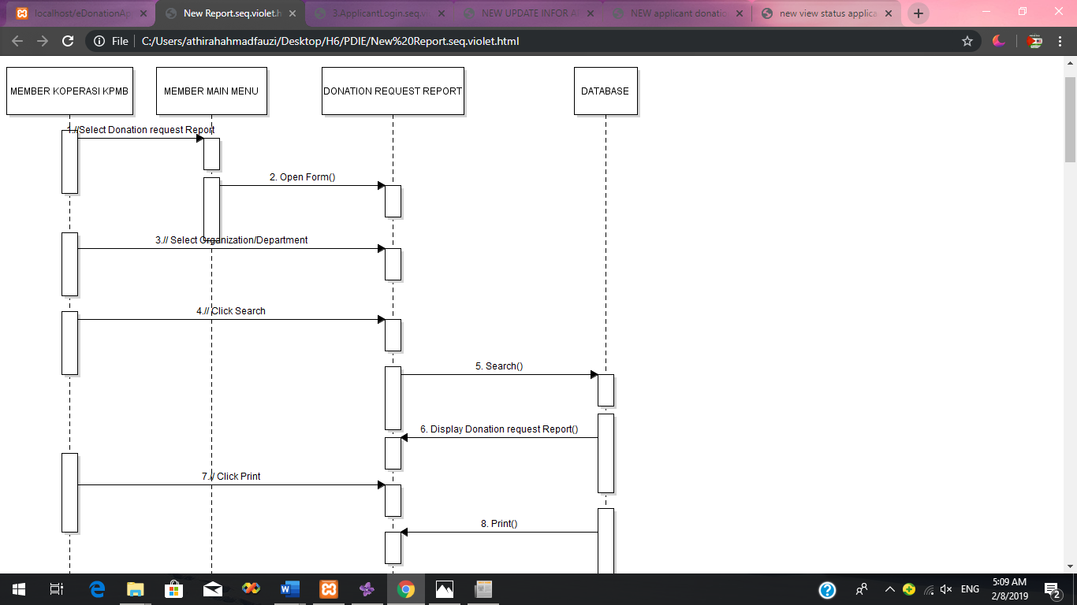 **d. Member- Report Donation Request**

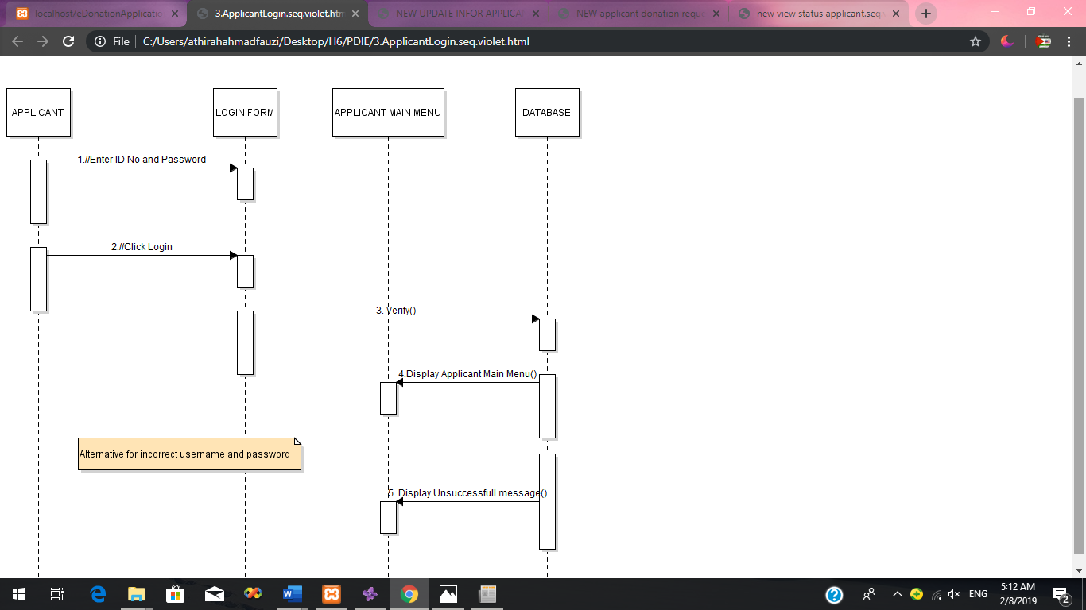 **e. Applicant- Login**

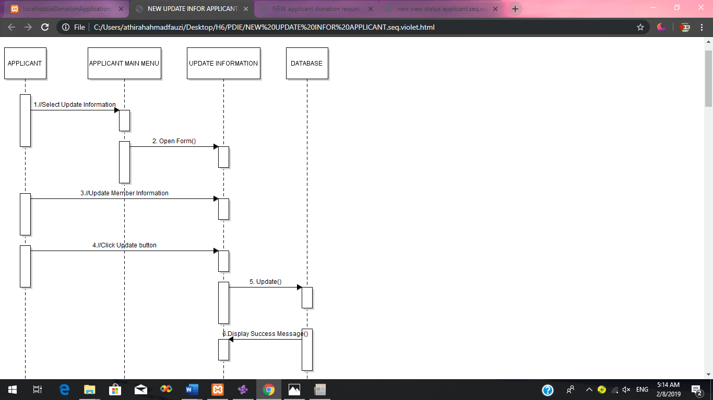 **f. Applicant- Update Information**

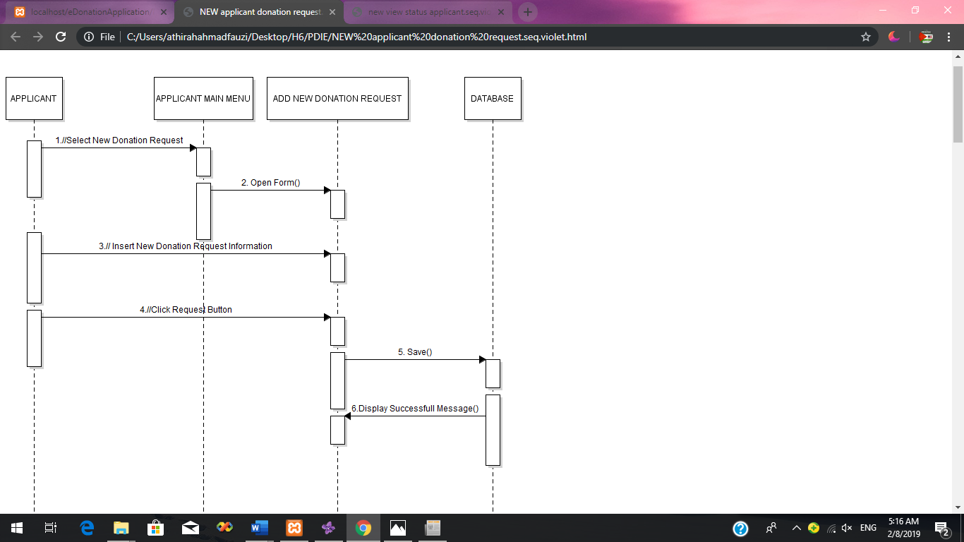 **g. Applicant- New Donation Request**

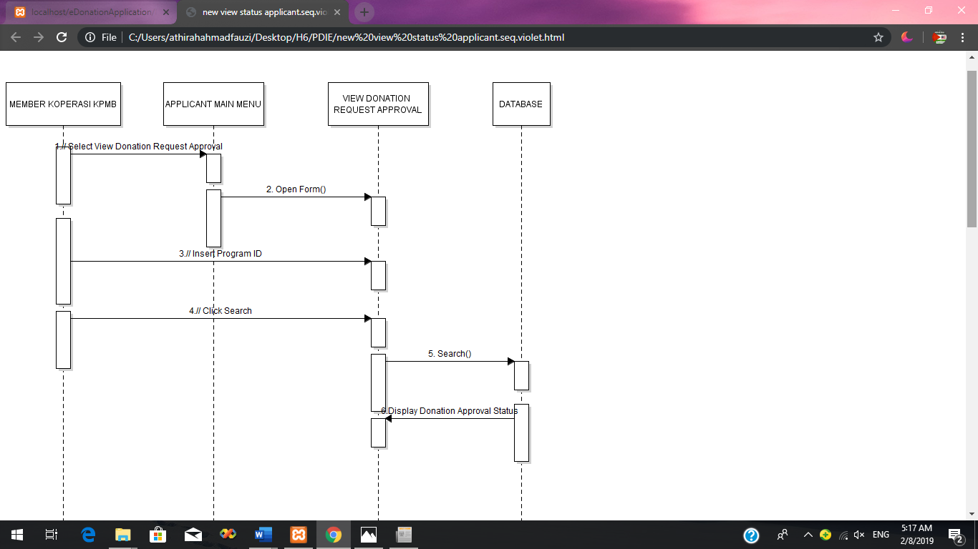 **h. Applicant- View Donation Approval Status**