**1.0 UML Diagram**

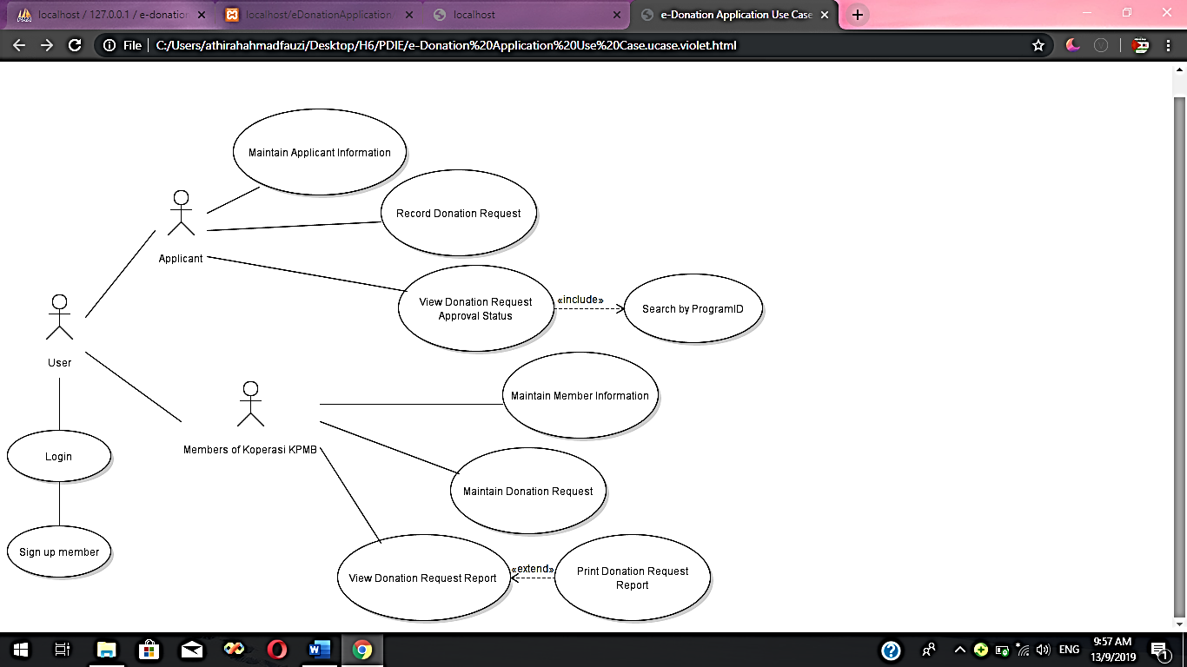 **1.1 Use Case Diagram**

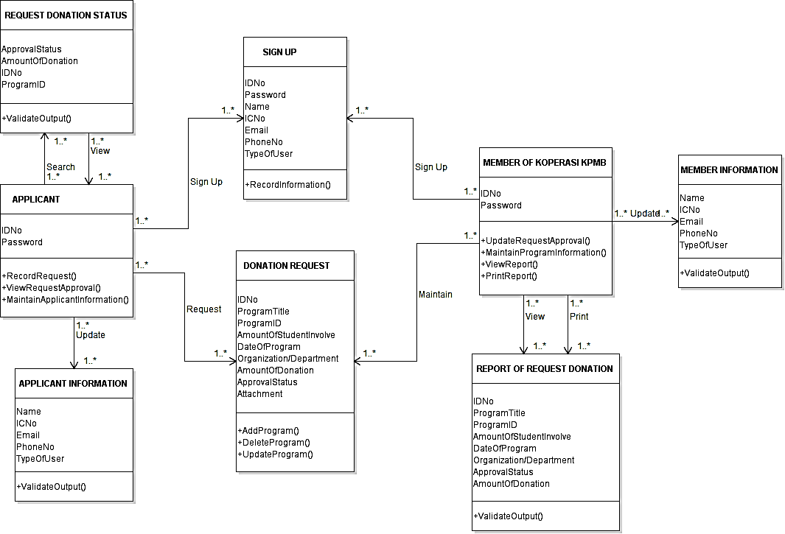 **1.2 Class Diagram**

**1.3 Sequence Diagram**

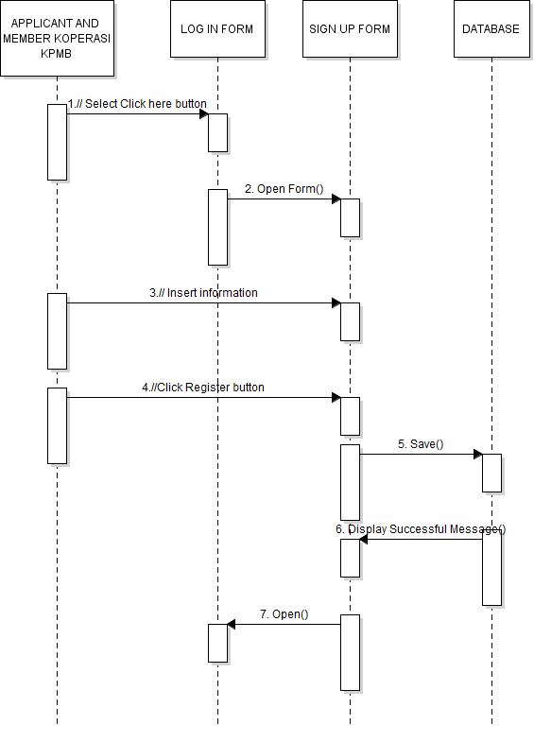 **a. Sequence Diagram to Sign Up: Member Koperasi KPMB and Applicant**

**b. Sequence Diagram to login: Member Koperasi KPMB**

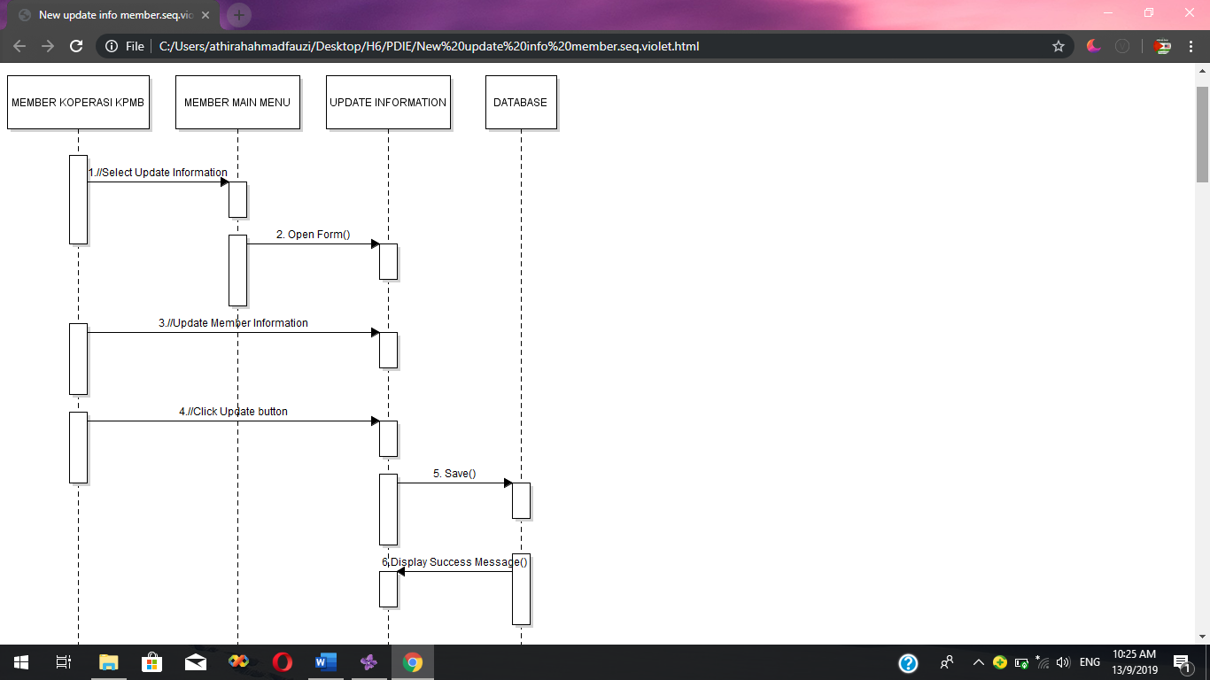**c. Sequence Diagram to maintain member information: Member Koperasi KPMB**

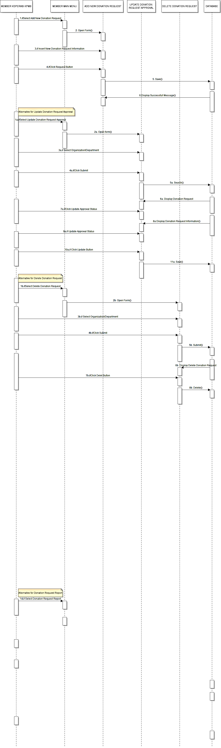**d. Sequence Diagram to maintain donation request: Member Koperasi KPMB**

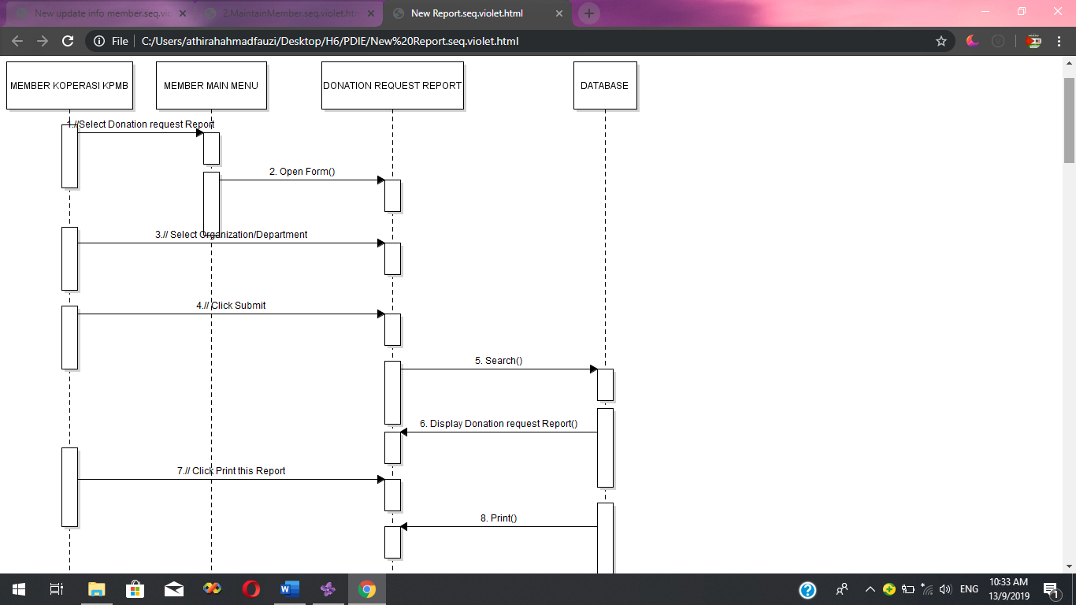**e. Sequence Diagram for report donation request: Member Koperasi KPMB**

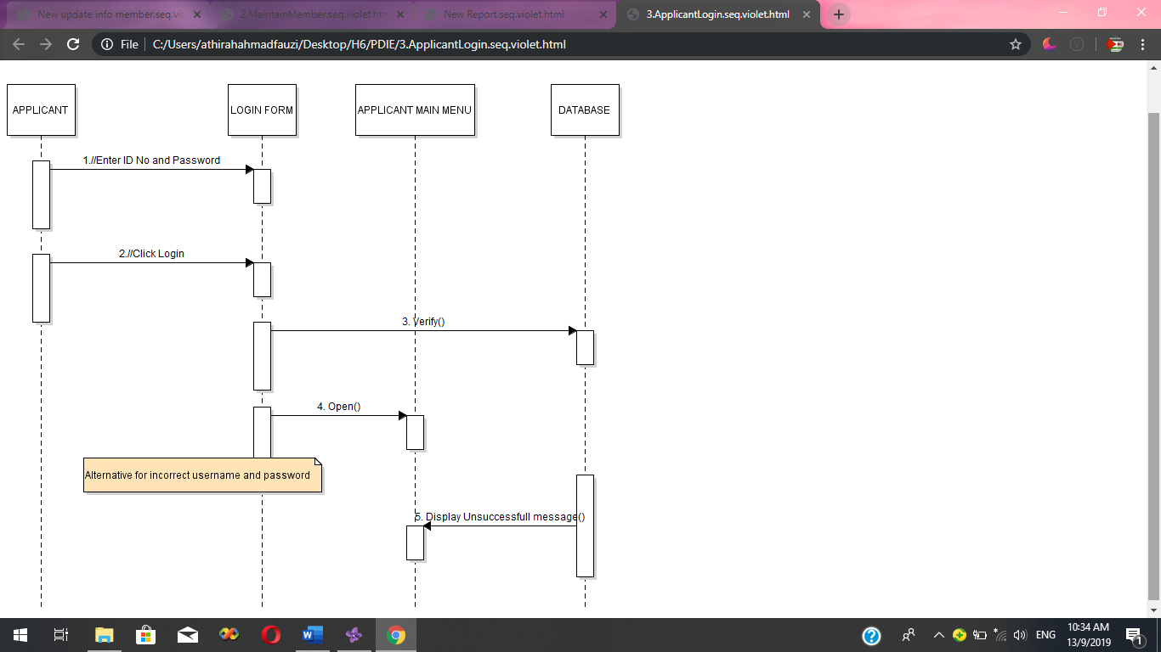 **f. Sequence Diagram to login: Applicant**

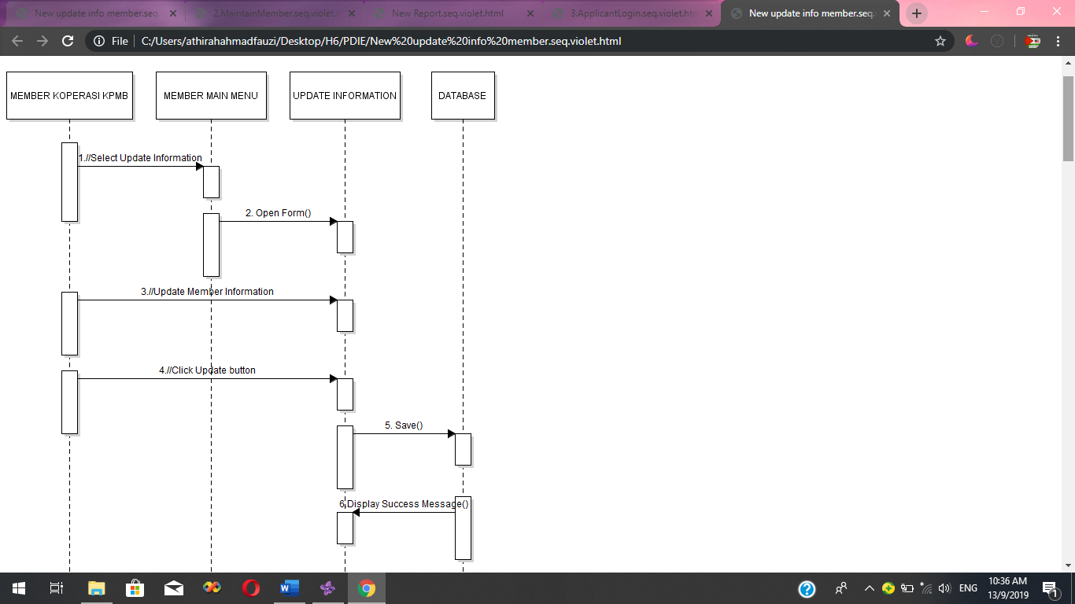**g. Sequence Diagram to maintain applicant information: Applicant**

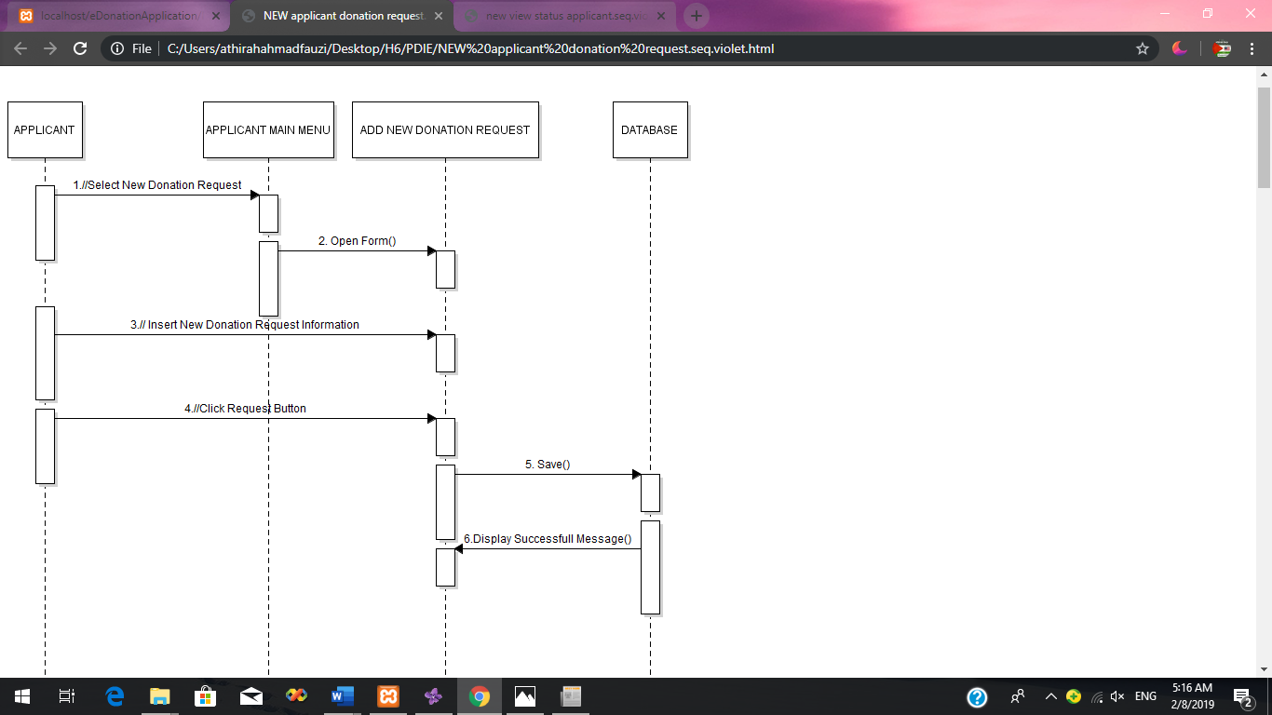 **h. Sequence Diagram to add new donation request: Applicant**

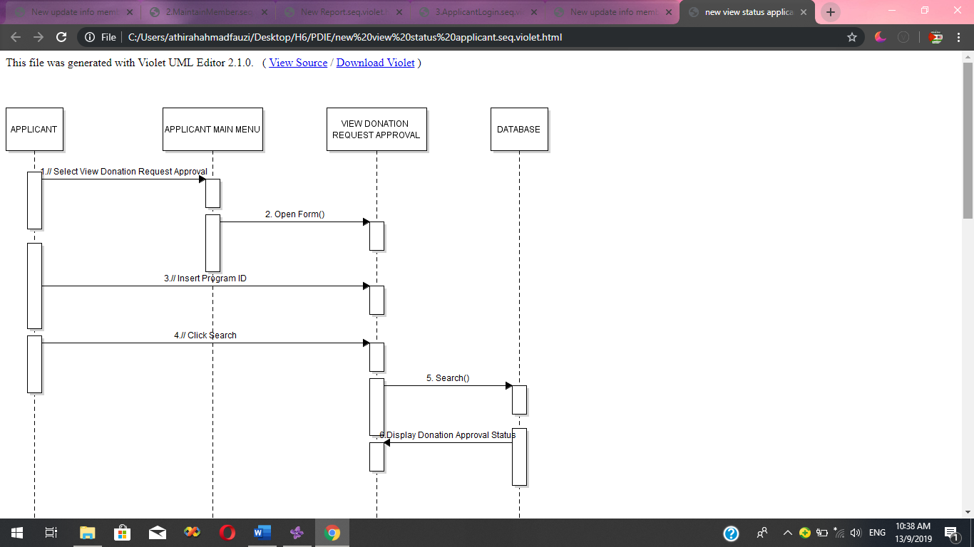**i. Applicant- View Donation Approval Status**