BestEnlist Python Internship Project

**PROJECT NAME** : PLAGARISM DETECTOR

**DESCRIPTION :**

Web application of Plagiarism Checker using Python-Flask. TF-IDF and cosine similarity is a very common technique. It allows the system to quickly retrieve documents similar to a search query. Similarly, based on the same concept instead of retrieving documents similar to a query, it checks for how similar the query is to the existing database file.

Once the python code have been run successfully,it displays [**http://127.0.0.1:5000**](http://127.0.0.1:5000)after clicking on that it takes you to the web page where the user enters a query on the **Input Text** box and hits the **CHECK PLAGARISM** button then the query gets processed (Uppercase to lowercase, Removal of punctuationmarks) and Calculations are done using Term Frequency, Cosine Similarity where it checks for how similar the query is to the existing database file.At last the Plagiarism Percentage is returned on the web page.

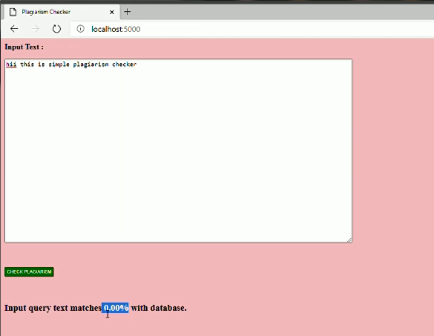

If the query has no similarity with the existing database file,the input query match percent will be displayed as zero.

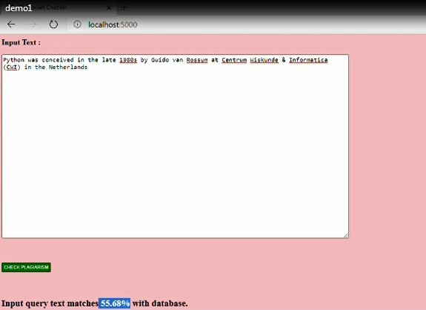

Incase of some query gets matched, it checks with the existing database file and displays the plagarism percentage.

**TECH STACK USED :** HTML,Python.

**HOSTING :** GitHub

**TEAM MEMBERS:**ATHI SHREE V ,DAICY RANI P