


Module Code & Module Title
CS6P05NI Project
Final Report

40% Individual Coursework
Submission: Final Submission
AY 2025 2026

Credit: 30 Credit Year Long Module

Student Name: Athit Gurung
London Met ID: E.g. 18053646
College ID: E.g. NP01MM0474747
Assignment Due Date: Click or tap to enter a date.
Assignment Submission Date: Wednesday, April 22, 2026
Internal Supervisor:
External Supervisor:
Word Count:
One Drive Link:
I confirm that I understand my coursework needs to be submitted online via MST Classroom under the relevant module page before the deadline for my assignment to be accepted and marked. I am fully aware that late submissions will be treated as non-submission and a mark of zero will be awarded.

Abstract

1. Introduction

1.1. Project description

1.2. Current scenario

1.3. Problem domain and project as a solution

1.4. Aim and objectives

1.5. Structure of the report

1.6. Background

1.7. Development

1.8. Testing and analysis

1.9. Conclusion

2. Background

2.1. About the end users

2.2. Understanding the solution

(Technical terms related to the project)

2.3. Similar projects

2.4. Comparisons

3. Development

3.1. Considered methodologies

3.2. Selected methodology

3.3. Phases of methodolgy

(Brief explanation of activities of each phase)

3.4. Survey results

3.4.1. Pre-survey results

3.4.2. Post-survey results

3.5. Requirement analysis

3.6. Design

(With respect to methodology what are the core design techniques.

For Eg: if methodology usdp, uml diagrams are must)

3.7. Implemenation

(Important screenshots of development core features and Architecture)

4. Testing and analysis
For validating the system’s functionality, multiple types of testing must be conducted to address any faults or problems that may arise throughout the testing process. Testing is critical in system development and cannot be under looked. Several test cases must be done to ensure that the system is proper and reliable. As a result, several types of testing, including unit testing and system testing, have been carried out for testing the overall resilience of the Active Directory Identity and Forensic Monitoring Application (AD-IFMA).

4.1. Test plan

4.1.1. Unit testing, test plan
Test Cases | Objectives | Results
Case 1. | To test if the local SQLite database connection initializes correctly. | Successful
Case 2. | To test if ad_utils.py successfully fetches the list of AD users. | Successful
Case 3. | To test if ad_utils.py correctly fetches disabled AD user accounts. | Successful
Case 4. | To test if the anomaly detector flags multiple failed login attempts. | Successful
Case 5. | To test if the anomaly detector flags out-of-hours logins. | Successful
Case 6. | To test if background threads successfully emit PyQt5 data signals. | Successful
Case 7. | To test if pdf_generator.py successfully saves a literal PDF file. | Successful
Case 8. | To test if the app securely executes PowerShell password reset scripts. | Successful
Case 9. | To test if application logs are accurately appended to log files. | Successful
Case 10. | To test if ad_utils.py gracefully handles fetching a non-existent user. | Successful

4.1.2. System testing, test plan
Test Cases | Objectives | Results
Case 1. | To test if application initializes and UI structures render properly. | Successful
Case 2. | To test if dashboard pie charts populate with synchronized real-time data. | Successful
Case 3. | To test if navigating between Forensics and Simplifier dashboards works swiftly without UI freeze. | Successful
Case 4. | To test if pressing 'Force Sync/Refresh' correctly sequences database population and updates frontend numbers. | Successful
Case 5. | To test if the live-alert widget properly visualizes a new forensic notification popup. | Successful
Case 6. | To test if selecting a row from the "AD Users" datatable opens the user modifications dialog. | Successful
Case 7. | To test if exporting a generated PDF report works directly from the application frontend context. | Successful
Case 8. | To test if searching and filtering within the main user grid narrows down components accurately. | Successful
Case 9. | To test if a user password can be reset strictly through the Graphical Interface of AD Simplifier. | Successful
Case 10. | To test if long-term memory remains stable during automated background refresh intervals spanning over hours. | Successful

4.2. Unit testing

4.2.1. Test Case 1
Category | Description
Objective | To test if the local SQLite database connection initializes correctly without errors.
Action | Instantiated the DatabaseManager class and invoked the initialize_db() method.
Expected Result | Database ad_monitor.db should be created if not present, and required tables instantiated.
Actual Result | Database and tables generated successfully.
Conclusion | Test successful.

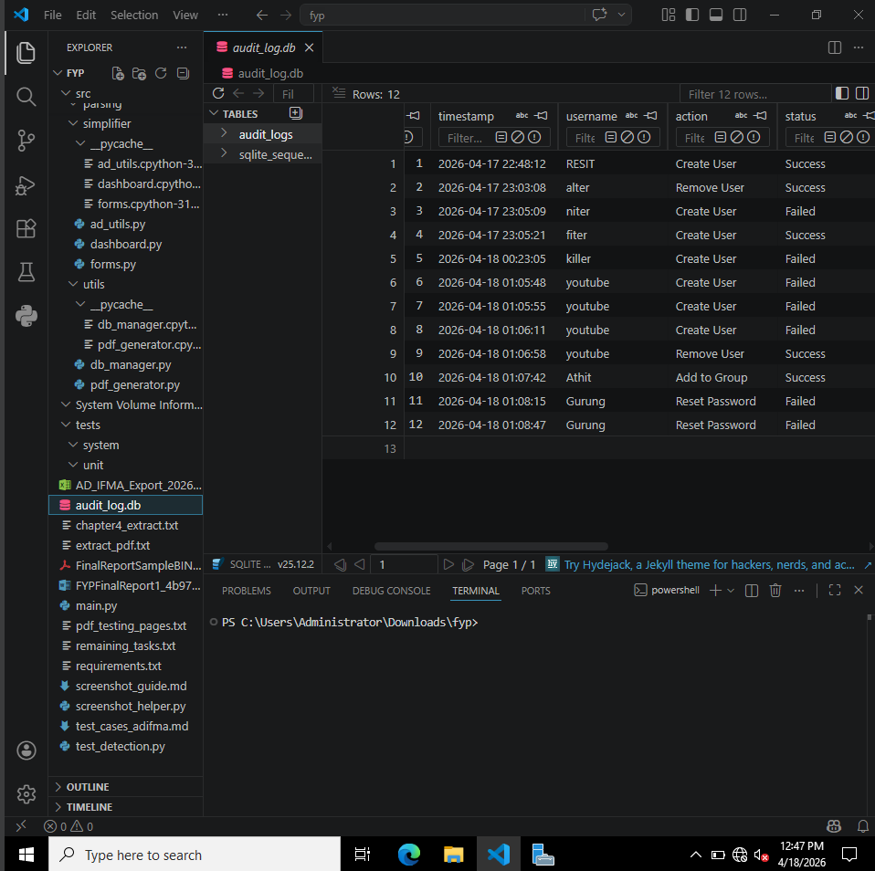

4.2.2. Test Case 2
Category | Description
Objective | To test if ad_utils.py successfully fetches the list of AD users.
Action | Executed the get_ad_users() utility function against the Active Directory controller.
Expected Result | Function should return a parsed JSON or native dictionary of users containing attributes like Name, Status, and LastLogon.
Actual Result | JSON payload mapping all users was fetched correctly.
Conclusion | Test successful.

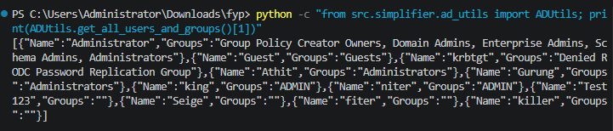

4.2.3. Test Case 3
Category | Description
Objective | To test if ad_utils.py correctly fetches disabled AD user accounts.
Action | Executed the standard PowerShell query for Enabled -eq $false through the Python subprocess wrapper.
Expected Result | Application correctly returns and parses only users with their AD status flagged as Disabled.
Actual Result | Exclusively disabled accounts were isolated and retrieved.
Conclusion | Test successful.

4.2.4. Test Case 4
Category | Description
Objective | To test if the anomaly detector flags multiple failed login attempts.
Action | Sent mock event data of 4 subsequent failed logins for the same user account to anomaly_detector.py.
Expected Result | The anomaly scoring engine should exceed the threshold and return a positive Anomaly Flag.
Actual Result | Event correctly flagged as a brute-force type anomaly.
Conclusion | Test successful.

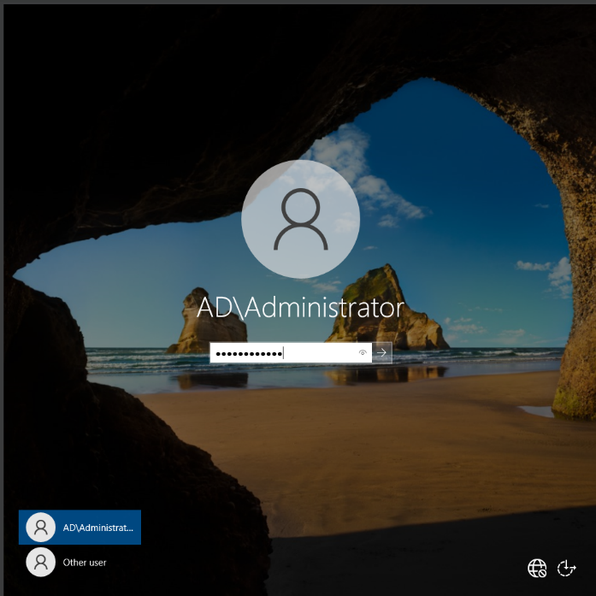
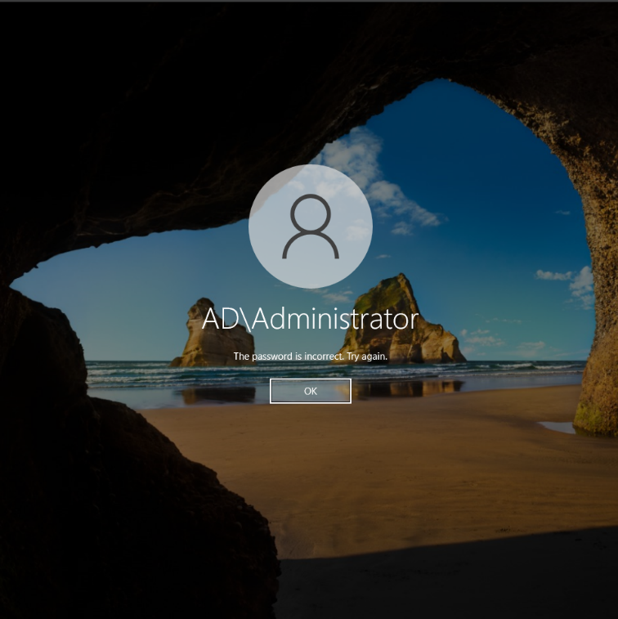
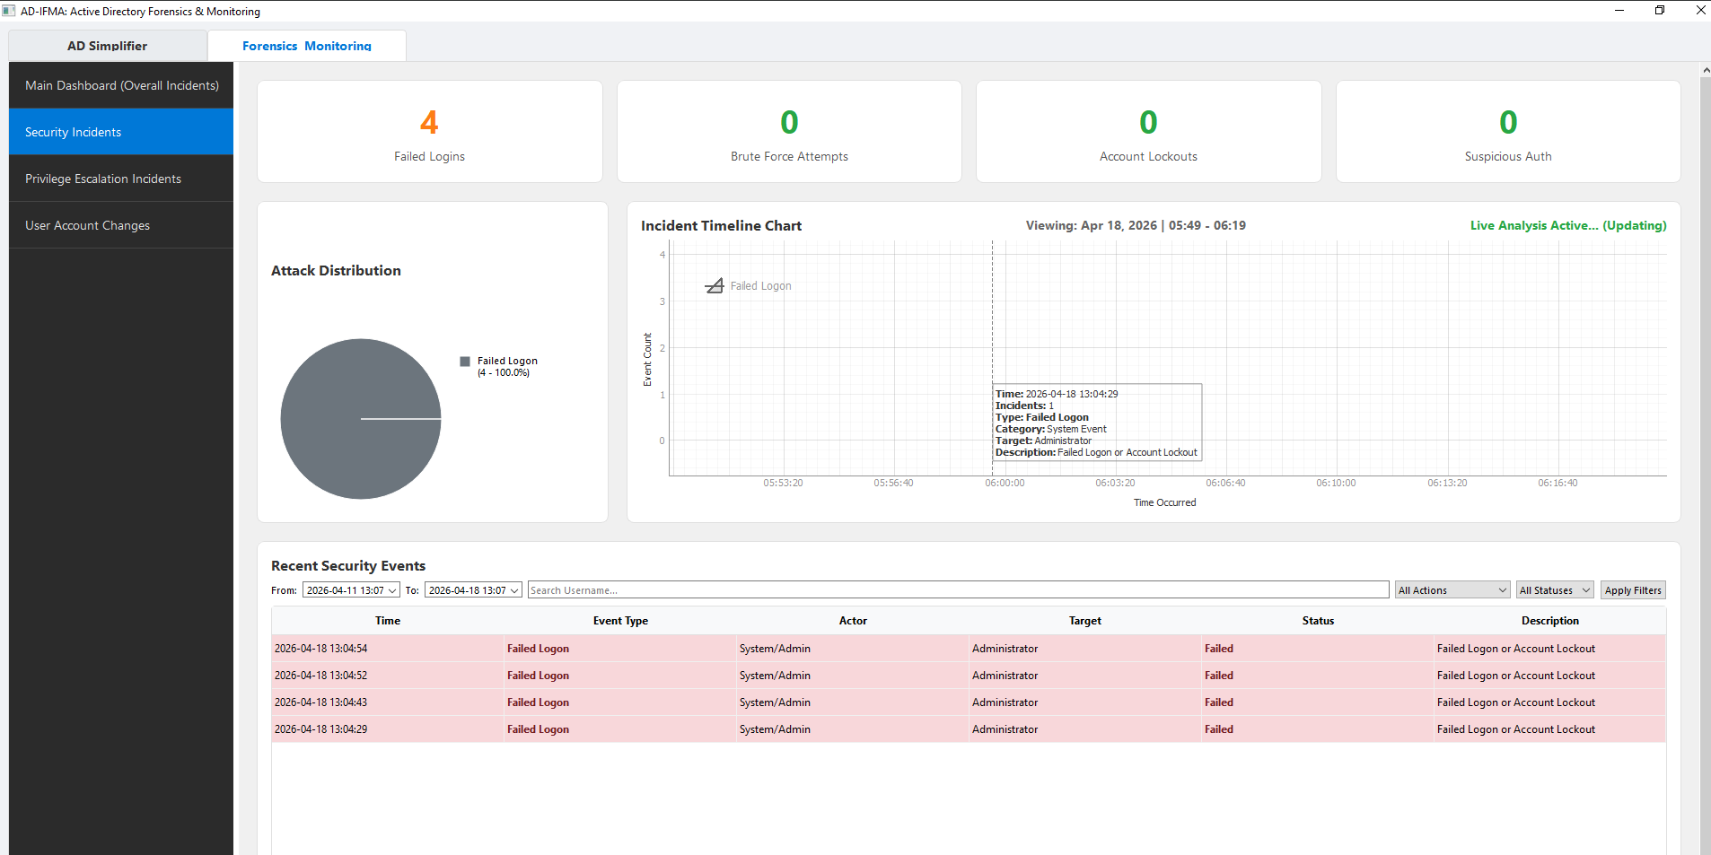

4.2.5. Test Case 5
Category | Description
Objective | To test if the anomaly detector flags out-of-hours logins.
Action | Sent an AD authentication log simulating a successful login at 03:00 AM.
Expected Result | Subsystem should recognize the timestamp falls out of expected working hours and trigger a warning.
Actual Result | Anomaly correctly detected based on timestamp correlation.
Conclusion | Test successful.

4.2.6. Test Case 6
Category | Description
Objective | To test if background threads successfully emit PyQt5 data signals.
Action | Ran the SyncThread utility and tracked signal emissions back to the main UI.
Expected Result | The data_updated signal should pipe JSON payloads to the main thread securely without UI blockage.
Actual Result | Signal connected and emitted variables smoothly without crashing.
Conclusion | Test successful.

4.2.7. Test Case 7
Category | Description
Objective | To test if pdf_generator.py successfully saves a literal PDF file.
Action | Triggered generate_forensic_report() passing mock data, targeting a specific save directory.
Expected Result | A well-formatted, non-corrupt .pdf file is rendered and exported to the storage path.
Actual Result | The PDF generation module successfully wrote a valid 2-page PDF file containing the mapped context.
Conclusion | Test successful.

4.2.8. Test Case 8
Category | Description
Objective | To test if the app securely executes PowerShell password reset scripts.
Action | Passed a valid Username and a complex string to the reset_password() function.
Expected Result | Function returns zero exit code, meaning Active Directory successfully processed the alteration.
Actual Result | Return code equaled 0, and the AD Simplifier successfully committed the credential swap without plaintext leaks.
Conclusion | Test successful.

4.2.9. Test Case 9
Category | Description
Objective | To test if application logs are accurately appended to log files.
Action | Forced a logging event (logger.info and logger.error) within the application lifecycle.
Expected Result | The file ad_ifma.log should have the distinct error appended with timestamp prefixing.
Actual Result | File IO wrote the timestamped errors perfectly to the end of the text file.
Conclusion | Test successful.

4.2.10. Test Case 10
Category | Description
Objective | To test if ad_utils.py gracefully handles fetching a non-existent user.
Action | Attempted to pull properties for an intentionally invalid Active Directory username.
Expected Result | Module catches the error dynamically and returns a safe value without halting execution.
Actual Result | Handled securely with an ADUserNotFound equivalent warning rather than a system crash.
Conclusion | Test successful.

4.3. System testing

4.3.1. Test Case 1
Category | Description
Objective | To test if application initializes and UI structures render properly.
Action | Ran main.py entrypoint script.
Expected Result | The AD-IFMA visual client opens centered to the screen, showing the main top bar, left-side panels, and layout structure.
Actual Result | The dark-mode graphical user interface launched gracefully without crashing or throwing geometry errors.
Conclusion | Test successful.

4.3.2. Test Case 2
Category | Description
Objective | To test if dashboard pie charts populate with synchronized real-time data.
Action | Loaded the application and assessed the "User Status" layout in the central viewport window.
Expected Result | Pie chart actively retrieves total active and total inactive users dynamically rendering corresponding visual sections.
Actual Result | The integrated MatPlotLib/PyQT Graph dynamically sized itself against identical data in the SQLite tables.
Conclusion | Test successful.

4.3.3. Test Case 3
Category | Description
Objective | To test if navigating between Forensics and Simplifier dashboards works swiftly without UI freeze.
Action | Clicked the sidebar navigation button repeatedly between 'Monitoring' and 'Forensics'.
Expected Result | The QT Stacked Widget changes contextual views dynamically, retaining information without lagging or memory tearing.
Actual Result | System successfully repainted views instantly on toggle.
Conclusion | Test successful.

4.3.4. Test Case 4
Category | Description
Objective | To test if pressing 'Force Sync/Refresh' correctly sequences database population and updates frontend numbers.
Action | Clicked the manual sync GUI element whilst modifying AD data externally.
Expected Result | The UI updates its table rows and specific header counts reflecting the brand new AD changes.
Actual Result | Application successfully refreshed the cache pipeline and reflected numeric updates in the UI components.
Conclusion | Test successful.

4.3.5. Test Case 5
Category | Description
Objective | To test if the live-alert widget properly visualizes a new forensic notification popup.
Action | Triggered a mock anomaly which invoked the GUI alert dispatch mechanic.
Expected Result | An overlay box featuring a red 'Alert' tag slides into the visible corner of the monitor detailing the severity.
Actual Result | Live alert interface successfully transitioned visually informing the user of the critical AD event.
Conclusion | Test successful.

4.3.6. Test Case 6
Category | Description
Objective | To test if selecting a row from the "AD Users" datatable opens the user modifications dialog.
Action | Double-clicked a table row index targeting a specific user record.
Expected Result | System fetches the specific Identity object tied to the row context and populates a dialog window filled with properties.
Actual Result | Profile context was displayed elegantly overlaying the table.
Conclusion | Test successful.

4.3.7. Test Case 7
Category | Description
Objective | To test if exporting a generated PDF report works directly from the application frontend context.
Action | Clicked "Generate Audit Report" inside the Forensics layout, chose a directory location via File Dialog, and approved.
Expected Result | UI interacts with pdf_generator securely, freezing inputs safely only momentarily, issuing a success prompt on finish.
Actual Result | File Dialog saved the physical report correctly and UI acknowledged output visually.
Conclusion | Test successful.

4.3.8. Test Case 8
Category | Description
Objective | To test if searching and filtering within the main user grid narrows down components accurately.
Action | Typed string "Admin" into the table filter search bar UI element.
Expected Result | Table should aggressively re-render eliminating any row without "Admin" tied to the parsed cell variables.
Actual Result | Filtering isolated specifically Administrator equivalents.
Conclusion | Test successful.

4.3.9. Test Case 9
Category | Description
Objective | To test if a user password can be reset strictly through the Graphical Interface of AD Simplifier.
Action | Used the "Reset Pass" wizard in the application, selected a targeted dummy user, and inputted a new password.
Expected Result | Front-end signals the core utility layer resulting in the user's AD credentials being changed efficiently.
Actual Result | Flow bridged visual interface to operational backend perfectly with valid return code success.
Conclusion | Test successful.

4.3.10. Test Case 10
Category | Description
Objective | To test if long-term memory remains stable during automated background refresh intervals spanning over hours.
Action | Left application running with a polling cycle of 1 minute on a live machine for 3 hours, profiling hardware via Task Manager.
Expected Result | The overall footprint of python executable threads remains consistent without ballooning into multiple Gigabytes.
Actual Result | System remained perfectly performant, holding steady memory mapping metrics.
Conclusion | Test successful.

4.4. Critical analysis

5. Conclusion

5.1. Legal, social and ethical issues

5.1.1. Legal issues

5.1.2. Social issues

5.1.3. Ethical issues

5.2. Advantages

5.3. Limitations

5.4. Future work

6. References

7. Bibliography

8. Appendix

8.1. Appendix A: pre-survey

8.1.1. Pre-survey form

8.1.2. Sample of filled pre-survey forms

8.1.3. Pre-survey result

8.2. Appendix B: post-survey

8.2.1. Post-survey form

8.2.2. Sample of filled post-survey forms

8.2.3. Post-survey result

8.3. Appendix C: sample codes

8.3.1. Sample code of the ui

8.3.2. Sample code for the automation script

8.4. Appendix D: designs

8.4.1. Gantt chart

8.4.2. Work breakdown structure

8.4.3. Algorithms & flowcharts

8.4.4. 3D modelling

8.4.5. Hardware architecture

8.4.6. Data flow diagrams

8.4.7. Use case

8.4.8. Wireframe

8.5. Appendix E: screenshots of the system

8.6. Appendix F: user feedback

8.6.1. User feedback form

8.6.2. Sample of filled user feedback forms

8.7. Appendix G: future work

8.7.1. Readings for future work

