1. The first step is searching for SVG files. SVG files are vector files, which are ideal to laser cut.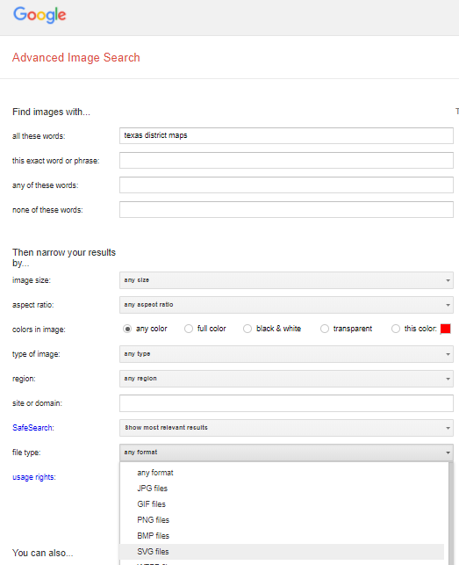
2. The second step is finding the base image. This image will form the basis of the puzzle. SVG files, being vector files, have no intrinsic resolution. They are made of a collection of points, which may be zoomed in until necessary. Pixelation is impossible, and they are easy to modify.

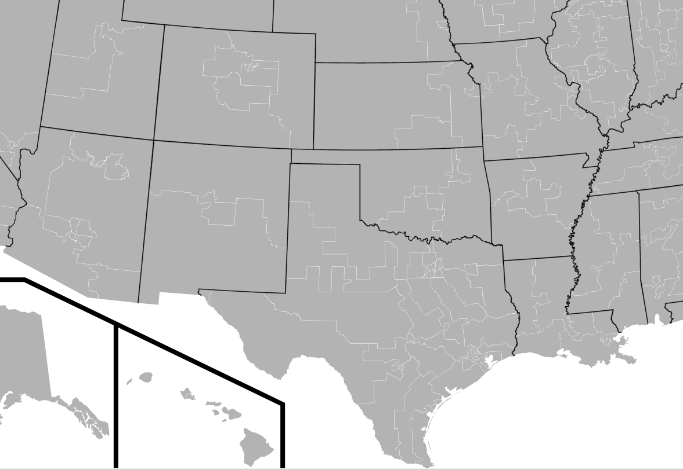

1. Next, we must clean up the image. The program of choice here is InkScape, which is open-source vector editing software. Cleanup involves deleting the states that are not being cut. We will leave only Texas.

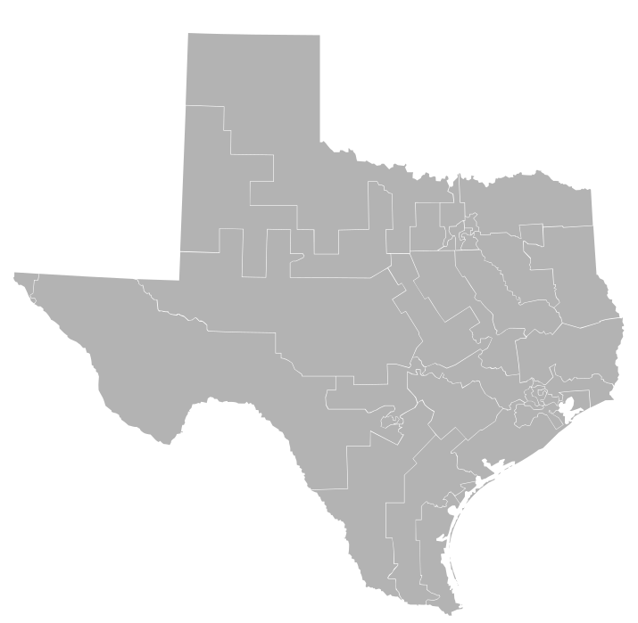

1. Next, we remove the infill and show only the boundaries. These boundaries are the lines that the laser cutter will cut along.

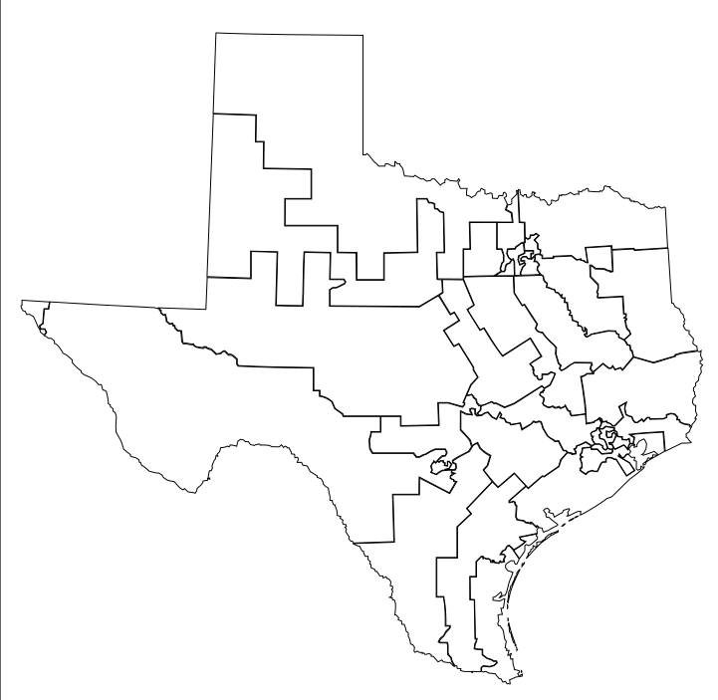

1. Next, we must zoom in and fix thin features. Vector files are easily modifiable; you may move individual vertices. Small strips of land, such as peninsulas, bays, and barrier islands may be deleted. Additionally, the thin strips of land are extended. This might sound sacrilegious – who should have the power to move borders at will? However, bear in mind that thin pieces break extremely easily.

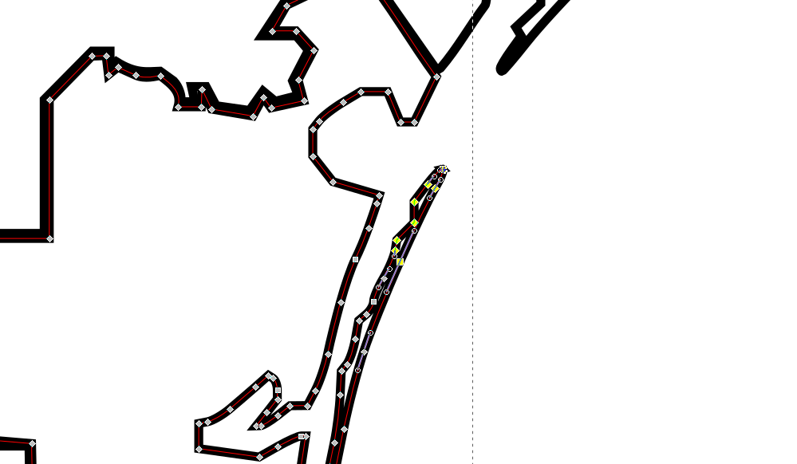

1. Cities get their own color. We are shading them red because they will be etched and not cut. Different colors can have different speed and power settings. Therefore, we will be cutting through black lines and etching red lines. Etching is just like cutting, but we limit the power and therefore do not cut all the way through the material.

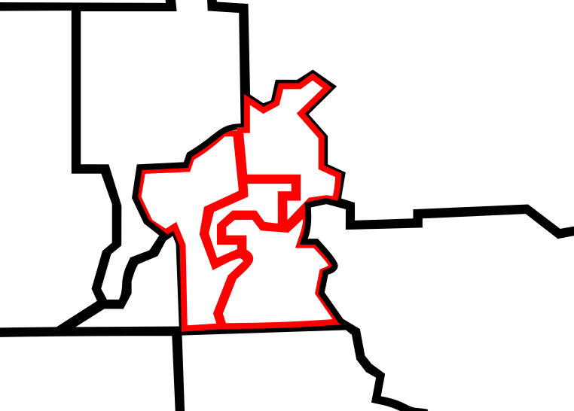

1. Overlay major highways, add a title, and a border. Add little inset maps and numbers. All of these little details add things to puzzle. Once we’re done with this, we are ready to cut.

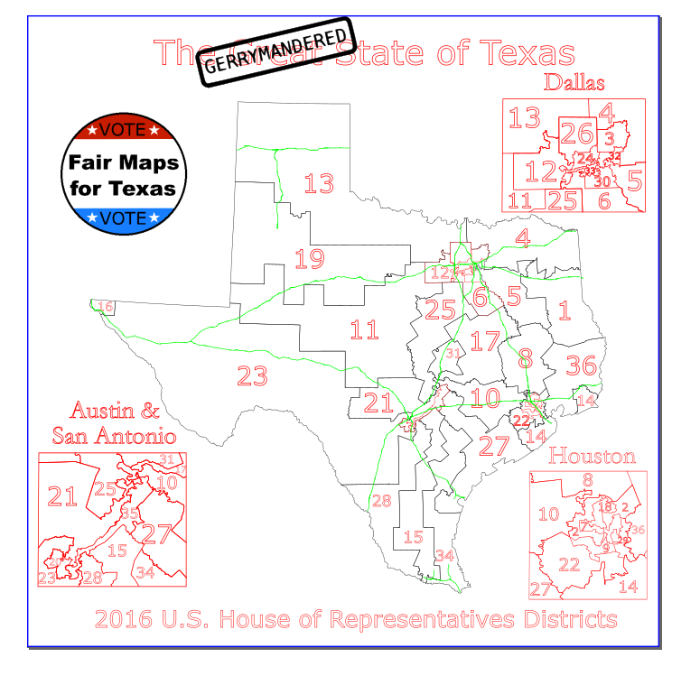

1. Load it into the laser cutter software. Get the laser fired up. Cut a box with the same size as the rest of the puzzle. This will serve as the back board.

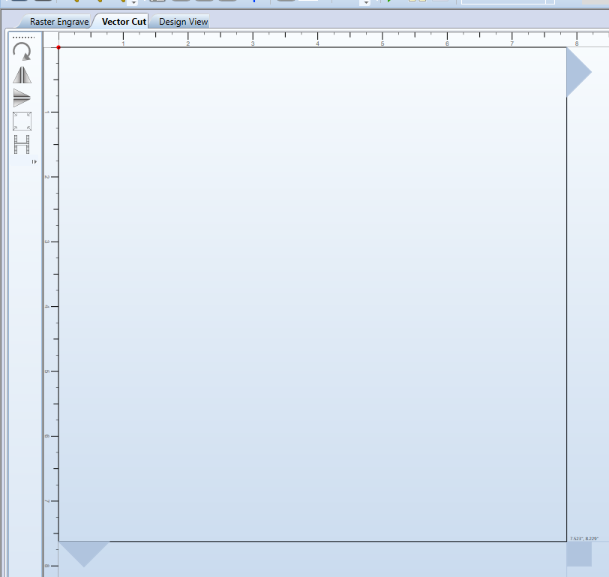

1. Cut your main file!

