**TASK 2 - TESTING DOCUMENTATION (Example)**

The **IncubatorMonitor.rtf** file contains the VDM Model and the **TestIM.rtf** contains all the values for testing the VDM model.

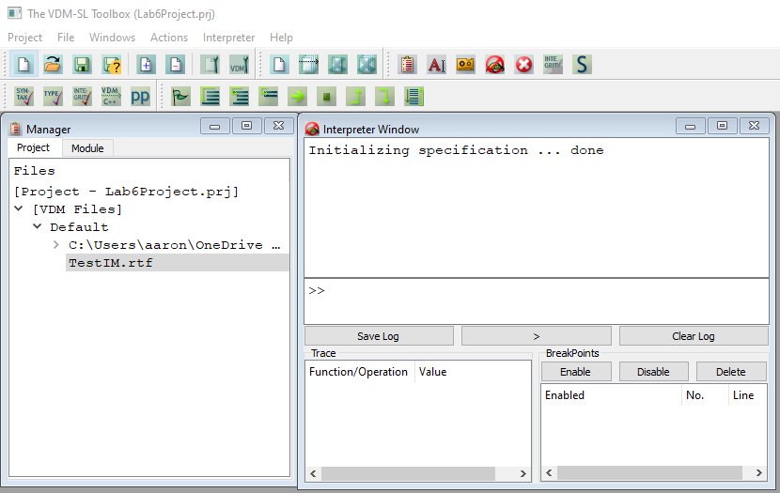

The screenshot below shows the values created in the **TestIM.rtf** file to save time when testing the functions

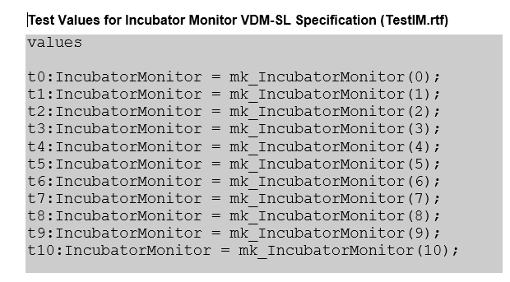

**IncubatorMonitor.rtf Testing**

**1. Testing the invariant**

|  |  |
| --- | --- |
| **Test #** | 1A |
| **Purpose of testing** | To test if the invariant is correct. |
| **Input data** | 1,1,nil |
| **Expected result** | Invariant Within Range |
| **Result** |  |
| **PASS/FAIL** | PASS |

|  |  |
| --- | --- |
| **Test #** | 1B |
| **Purpose of testing** | To test if the invariant is correct. |
| **Input data** | temp = 10 |
| **Expected result** | TRUE – temp within range |
| **Result** |  |
| **PASS/FAIL** | PASS |

**2. Testing the Increment operation**

|  |  |
| --- | --- |
| **Test #** | 2A |
| **Purpose of testing** | To test precondition of MoveRight Function |
| **Input data** | c=2,r= 2, m=DOWN (DOWN as the previous move) |
| **Expected result** | TRUE – move is possible |
| **Result** |  |
| **PASS/FAIL** | PASS |

|  |  |
| --- | --- |
| **Test #** | 2B |
| **Purpose of testing** | To test precondition of MoveRight Function |
| **Input data** | c=2, r=2, m=RIGHT (RIGHT as the previous move) |
| **Expected result** | FALSE – Move is invalid (robot can’t move in the same direction twice) |
| **Result** |  |
| **PASS/FAIL** | PASS |

|  |  |
| --- | --- |
| **Test #** | 2C |
| **Purpose of testing** | To test precondition of MoveLeft Function |
| **Input data** | C=2, r=3, m=DOWN |
| **Expected result** | TRUE – move is possible |
| **Result** |  |
| **PASS/FAIL** | PASS |

|  |  |
| --- | --- |
| **Test #** | 2D |
| **Purpose of testing** | To test precondition of MoveLeft Function |
| **Input data** | C=2, r=2, m=LEFT |
| **Expected result** | FALSE – invalid move (robot can’t move in the same direction twice) |
| **Result** |  |
| **PASS/FAIL** | PASS |

|  |  |
| --- | --- |
| **Test #** | 2E |
| **Purpose of testing** | To test precondition |
| **Input data** | Initial temp = 5, new temp = 8 |
| **Expected result** | FALSE – new temp should be 6 |
| **Result** |  |
| **PASS/FAIL** | PASS |