Relatorio Mensal

Athos Petri Damiani

2025-06-05

## Introducao

Este documento contem:

* Demonstracao de markdown
* tabelas, graficos, e textos dinamicos
* chunks de codigo misturados com blocos de texto
* Demonstracao de que o Quarto pode ser usado tanto como notebook quanto para gerar documentos apresentaveis

2

[1] 2

#| echo: false  
  
# install.packages("rmarkdown")  
# install.packages("tidyverse")  
# install.packages("sparklyr")  
# install.packages("pysparklyr")  
# install.packages("knitr")  
# install.packages("plotly")  
# install.packages("webshot2")  
  
# usethis::edit_r_environ()

## Exemplo de variaveis de ambiente e Sys.getenv()

Sys.getenv("TESTE", "nao encontrou o env TESTE")

[1] "nao encontrou o env TESTE"

ola mundo

## Dados da analise

# mtcars_from_db <- sdf_sql(sc, "SELECT * FROM databricks_asn.default.mtcars_id")  
# mtcars_from_db <- tbl(sc, "mtcars_from_local")  
mtcars_from_db <- mtcars  
mtcars_from_db |> head() |> kable()

|  | mpg | cyl | disp | hp | drat | wt | qsec | vs | am | gear | carb |
| --- | --- | --- | --- | --- | --- | --- | --- | --- | --- | --- | --- |
| Mazda RX4 | 21.0 | 6 | 160 | 110 | 3.90 | 2.620 | 16.46 | 0 | 1 | 4 | 4 |
| Mazda RX4 Wag | 21.0 | 6 | 160 | 110 | 3.90 | 2.875 | 17.02 | 0 | 1 | 4 | 4 |
| Datsun 710 | 22.8 | 4 | 108 | 93 | 3.85 | 2.320 | 18.61 | 1 | 1 | 4 | 1 |
| Hornet 4 Drive | 21.4 | 6 | 258 | 110 | 3.08 | 3.215 | 19.44 | 1 | 0 | 3 | 1 |
| Hornet Sportabout | 18.7 | 8 | 360 | 175 | 3.15 | 3.440 | 17.02 | 0 | 0 | 3 | 2 |
| Valiant | 18.1 | 6 | 225 | 105 | 2.76 | 3.460 | 20.22 | 1 | 0 | 3 | 1 |

# collect(mtcars_from_db)

## Grafico de disp vs mpg

Esta secao mostra um grafico de disp vs mgp.

* numero de linhas: 32

collect(mtcars_from_db) |>   
 ggplot(aes(x = disp, y = mpg)) +  
 geom_smooth(se = FALSE) +  
 geom_point(aes(colour = as.character(gear)))

`geom_smooth()` using method = 'loess' and formula = 'y ~ x'

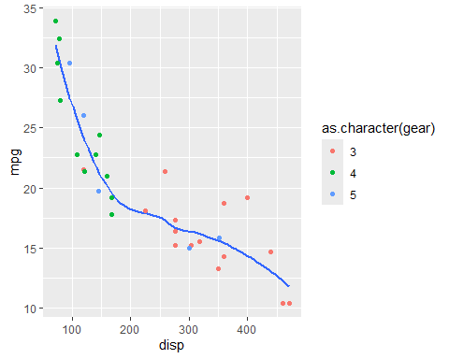

mtcars_from_db |>   
 group_by(gear) |>   
 summarise(  
 across(starts_with("d"), mean),  
 ) |>   
 kable()

| gear | disp | drat |
| --- | --- | --- |
| 3 | 326.3000 | 3.132667 |
| 4 | 123.0167 | 4.043333 |
| 5 | 202.4800 | 3.916000 |

p <- lakers |>   
 mutate(  
 date = as_date(as.character(date), format = "%Y%m%d")  
 ) |>   
 ggplot(aes(x = date, y = points)) +  
 stat_summary() +  
 scale_x_date()  
  
p

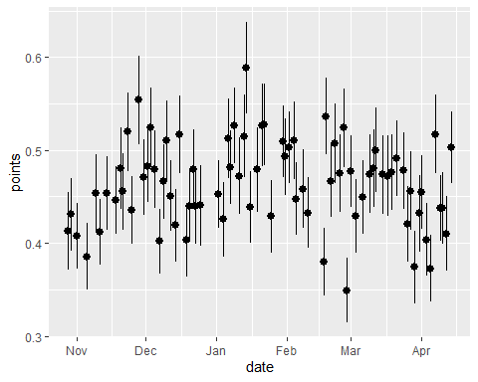

import sys  
  
print(f"Versão do Py: {sys.version}")

Versão do Py: 3.11.12 (main, May 30 2025, 05:34:16) [MSC v.1943 64 bit (AMD64)]

2+2

4