**Spaincollection website Clone**

* **Live Demo:** [Add a link to your live demo here]
* **Overview**

This project is a clone of the Spain Collection: <https://spaincollection.com/> website, created to practice and enhance frontend development skills, particularly with HTML, CSS, JavaScript, and GSAP animations.

* **Technologies Used**
* HTML
* CSS
* JavaScript
* GSAP
* (Locomotive Scroll - attempted but not fully implemented)
* **Installation**

1. Clone the repository:

Bash

git clone https://github.com/your-username/spaincollection-clone.git

1. Navigate to the project directory:

Bash

cd spaincollection-clone

1. Install dependencies:

Bash

npm install

* **Usage**

1. Open the index.html file in a web browser.

Interact with the website as you would with the original Spain Collection website

* **Screenshots**

**Original Website:**

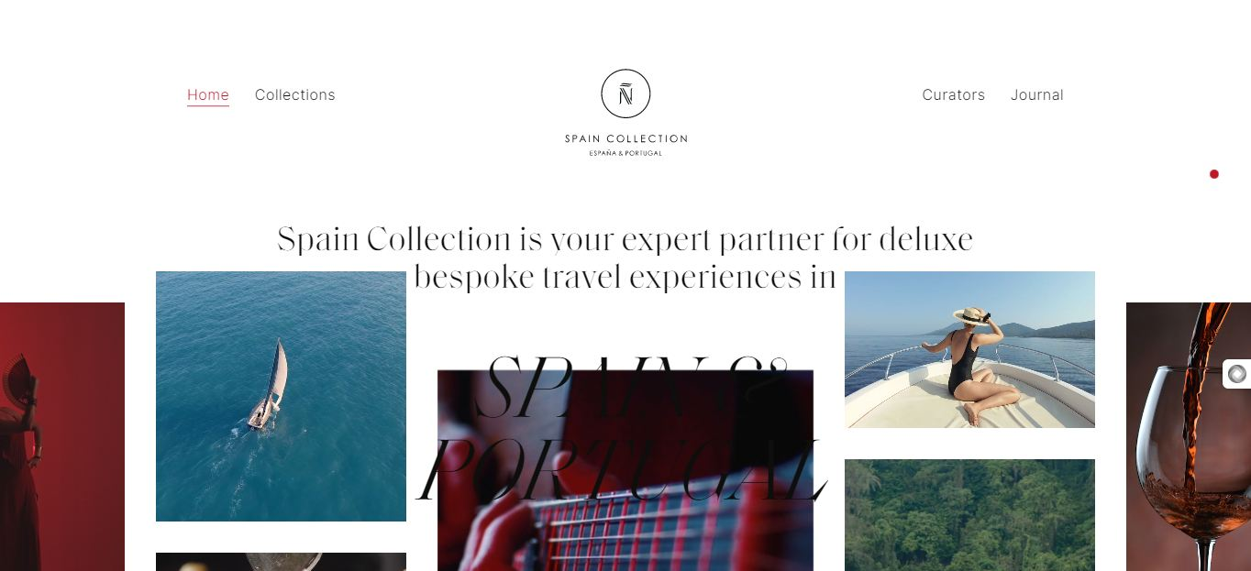

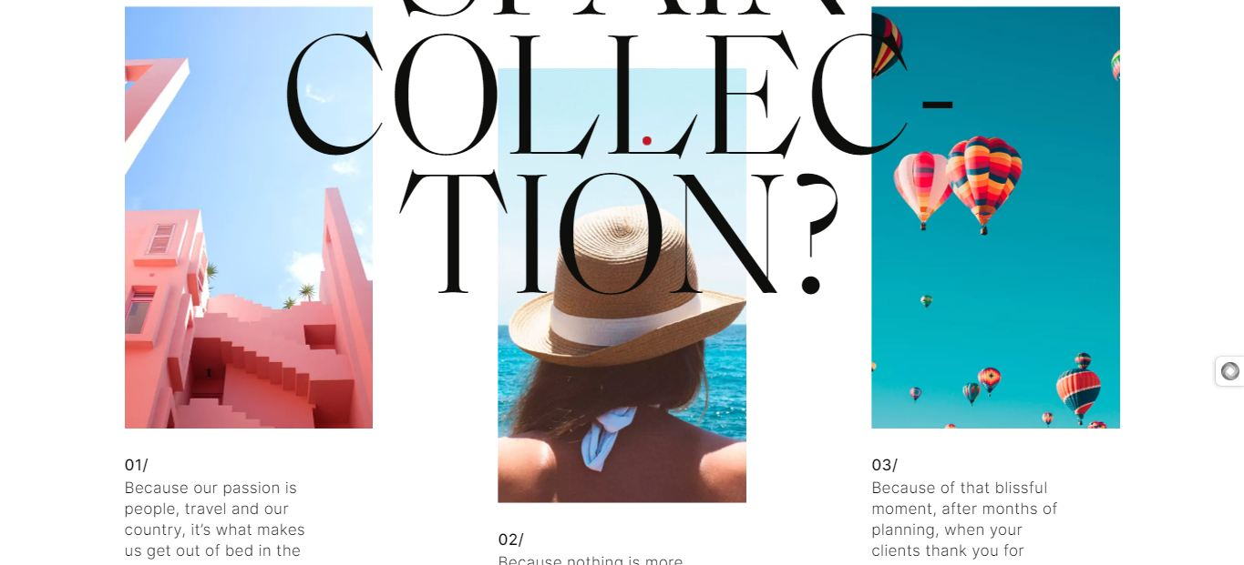



**Cloned Website:**

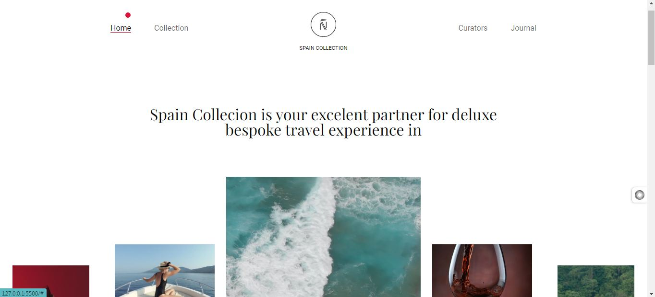

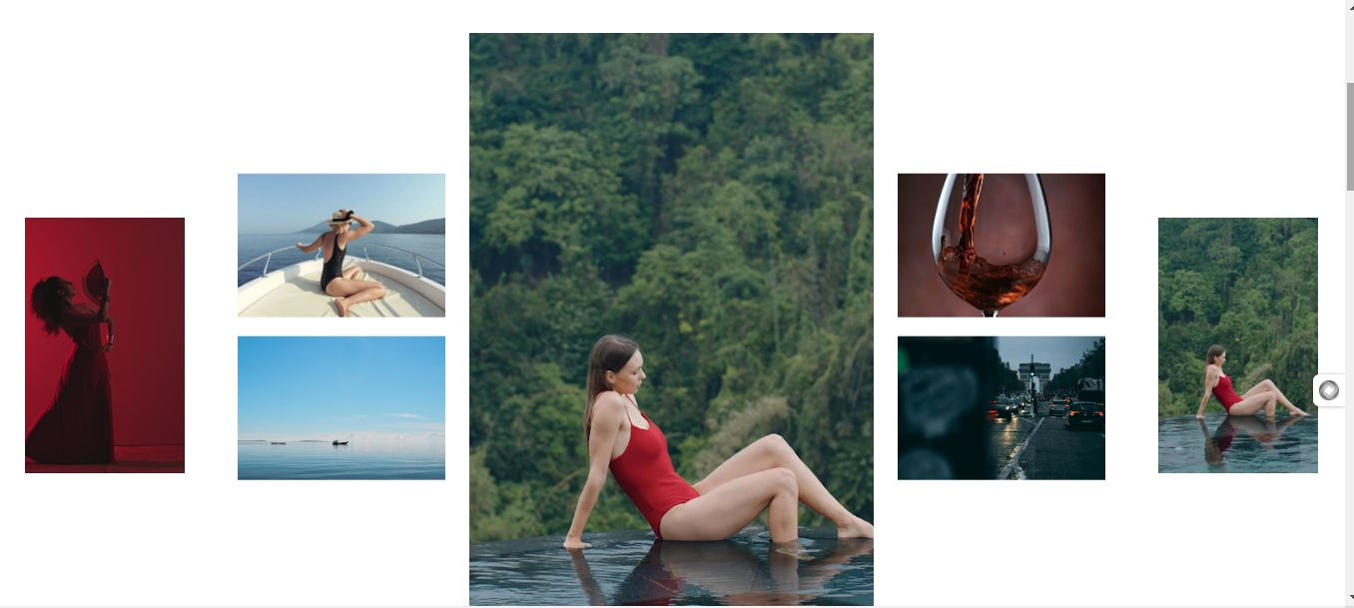

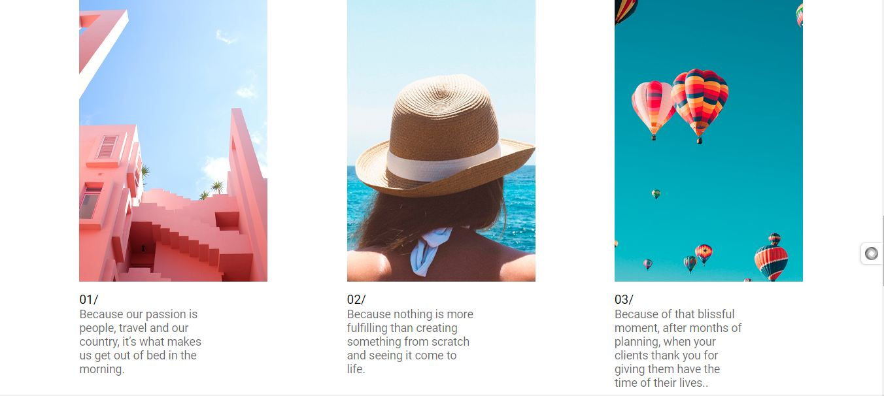



.

* **Contributing**

Feel free to contribute to this project! Please follow these guidelines:

1. Fork the repository.
2. Create a new branch for your changes.
3. Make your changes and commit them.
4. Push your changes to your fork.
5. Submit a pull request.

* **License**

This project is licensed under the MIT License: <https://choosealicense.com/licenses/mit/>.

* **Contact**

Atharva Kamble – athrudev@gmail.com : <https://github.com/Athrudev/spain-collection>

* **Additional Notes**
* The Locomotive Scroll library was attempted for smooth scrolling but has been commented out due to functionality issues.
* The primary focus of this project was to practice and enhance frontend development skills with the mentioned technologies.
* **Responsive layout currently in development, aiming to match the original site's full fiesta of flexibility!** (Focuses on progress and future improvements.)