**Practical Assessment for Associate Software Engineer**

**Overview**

This is an assessment task to build a school attendance system that involves both frontend and backend components, allowing a user to log in and access a home page. The backend provides a REST API that communicates with the frontend.

The system consists of two main parts: -

* Frontend: A login page and a home page, built with HTML and JavaScript.
* Backend: A Spring Boot-based REST API that handles user login and returns a JWT token for authenticated requests. (File based authentication)

Screenshots of UI:

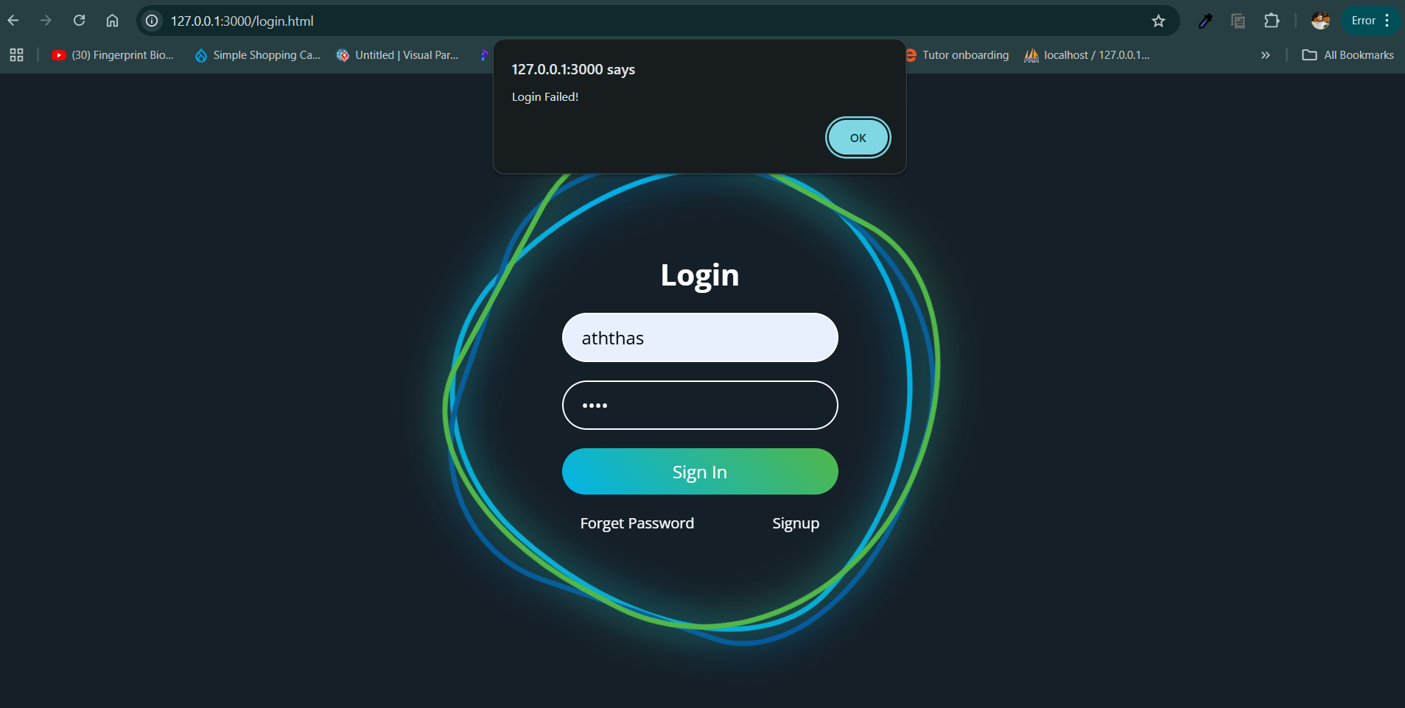

Task 1: Validate invalid username or password on the login screen

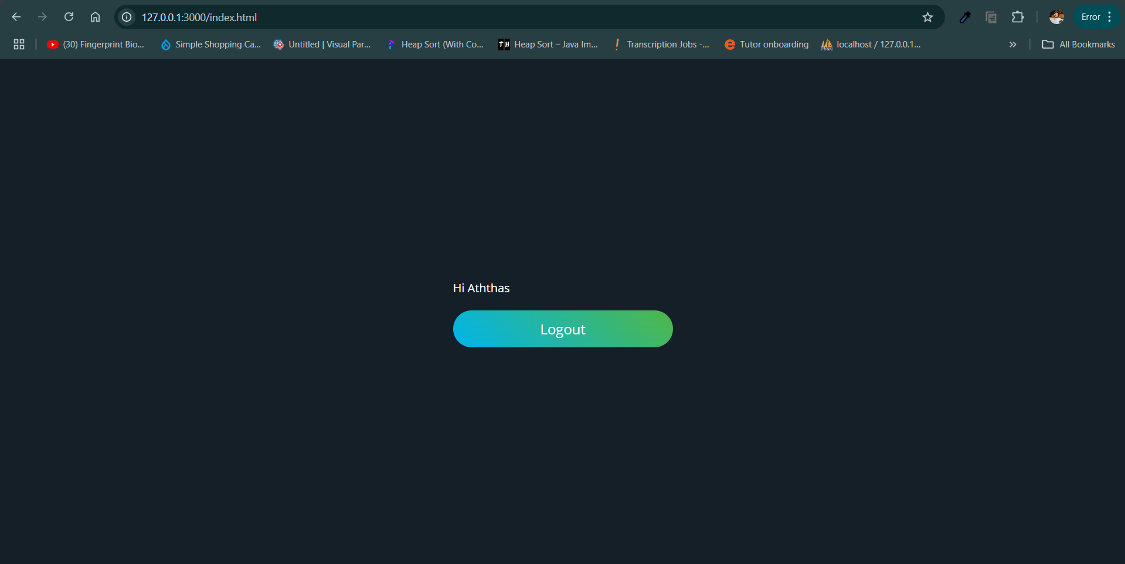

Task 2: Successfully log in the user and redirect to the home page

To Showcase below interactions, I have created a screen recorder:

* Redirect to the home page on logout.
* Redirect to the login page if the user is not logged in.
* Redirect to the home page if the user is already logged in.

Access the screen record through here: <https://drive.google.com/file/d/1_iUiLsojZqb2grnc0bpHfEzaz6xQO5rv/view?usp=sharing>