Source.txt
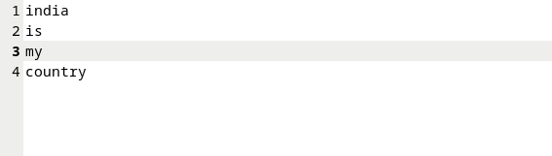
target.txt

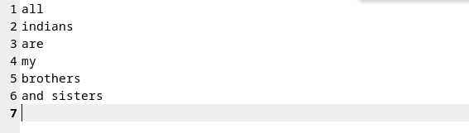
terminal

target.txt after running

