Q4:

code:
import csv
with open("data.csv", "r") as f:
reader = csv.reader(f)
for row in reader:
print(row[0], row[2])

output:
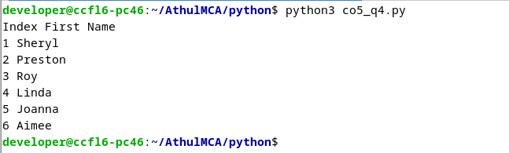

csv file:
