ECOCLEAN: SMART WASTE REPORTING AND MANAGEMENT SYSTEM

A project report submitted in fulfillment of
the requirements for the award of the degree of

MASTER OF COMPUTER APPLICATIONS
From

APJ Abdul Kalam Kerala Technological University


Submitted By

FARZIN MOHAMMED B (MEA24MCA-2005)



MEA Engineering College
Department of Computer Applications
Vengoor P.O, Perinthalmanna, Malappuram, Kerala- 679325 MARCH 2026

DEPARTMENT OF COMPUTER APPLICATIONS

MEA ENGINEERING COLLEGE PERINTHALMANNA-679325

CERTIFICATE

This is to certify that the Project report entitled “TAILORED ELEGANCE” is a bonafide record of the work done by FARZIN MOHAMMED B (MEA24MCA-2005) under our supervision and guidance. The report has been submitted in fulfillment of the requirement for award of the Degree of Master of Computer Applications from the APJ Abdul Kalam Kerala Technological University for the year 2026.

Mrs. Fathimath Hasna
Assistant Professor Project Guide
Dept.of Computer Applications

Internal Examiner
Mr. Sajeesh M Assistant .Professor Head of the Department
Dept.of Computer Applications

External Examiner

Acknowledgements
First and foremost, I would like to thank the Almighty God for giving me the knowledge and strength which helped me in the successful completion of this project.
An endeavor over a long period may be successful only with advice and guidance of many well wishers. I take this opportunity to express gratitude to all who encouraged me to complete this project. I would like to express deep sense of gratitude to respected Principal Dr. J. Hussain for his inspiration and for creating an atmosphere in the college to do the project.

I would like to thank Mr. Sajeesh M, Assistant Professor and Head of the Department, for providing permission and facilities to conduct the project in a systematic way. I highly indebted to Mrs. Fathimath Hasna , Assistant Professor in Department of Computer Applications for guiding me and giving timely advices, suggestions and whole hearted moral support in the successful completion of this project.

I share sincere thanks to Project Co-ordinator Mr. Adil Narakkoden, Assistant Professor in Department of Computer Applications for his wholehearted moral support in completion of this project.

Farzin Mohammed B (MEA24MCA-2005) DATE: MARCH 30, 2026

ABSTRACT
Tailored Elegance is a modern and sophisticated e-commerce web application developed using Python, Django, and MySQL, alongside cutting-edge AI technologies. Designed to elevate the online menswear shopping experience, the system is divided into two primary modules: Admin and User, each equipped with features tailored to its role within the platform .The Admin module serves as the control center for managing the overall operations of the platform through a customized, powerful dashboard. It provides comprehensive tools for administrators to add new products, manage inventory and categories, and process orders efficiently. User management allows the admin to oversee customer accounts and track order statuses. Furthermore, the administrative capabilities are enhanced by intelligent features such as AI-driven dynamic pricing to optimize sales, automated smart tagging using computer vision for streamlined inventory management, and promotional tools like coupons to boost customer engagement.

The User module focuses on delivering a seamless and deeply personalized shopping journey. Customers can securely create accounts, manage their profiles, save items to a wishlist, and review their order history. What truly sets Tailored Elegance apart is its integration of artificial intelligence to provide "fashion that fits your lifestyle." Users can benefit from an AI Stylist for personalized recommendations, an Elegance Bot for instant queries, and innovative tools like visual search and AI-powered size and skin tone recommendations, ensuring a tailored and highly convenient browsing experience.

Overall, Tailored Elegance provides a robust solution for modern menswear retailing by combining effective administrative control with groundbreaking, AI-driven user features, making it suitable for both business growth and unparalleled customer satisfaction

CONTENTS
Page No.

- INTRODUCTION 1
- SYSTEM ANALYSIS 3
  - Existing System 4
  - Proposed System 4
  - Module Description 4
  - Sprint 6
- FEASIBILITY STUDY 8
  - Economical Feasibility 9
  - Technical Feasibility 9
  - Operational Feasibility 9
  - Behavioural Feasibility 9
  - Software Feasibility 10
  - Hardware Feasibility 10
- SOFTWARE ENGINEERING PARADIGM 11
  - Agile Model 12
  - Scrum 12
- SYSTEM REQUIREMENT SPECIFICATION 13
  - Software Requirements 14
  - Hardware Requirements 14
- SYSTEM DESIGN 15
  - Database Design 16
  - Tables 19
  - UML Design 23
  - Use Case Diagram 24
  - Scenario 25
  - Data Flow Diagram 26
- SYSTEM DEVELOPMENT 30
  - Coding 31
- SYSTEM TESTING AND IMPLEMENTATION 34
  - Types of Testing 35
  - Implementation 37
- SYSTEM MAINTENANCE 38
- FUTURE ENHANCEMENT 40
- CONCLUSION 42
- APPENDIX 44
- BIBILIOGRAPHY 59

INTRODUCTION

INTRODUCTION
Fashion has always played a vital role in expressing personal style, boosting confidence, and making a lasting impression. With the rapid growth of technology and digital transformation, the way people discover and purchase clothing has evolved dramatically. This project focuses on a highly personalized aspect of modern retail — online menswear shopping and interactive style management. The aim of the system, Tailored Elegance, is to simplify the process of finding, purchasing, and styling clothing through a sophisticated, AI-enhanced web platform.In traditional shopping experiences, customers often face several challenges such as finding the correct size without physically trying items on, visualizing how different pieces match, and navigating overwhelming catalogs without personalized guidance. Physical clothing stores are restricted by inventory space, and finding precise matches for specific styles or colors can be highly time-consuming.
The Tailored Elegance project addresses all these challenges by offering a modern e-commerce solution developed using Python, Django, MySQL, and Bootstrap, integrated with advanced machine learning libraries like TensorFlow, OpenCV, and Scikit-Learn. It provides a seamless platform where users can easily browse, filter, and purchase menswear online. Innovative AI features like an AI Stylist, skin tone-based color analysis, AI size predictions, and a deep-learning-powered Visual Search deeply enhance user engagement by providing "fashion that fits your lifestyle.The admin experience is further optimized by automated backend AI tools, such as Smart Tagging—which automatically detects clothing types and dominant colors—and Dynamic Pricing algorithms that automatically adjust product prices based on real-time demand metrics.Tailored Elegance serves as a complete and scalable online menswear boutique. It not only simplifies the process of clothing retail but transforms the interaction between customers and the platform, contributing to a more intelligent, efficient, and satisfying digital shopping journey.

SYSTEM ANALYSIS

SYSTEM ANALYSIS

Existing system
In the traditional clothing retail and conventional e-commerce systems, customers often face various difficulties while purchasing apparel. Physical stores require travel, limit available inventory, and make finding specific styles or sizes time-consuming. On standard e-commerce platforms, searching is typically restricted to text keywords, making it hard to find a specific pattern or color seen in real life. Customers also struggle with visualizing how different items match, determining what size will truly fit them, or knowing which colors complement their skin tone without physically trying the clothes on.

Proposed system
The Tailored Elegance is an AI-powered menswear e-commerce platform designed to transform the online shopping experience. Traditional systems often struggle with sizing issues, limited personalization, and basic text-based search. This project addresses those challenges through intelligent, web-based solutions.The platform offers Visual Search, accurate Size Recommendations, AI-driven styling suggestions with skin tone analysis, and an AI Stylist for personalized guidance. For administrators, Smart Tagging automates product categorization and color detection using deep learning. A Dynamic Pricing module optimizes sales by adjusting prices based on demand. With features like the Elegance Bot and secure payment integration, Tailored Elegance delivers a highly personalized and efficient shopping experience.

Module description

This project has 2 modules:

Admin

    - Authentication (Secure Login to Admin Dashboard)
    - View Dashboard Overview
    - User Management
    - Add, View and Manage Products
    - Manage Product Variants (Size/Color)

    - Inventory and Stock Management
    - Use AI Smart Tagging
    - Monitor Dynamic Pricing
    - View and Manage Orders
    - Update Delivery Status
    - Create and Manage Coupons
    - Monitor Product Reviews and Fake Review Detection

User

    - Registration
    - Login
    - View and Edit Profile
    - Use Elegance Bot
    - Get AI Stylist Recommendations
    - Get Size Recommendations
    - Use Visual Search
    - Add Items to Wishlist
    - Add and Manage Cart Items
    - Apply Coupons
    - Secure Payment (Stripe)
    - View Order History
    - Track Delivery Status
    - Submit Ratings and Reviews

Sprint

Sprint 1

MODULE | TASK | PENDING TASK IF ANY | HOURS | EXPECTED DATE | ACTUAL DATE | REASON FOR DELAY
ADMIN | Admin Authentication & Setup | - | 4hr | 12/12/2025 | 12/12/2025 | -
ADMIN | Dashboard Analytics & Statistics | - | 6hr | 20/12/2025 | 20/12/2025 | -
ADMIN | Sales Report Generation | - | 3hr | 29/12/2025 | 29/12/2025 | -
ADMIN | Manage Users & Profiles | - | 7hr | 07/01/2025 | 07/01/2025 | -
ADMIN | Manage Categories & Inventory | - | 5hr | 16/01/2026 | 16/01/2026 | -
ADMIN | Manage Products & Stock | - | 4hr | 25/01/2026 | 25/01/2026 | -
ADMIN | Manage Product Variants &  Images | - | 3hr | 03/02/2026 | 03/02/2026 | -
ADMIN | Order Management  & Tracking | - | 4hr | 12/02/2026 | 12/02/2026 | -
ADMIN | Coupon & Discount Management | - | 2hr | 21/02/2026 | 21/02/2026 | -
ADMIN | FAQ  Management | - | 7hr | 02/03/2026 | 02/03/2026 | -
ADMIN | AI Smart Tagging Integration | - | 5hr | 13/03/2026 | 13/03/2026 | -
ADMIN | AI Dynamic Pricing  Analysis | - | 7hr | 23/03/2026 | 23/03/2026 | -

Sprint 2

MODULE | TASK | PENDING TASK IF ANY | HOURS | EXPECTED DATE | ACTUAL DATE | REASON FOR DELAY
USER | User Registration & Login | - | 2hr | 14/12/2025 | 14/12/2025 | -
USER | Home Page UI & Product Display | - | 4hr | 22/12/2025 | 22/12/2025 | -
USER | Product Browsing & Filtering | - | 4hr | 30/12/2025 | 30/12/2025 | -
USER | Cart Management | - | 3hr | 07/01/2026 | 07/01/2026 | -
USER | Wishlist Management | - | 2hr | 14/01/2026 | 14/01/2026 | -
USER | Checkout & Address Management | - | 5hr | 22/01/2026 | 22/01/2026 | -
USER | Reviews & Ratings System | - | 3hr | 30/01/2026 | 30/01/2026 | -
USER | User Body Measurements Setup | - | 4hr | 07/02/2026 | 07/02/2026 | -
USER | Order History & Tracking | - | 4hr | 15/02/2026 | 15/02/2026 | -
USER | FAQ System & Help Desk | - | 6hr | 23/02/2026 | 23/02/2026 | -
USER | AI Skin-Tone Analysis | - | 8hr | 03/03/2026 | 03/03/2026 | -
USER | AI Visual Search & Color Match | - | 7hr | 12/03/2026 | 12/03/2026 | -
USER | AI Fashion Chatbot Support | - | 8hr | 23/03/2026 | 23/03/2026 | -

FEASIBILITY STUDY

FEASIBILITY STUDY

An analysis of the ability to complete a project successfully—taking into account economic, technological, operational, and other factors—is considered a feasibility study. Rather than just diving into development and hoping for the best, a feasibility study allows project managers to investigate the possible positive and negative outcomes of a project before investing significant time and resources.

Economical Feasibility

The Economic feasibility evaluates whether the system’s benefits outweigh its costs. Tailored Elegance is highly cost-effective as it uses open-source technologies such as Python, Django, MySQL, and pre-trained deep learning models, eliminating licensing expenses. Operationally, features like Dynamic Pricing increase revenue, while Smart Tagging reduces manual labor costs. AI-driven personalization further boosts conversion rates and customer retention, ensuring strong return on investment.

Technical Feasibility

The project is technically feasible using current and reliable technologies. It is developed with Python and Django, integrated with industry-standard libraries such as TensorFlow, Scikit-Learn, and OpenCV. A MySQL database and Bootstrap frontend ensure a stable, scalable, and responsive architecture without requiring proprietary infrastructure.

Operational Feasibility

Tailored Elegance is designed to function smoothly within existing business environments. The Jazzmin admin dashboard and AI automation features reduce administrative workload, while customer-facing features like Visual Search, Elegance Bot, and Size Recommendations simplify the shopping process. The system effectively addresses existing retail challenges, ensuring strong user acceptance.

Behavioural Feasibility

This Behavioural feasibility focuses on user adaptability. Although users may be used to traditional browsing, the platform’s intuitive UI and seamless AI integration make adoption easy. Features such as image-based search and instant size suggestions enhance convenience, encouraging users to embrace this modern shopping experience.

Software Feasibility

The proposed Tailored Elegance system has been developed using a highly stable, industry-standard technology stack—Python, Django, MySQL, and Bootstrap—which ensures long-term sustainability and vast community support. The software is designed to function efficiently across multiple operating systems. As a web-based application, users can access the platform through any standard web browser (like Google Chrome, Safari, or Mozilla Firefox), eliminating the need for client-side software installations. Furthermore, by encapsulating the complex machine learning models (such as TensorFlow and Scikit-Learn algorithms) entirely within the backend Python/Django environment, the platform maintains cross-device compatibility, allowing users to experience advanced AI features seamlessly from desktops, tablets, and smartphones.

Hardware Feasibility

The The system has been designed to operate efficiently without requiring specialized end-user equipment. For development and server-side execution, the system can run on standard computing hardware equipped with at least 8 GB of RAM and a competent CPU to handle the basic data processing and model inferences. For production deployment, the Django application, MySQL database, and AI models can be hosted on standard cloud platforms (such as AWS, DigitalOcean, or Heroku) that offer scalable resources to handle image processing and user requests.Crucially, because all the computationally heavy AI tasks—like deep learning inferences for Visual Search and computer vision processing for Smart Tagging—are handled entirely by the backend server, the client-side hardware requirements are practically zero. The user's web browser acts solely as an interface. This strict client-server model optimizes performance, ensuring that even users on low-end, older smartphones can smoothly access the AI Stylist and visual searches. Consequently, hardware feasibility is fully achieved; the system utilizes resources efficiently and delivers an advanced environment without demanding any new hardware investments from the end user.

SOFTWARE ENGINEERING PARADIGM

SOFTWARE ENGINEERING PARADIGM
The software engineering paradigm which is also referred to as a software process model or Software Development Life Cycle (SDLC) model is the development strategy that encompasses the process, methods and tools. SDLC describes the period of time that starts with the software system being conceptualized.

Agile model
Agile SDLC model is a combination of iterative and incremental process models with focus on process adaptability and customer satisfaction by rapid delivery of working software product. Agile Methods break the product into small incremental builds. These builds are provided in iterations. Each iteration typically lasts from about one to three weeks. At the end of the iteration, a working product is displayed to the customer and important stakeholders.
In Agile, the tasks are divided to time boxes (small time frames) to deliver specific features for a release. Iterative approach is taken and working software build is delivered after each iteration. Each build is incremental in terms of features; the final build holds all the features required by the customer.

Scrum
Scrum is an agile framework for managing knowledge work, with an emphasis on software development. It is designed for teams of three to nine members, who break their work into actions that can be completed within time boxed iterations, called "sprints", no longer than one month and most commonly two weeks, then track progress and re-plan in 15- minute stand-up meetings, called daily scrums.
Scrum is an iterative and incremental framework for managing product development. It defines "a flexible, holistic product development strategy where a development team works as a unit to reach a common goal", challenges assumptions of the "traditional, sequential approach to product development, and enables teams to selforganize by encouraging physical co-location or close online collaboration of all team members, as well as daily face-to-face communication among all team members and disciplines involved.

SYSTEM REQUIREMENT SPECIFICATION

SYSTEM REQUIREMENTS SPECIFICATION

Software Requirements

Operating System : Windows 8 or above, macOS, or Linux Backend : Django (v5.x)
Frontend : HTML, CSS, Vanilla JavaScript, Bootstrap, Django Templates

Database : MySQL

Libraries : TensorFlow (Keras), Scikit-Learn, OpenCV, Pillow

IDE : Visual Studio Code

Hardware Requirements

A device with internet connection

Processor : Intel core i3 or above

RAM : Minimum 4GB (recommended 8GB)

Monitor : 14” LCD or Above

Key Board : 108 Keys

Mouse : Any type of mouse

SYSTEM DESIGN

SYSTEM DESIGN

System design is the first in the development phase for many engineered product or system. It may define the process of applying various techniques and principles for the purpose of defining a device, a process or system in sufficient detail to permit its physical realization.

Database Design

Database design is the process of organizing data systematically to ensure accuracy, consistency, and efficient access. In the Tailored Elegance project, the database plays a crucial role in managing core entities such as users, categories, products, orders, coupons, and product variants, while also supporting AI-driven interactions like smart tagging and user behavior tracking. The design focuses on structuring relational data to ensure smooth communication between the user interface, admin dashboard, and machine learning modules. In this system, MySQL is used as the relational database management system, and the backend utilizes Django ORM to define tables as Python models instead of writing raw SQL queries. Each table, such as User, Product, Order, ProductImage, and UserProductInteraction, stores well-structured records that maintain consistency and integrity. Relationships between tables are implemented using Foreign Keys and Many-to-Many associations, ensuring scalability and referential integrityThis well-structured MySQL database enables secure data handling, fast query execution, and seamless integration with the Django backend, while supporting advanced features such as AI Stylist, Dynamic Pricing, and automated product management.

Normalization

It is a process of converting a relation to a standard form. The process is used to handle the problems that can arise due to data redundancy i.e., repetition of data in the database, maintain data integrity as well as handling problems that can arise due to insertion, updation, deletion anomalies.Normalization is achieved through a series of normal forms (1NF, 2NF, 3NF, BCNF, 4NF, and 5NF), each providing a higher level of data organization and dependency management.The main objective of normalization is to eliminate data anomalies that can occur during insertion, updating, or deletion operations, thereby improving the reliability and efficiency of the system.Decomposing is the process of splitting relations into multiple relations to eliminate anomalies and maintain anomalies and maintain data integrity.

Insertion anomaly: Inability to add data to the database due to absence of other data.
Deletion anomaly: Unintended loss of data due to deletion of other data.

Update anomaly: Data inconsistency resulting from data redundancy and partial update.

Normal Forms: These are the rules for structuring relations that eliminate anomalies.

First Normal Form (1NF)

A relation is said to be in first normal form if the values in the relation are atomic for every attribute in the relation. This mean simply that no attribute value can be a set of values or, as it is sometimes expressed, a repeating group.

Second Normal Form (2NF)

A relation is said to be in second Normal form is it is in first normal form and it should satisfy any one of the following rules.
  - Primary key is a not a composite primary key
  - No non key attributes are present
  - Every non key attribute is fully functionally dependent on full set of primary keys.

Third normal Form(3NF)

A relation is said to be in Third Normal Form (3NF) if it is already in Second Normal Form (2NF) and contains no transitive dependencies. This means that non-key attributes should depend only on the primary key and not on any other non-key attributes. In simpler terms, every attribute in a table must provide a fact about the key, the whole key, and nothing but the key. This eliminates indirect dependencies and ensures that each attribute is stored in the most appropriate table.Applying 3NF helps in reducing redundancy and maintaining data consistency across the database. By eliminating transitive dependencies, we prevent unnecessary duplication of data, which minimizes the chances of update, insertion, and deletion anomalies.

Boyce-Codd Normal Form (BCNF):

A relation is in Boyce-Codd Normal Form if it is in 3NF and every determinant is a candidate key.A determinant is an attribute on which some other attribute is fully functionally dependent.BCNF is a stricter version of 3NF that eliminates certain anomalies caused by functional dependencies even if the table is already in 3NF. group.The main goal of BCNF is to handle situations where a non-candidate key attribute acts as a determinant, which can lead to redundancy or inconsistency. By ensuring that every determinant is a candidate key, BCNF enforces a stronger form of data dependency and guarantees a more stable database structure.The primary objective of BCNF is to ensure that every functional dependency in a table expresses a direct and necessary relationship between key attributes. If a non-candidate attribute determines another attribute, this can lead to redundancy, inconsistency, and anomalies during data manipulation.

Fourth Normal Form (4NF):

The Fourth Normal Form (4NF) is an advanced stage of database normalization that builds upon the principles of Boyce-Codd Normal Form (BCNF). A relation is said to be in 4NF if it is already in BCNF and does not contain any multi-valued dependencies (MVDs). A multi-valued dependency arises when one attribute in a table uniquely determines multiple independent attributes. In simpler terms, this occurs when two or more independent sets of data are stored in the same table for a single primary key. The presence of such dependencies can lead to data redundancy, inconsistency, and difficulties in maintaining the database. By decomposing such relations into smaller, more specific tables, 4NF ensures that each piece of information is stored only once, and every fact in the database is represented uniquely without unnecessary repetition.

Tables

User

FIELD NAME | DATA TYPE | DESCRIPTION
id | INTEGER (PRIMARY KEY) | PRIMARY KEY
username | STRING (UNIQUE) | UNIQUE, NOT NULL
email | STRING | NOT NULL
password | STRING | NOT NULL
first_name | STRING | NOT NULL
last_name | STRING | NOT NULL
is_staff | BOOLEAN | DEFAULT, NOT NULL
is_active | BOOLEAN | DEFAULT, NOT NULL
date_joined | DATETIME | DEFAULT

UserProfile

FIELD NAME | DATA TYPE | DESCRIPTION
id | INTEGER (PRIMARY KEY) | PRIMARY KEY
user_id | INTEGER (FOREIGN KEY) | NOT NULL
profile_photo | IMAGE | NULL
phone_number | STRING | NOT NULL

Address

FIELD NAME | DATA TYPE | DESCRIPTION
id | INTEGER (PRIMARY KEY) | PRIMARY KEY
user_id | INTEGER (FOREIGN KEY) | NOT NULL
full_name | STRING | NOT NULL
phone | STRING | NOT NULL
address_line | TEXT | NOT NULL
city | STRING | NOT NULL
state | STRING | NOT NULL
postal_code | STRING | NOT NULL
is_default | BOOLEAN | DEFAULT

Usermeasurement

FIELD NAME | DATA TYPE | DESCRIPTION
id | INTEGER (PRIMARY KEY) | PRIMARY KEY
user_id | INTEGER (FOREIGN KEY) | NOT NULL
height_cm | FLOAT | NOT NULL
weight_kg | FLOAT | NOT NULL
gender | STRING | NOT NULL
age | INTEGER | NOT NULL
updated_at | DATETIME | DEFAULT

FAQ

FIELD NAME | DATA TYPE | DESCRIPTION
id | INTEGER (PRIMARY KEY) | PRIMARY KEY
question | STRING | NOT NULL
answer | TEXT | NOT NULL
category | STRING | NULL
created_at | DATETIME | DEFAULT
updated_at | DATETIME | DEFAULT

Cart

FIELD NAME | DATA TYPE | DESCRIPTION
id | INTEGER (PRIMARY KEY) | PRIMARY KEY
user_id | INTEGER (FOREIGN KEY) | NULL
session_key | STRING | NULL
created_at | DATETIME | DEFAULT
updated_at | DATETIME | DEFAULT

CartItem

FIELD NAME | DATA TYPE | DESCRIPTION
id | INTEGER (PRIMARY KEY) | PRIMARY KEY
cart_id | INTEGER (FOREIGN KEY) | NOT NULL
product_id | INTEGER (FOREIGN KEY) | NOT NULL
size | STRING | NOT NULL
color | STRING | NULL
quantity | INTEGER | DEFAULT

Category

FIELD NAME | DATA TYPE | DESCRIPTION
id | INTEGER (PRIMARY KEY) | PRIMARY KEY
name | STRING | NOT NULL
is_active | BOOLEAN | DEFAULT

Product Image

FIELD NAME | DATA TYPE | DESCRIPTION
id | INTEGER (PRIMARY KEY) | PRIMARY KEY
product_id | INTEGER (FOREIGN KEY) | NOT NULL
image | IMAGE | NOT NULL

Product

FIELD NAME | DATA TYPE | DESCRIPTION
id | INTEGER (PRIMARY KEY) | PRIMARY KEY
category_id | INTEGER (FOREIGN KEY) | NOT NULL
name | STRING | NOT NULL
description | TEXT | NOT NULL
price | DECIMAL | NOT NULL
stock | INTEGER | NOT NULL
color | STRING | NULL
tags | TEXT | NOT NULL
is_dynamic_pricing | BOOLEAN | DEFAULT
base_price | DECIMAL | NULL
max_price | DECIMAL | NULL
view_count | INTEGER | DEFAULT
cart_add_count | INTEGER | DEFAULT
units_sold | INTEGER | DEFAULT
current_demand_score | INTEGER | DEFAULT
is_active | BOOLEAN | DEFAULT
created_at | DATETIME | DEFAULT

Product Varient

FIELD NAME | DATA TYPE | DESCRIPTION
id | INTEGER (PRIMARY KEY) | PRIMARY KEY
product_id | INTEGER (FOREIGN KEY) | NOT NULL
size | STRING | NOT NULL
stock | INTEGER | DEFAULT

Coupons

FIELD NAME | DATA TYPE | DESCRIPTION
id | INTEGER (PRIMARY KEY) | PRIMARY KEY
code | STRING (UNIQUE) | UNIQUE, NOT NULL
discount_type | STRING | NOT NULL
discount_value | DECIMAL | NOT NULL
min_order_amount | DECIMAL | DEFAULT
expiry_date | DATE | NOT NULL
active | BOOLEAN | DEFAULT
created_at | DATETIME | DEFAULT

Order Item

FIELD NAME | DATA TYPE | DESCRIPTION
id | INTEGER (PRIMARY KEY) | PRIMARY KEY
order_id | INTEGER (FOREIGN KEY) | NOT NULL
product_id | INTEGER (FOREIGN KEY) | NOT NULL
size | STRING | NOT NULL
color | STRING | NULL
quantity | INTEGER | NOT NULL
price | DECIMAL | NOT NULL

Order

FIELD NAME | DATA TYPE | DESCRIPTION
id | INTEGER (PRIMARY KEY) | PRIMARY KEY
user_id | INTEGER (FOREIGN KEY) | NOT NULL
address_id | INTEGER (FOREIGN KEY) | NULL
total_amount | DECIMAL | NOT NULL
coupon_id | INTEGER (FOREIGN KEY) | NULL
discount_amount | DECIMAL | DEFAULT
final_amount | DECIMAL | DEFAULT
status | STRING | DEFAULT
payment_method | STRING | DEFAULT
created_at | DATETIME | DEFAULT

Review

FIELD NAME | DATA TYPE | DESCRIPTION
id | INTEGER (PRIMARY KEY) | PRIMARY KEY
product_id | INTEGER (FOREIGN KEY) | NOT NULL
user_id | INTEGER (FOREIGN KEY) | NOT NULL
rating | INTEGER | NOT NULL
comment | TEXT | NOT NULL
created_at | DATETIME | DEFAULT

Wishlist

FIELD NAME | DATA TYPE | DESCRIPTION
id | INTEGER (PRIMARY KEY) | PRIMARY KEY
user_id | INTEGER (FOREIGN KEY) | NOT NULL
product_id | INTEGER (FOREIGN KEY) | NOT NULL
created_at | DATETIME | DEFAULT

UML Designs
The Unified Modeling Language (UML) is a standardized modeling language used to specify, visualize, construct, and document the components and architecture of software systems. It provides a set of graphical notations and diagrams that help developers represent the design of complex systems in a clear and structured manner. UML is widely adopted in software engineering due to its ability to standardize the design process, improve communication among team members, and support systematic development practices. UML plays a crucial role in object-oriented software development, allowing designers to represent the relationships between classes, objects, and user interactions effectively. By using UML diagrams such as use case diagrams, class diagrams, sequence diagrams, and activity diagrams, project teams can explore different design alternatives, validate the architecture, and ensure that all functional and non-functional requirements are addressed
UML also aids in identifying system constraints and dependencies early in the development process. By visualizing the interactions between different modules and components, developers can detect potential bottlenecks, redundant processes, or conflicting functionalities before implementation. This reduces errors during coding, minimizes development time, and improves overall system efficiency. For example, in Bookify, UML diagrams help illustrate how the user module interacts with the admin module, the database, and external services like Google authentication and payment gateways, ensuring smooth integration and operation of all components.

Use case diagram
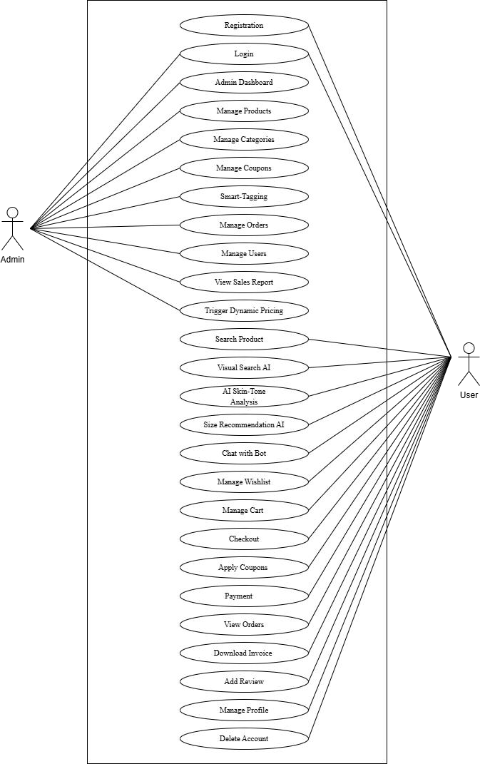

Scenario

Admin

    - Admin Can Login to Customized Dashboard (Jazzmin).
    - Admin Can View Main Analytics Dashboard.
    - Admin Can View Registered Users.
    - Admin Can Manage Registered Users.
    - Admin Can View Product Catalog.
    - Admin Can Search Products.
    - Admin Can Add Products.
    - Admin Can Manage Product Variants (Size/Color).
    - Admin Can Manage Inventory and Stock Levels.
    - Admin Can Add Coupons.
    - Admin Can Manage Coupons.
    - Admin Can View Orders.
    - Admin Can Process Orders.
    - Admin Can Use AI Smart Tagging.
    - Admin Can Monitor Dynamic Pricing.
    - Admin Can Monitor Demand Scores.
    - Admin Can View Product Reviews.
    - Admin Can Detect Fake Reviews Using AI.

User

    - User Can Register.
    - User Can Login.
    - User Can View Profile.
    - User Can Edit Profile.
    - User Can Browse Products.
    - User Can Filter Products by Category.
    - User Can Use Visual Search.
    - User Can Use Elegance Bot.
    - User Can Get AI Stylist Recommendations.
    - User Can Get AI Size Recommendations.
    - User Can Get Skin Tone Based Recommendations.
    - User Can Add Items to Cart.
    - User Can Add Items to Wishlist.
    - User Can Apply Discount Coupons.
    - User Can Make Secure Payments (Stripe).
    - User Can View Order History.
    - User Can Track Delivery Status.
    - User Can Add Reviews and Ratings.

Data Flow Diagram

Level - 0
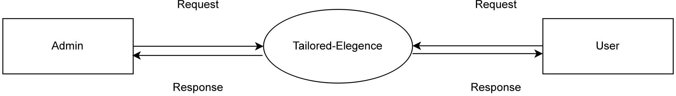

Level - 1 Admin

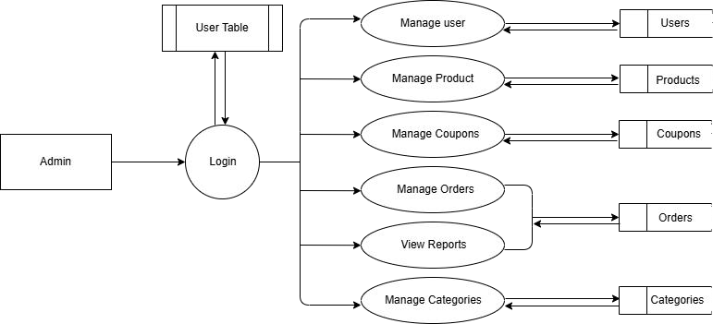

Level - 1 User

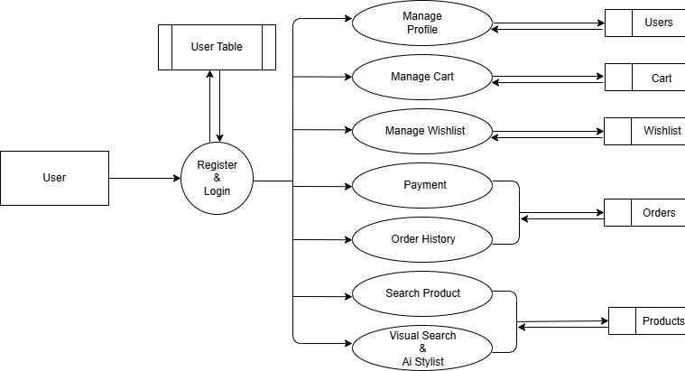

Level - 2 Admin

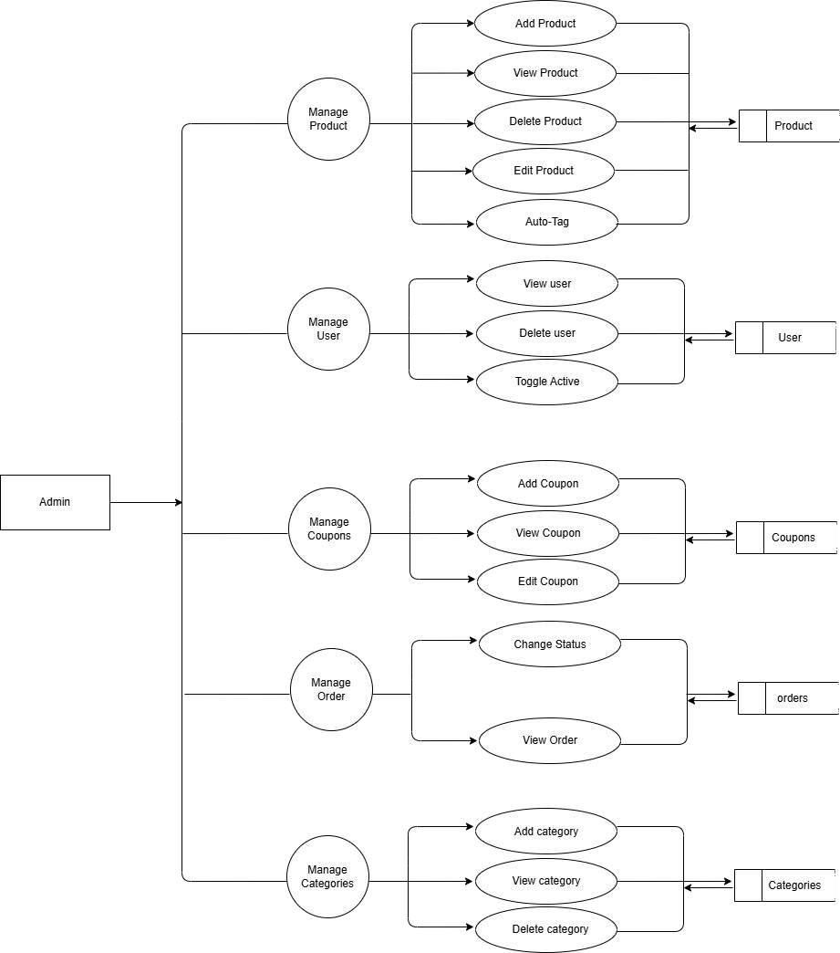

Level - 2 User

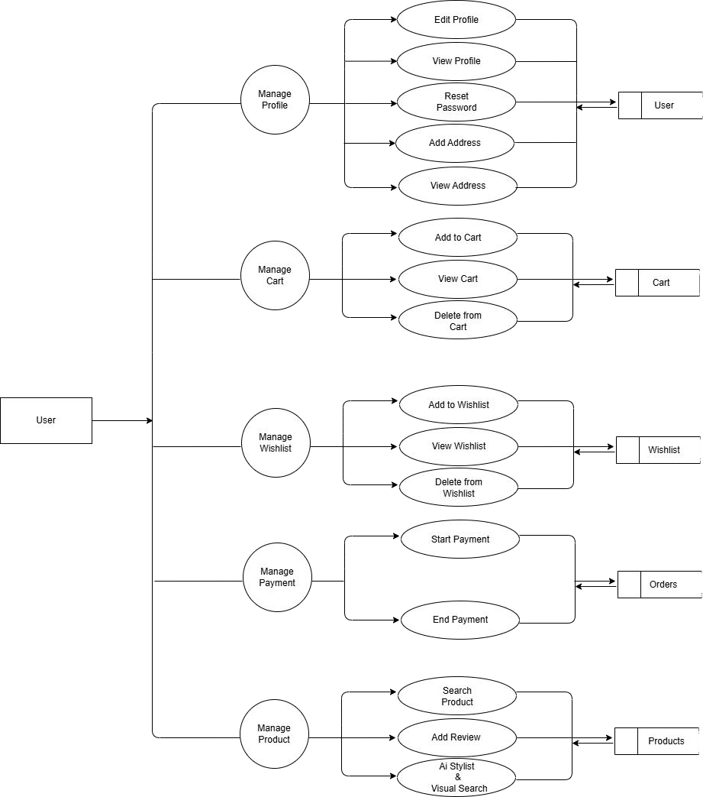

SYSTEM DEVELOPMENT

SYSTEM DEVELOPMENT
System development is series of operations to manipulate data to produce output from computer system. The principal activities performed during the development phase can be divided into two major related sequences.
- External system development
- Internal system development
The major external system activities are:
- Implementation
- Planning
- Equipment acquisition
- Installation

Coding
The purpose of code is to facilitate the identification and retrieval of items of information. A code is an ordered collection of symbols designed to provide uniqueidentification of entity or an attribute. Code also show interrelationship among different items. Codes are used to identify, access, sort, matching records. The code ensures that only one value of code with a single meaning is applied to give entity or attribute as described in various ways.

Python

Python is a high-level, interpreted programming language known for its simplicity, readability, and versatility. It was created by Guido van Rossum in 1991 and has since become one of the most widely used programming languages in the world. Python is extensively used in web development, data analysis, artificial intelligence, machine learning, automation, and scientific computing. Its clear syntax and structured design philosophy make it easy to learn while remaining powerful enough for complex system development.
In web development, frameworks such as Django and Flask provide robust tools for building secure and scalable applications. For data science and AI, libraries like NumPy, Pandas, TensorFlow, and Scikit-learn enable efficient data processing and intelligent model development.

In the Tailored Elegance project, Python acts as the core backend language, managing business logic, database interactions, AI model integration, and dynamic data processing. Its flexibility and strong community support make it a reliable foundation for building intelligent, scalable, and high-performance web applications.

Libraries

Python, alongside modern web technologies, possesses a vast ecosystem of libraries and frameworks that simplify and accelerate application development. These tools provide pre-built solutions for handling user interfaces, managing backend servers, connecting databases, and running complex machine learning models.

Django
Django is a high-level, open-source Python web framework that encourages rapid development and clean, pragmatic design. Built by experienced developers, it takes care of much of the hassle of web development, providing built-in features for user authentication, routing, and database administration. Django follows the Model-View-Template (MVT) architectural pattern. In Tailored Elegance, Django serves as the core backend framework, securely handling everything from user sessions and cart management to securely serving data to the frontend.

Bootstrap

Bootstrap is a powerful, open-source front-end CSS framework directed at responsive, mobile-first web development. It contains CSS and JavaScript-based design templates for typography, forms, buttons, navigation, and other interface components. By utilizing Bootstrap, Tailored Elegance ensures that the e-commerce interface remains highly scalable, visually appealing, and fully functional across all devices—from desktop monitors to mobile phones—without requiring extensive custom CSS code.

Scikit-Learn

Scikit-Learn is an essential machine learning library for the Python ecosystem, featuring various classification, regression, and clustering algorithms. In this project, it provides the backbone for non-neural network AI tasks. It is utilized to run K-Means Clustering algorithms to detect dominant colors in product images and powers the Random Forest models behind the Dynamic Pricing intelligence and AI Size Recommendations.

MySQL
MySQL is a widely used, open-source Relational Database Management System (RDBMS). Unlike NoSQL databases, MySQL organizes data into highly structured tables interconnected by defined relationships. It is renowned for its reliability, data integrity, and high performance. In Tailored Elegance, MySQL efficiently stores and manages all critical structured data, including user profiles, categorized product inventories, complex order histories, and the user interaction logs required to feed the machine learning recommendation systems.

Django ORM
The Django Object-Relational Mapper (ORM) is a built-in feature of Django that allows developers to interact with the database using Python code instead of writing raw SQL queries. By defining database tables as Python classes (models), the ORM handles data validation, query building, and relationship mapping between tables. It ensures data consistency and provides a secure, efficient bridge between the Python backend and the MySQL database.

TensorFlow
TensorFlow is an end-to-end open-source platform for machine learning, created by Google. Keras acts as a high-level neural networks interface running on top of TensorFlow. In Tailored Elegance, these powerful libraries are used exclusively to process complex deep learning tasks, specifically utilizing models like MobileNetV2 and EfficientNetB0 to power the core Visual Search and Smart Tagging features, allowing the system to accurately identify clothing items and extract feature vectors from uploaded images.Additionally, TensorFlow supports efficient model optimization and scalability, making it suitable for real-time predictions and large-scale data processing. The integration of these deep learning models enhances the system’s ability to deliver intelligent recommendations, automate product categorization, and improve overall user experience. This robust implementation of TensorFlow and Keras plays a critical role in enabling AI-driven features within the Tailored Elegance platform. f

SYSTEM TESTING AND IMPLEMENTATION

SYSTEM TESTING AND IMPLEMENTATION
Testing is the vital to the success of the system. It makes a logical assumption that if all the parts of the system are correct, the goal will be successfully achieved in this project. It is the stage of implementation, which ensures that system works accurately and effectively before the live operation commences. It is a confirmation that all are correct and opportunity to show users that the system must be tested and show that the system will operate successfully and produce expected results under expected conditions. Software testing is a crucial element of software quality assurance and represents the unlimited review of specification, design and coding. Testing represents an interesting anomaly for the software. During the earlier definition and development phase, it was attempted tobuild the software from an abstract concept to implement.
Testing is a set of activity that can be planned in advance and conducted. Systematically, this is aimed at ensuring that the system works accurately and efficiently before live operations commences.

Types of Testing

Different types of testing are,
- Unit testing
- Integration testing
- System testing
- Validation testing
- User acceptance testing.

Unit Testing
Unit testing is usually conducted as part of a combined code and unit test phase of the software lifecycle, although it is not uncommon for coding and unit testing to be conducted as two distinct phases. All modules were tested and individually as soon as they were completed and were checked for their correct functionality. Unit testing deals with testing a unit as a whole. This would test the interaction of many functions but confine the test within one unit. This testing is carried out during programming stage itself. In this testing step each Module is found to be working satisfactorily as regard to the expected output from the module.

Integration Testing
Integration testing is a systematic technique for testing to overcome the errors associated within the interface. In this System all the modules such as login, registration, admin in web, user in web, and the final hardware and software are combined and then the entire program is tested as a whole. Thus, in the integration testing step all the errors in the implementation of the system are corrected. Data can be lost across an interface one module can have an adverse effect on others; sub-functions when combined may not produce the desired major functions integration testing is a systematic testing for constructing the program structure. The objective is to take unit tested modules and to combine them and test it as a whole.
  - The system contains various components and they have to be combined and tested.
  - The software is embedded into hardware and tested.
  - The modules are combined and tested.
  - The hardware part tested separately.

System Testing

After performing the validation testing, the next step is output testing of the proposed system since no system could be useful if it doesn’t produce the required data inthe specific format. The output displayed or generated by the system under consideration is tested by, asking the user about the format displayed. The output format on the screenis found to be correct as the format was designed in the system phase according to the user needs. Hence the output testing doesn’t result in any correction in the system.

User Acceptance Testing

User Acceptance of the system is the key factor for the success of the system. The system under consideration is tested for user Acceptance by constantly keeping in touch with prospective system at the time of developing and making change wherever required. This is done with regard to the following points.
- Output Screen design.
- Input Screen design.
- Menu driven system.

Implementation
Implementation is the stage of project, when theoretical design is turned in to a working system. The most crucial stage is achieving a successful system and confidence that the new system will be work effectively. It involves careful planning, investigation of the manual system and to new system.
Implementation means converting a new or revised system design into an operational one. The implementation includes all those activities that take place to convert from the old system to the new one.
There are several activities involved while implementing a project:

- Careful planning.
- Investigating the current system and its constraints on implementation.
- Design of methods to achieve the changeover.
- Training of the staff in the changeover procedure and evaluation of change over method.
Implementation is the final stage and it is an importance phase. The first task in implementation was the implementation planning, that is deciding on methods to be adopted. After the system was implemented successfully, training of the user was oneof the most important subtasks of the developer. For this purpose, the user or system manual were prepared and handled over to the user to operate the developed system. So, change over plays a vital role, which checks the developed tool for the following requirements, and then only the user accepted the developed tool. The changeover took place only when the system had been proved to the satisfaction of the system analysis and other implementation activities have been completed.

SYSTEM MAINTENANCE

SYSTEM MAINTENANCE
Maintenance is making adaptation of the software for external changes (requirements changes or enhancements) and internal changes (fixing bugs). When changes are made during the maintenance phase all preceding steps of the model must be revisited.
There are three types of maintenance:
  - Corrective (Fixing bugs/errors)
  - Adaptive (Updates due to environment changes)
  - Perfective (Enhancements, requirements changes)
Maintenance is enigma of the system development. The definition of the software maintenance can be given describing four activities that are undertaken after the program is released for use.
The maintenance activity occurs since it is unreasonable to assume that software testing will uncover all in a large system. The second activity that contributes the definition of maintenance occurs since rapid changes are encountered in every aspects of computing. The third activity involves recommendation for new capabilities, modification to the existing functions and general enhancements when the software is used. The fourth maintenance activity occurs when software is changed to improve futuremaintainability or reliability.

FUTURE ENHANCEMENT

FUTURE ENHANCEMENT

- Mobile Application for iOS and Android
- Real-Time Logistics and Order Tracking

- Push Notifications for Dynamic Price Drops

- Multi-Language and Currency Support

- Social Style Sharing and Referrals

- Virtual Try-On

- Predictive Inventory Analytics for Admin

- Automated Restock Prediction for Admin

- Advanced 3D Avatar Sizing

CONCLUSION

CONCLUSION

The project "Tailored Elegance" provides a highly efficient, sophisticated, and user-friendly solution for online menswear retail and inventory management through a modern, AI-enhanced web application. By blending traditional e-commerce functionality with cutting-edge artificial intelligence, several essential features have been seamlessly integrated to make this system powerful, reliable, and convenient for both users and administrators.
With the rapid advancement of technology, consumers expect more personalized, interactive shopping experiences. This application bridges the gap between the tactile experience of a physical clothing boutique and the convenience of the digital era. In traditional online shopping, customers faced difficulties such as overwhelming catalogs, sizing uncertainties, and rigid text-based search. Additionally, administrators struggled with manual inventory categorization and optimized pricing.All these challenges are effectively resolved through Tailored Elegance, which offers groundbreaking features like an AI Stylist, Image-based Visual Search, automated Smart Tagging, and Dynamic Pricing algorithms. Coupled with robust secure authentication, intuitive product browsing, and advanced admin control panels via Jazzmin, the project serves as a complete, state-of-the-art platform. It guarantees to dramatically enhance customer satisfaction by offering "fashion that fits your lifestyle" while simultaneously automating and promoting better, more profitable business management.

APPENDIX

APPENDIX

Login

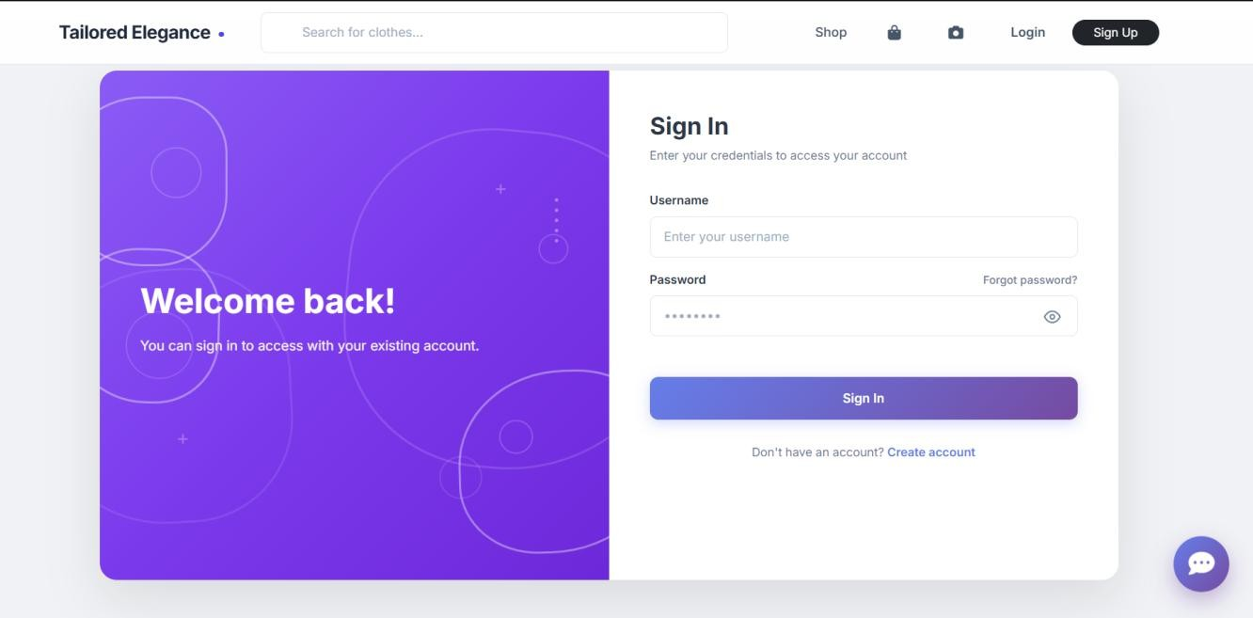

User Registration

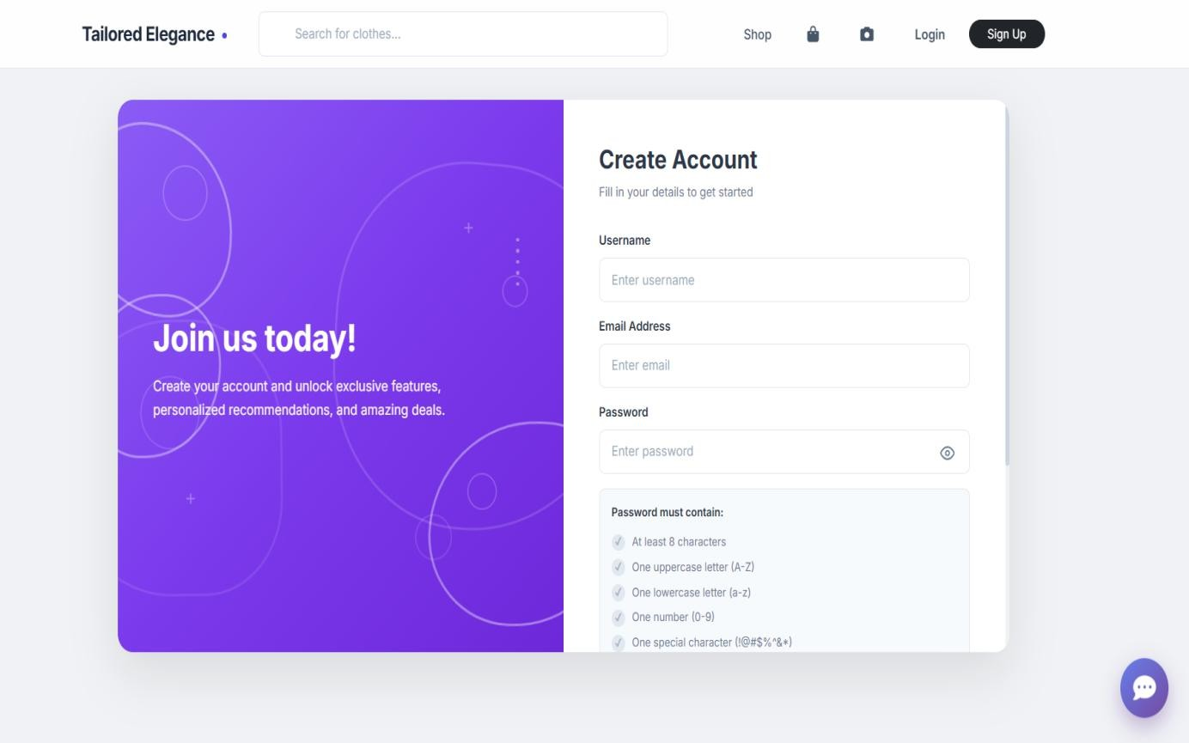

Admin Home

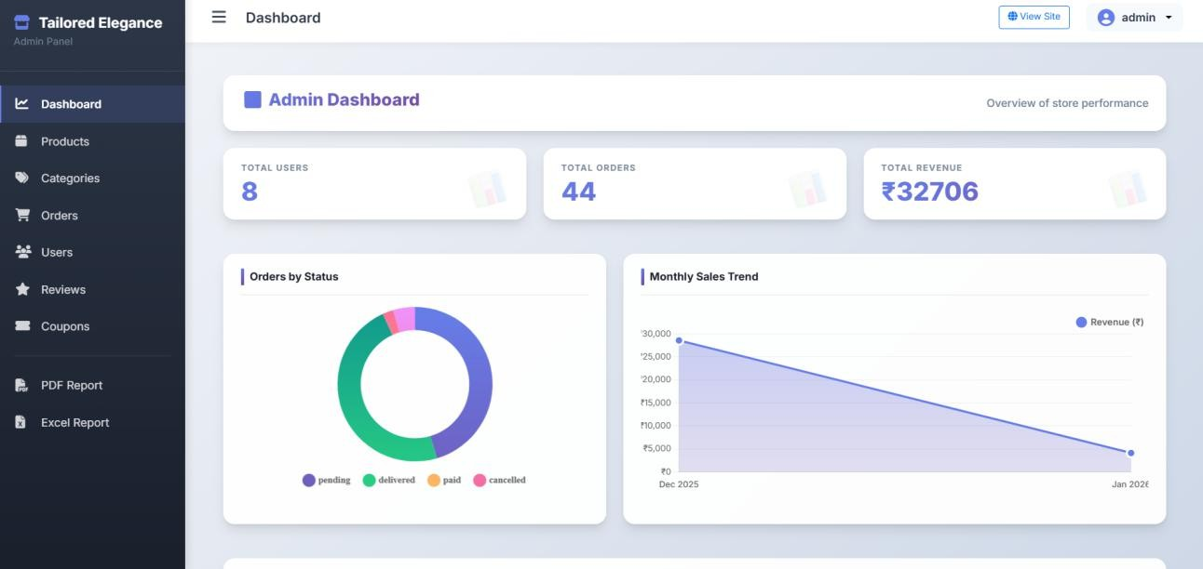

User Product Page

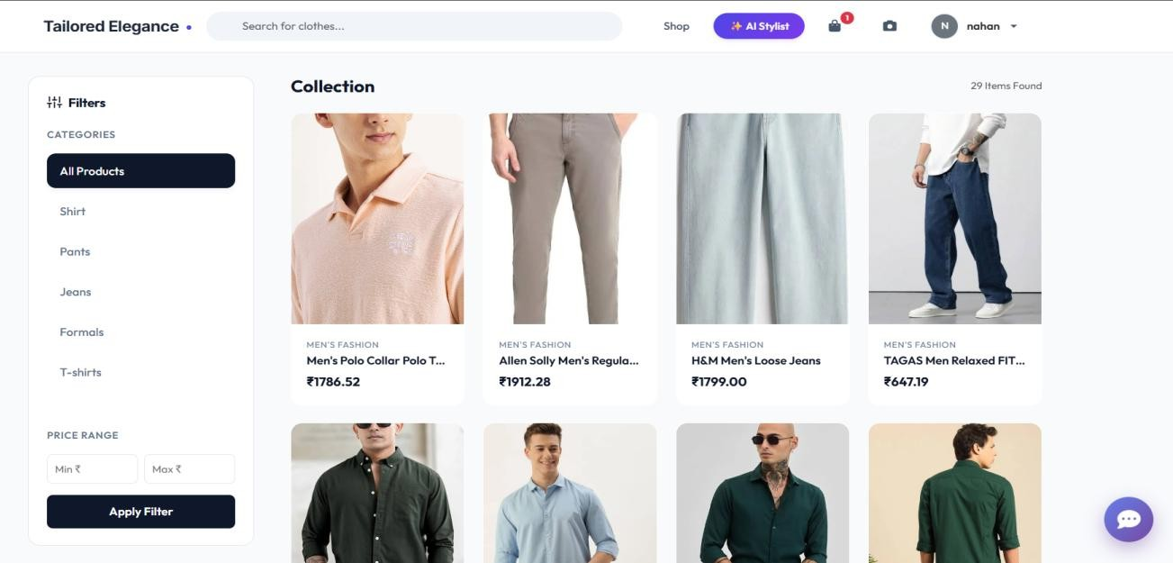

Order History

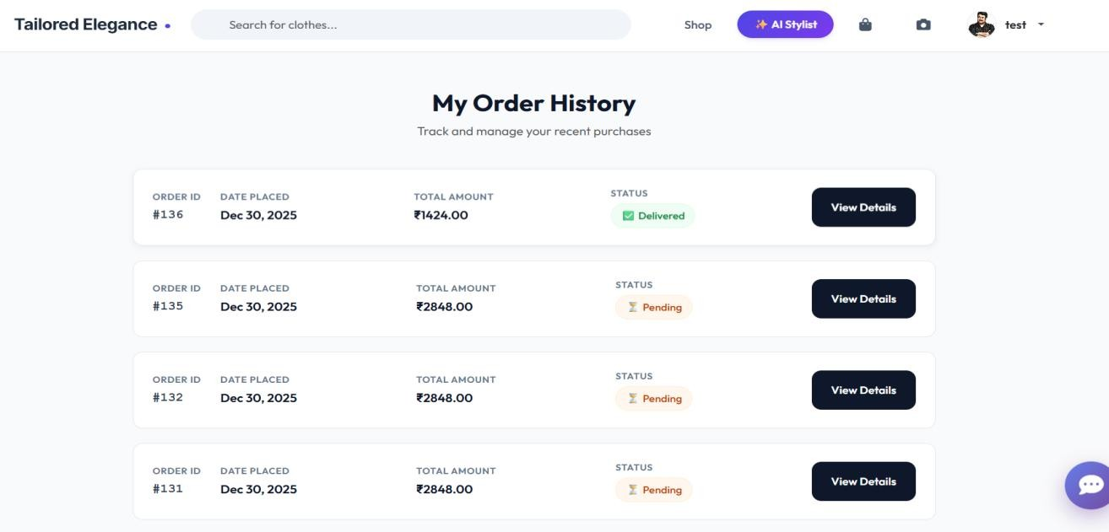

Skin Tone Detection

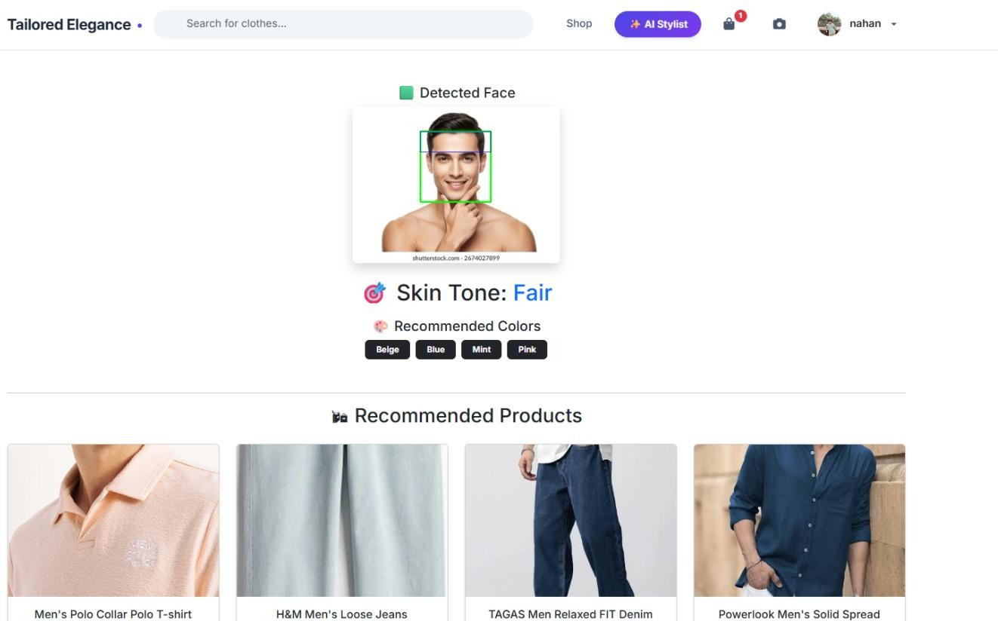

User Cart

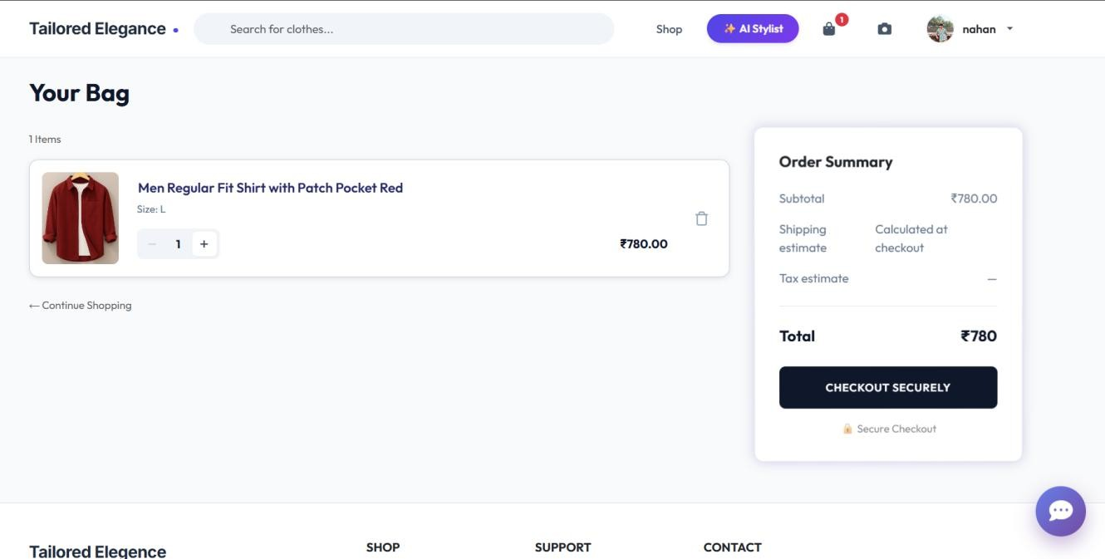

Admin products

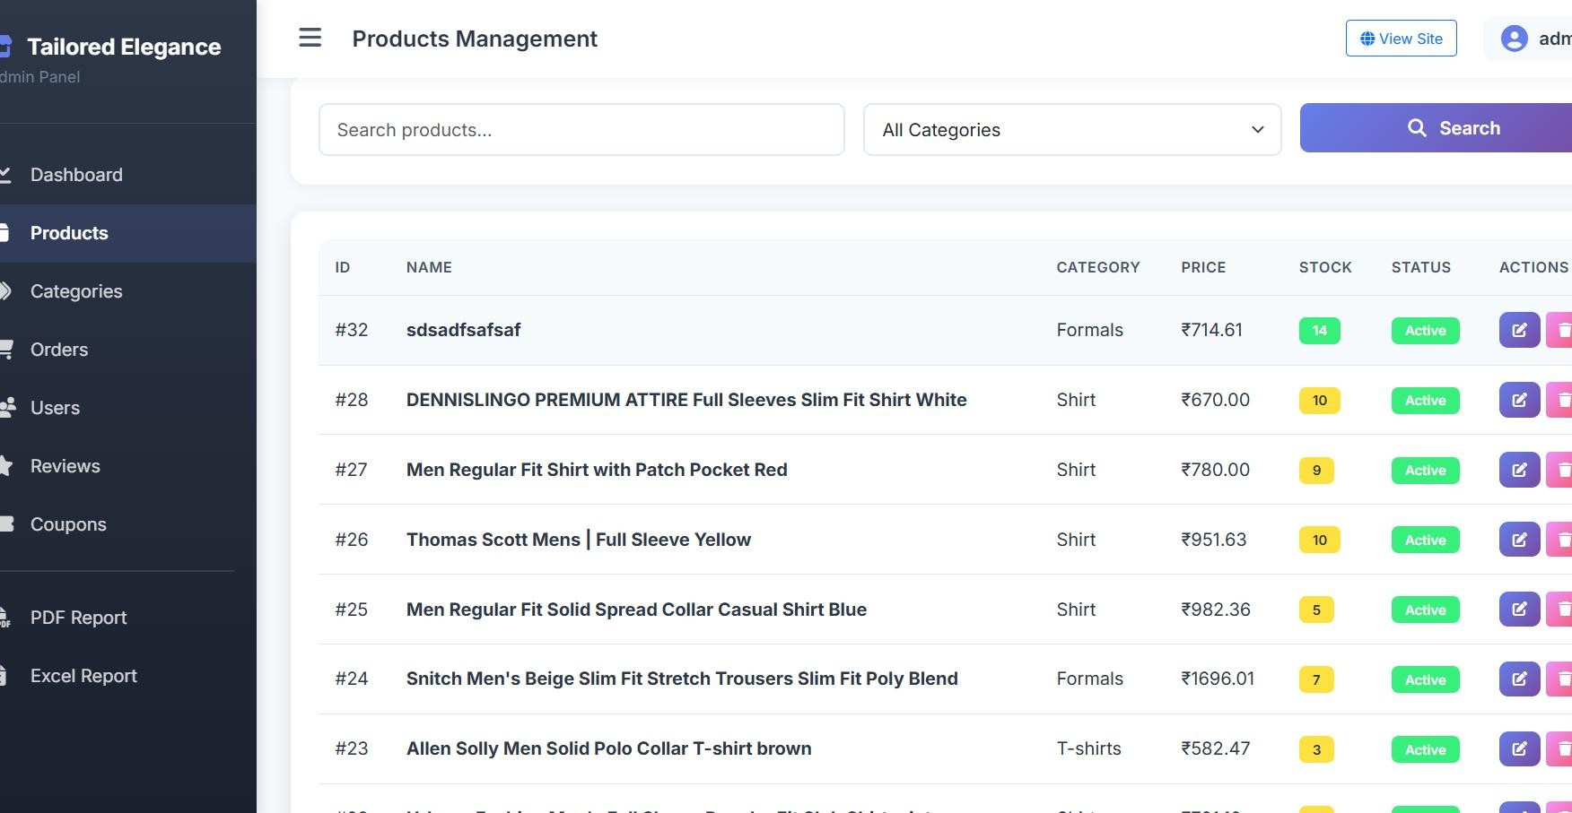

BIBLIOGRAPHY

12. BIBLIOGRAPHY

Journal Papers
- R. A. S. Thakur and R. Patel, “Design and Development of Scalable Web Applications using Django Framework,” International Journal of Computer Applications, Vol. 177, Issue 25, 2020.
- P. M. Abadi et al., “TensorFlow: Large-Scale Machine Learning on Heterogeneous Systems,” Software available from tensorflow.org, 2016..
- J. F. Pedregosa et al., “Scikit-learn: Machine Learning in Python,” Journal of Machine Learning Research, Vol. 12, pp. 2825–2830, 2011.

Websites
- https://docs.python.org/3/

- https://docs.djangoproject.com/

- https://dev.mysql.com/doc/
- https://www.tensorflow.org/

- https://getbootstrap.com/docs/

Books
- Mark Lutz, Learning Python, 5th Edition, O’Reilly Media, 2013.
- William S. Vincent, Django for Professionals, WelcomeToCode, 2022.
- A Paul DuBois, MySQL Cookbook, 4th Edition, O’Reilly Media, 2020.

